Week: 16 Date of planning: 16/12/2023
Period: 61 Date of teaching: 18/12/2023
REVIEW
Units 1-4 (page 63)

- Objectives
By the end of this lesson, students will be able to review their English skills from Unit 1 to Unit 4.
  - Language knowledge and skills
Vocabulary: play the guitar, play the piano, drive a car, ride a bike, do gymnastics, play the drums, ibrary, stadium, park, market, water park, swimming pool.
Sentence patterns: What can you do? I can play the piano. What can your mom do? She can drive a car. What can your friends do? They can ride bikes. What are you doing? I'm swimming at the pool. What are you doing? We're reading at the library.
  - Competences
Self-control and independent learning: review the vocabulary about animals, someone’s abilities, weather and activities.
Communication and collaboration: work in pairs or groups to talk about animals, someone’s abilities, weather and activities.
Critical thinking and creativity: learn how to talk about animals, someone’s abilities, weather and activities.
  - Attributes
Kindness: support their friends to complete the learning tasks.
Diligence: focus on the lesson and work hard to complete all the tasks.
Honesty: play fair.
Accountability: appreciate kindness, diligence, and honesty.
- Teaching aids and materials
- Teacher’s aids: Tiếng Anh 4 i-Learn Smart Start Student’s Book and Teacher’s book, Class CDs, Flashcards, Digital Book (DCR & DHA on Eduhome), Projector/Interactive Whiteboard /TV (if any), PowerPoint slides.
- Students’ aids: Tiếng Anh 4 i-Learn Smart Start Student’s Book, Workbook, Notebook.
- Procedures
- Warm up (5 minutes)
- Objectives: To help the students review the vocabulary (Units 1-4), generate the students’ interests, and lead in the Review lesson.
- Content: Playing the game: “Go get it”.
- Expected outcomes and assessment
- Task completed with excellence: Students quickly identify and get the correct flashcards.
- Task completed: Students can identify and get the correct flashcards.
- Task uncompleted: Students are unable to identify and get the correct flashcards.
- Organization
Teacher’s activities | Students’ activities
Play the Go get it game.  - Divide the class into two teams.  - Place the flashcards around the class.  - Say the word twice so that the students can hear.  - Say “Go get it” and then the student from each team has to run quickly to find and grab the flashcard the teacher said and they have to repeat the word.  - The team with the most flashcards at the end wins. | - Work with their teammates to complete the task.  - Look at the flashcards around the class.  - Carefully listen to the word the teacher said and quickly grab that flashcard.

- Main lesson
- Practice 1 (5 minutes)
- Objectives: To help the students identify and to talk about animals, someone’s abilities, weather and activities.
- Content: Speaking.
- Expected outcomes and assessment
Task completed with excellence: Students can identify and name the vocabulary about animals, someone’s abilities, weather and activities correctly.
Task completed: Students can identify and name the vocabulary about animals, someone’s abilities, weather and activities.
Task uncompleted: Students are unable to identify and name the vocabulary to talk about animals, someone’s abilities, weather and activities.
- Organization
Teacher’s activities | Students’ activities
Answer the questions.  - Use the flashcards (Units 1-4) to show to the students.  - Divide the class into two teams.  - Ask each team to take turns saying the word in each card.  - Correct them with their pronunciation if needed. | - Look at the flashcards.  - Work in teams to complete the task.  - Take turns saying the word in each card.

- Practice 2 (10 minutes)
- Objectives: To listen and put a tick or cross, read and fill in the blanks, write about zebras.
- Contents: Listening, Reading and Writing.
- Expected outcomes and assessment
- Task completed with excellence: Students can listen and put a tick or cross, read and fill in the blanks, write about zebras quickly.
- Task completed: Students can listen and put a tick or cross, read and fill in the blanks, write about zebras.
- Task uncompleted: Students fail to listen and put a tick or cross, read and fill in the blanks, write about zebras.
- Organization:
Teacher’s activities | Students’ activities
5. Listen and put a tick or a cross. (CD2 – Track 26)  - Demonstrate the activity using the example.  - Have the students listen and put a tick or a cross in their Student’s Books.  - Divide the class into pairs and have them check each other’s work.  - Use DCR on Eduhome to check the answers as a whole class.  - Have some pairs practice saying the sentences.  - Monitor the class and support if needed. | - Carefully look at the teacher demonstrating the activity.  - Listen and put a tick or a cross the sentences in their Student’s Books.  - Work in pairs and check their partner’s answers.  - Check the answers with the teacher and friends.  - Practice saying the sentences with a friend.
6. Read and fill in the blanks.  - Demonstrate the activity using the example.  - Have the students read and fill in the blanks.  - Check answers as a whole class using DCR. | - Listen and follow their teacher’s demonstration.  - Read and fill in the blanks.  - Check the answers as a whole class.
7. Look at Part 6 and write about zebras.  - Have the students identify the text and read aloud.  - Ask them to read the sentences and wite the missing words about zebras.  - Use DCR on Eduhome to check answers as a whole class. | - Identify the text and read the sentences.  - Read the sentences and write the missing in the blanks.  - Check answers as a whole class.
8. Look at Part 4 and Part 7 and write about an animal you like. Write about what it looks like and what it can do.  - Demonstrate the activity using the example.  - Ask them to write about an animal.  - Use DCR on Eduhome to check answers as a whole class. | - Listen and follow their teacher’s demonstration.  - Write about an animal.  - Check answers as a whole class.

- Production (10 minutes)
- Objectives: To help them remember the vocabulary and sentence pattern.
- Content: Asking and answering the questions.
- Expected outcomes and assessment
- Task completed with excellence: Students can confidently talk about t animals, someone’s abilities, weather and activities.
- Task completed: Students are able to talk about animals, someone’s abilities, weather and activities.
- Task uncompleted: Students cannot talk about animals, someone’s abilities, weather and activities.
- Organization
Teacher’s activities | Students’ activities
9. Ask and answer.  - Let the class work in pairs to complete the task.  - Have the students practice using the structures (from tasks 4 &5) to talk about animals, someone’s abilities, weather and activities.  - Show the flashcards to the class.  - Require them to look at the flashcards and use the appropriate structures to ask their friends.  - Monitor the class and support them if necessary. | - Work with their partner to complete the task.  - Follow their teacher’s instructions.  - Look at the flashcards and use the appropriate structures to ask their friends.

- Consolidation and homework assignment (5 minutes)
- Objectives: To help the students memorize the key language structures they learned.
- Contents: Asking the questions and assigning homework.
- Expected outcomes and assessment
- Task completed with excellence: Students can memorize the target sentence patterns correctly.
- Task completed: Students are able to memorize the target sentence patterns.
- Task uncompleted: Students fail to memorize the target sentence patterns.
- Organization
Teacher’s activities | Students’ activities
Consolidation  - Give the students enough time to memorize the target language structures they learned.  - Ask some students to say the language structures in front of the class.  - Correct the students if needed. | - Memorize the target language structures they learned.  - Present the language structures in front of the class.
Homework Assignment  - Ask them to review the vocabulary and grammar from Unit 1 to Unit 4.  - Ask them to prepare the next lesson on page 64 in the Student’s Book. | - Review the vocabulary and grammar from Unit 1 to Unit 4.  - Prepare the new lesson.

- Reflection

- What I liked most about this lesson today:
…………………………………………………………………………
- What I learned from this lesson today:
…………………………………………………………………………
- What I should improve for this lesson next time:
…………………………………………………………………………
______________________________________________

Week: 16 Date of planning: 17/12/2023
Period: 62 Date of teaching: 19/12/2023
REVIEW FOR THE FIRST FINAL TEST

- Objectives
By the end of this lesson, students will be able to review their English skills from Unit 1 to Unit 4.
  - Language knowledge and skills
Vocabulary: unit 1-4
Sentence patterns: unit 1-4
  - Competences
Self-control and independent learning: review the vocabulary about animals, someone’s abilities, weather and activities.
Communication and collaboration: work in pairs or groups to talk about animals, someone’s abilities, weather and activities.
Critical thinking and creativity: learn how to talk about animals, someone’s abilities, weather and activities.
  - Attributes
Kindness: support their friends to complete the learning tasks.
Diligence: focus on the lesson and work hard to complete all the tasks.
Honesty: play fair.
Accountability: appreciate kindness, diligence, and honesty.
- Teaching aids and materials
- Teacher’s aids: Tiếng Anh 4 i-Learn Smart Start Student’s Book and Teacher’s book, Class CDs, Flashcards, Digital Book (DCR & DHA on Eduhome), Projector/Interactive Whiteboard /TV (if any), PowerPoint slides.
- Students’ aids: Tiếng Anh 4 i-Learn Smart Start Student’s Book, Workbook, Notebook.
- Procedures
- Warm up (5 minutes)
a. Objectives: To help the students review the vocabulary (Units 1-4), generate the students’ interests, and lead in the Review lesson.
- Content: Playing the game: “Go get it”.
- Expected outcomes and assessment
- Task completed with excellence: Students quickly identify and get the correct flashcards.
- Task completed: Students can identify and get the correct flashcards.
- Task uncompleted: Students are unable to identify and get the correct flashcards.
- Organization
Teacher’s activities | Students’ activities
Play the Go get it game.  - Divide the class into two teams.  - Place the flashcards around the class.  - Say the word twice so that the students can hear.  - Say “Go get it” and then the student from each team has to run quickly to find and grab the flashcard the teacher said and they have to repeat the word.  - The team with the most flashcards at the end wins. | - Work with their teammates to complete the task.  - Look at the flashcards around the class.  - Carefully listen to the word the teacher said and quickly grab that flashcard.

- Main lesson
- Practice 1 (30 minutes)
a. Objectives: To help the students practice listening skills.
- Content: Listening
- Expected outcomes and assessment
Task completed with excellence: Students can have all correct answers.
Task completed: Students can make some small mistakes.
Task uncompleted: Students are unable to finish the tasks.
- Organization
- Teacher gives students paper exercises to practice listening.
- Work in pairs to check the correct answer with teacher.

Ex 1: Listen and number the pictures. There is one example
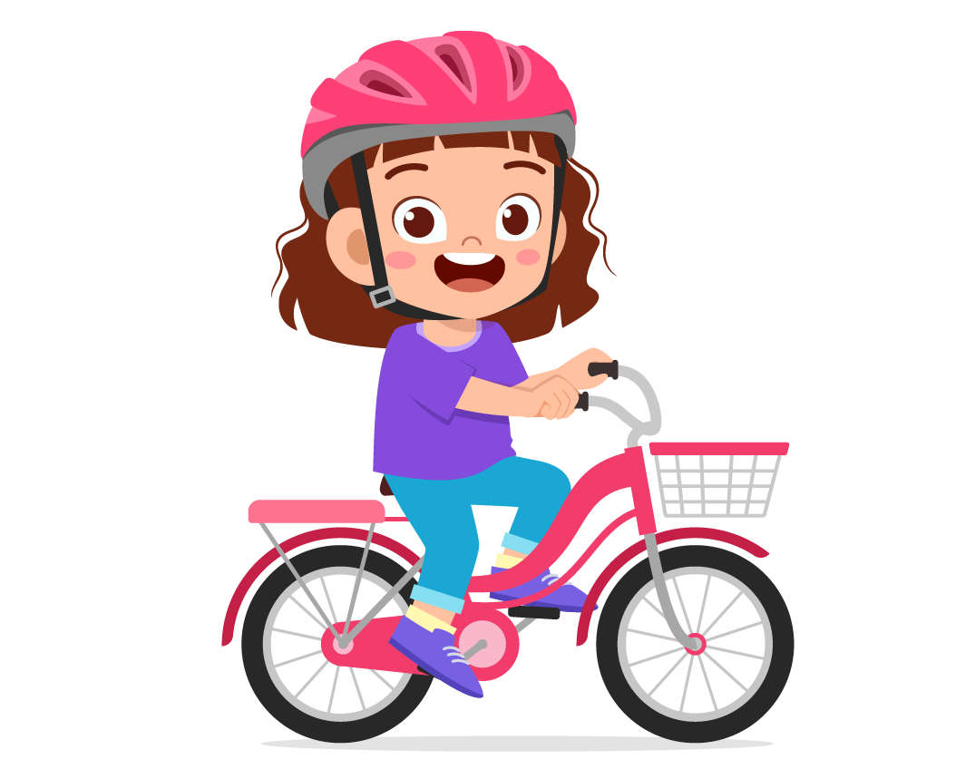

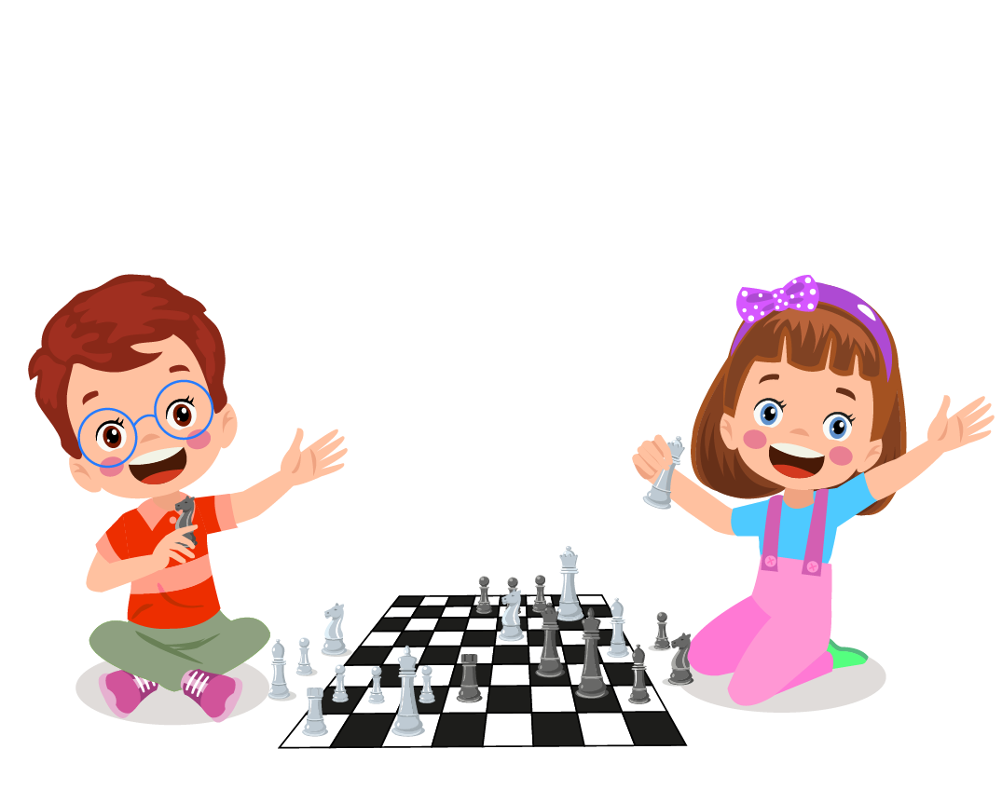



0




Ex 2: Listen and choose the correct picture. There is one example

A. ☐

B. ☑

C. ☐
A. ☐ B. ☑ C. ☐

Questions:

- Where does Lisa want to go?


C. ☐

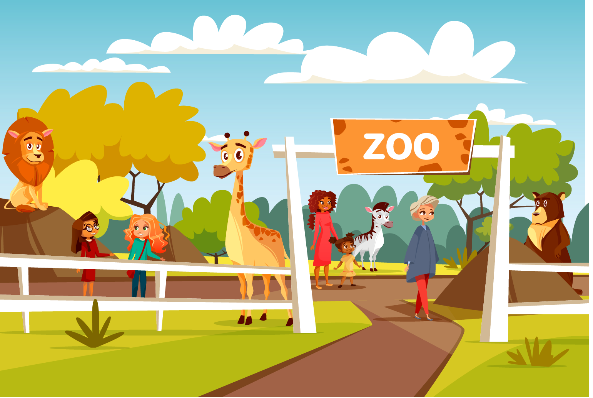


B. ☐
A. ☐ B. ☐ C. ☐
- What is Lisa’s favorite animal?


C. ☐




B. ☐

A. ☐ B. ☐ C. ☐

- What does Lisa need to bring?




A. ☐

B. ☐
A. ☐ B. ☐ C. ☐
Ex 3: Listen and write. There is one example.
0. Lucy is 8/eight years old.
8. Lucy usually cooks with her _______________ and sister.
9. Lucy can make salad, but she can’t make ________________ .
10. Her mom can make ________________ and Lucy love them so much.

_______________________________________________________

Week: 16 Date of planning: 19/12/2023
Period: 63 Date of teaching: 21/12/2023
REVIEW FOR THE FIRST FINAL TEST

- Objectives
By the end of this lesson, students will be able to review their English skills from Unit 1 to Unit 4.
  - Language knowledge and skills
Vocabulary: unit 1-4
Sentence patterns: unit 1-4
  - Competences
Self-control and independent learning: review the vocabulary about animals, someone’s abilities, weather and activities.
Communication and collaboration: work in pairs or groups to talk about animals, someone’s abilities, weather and activities.
Critical thinking and creativity: learn how to talk about animals, someone’s abilities, weather and activities.
  - Attributes
Kindness: support their friends to complete the learning tasks.
Diligence: focus on the lesson and work hard to complete all the tasks.
Honesty: play fair.
Accountability: appreciate kindness, diligence, and honesty.
- Teaching aids and materials
- Teacher’s aids: Tiếng Anh 4 i-Learn Smart Start Student’s Book and Teacher’s book, Class CDs, Flashcards, Digital Book (DCR & DHA on Eduhome), Projector/Interactive Whiteboard /TV (if any), PowerPoint slides.
- Students’ aids: Tiếng Anh 4 i-Learn Smart Start Student’s Book, Workbook, Notebook.
- Procedures
A. Warm up (5 minutes)
a. Objectives: To help the students review the vocabulary (Units 1-4), generate the students’ interests, and lead in the Review lesson.
- Content: Playing the game: “Go get it”.
- Expected outcomes and assessment
- Task completed with excellence: Students quickly identify and get the correct flashcards.
- Task completed: Students can identify and get the correct flashcards.
- Task uncompleted: Students are unable to identify and get the correct flashcards.
- Organization
Teacher’s activities | Students’ activities
Play the Go get it game.  - Divide the class into two teams.  - Place the flashcards around the class.  - Say the word twice so that the students can hear.  - Say “Go get it” and then the student from each team has to run quickly to find and grab the flashcard the teacher said and they have to repeat the word.  - The team with the most flashcards at the end wins. | - Work with their teammates to complete the task.  - Look at the flashcards around the class.  - Carefully listen to the word the teacher said and quickly grab that flashcard.

B. Main lesson
- Practice 1 (30 minutes)
a. Objectives: To help the students practice reading skills.
- Content: reading
- Expected outcomes and assessment
Task completed with excellence: Students can have all correct answers.
Task completed: Students can make some small mistakes.
Task uncompleted: Students are unable to finish the tasks.
- Organization
- Teacher gives students paper exercises to practice reading.
- Work in pairs to check the correct answer with teacher.

Ex 1: Read and tick True or False
 | 0. I can make salad. | ☑ True ☐ False
 | 1. What can your friends do? They can jump rope. | ☐ True ☐ False
 | 2. Is he watching television? Yes, he is. | ☐ True ☐ False
 | 3. What can Janet do? She can do gymnastics. | ☐ True ☐ False
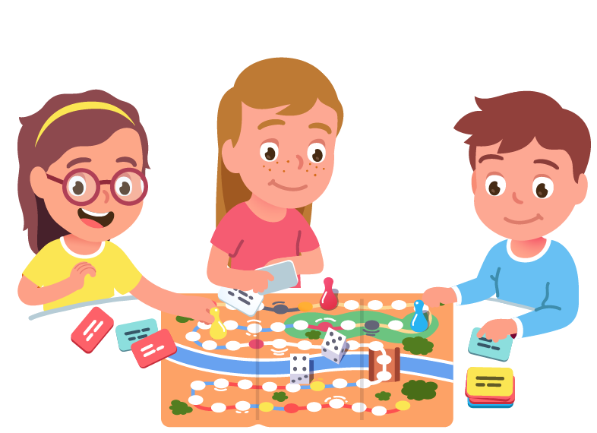 | 4. What are they doing? They’re having a picnic. | ☐ True ☐ False
Ex 2: Read this. Choose a word from a box. Write the correct word next tot numbers 1-5. There is one example.
- A horse
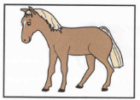
I have an animal. I stand on my four long (1)________________ and I have a beautiful long tail too. I see with my two black (2) ________________. I like eating lots of things, for example (3)_______________ and apples. I drink lots of (4) _______________ in the day. Men, women and (5) _____________ like riding me. What am I? I am a horse.
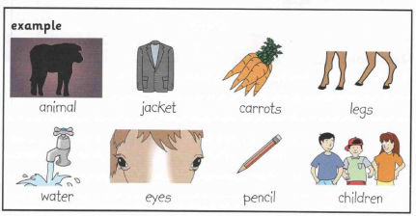
Ex 3: Read and circle the correct answer. There is one example
Hi! My name is Minh. I live in Phu Quoc. It’s in Vietnam. It has lots of beautiful beaches. The weather here is often hot and sunny. I like having a picnic or riding a bike with my friends when it’s sunny. On weekends, I go to the park with my family. Sometimes, it rains, too. When it’s rainy, I stay at home and read comic books.
- Example:
0. Minh lives in Phu Quoc / Nha Trang.
A. Phu Quoc B. Nha Trang

- Questions:

1. The weather in Phu Quoc is often cool and sunny/hot and sunny
A. cool and sunny B. hot and sunny.
2. Minh likes having a picnic / flying a kite when it’s sunny.
A. having a picnic B. flying a kite
3. He goes to the park / walks the dog with his family on weekends.
A. goes to the park B. walks the dogs
4. When it’s rainy, he stays at home and watches television / reads comic books.

A. watches television B. reads comic books

Week: 16 Date of planning: 20/12/2023
Period: 64 Date of teaching: 22/12/2023
REVIEW FOR THE FIRST FINAL TEST

- Objectives
By the end of this lesson, students will be able to review their English skills from Unit 1 to Unit 4.
a. Language knowledge and skills
Vocabulary: unit 1-4
Sentence patterns: unit 1-4
- Competences
Self-control and independent learning: review the vocabulary about animals, someone’s abilities, weather and activities.
Communication and collaboration: work in pairs or groups to talk about animals, someone’s abilities, weather and activities.
Critical thinking and creativity: learn how to talk about animals, someone’s abilities, weather and activities.
- Attributes
Kindness: support their friends to complete the learning tasks.
Diligence: focus on the lesson and work hard to complete all the tasks.
Honesty: play fair.
Accountability: appreciate kindness, diligence, and honesty.
- Teaching aids and materials
- Teacher’s aids: Tiếng Anh 4 i-Learn Smart Start Student’s Book and Teacher’s book, Class CDs, Flashcards, Digital Book (DCR & DHA on Eduhome), Projector/Interactive Whiteboard /TV (if any), PowerPoint slides.
- Students’ aids: Tiếng Anh 4 i-Learn Smart Start Student’s Book, Workbook, Notebook.
- Procedures
A. Warm up (5 minutes)
a. Objectives: To help the students review the vocabulary (Units 1-4), generate the students’ interests, and lead in the Review lesson.
- Content: Playing the game: “Go get it”.
- Expected outcomes and assessment
- Task completed with excellence: Students quickly identify and get the correct flashcards.
- Task completed: Students can identify and get the correct flashcards.
- Task uncompleted: Students are unable to identify and get the correct flashcards.
- Organization
Teacher’s activities | Students’ activities
Play the Go get it game.  - Divide the class into two teams.  - Place the flashcards around the class.  - Say the word twice so that the students can hear.  - Say “Go get it” and then the student from each team has to run quickly to find and grab the flashcard the teacher said and they have to repeat the word.  - The team with the most flashcards at the end wins. | - Work with their teammates to complete the task.  - Look at the flashcards around the class.  - Carefully listen to the word the teacher said and quickly grab that flashcard.

B. Main lesson
1. Practice 1 (30 minutes)
a. Objectives: To help the students practice writing skills.
- Content: writing
- Expected outcomes and assessment
Task completed with excellence: Students can have all correct answers.
Task completed: Students can make some small mistakes.
Task uncompleted: Students are unable to finish the tasks.
- Organization
- Teacher gives students paper exercises to practice reading.
- Work in pairs to check the correct answer with teacher
Ex 1: Look at the pictures, read the question and write the answer
 | 0. What do you like doing when it’s stormy?  I like doing arts and crafts.
 | 1. What’s the weather like today?  It________________________.
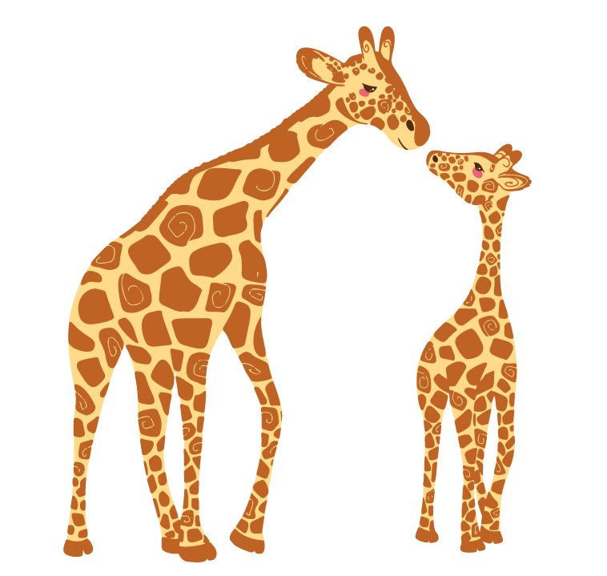 | 2. What are these?  They________________________
 | 3. What can Jerry do?  He can __________________.
 | 4. Are you watching television?  No, I’m not. I’m______________________.

Ex 2: Reorder the words to make a correct sentence. There is one example.
Example:
0. Keywords: weather/What's/like?/the
→ What's the weather like?
- Questions:
1. Keywords: Bats/wings/fly./use/to/their
→ .......................................
2. Keywords: raincoat/your/Bring/because it’s/today./rainy
→ .......................................
3. Keywords: like/warm./I/when it’s/watching TV
→ .......................................
4. Keywords: you/to go/like/Would/with me?/for a walk
→ .......................................
5. Keywords: Nancy/can/ropes./her friends/jump/and
→ .......................................

