Week: 33 Date of planning: 30/04/2024
Period: 129 Date of teaching: 02/05/2024

THE SECOND TERM SPEAKING TEST ( period 1)
I. Objective
- Check Ss’s speaking skill.
- Assess Ss if understand or not the lesson and Ss’ level to find out suit methods when teaching.
II. Preparation
- SPEAKING TESTS
III. Procedure
- Call each student and then ask Ss some questions.
- Offer to be serious in the test period
Organization:
Class | Date of preparing | Date of teaching
3C
Question 7: Getting to know each other
1. What’s your name?
2. How do you spell your name?
Question 8: Talking about familiar topic
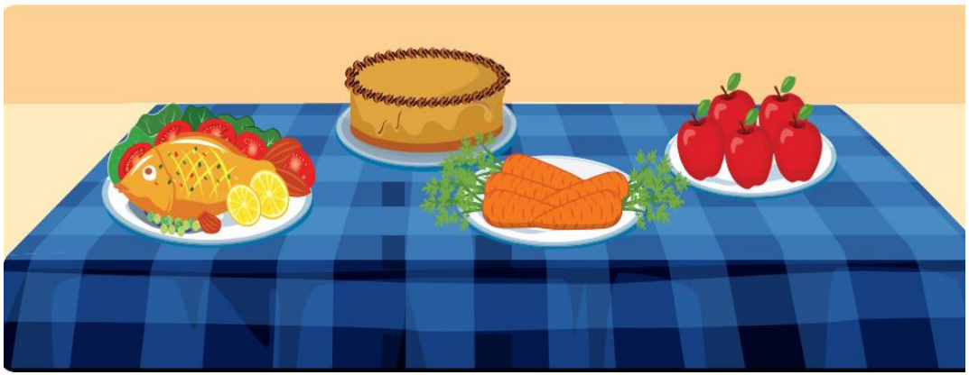
Example: 0. What can you see? I can see fish, carrots, apples, cake.
1. How many apples are there? There are five apples
2. Is there a cake? Yes, there is
3. Are there any donuts? No, there aren’t
4. Would you like some fish? Yes, please/ No, thank you.
________________________________________________________________

Week: 33 Date of planning: 01/05/2024
Period: 130 Date of teaching: 03/05/2024

THE SECOND TERM TEST
I. Objective
- Check Ss structures and vocabulary from Unit 5 to Unit 8.
- Assess Ss if understand or not the lesson and Ss’ level to find out suit methods when teaching.
II. Preparation
- PAPER TESTS
III. Procedure
Deliver paper tests for students
- Offer to be serious in the test period
Organization:
Class | Date of preparing | Date of teaching
3C
______________________________________________________________

Week: 33 Date of planning: 02/04/2024
Period: 131 Date of teaching: 04/05/2024

THE SECOND TERM SPEAKING TEST ( period 2)
I. Objective
- Check Ss’s speaking skill.
- Assess Ss if understand or not the lesson and Ss’ level to find out suit methods when teaching.
II. Preparation
- SPEAKING TESTS
III. Procedure
- Call each student and then ask Ss some questions.
- Offer to be serious in the test period
Organization:
Class | Date of preparing | Date of teaching
3C
Question 7: Getting to know each other
1. What’s your name?
2. How do you spell your name?

Question 8: Talking about familiar topic
Example: 0. What can you see? I can see fish, carrots, apples, cake.
1. How many apples are there? There are five apples
2. Is there a cake? Yes, there is
3. Are there any donuts? No, there aren’t
4. Would you like some fish? Yes, please/ No, thank you.

