Week: 33 Date of planning: 30/04/2024
Period: 129 Date of teaching: 02/05/2024
THE SECOND TERM TEST
I. Objective
- Check Ss structures and vocabulary from Unit 5 to Unit 8.
- Assess Ss if understand or not the lesson and Ss’ level to find out suit methods when teaching.
II. Preparation
- PAPER TESTS
III. Procedure
Deliver paper tests for students
- Offer to be serious in the test period
Organization:
Class | Date of preparing | Date of teaching
4A,4B,4C

______________________________________________________________

Week: 33 Date of planning: 01/05/2024
Period: 130 Date of teaching: 03/05/2024
THE SECOND TERM SPEAKING TEST ( period 1)
I. Objective
- Check Ss’s speaking skill.
- Assess Ss if understand or not the lesson and Ss’ level to find out suit methods when teaching.
II. Preparation
- SPEAKING TESTS
III. Procedure
- Call each student and then ask Ss some questions.
- Offer to be serious in the test period
Organization:
Class | Date of preparing | Date of teaching
4A,4B,4C

SPEAKING TEST
I: Respond to familiar structures (1 point)
- Greeting
- What does your father/mother/brother/sister look like?
He’s/ She’s………………….
- What does your father/mother/brother/sister do?
He’s/ She’s………………….
II. Look at the picture and answer the questions.(1point)
- What does the boy/girl do?
- What does the man/woman do?
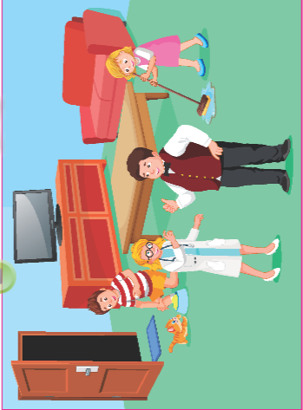
___________________________________________________________

Week: 33 Date of planning: 02/04/2024
Period: 131 Date of teaching: 04/05/2024

THE SECOND TERM SPEAKING TEST ( period 2)
I. Objective
- Check Ss’s speaking skill.
- Assess Ss if understand or not the lesson and Ss’ level to find out suit methods when teaching.
II. Preparation
- SPEAKING TESTS
III. Procedure
- Call each student and then ask Ss some questions.
- Offer to be serious in the test period
Organization:
Class | Date of preparing | Date of teaching
4A,4B,4C
SPEAKING TEST
I: Respond to familiar structures (1 point)
- Greeting
- What does your father/mother/brother/sister look like?
He’s/ She’s………………….
- What does your father/mother/brother/sister do?
He’s/ She’s………………….
II. Look at the picture and answer the questions.(1point)
- What does the boy/girl do?
- What does the man/woman do?

