Week: 35 Date of planning: 11/05/2024
Period: 136 Date of teaching: 13/05/2024

REVIEW
TASK 1.

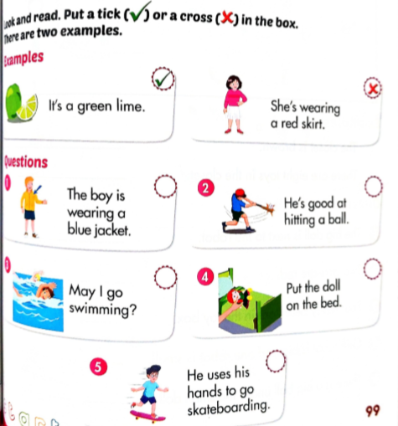

TASK 2.
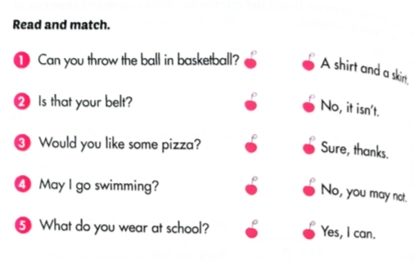
Week: 35 Date of planning: 12/05/2024
Period: 137 Date of teaching: 14/05/2024

REVIEW

TASK 1
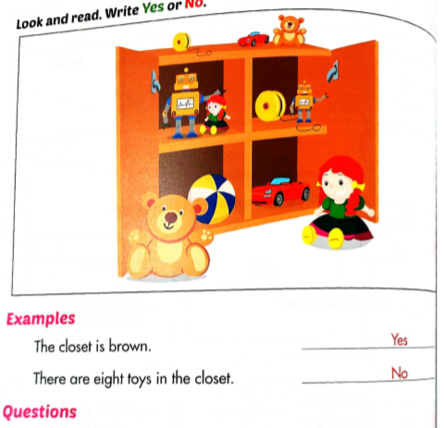
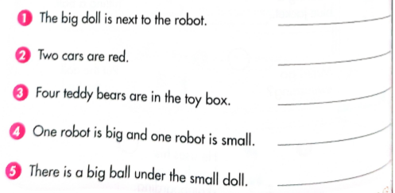

TASK 2.
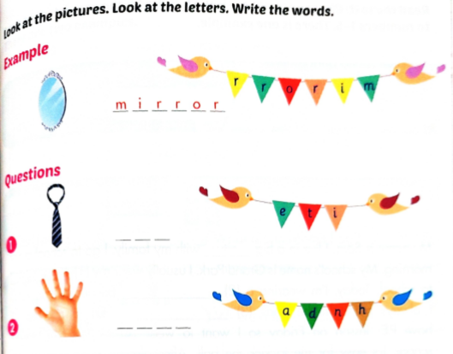
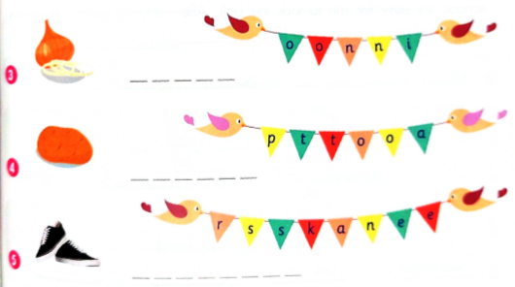

Week: 35 Date of planning: 14/05/2024
Period: 138 Date of teaching: 16/05/2024

CORRECT THE FINAL TERM TEST
ANSWER KEYS
PART 1: LISTENING (4 POINTS)
Question 1: Listen and put a tick () in the box. There is one example
(2 points)
Example: 0. a
1. b 2. c 3. a 4. c
Question 2: Listen and number. There is one example (2 points)
Example: 0. a
1. d 2. b 3. c 4. e
PART 2: READING (2 POINTS)
Question 3: Look, read and choose the correct pictures. There is one example. (1 point)
Example: 0. B
1. B 2. B 3. A 4. B
Question 4: Look, read and tick True or False. There is one example
(1 point)
Example: 0. False
1. True 2. False 3. True 4. False
PART 3: WRITING (2 POINTS)
Question 5: Order the letters. There is one example (1 point)
Example: 0. Scarf
1. ice cream 2. fries 3. kick 4. dice
Question 6: Reorder the words to make a correct sentence. There is one example (1 point)
Example:
0. What is she wearing?
1. There are some potatoes.
2. Would you like some onion?
3. Put the robot on the bed.
4. How many marbles do you have?

Week: 35 Date of planning: 15/05/2024
Period: 139+140 Date of teaching: 17/05/2024

SUMMARISE THE SECOND TERM

