Week: 35 Date of planning: 11/05/2024
Period: 136 Date of teaching: 13/05/2024

REVIEW

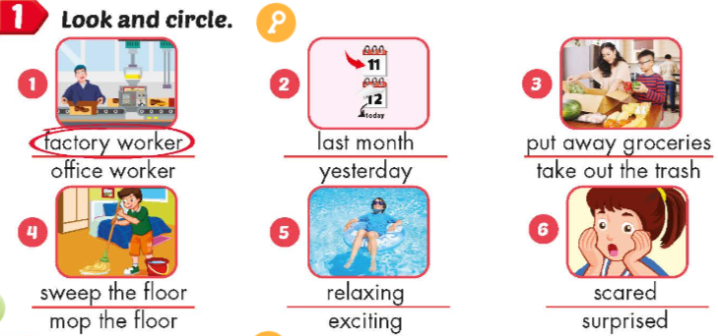

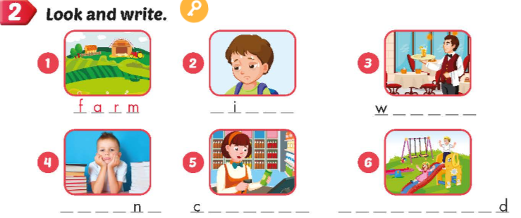

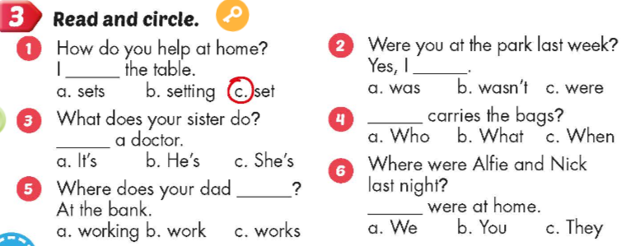

Week: 35 Date of planning: 12/05/2024
Period: 137 Date of teaching: 14/05/2024

REVIEW

TASK 1: read and match

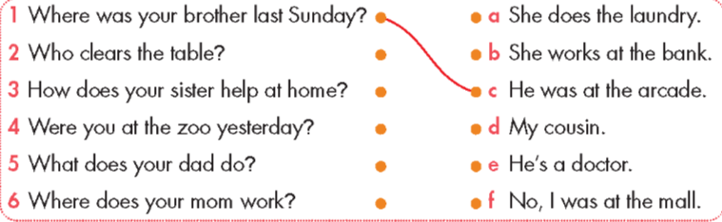

TASK 2: Read and fill the blank

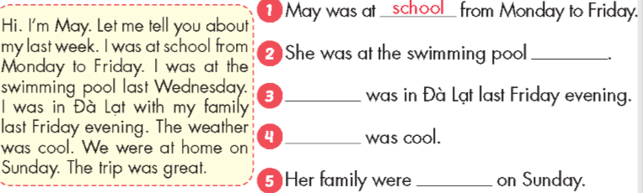

TASK 3: Write about your last weekend

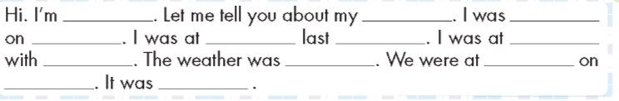

Week: 35 Date of planning: 14/05/2024
Period: 138 Date of teaching: 16/05/2024

CORRECT THE FINAL TERM TEST
ANSWER KEYS
PART 1: LISTENING

I. Listen and draw lines. (1 point)






E0. 1. 2. 3. 4.

last month
last weekend
yesterday
last night
last Friday

II. Listen and choose the correct answer. (1,25 points)

1: A 2: C 3:A 4: A 5:C

III. Listen and write. (0,75 point)

1: exciting 2: Sunday 3: tired

PART 2: READING AND DRAWING
I. Read and circle the odd one out. (1 point)

1: D 2:B 3: A 4:A

II. Read and circle the correct answer (2 points)

1: C 2:C 3:B 4:D

III. Read the text. Write some words to complete the sentences (1point)

1: blue 2: cashier 3: washes the dishes 4: amusement park

IV. Reorder the words to make a correct sentence (1 point)
1: I go to the swimming pool by bus.
2: At home, my brother clears the table.
3: My mother and I at the supermarket last Saturday.
4: My sister has short, blond hair.
PART 3: SPEAKING
I: Respond to familiar structures (1 point)
- Greeting
- He’s/ She’s young/old/handsome/pretty……
- He’s/she’s a/an farmer, office worker…….
II. Look at the picture and answer the questions.(1point)
- The boy feeds the cat.
The girl mops the floor.
- She’s a doctor.
He’s a waiter.
__________________________________________________________

Week: 35 Date of planning: 15/05/2024
Period: 139+140 Date of teaching: 17/05/2024

SUMMARISE THE SECOND TERM

