MINH CHÂU PRIMARY SCHOOL THE MID-TERM 2
Mark

Full name :………………………………. Subject : English
Class : 4……………………….… Grade : 4
Time : 35 minite
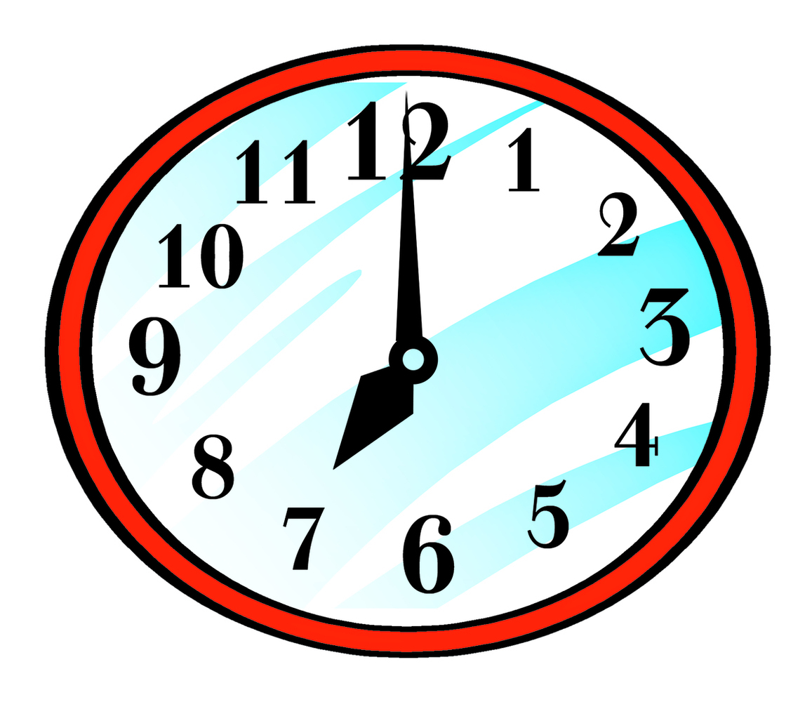
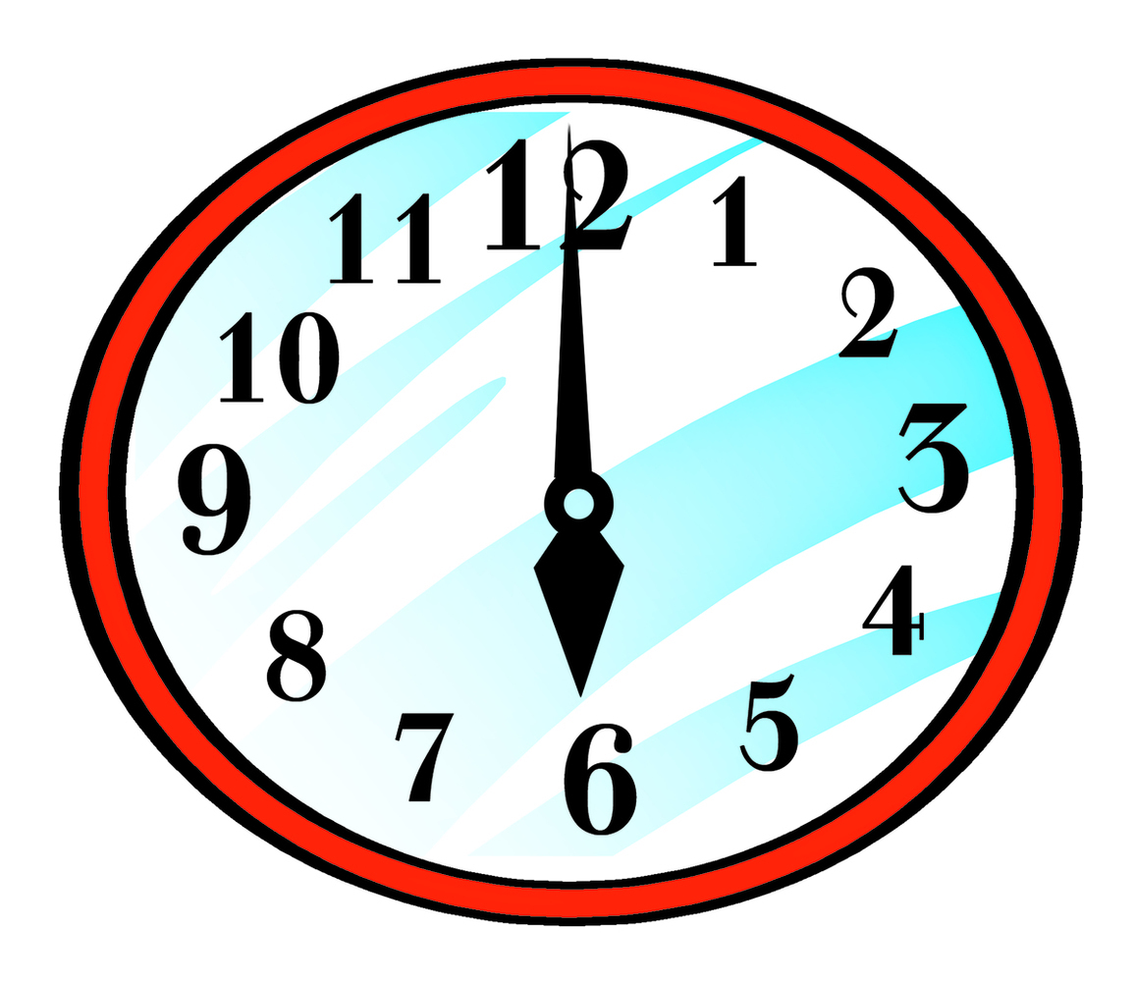
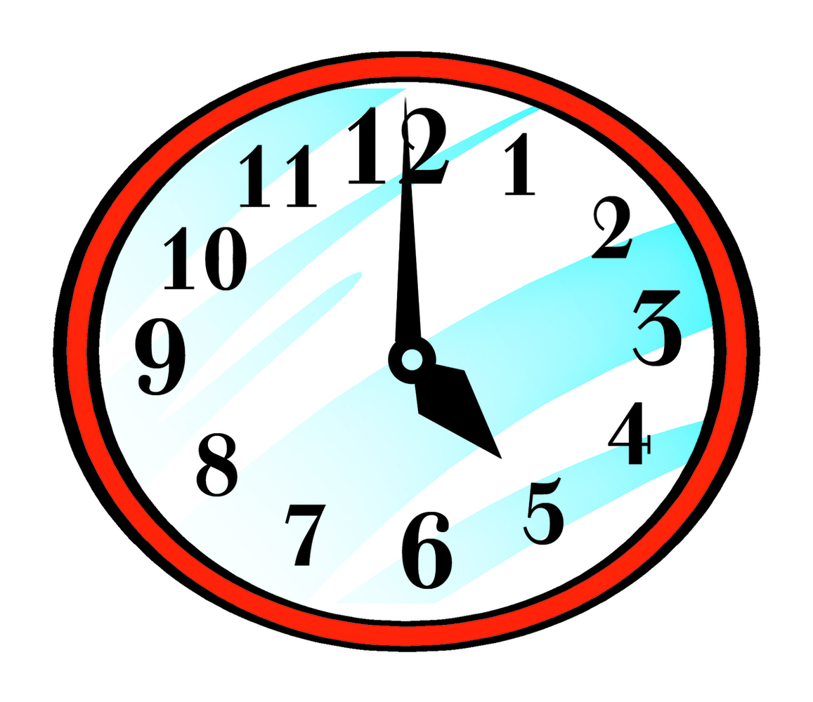
Question 1: Listen and tick (1,5p)
b
a
c
1

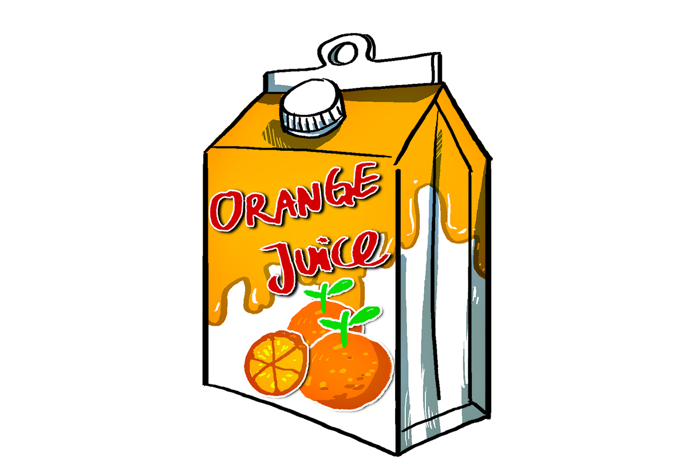


b
c
a
2

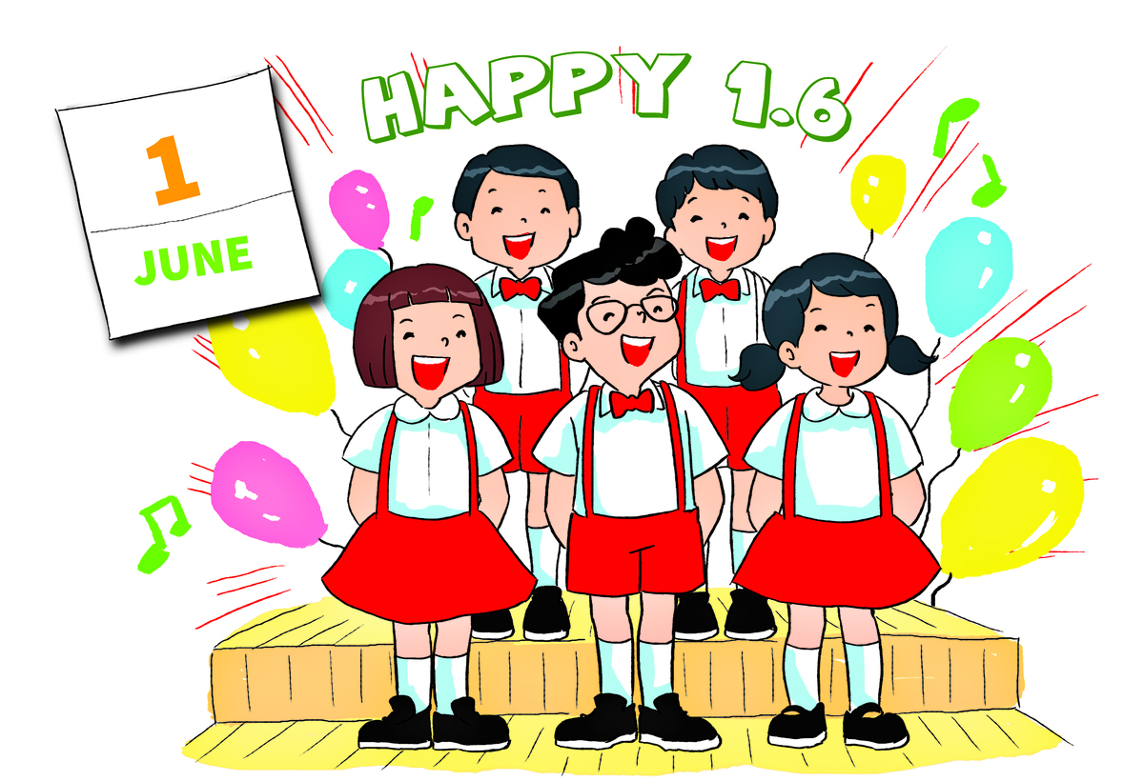
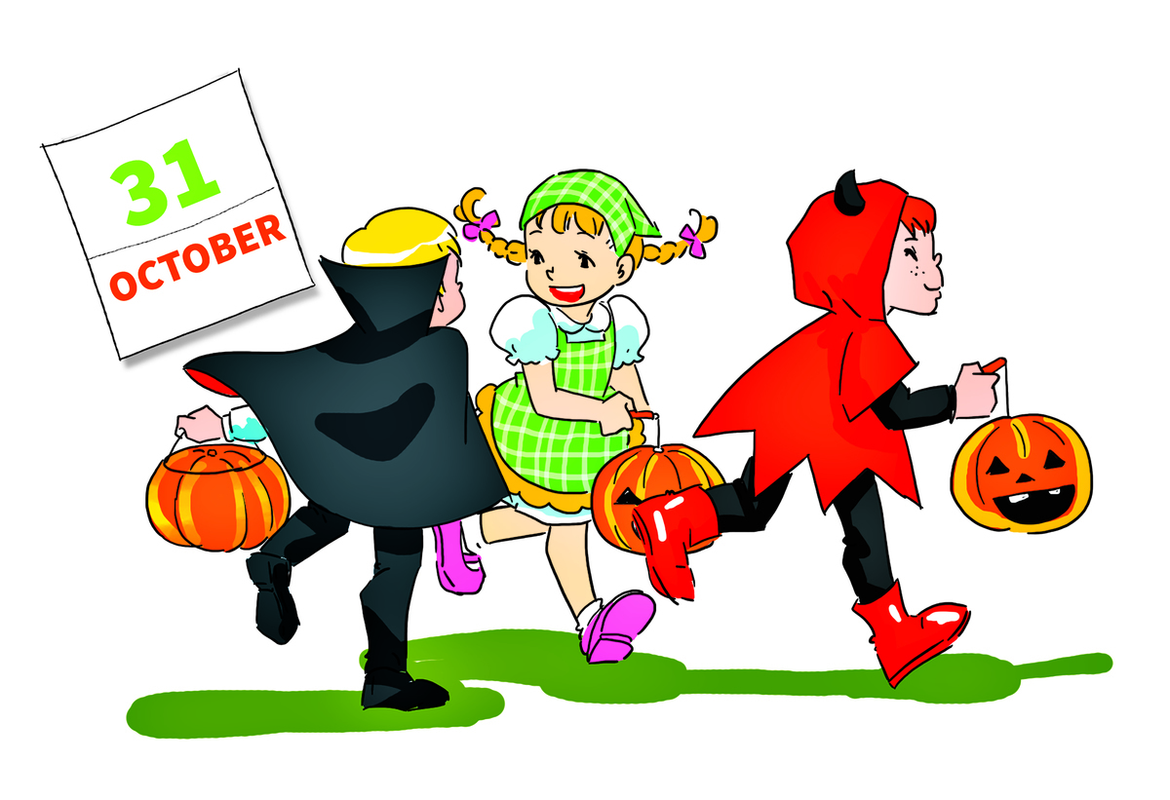
c
b
a

3

Question 2: Listen and circle (2p)
1. Nam is ___________ than his sister.
a. taller b. slimmer c. shorter
2. Would you like some ______?
a. fish b. beef c. chicken
3. What time is it, Mai?
It’s ………..
- eight fifteen b. seven fifteen c. six fifteen
4. What’s your favourite drink?
a. water b. orange juice c. milk

Question 3: circle the odd one out(1p)
- A. lemonade B. chicken C. orange juice D. water
- A. Children’s Day B. Teachers’ Day C. Chrismas D. Sunday
- A. taller B. bigger C. sister D. shorter
- A. teacher B. breakfast C. dinner D. lunch
- A. six fifteen B. seven o’clock C. eight forty D. five five

Question 4: Look and write(1)
A |  | B
1.What time is it? |  | a.He’s a doctor.
2.What does your mother look like? |  | b.It’s on the first of June.
3.What does your father do? |  | c. She’s tall and slim
4.What’s your favourite food? |  | d.It’s seven twenty
5.When’s Children’s Day? |  | e.It’s chicken and beef.

Question 5: Choose the correct answer(1p)
1. I like beef. It’s my favourite …………

A. drink B. milk C. food D. juice
2. I have dinner ___________ seven o’clock.
A. at B. to C. with D. for
3. Would you like ___________ water?
A. many B. much C. some D. any
4. He is ___________ teacher.
A. the B. X C. an D. a
5. My brother is _________ than my sister
A. taller B. shortest C. fat D. thin

Question 6: Read the passage and complete the sentence.
My brother’s name is Dat. He is 10 and he studies at Cambridge Primary School. He often gets up at six o’clock in the morning. He usually has breakfast at six thirty. Then, he goes to school by bus. He has got Maths and Science in the morning and his class starts at seven o’clock . He studies to eleven o’clock. He and his friends have lunch in the canteen. He learns English and History in the afternoon. His class finishes at five p.m . He is at home at five thirty and helps his mother to clear the table and cook the dinner. He watches TV, then goes to bed at 11 p.m.
1. Dat studies at __________________.
2. He _______________ at six o'clock in the morning.
3. His class starts at __________________.
4. He has lunch in _________________.
5. He _________________________to clear the table and cook the dinner.
6. He __________________ at 11 p.m.

Question 7: Reorder the sentences(1p)
- your/ work/ father/ Where/ does?
..........................................................................................................................

- 7 o’clock/ get/ I/ up/ often/ at.
............................................................................................................................
3. than/ brother/ sister/ My/ is/ taller/my .............................................................................................................................
4. day/ is/ When/ children’s/ the?
............................................................................................................................
5. your/ like?/ What/ brother/ does/ look
............................................................................................................................

-The end-

