MINH CHÂU PRIMARY SCHOOL THE MID-TERM 2
Mark

Full name :………………………………. Subject : English
Class : 5……………………….… Grade : 5
Time : 35 minite
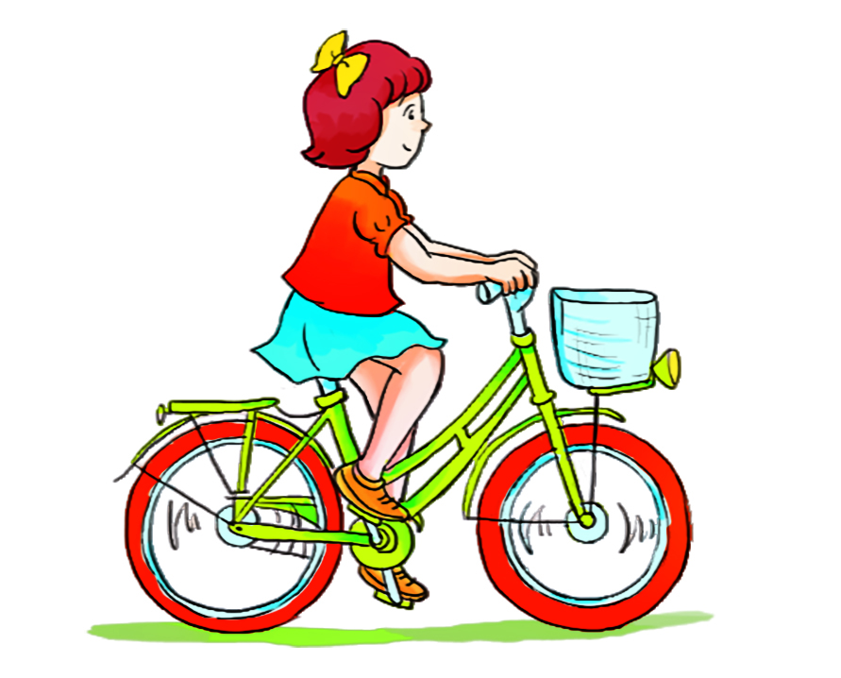
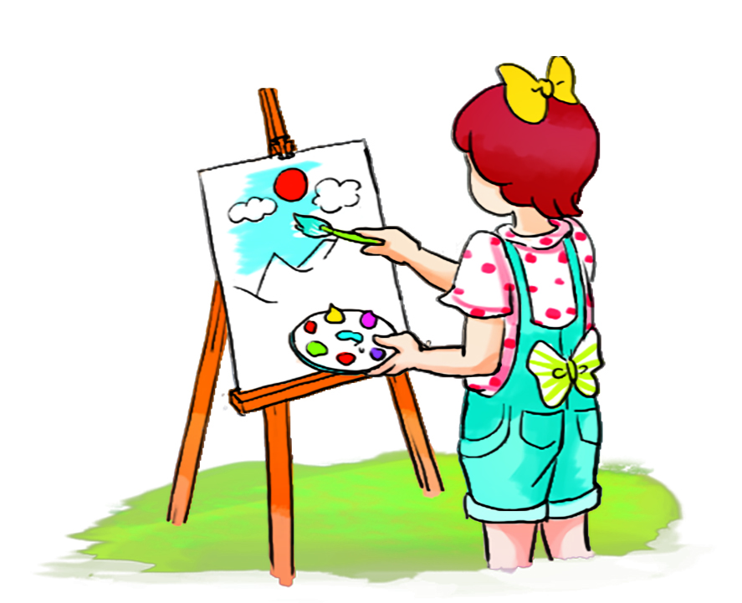

Question 1: Listen and tick (2)
b
a
c
1
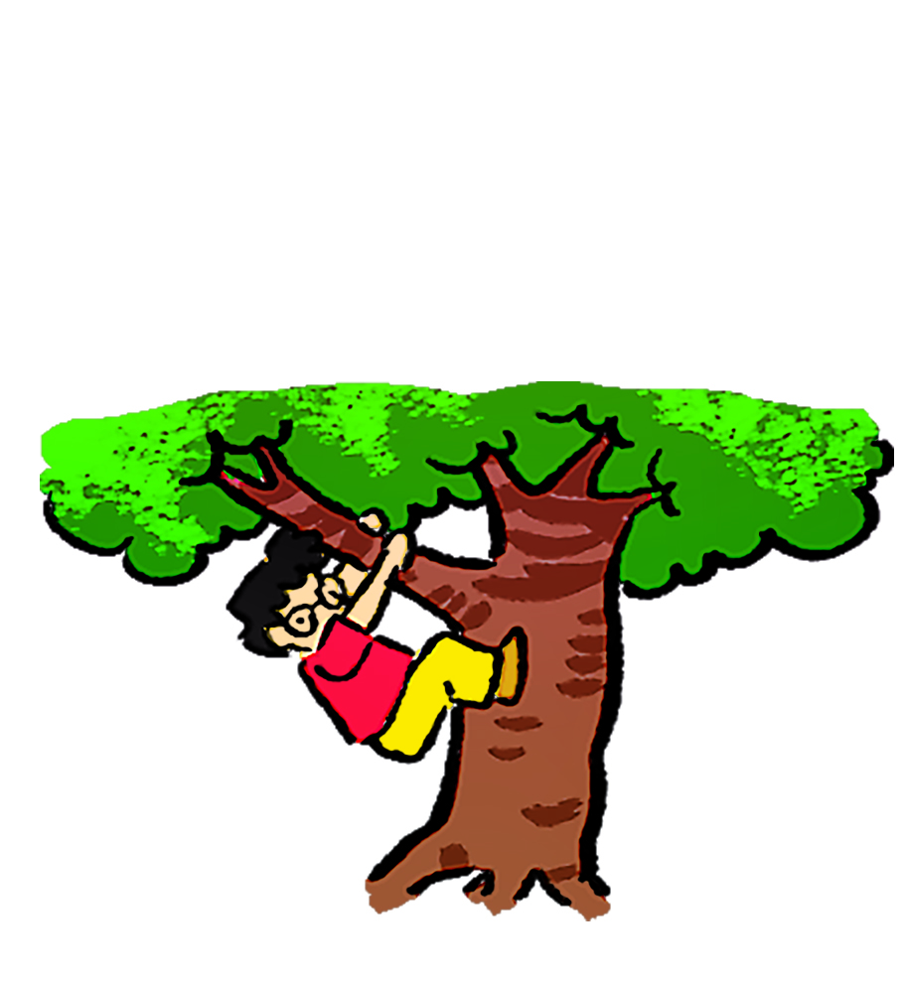
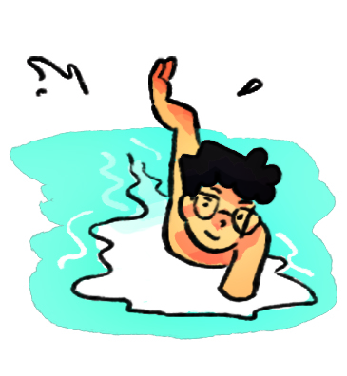
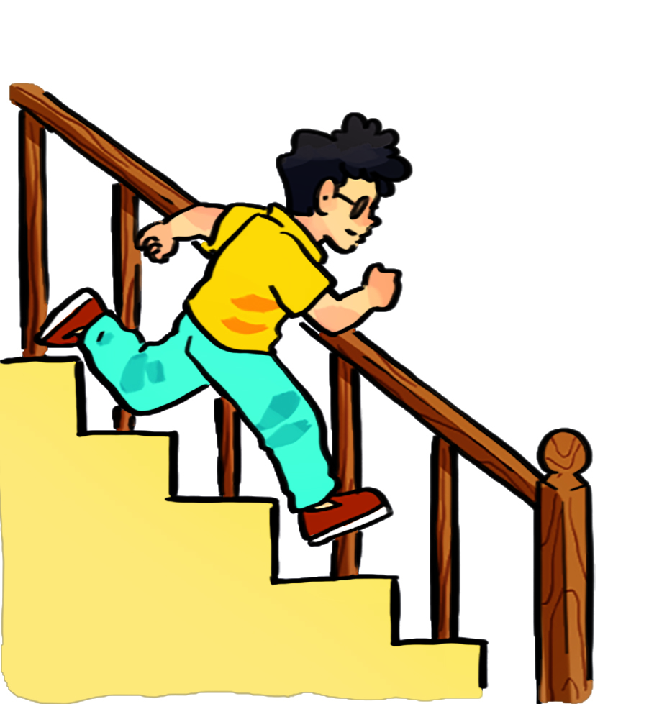
b
c
a
2

c
b
a
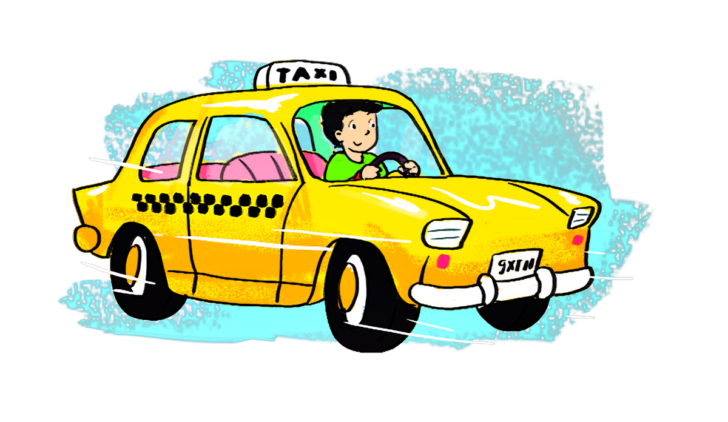
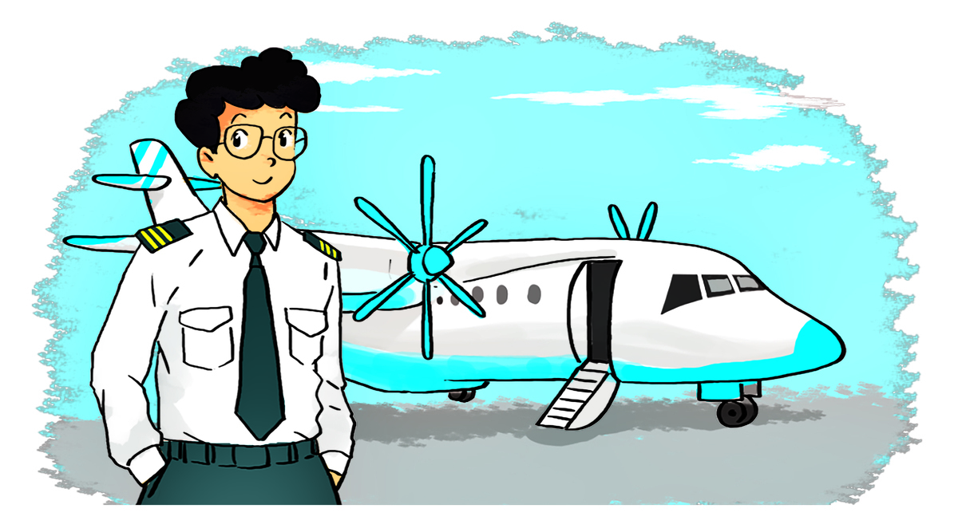
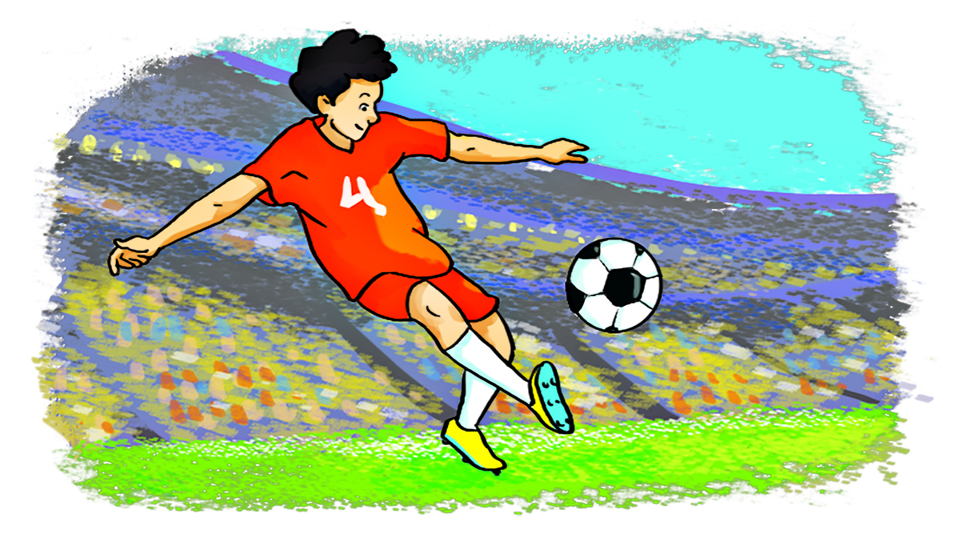
3


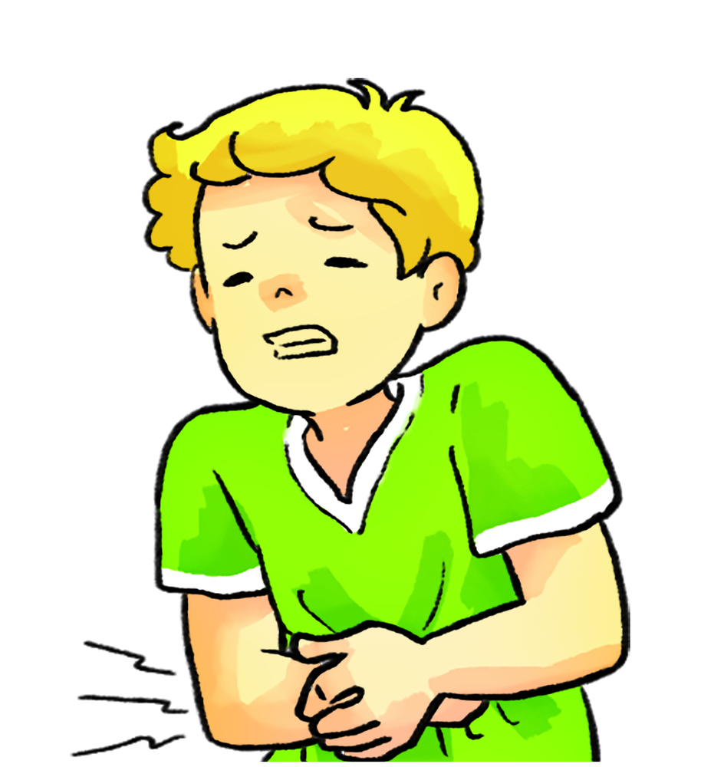
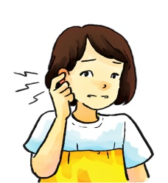
c
b
a
4

Question 2: Listen and circle (2p)
1. What's the matter with you?
I have a ____________.
a.toothache b.headache c. backache d. stomach ache
2. What does she do in her free time? She ______.
a.goes skating b.goes fishing c. does karate d. goes to the cinema
3. Tony would like to ___________.
a.drive a car b.fly a plane c.work in a factory d. look after flowers
4. What do they do in their free time? They ________.
a.work in the garden b.go shopping c. watch cartoons d. clean the house

Question 3: circle the odd one out(1,25p)
- A. writer B. teacher C. doctor D. brother
- A. first B. happen C. then D. next
- A. stomach B. headache C. toothache D. earache
- A. kind B. mouse C. greedy D. intelligent
- A. cooking B. swimming C. fishing D. sing

Question 4: Look and write(1,25)
A |  | B
- What happened in the story? |  | a. She shouldn’t eat a lot of sweets.
- Why would you like to be a writer? |  | b. It is Doraemon.
- Miss Hien has a toothache. |  | c. He’d like to be a teacher.
4. Who is the main character in this story? |  | d. First, the prince visited the castle and he met a beautiful princess.
5. What would he like to be in the future? |  | e. Because I’d like to write stories for children.
Question 5: Choose the correct answer(1,25p)
1. What the matter ________ you?
A. on B. with C. without D. about
2. Why shouldn’t ________ the stairs? - Because you may break your arm
A. running down B. runs down C. run down D. runing down
3. What would Tony like to be ________?
A. at the future B. on the future C. in the future D. to the future
4. My father ________ in the forest because he _______ sports
- goes hiking/ like B. goes hiking/ likes C. go hiking/ likes D. go hiking/ like
5.She has a pain in her back. - She has __________.
- a backache B. backaches C. the backache D. an backache
Question 6: Read the passage and complete the sentence.(1,25p)
My name is Hoang Anh. In my free time, I often go camping with my family. The camp is in the forest near Ba Na Hills. We go there by car in the morning. My father likes fishing in the stream. My mother likes cooking barbecue for us. My brother and I usually play hike-and-seek. It’s so fun. We return home late in the evening. We enjoy camping very much.
1. What’s her name?
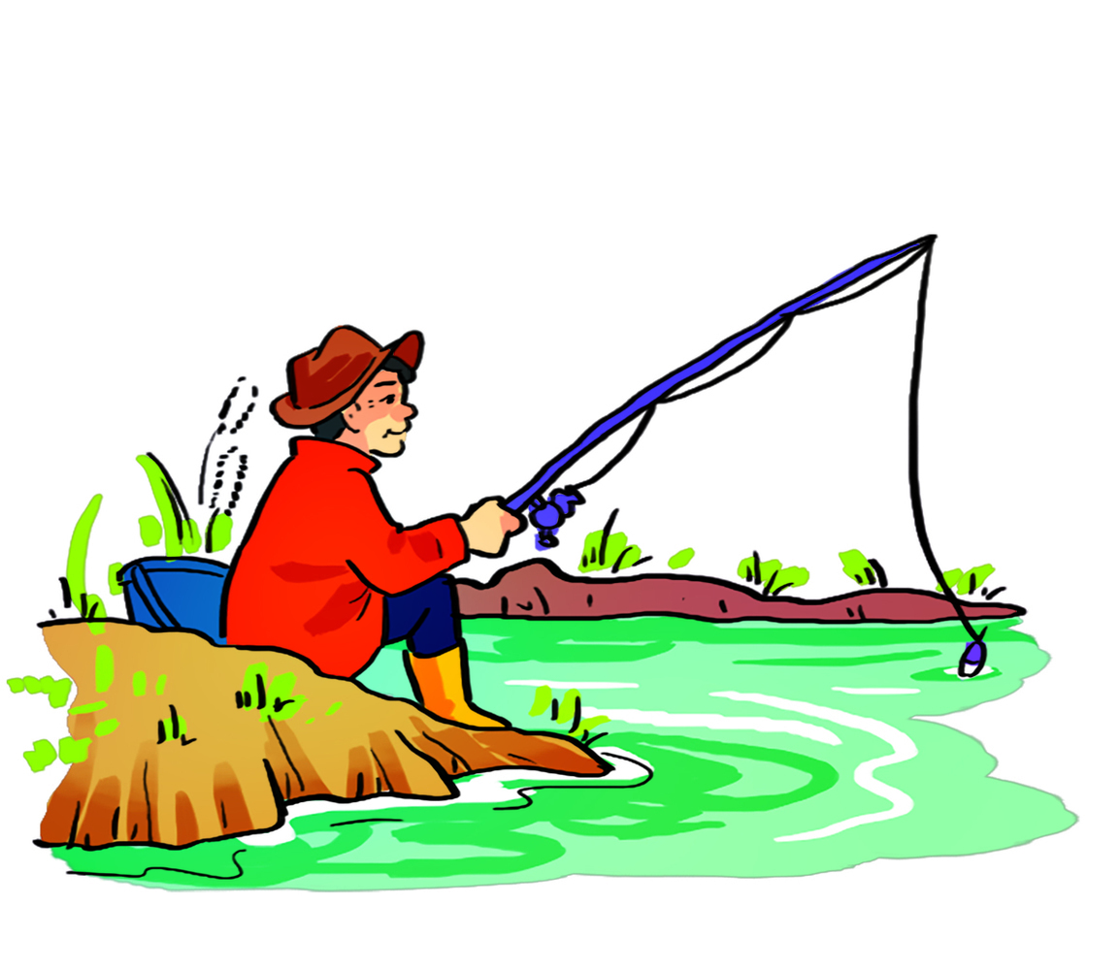
…………………………………………………………………………………..
2. What does she do in her free time?
…………………………………………………………………………………..
3. What does her father like doing?
…………………………………………………………………………………..
4. What does her mother like doing?
…………………………………………………………………………………..
5. When do they return home?
…………………………………………………………………………..............

-The end-

