WEEK 18
Date of teaching: 3/1/ 2023
Period 69 - REVIEW 2 (4-5-6)

I. OBJECTIVES:
Language focus: By the end of the lesson, pupils will be able to review the following sentence patterns:
  - Is this our ?– Yes, it is. / No, it isn’t.
  - Let’s go to the . – OK, let’s go.
  - , please.
  - May I ? − Yes, you can. / No, you can’t.
  - I have .
  - Do you have ? − Yes, I do. / No, I don’t.
  - What colour is it? − It’s .
  - What colour are they? − They’re .
  - I at break t ime.
  - What do you do at break time? – I .
Core competencies: Teamwork, reliability, motivation, adaptability, problem-solving, integrity, communication.
General Competences: Written Communication: practice writing.
Self-control & independent learning: perform listening tasks.
Communication and collaboration: work in pairs or groups.
Problem-solving and creativity: answer comprehension questions after reading the story.
Sociability: talk to each other, say good words to others.
Attributes: Kindness: help partners to complete learning tasks; Diligence: complete learning tasks; Leadership: collaborate with teachers to enhance language skills.
II. RESOURCES AND MATERIAL:
Student’s book Page 75; Flashcards/pictures and posters; Lesson plan; Loud speaker; Smart phone….
III. PROCEDURE:
Teacher’s activities | Pupils’ activities
Warm-up and review: 5 minutes
- Say the chant on page 72. | Group work.
Activity 3. Read and match. 8 minutes
Goal: To read and match pairs of target sentence patterns.
Procedure:  - Draw ps’ attention to the five pairs of sentence patterns. Tell them about the activity. Get ps to read Q1 in chorus and elicit the answer (Sentence e). Then give feedback and match with Sentence e. Have the class role-play the exchange.  - Give ps time to do the task. Go around the classroom to offer support where necessary.  - Tell pupils to swap books with a partner, then check answers as a class. Write the correct answers on the board for pupils to correct their answers. | Whole class.  Whole class/ Individual work.  Whole class/ Individual work.
Activity 4. Look, complete and read. 9 minutes
Goal: To understand and complete two incomplete sentence patterns and two exchanges.
Procedure:  - Draw ps’ attention to the incomplete sentences and pic cues. Tell ps about the activity. Get them to read the first sentence. Elicit the missing words and give feedback. Com plete the sentence and get ps to read the completed sentence in chorus.  - Give ps t ime to look, complete and read the rest of the sentences. Go around the classroom to offer support where necessary.  - Get ps to swap books with a partner, then check answers as a class. Write the correct answers on the board for ps to correct their answers. | Whole class/ Individual work.  Whole class/ Individual work.  Whole class/ Individual work.
Activity 5. Ask and anwer. 8 minutes
Goal: To read and understand five question patterns, then take it in turns to ask and answer the questions.
Procedure:  - Draw ps’ attention to the questions and the pics. Tell them about the activity. Point at Question 1, tell ps to look at the pic, elicit the answer and give feedback. Write the answer on the board and have ps read the question and the answer as a class.  - Repeat Step 1 with the rest of the questions.  - Have ps work in pairs. Tell them to take it in turns to ask and answer the questions. Go around the classroom to offer support where necessary. | Whole class/ Individual work.  Whole class/ Individual work.  Pair work.
Fun corner and wrap up: 5 minutes
Game: Pass the ball. | Group work.
IV. Adjustments (if necessary)
……………………………………………………………………………………………………………………………………………………………………………………………………………………………………………………………………………………..

Date of teaching: 3/1/ 2023
Period 70 - REVIEW 2: FUN TIME

I. OBJECTIVES:
Language focus: By the end of the lesson, pupils will take part in three fun activities related to their language knowledge and competences.
Core competencies: Teamwork, reliability, motivation, adaptability, problem-solving, integrity, communication.
General Competences: Written Communication: practice writing; Self-control & independent learning: perform listening tasks; Communication and collaboration: work in pairs or groups; Problem-solving and creativity: answer comprehension questions after reading the story; Sociability: talk to each other, say good words to others.
Attributes: Kindness: help partners to complete learning tasks; Diligence: complete learning tasks; Leadership: collaborate with teachers to enhance language skills.
II. RESOURCES AND MATERIAL:
Student’s book Page 76,77; Lesson plan; Loud speaker; Smart phone; Flashcards/pictures and posters ….
III. PROCEDURE:
Teacher’s activities | Pupils’ activities
Warm-up and review: 5 minutes
Sing the song “ Sing a rainbow”. | Whole class.
Activity 1. Find and circle. 8 minutes
Goal: To revise vocabulary and sentence patterns by doing a word search.
Procedure:  - Have ps look at the ps and elicit the words. Write the words or stick the flash cards of the words, one by one, on the board. Point at each word on the board and have ps say the word as a class.  - Point at the word school, then find and circle it in the word search as an example. Tell ps to repeat the same procedure with the rest of the words.  - Check the answers as a class.  Extension: Have pupils work in pairs. Ask them to point at each circled word in the word search and say it aloud. Have pupils work in pairs, point at each picture and say the word aloud. | Whole class.  Whole class/ Individual work.  Whole class.  Pair work.
Activity 2. Quiz time. 5 minutes
Goal: To revise vocabulary and sentence patterns related to asking and answering questions that help to identify school things and their colours.
Procedure:  - Draw ps’ attention to the pic. Elicit the words and stick the flash cards on the board one by one as ps say the corresponding words. Point at each flash card and have ps say the word as a class.  - Point at a flash card and elicit the answers to the questions Do you have_______? and What colour is it? or What colour are they? Hold up a textbook, point at a pic of a school thing and ask these questions again.  - Show the class how to complete the task: Point at a pic of a school thing and ask the questions in pairs. Invite two more able ps to take turns asking and answering the questions as an example. Check comprehension and give feedback before having ps do the activity in pairs.  - Invite a few pairs to the front of the class to interact with each other. Encourage the class to praise them or cheer if they do a good job. | Whole class/ Individual work.  Whole class/ Individual work.  Whole class/ Individual work.  Individual work.
Activity 3. Look and write. 10 minutes
Goal: To understand how mixing two colours makes a third colour.
Procedure:  - Draw ps’ attention to the diagram and elicit the names of the three colours in the middle: red, blue, yellow.  - Use crayons or paints to show ps what happens when you mix red and blue. Explain that this third colour is called purple. Write purple on the board and model it for pupils to repeat.  - Repeat Step 2 for red and yellow (orange), yellow and blue (green). Step 4: Have ps complete the colour sums. Check answers together as a class. | Whole class/ Individual work.  Individual work.  Individual work/ Whole class.
Fun corner and wrap up: 5 minutes
Game: Space hunt  The rule is just the same with snake and ladders. | Group work.
IV. Adjustments (if necessary)
………………………………………………………………………………………………………………………………………………………………………………………………………………………………………………………………………………………

Date of teaching: 5/1/ 2023
Period 71: THE FINAL TEST 1
I. OBJECTIVES: By the end of lesson, Ss will able to: 1. Forming competence: Check knowledge for students from unit 1 to unit 10.
2. Knowledge: - Sentence Patterns: Revision - Vocabulary: Revision 3. Quality: - Love English, love class. - United friend. II. RESOURCES AND MATERIAL:
Lesson plan, loud speaker, smart phone, the test…..
III. PROCEDURE:
PART 1: LISTENING :( 4pts)
PART 1: Question 1 - 4: Listen and tick. (1pt)
1. A. 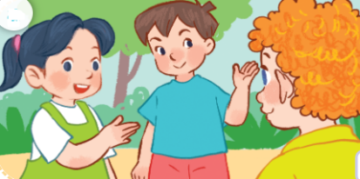 | B. 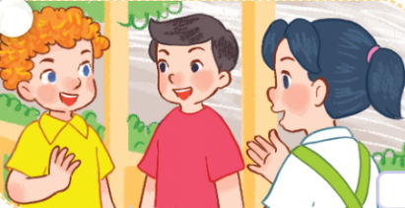
2. A.  | B. 
3. A. 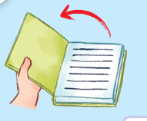 | B. 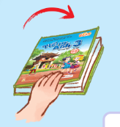
4. A. 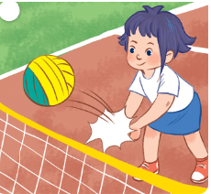 | B. 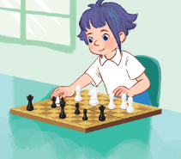

PART 2: Question 1 - 4: Listen and match. (1 pt)
A. 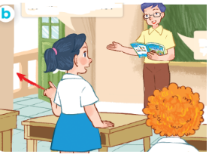 | B. 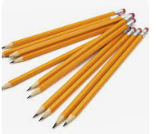 | C. 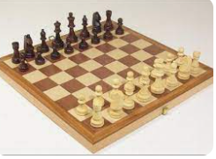 | D. 

4
3
2
1

PART 3: Question 1 – 4: Listen and number. (1 pt)
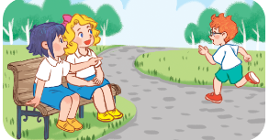  A. | 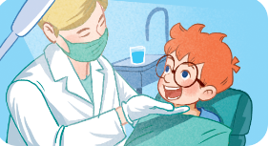  B. | 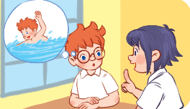  C. | 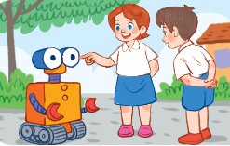  D.
PART4: Question 1– 4: Listen and complete. (1 pt)
1. Touch your…………………………! | 3. I have an……………………………
2. Let’s go to the……………………… | 4. A: What do you do at break time?  B: I play………………………...
PART 2: READING :( 2pts)
PART 1: Question 1- 4: Read and match. (1pt)
1. May I come in? |  | a. They’re blue.
2. Do you have a ruler? |  | b. I play chess.
3. What colour are they? |  | c. Yes, I do.
4. What do you do at break time? |  | d. Yes, you can.

PART 2: Question 1- 4: Read and complete. (1pt)
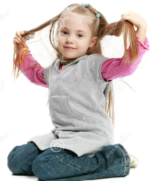  1. Touch your __________! | 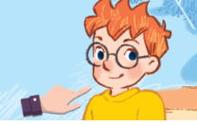  2. _____________is Ben.
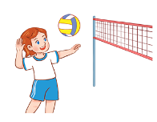  3. At break time, I play________________ |   4. I like _____________

PART 3: WRITING :( 2pts)
PART 1: Question 1- 4: Look at the picture and complete the sentences. (1 pt)
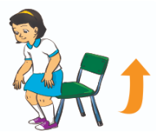  1. _____________ up, please! | 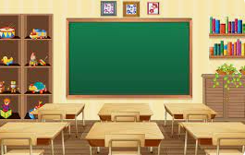  2. Is this our ________________?
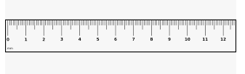  3. I have a ________________ | 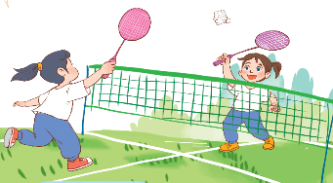  4. I play _____________ at break time.

PART 2: Question 1- 4: Reorder the words to make a correct sentence. (1 pt)
1. name/My/Mai./is _________________________________________
2. eye. /is / an / It/ _________________________________________
3. ruler? / What / the / is / colour / _________________________________________
4. badminton / at / I / break time. / play/ _______________________________________
PART 4: SPEAKING :( 2pts)
The end

IV. Adjustments (if necessary)
………………………………………………………………………………………………

_____________________________________________________________________
Date of teaching: 5/1/ 2023

Period 72: CORRECT THE TEST
I. OBJECTIVES:
Language focus: By the end of the lesson, pupils will be able to know their points and understand the mistakes in the test .
Core competencies: Teamwork, reliability, motivation, adaptability, problem-solving, integrity, communication.
General Competences: Self-control & independent learning: perform listening tasks; Communication and collaboration: work in pairs or groups; Problem-solving and creativity: answer comprehension questions after reading the story; Sociability: talk to each other, say good words to others.
Attributes: Kindness: help partners to complete learning tasks; Diligence: complete learning tasks; Leadership: collaborate with teachers to enhance language skills.
II. RESOURCES AND MATERIAL:
Lesson plan; Loud speaker; Smart phone; the test…
III. PROCEDURE:
Teacher’s activities | Pupils’ activities
Warm-up and review
Sing and dance along the song: Clap your hand. | Whole class.
Comment the students’ test
- Comment the test generally.  - Praise the pupils who did the test well. | Whole class.
Return the test
- Return the test.  - Get ps to check the test themselves. | Whole class.  Individual work.
Correct the test
- Correct the test.
KEY
PART 1: LISTENING :( 4pts)
PART 1: Question 1 – 4: Listen and tick. (1pt)
Mỗi câu đúng 0,25 điểm (0,25x4)

1. Mai: Bill, this is Nam.

Bill Hi, Nam

2. A: What’s your hobby?

B: I like cooking.

3. Ms Hoa: Open your book, please!

4. Linh: Hi, I’m Linh. I play volleyball at break time.
Answers: | - b | - b | - a | - a

PART 2: Question 1 - 4: Listen and match. (1 pt)
Mỗi câu đúng 0,25 điểm (0,25x4)

1. Nam: What’s your hobby?

Mary: I like cooking.

2. Mai: May I go out?

Mr Long: Yes, you can.

3. Lucy: Do you have pencils?

Minh: Yes, you do.

4. Ben: It’s break time. Let’s play chess.

Lucy: OK.
Answers: | 1.D | 2.A | 3.B | 4.C

PART 3: Question 1 – 4: Listen and number. (1 pt)
Mỗi câu đúng 0,25 điểm (0,25x4)
1. Dentist: Open your mouth, please!
2. Linh: What's your hobby?
Ben: I like swimming.
3. Lucy: What's this?
Minh: It's an eye.
4. Linh: Is that Bill?
Mary: No, it isn't. It's Ben.
Answers: | 1.B | 2.C | 3.D | 4.A
PART4: Question 1– 4: Listen and complete.. (1 pt)

1. Touch your ears!

2. Let’s go to the classroom.

3. I have an eraser.

4. A: What do you do at break time?

B: I play volleyball.
Answers: | 1.ear(s) | 2.classroom | 3.eraser | 4.volleyball

2: READING :( 2pts)
PART 1: Question 1- 3: Read and match. (1pt)
Mỗi câu đúng 0,25 điểm (0,25x4)
Answers: | 1.d | 2.c | 3.a | 4.b

PART 2: Question 1- 2: Read and complete. (1pt)
Mỗi câu đúng 0,25 điểm (0,25x4)
Answers: | 1.hair | 2.this | 3.volleyball | 4.cooking

PART 3: WRITING :( 2pts)
PART 1: Question 1- 4: Look at the picture and complete the sentences. (1pt)
Mỗi câu đúng 0,25 điểm (0,25x4)
Answers: | 1.stand | 2.classroom | 3.ruler | 4.badminton

PART 2: Question 1- 4: Reorder the words to make a correct sentence. (1 pt)
Mỗi câu đúng 0,25 điểm (0,25x4)
- My name is Mai.
- It is an eye.
- What colour is the ruler?
- I play badminton at break time?

PART 4: SPEAKING :( 2pts)

IV. Adjustments (if necessary)
………………………………………………………………………………………………

