GRADE 4 – TEST
THEME 4: CLOTHES

Full name:………………………….…………………...  School:…………………… …………………………….  Class:……………………………………………………... | Mark
LISTENING
Part 1

Listen and tick (). There is one example.
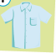
1. A B


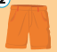



1. A B 2. A B
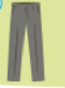


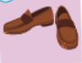

3. A B 4. A B

Part 2
Listen and circle.
Do you want …………..?

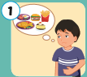 | Pizza/ cake/ fries
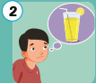 | Water/ juice/ milk
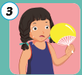 | Fan/ ice-cream/
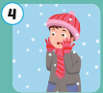 | Pajamas/ gloves/ sneakers

Part 3

Listen and draw the lines. There is on example:
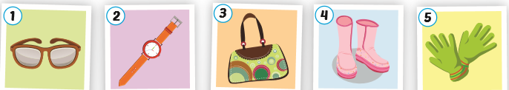
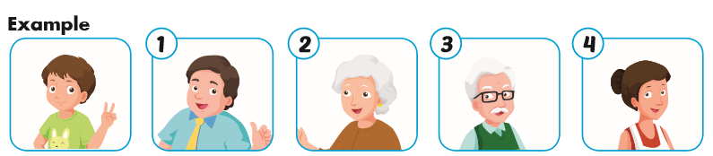

READING AND WRITING
Part 1
Answer the questions:
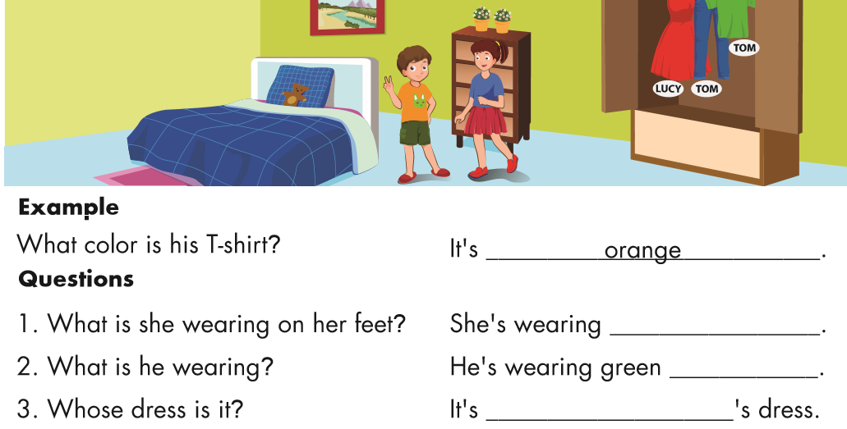
4. Where are the clothes? They

Part 2
Look at the picture and then write the words:
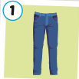
…………………………………..

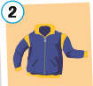
…………………………………..

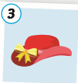
…………………………………..

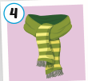

……………………………………

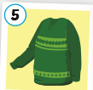

………………………………….

Part 3
Read and fill in the blanks:

