END-OF-TERM TEST 1 (SEMESTER 2)
Time allowed: 35 mins
Full name: ............. Grade: ............. Mark: ............. / 20
Listen and tick. | Listen and write Y or N. | Read and tick. | Look and write. | Let’s talk.
………/ 4 | ………/ 4 | ………/ 4 | ………/ 4 | ………/ 4

1. Listen and tick.

1.    a.❑ |   b.❑
2.  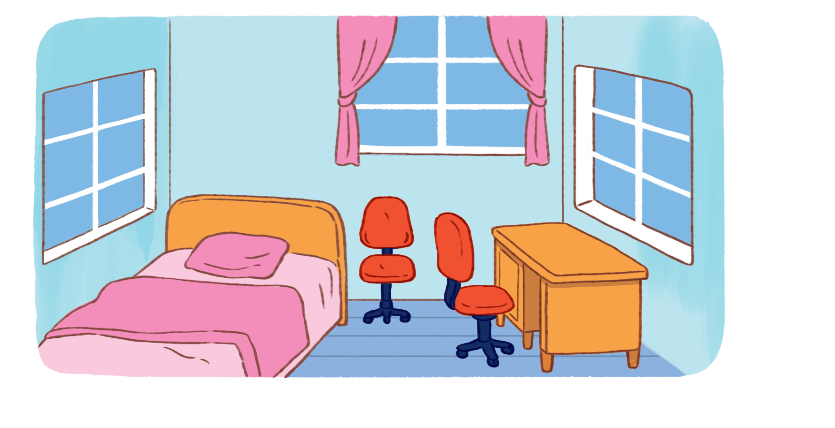  a.❑ | 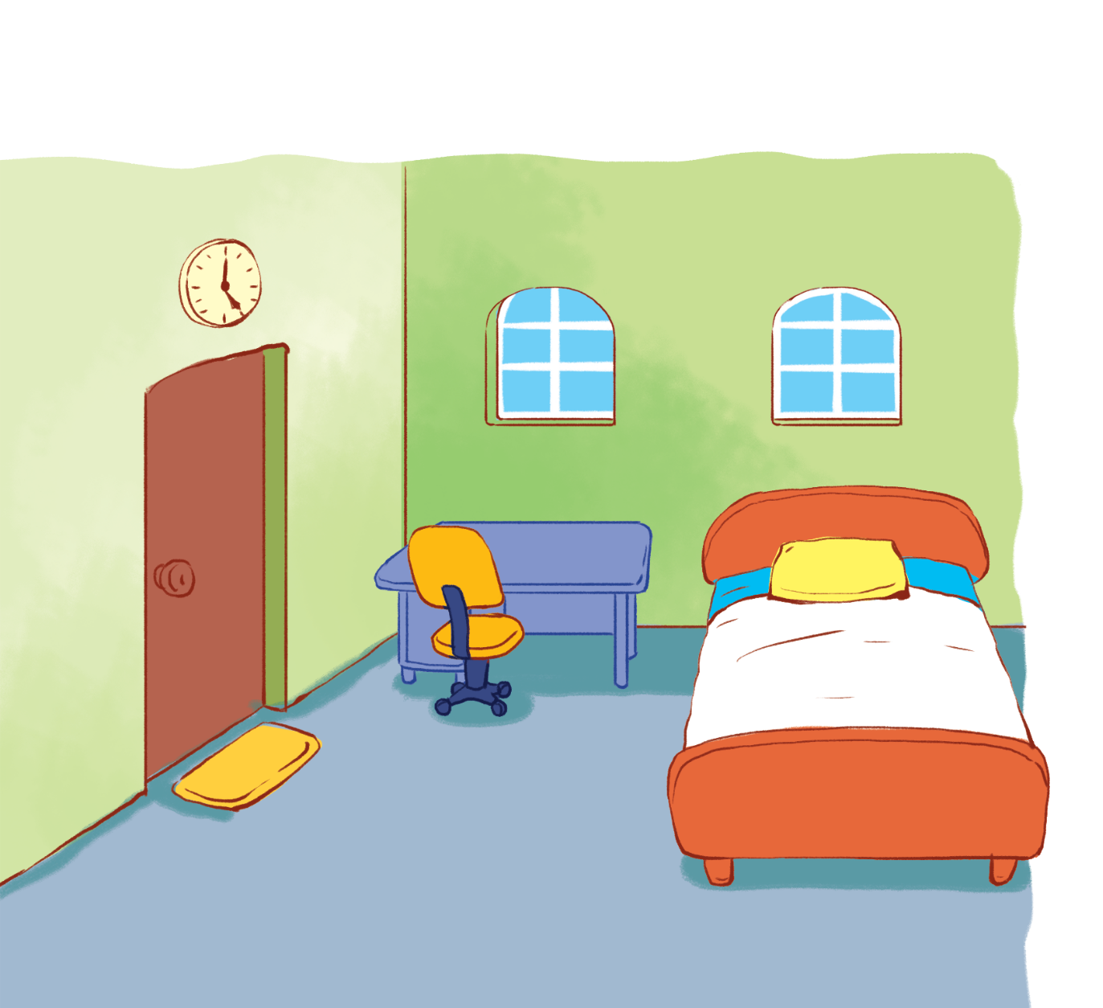  b.❑
3.    a.❑ |   b.❑
  a.❑ |   b.❑

2. Listen and write Y (Yes) or N (No).
1.    ❑ | 2.    ❑
3.  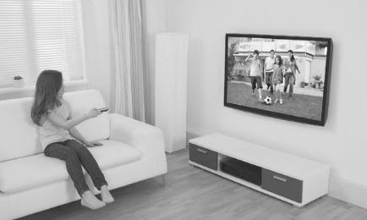  ❑ | 4.    ❑

3. Read and match.
1. A: Who’s that?  B: It’s my mother. |  |   a.
2. A: What’s his job?  B: He’s a worker. |  |   b.
3. A. How many pets do you have?  B: I have two parrots. |  | 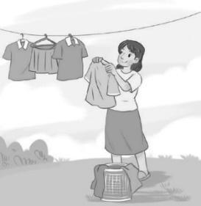  c.  
4. A: What’s the elephant doing?  B: It’s dancing. |  | d.  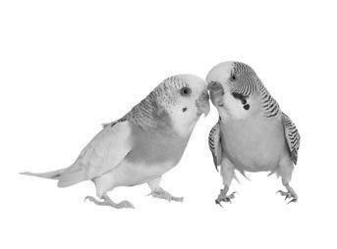

4. Look and write.

Mai Tom Phong Linh
My name (1) ________ Mai. I have three friends: Tom, Phong and Linh. We like sports and games. We are in the park now. I am (2) ___________. Tom is (3) ____________. Phong and Linh (4) ___________________________. We are having a good time.

5. Let’s talk.
Point, ask and answer. / Point and say.
- 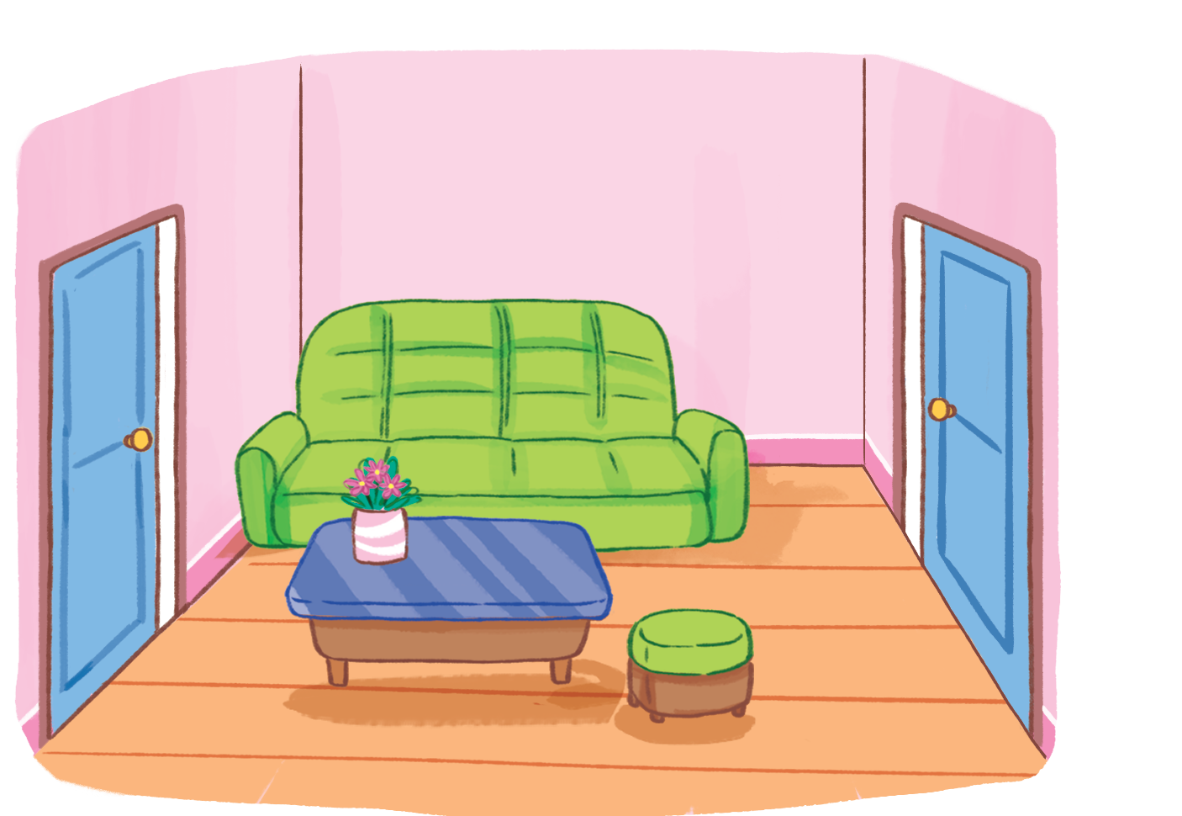 | 2.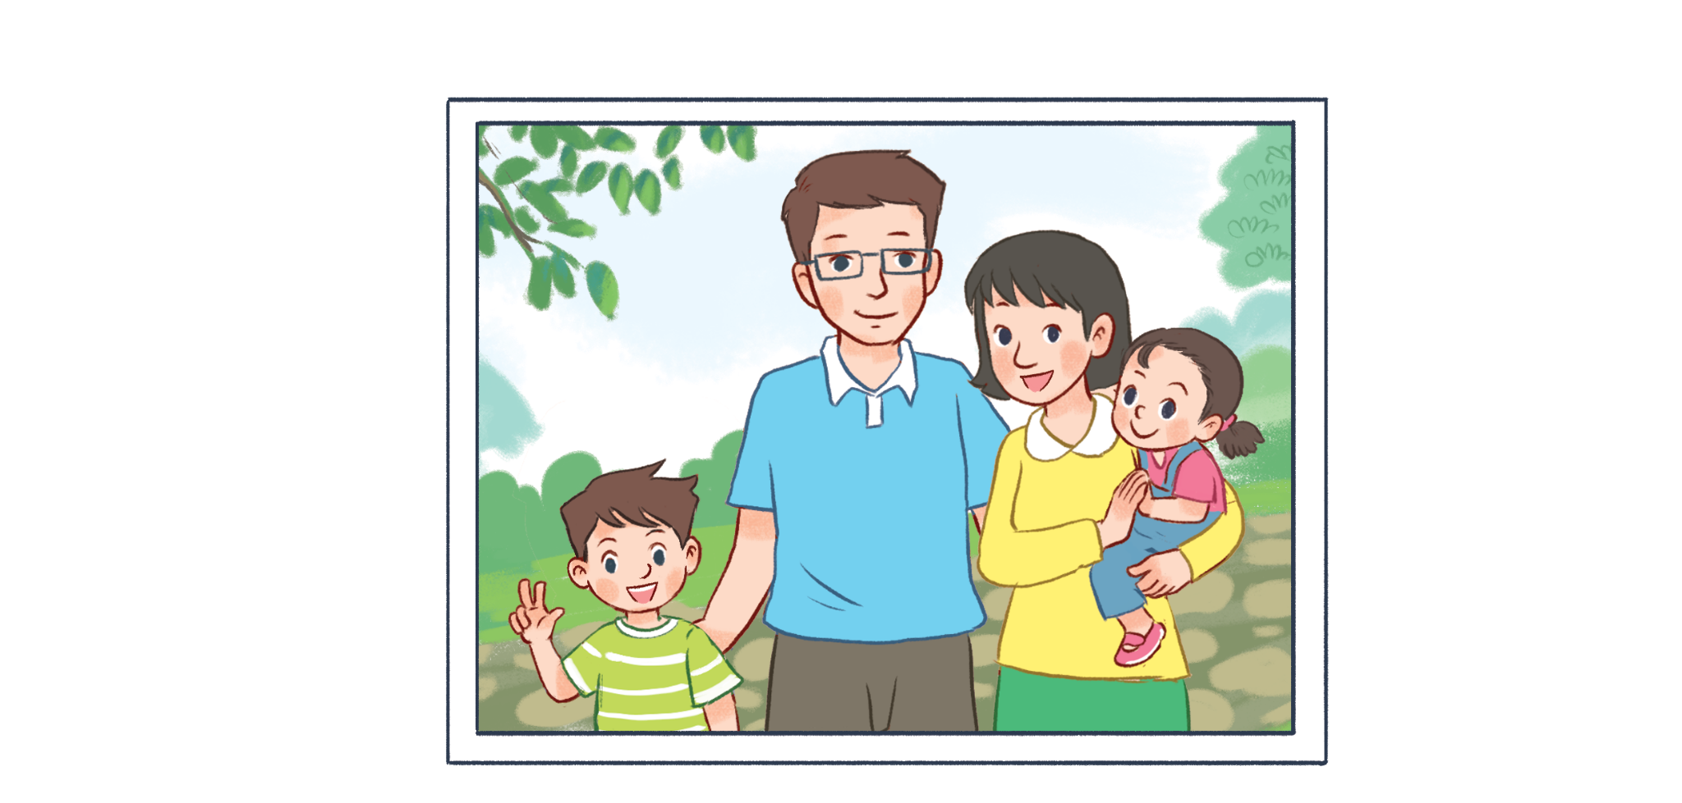
3.  | 4.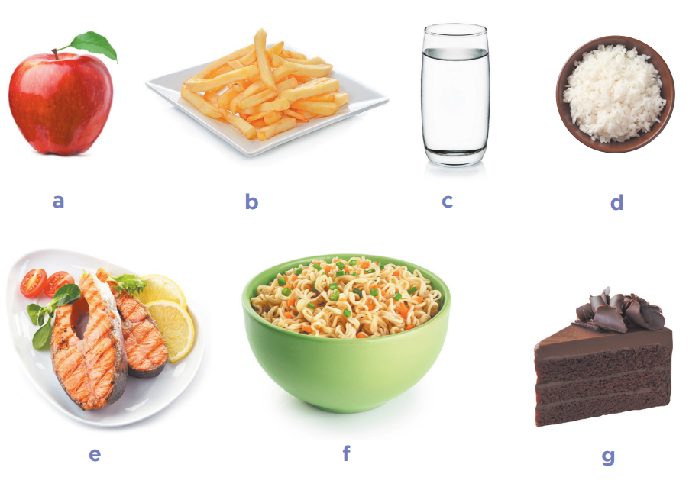

ANSWER KEY
1. Audio script:
1. I’d like some bread, please.
2. There are two windows in the bedroom.
3. She has three rabbits.
4. He’s flying a kite.
Key: 1. a 2. b 3. a 4. b
2. Audio script:
1. A: How old is he?
B: He’s twelve years old.
2. A: What would you like to eat?
B: I’d like some rice and fish, please.
3. A: What’s she doing?
B: She’s listening to music.
4. A: What can you see?
B: I can see a peacock.
Key: 1. Y 2. N 3. N 4. Y
3. 1. c 2. a 3. d 4. b
4. (1) is (2) skipping (3) skating (4) are playing football
5.
Lưu ý:
- Đối với kỹ năng nói, GV có thể sử dụng kết quả đánh giá thường xuyên trong các giờ học hoặc/và kết quả kiểm tra kỹ năng này cuối học kỳ.
- GV có thể tiến hành theo cá nhân HS hoặc chia cặp/nhóm để đánh giá về kỹ năng nói.
- GV có thể sử dụng tranh gợi ý trong bài test hoặc hỏi các câu hỏi khác liên quan đến các competencies đã học.
- Một số gợi ý về ngôn ngữ khi sử dụng tranh như sau:

 | Competences | Suggested language
1 | Asking and answering questions about the location of things in a room. | - Where’s the …?  - It’s …  - Where are the …?  - They’re …
1 | Talking about quantities of things in a room | - There’s / There are … in the room.
1 | Describing things in a room. | - The … is … / The … are …
2 | Asking and answering questions about a family member | - Who’s this?  - It’s …
2 | Asking and answering questions about the job of a family member | - What’s his/ her job?  - He’s / She’s …
2 | Asking and answering questions about the job of a family member | - Is he / she …?  - Yes, he / she is. / No, he / she isn’t.
3 | Asking and answering questions about the age of a family member | - How old is he / she?  - He’s / She’s …
4 | Offering and accepting or declining food or drinks | - Would you like some …?  - Yes, please. / No, thanks.
4 | Asking and answering questions about what someone would like to eat or drink | - What would you like to eat / drink?  - I’d like some …, please.

