END-OF-TERM TEST 2 (SEMESTER 1)
Time allowed: 35 mins
Full name: ............. Grade: ............. Mark: ............. / 20
Listen and circle. | Listen and tick. | Read and tick. | Look and write. | Let’s talk.
………/ 4 | ………/ 4 | ………/ 4 | ………/ 4 | ………/ 4

1. Listen and circle.
1. a. Thank you, Peter.
b. This is my house.
2. a. Hi. Nice to meet you.
b. This is my blue bedroom.
3. a. I like playing chess with my friends
b. Welcome to our classroom!
4. a. Can I have my book back, Mai?
b. My school is near here.
2. Listen and tick.
1 | 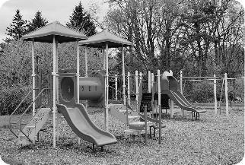  a.❑ | 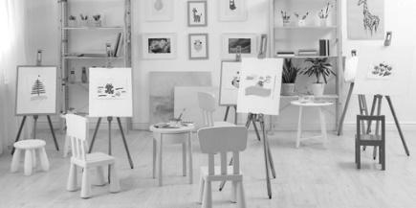  b.❑ | 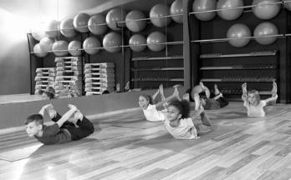  c.❑
2 |   a.❑ | 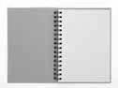  b.❑ | 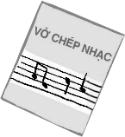  c.❑
3 |   a. ❑ | 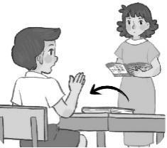  b. ❑ |   c. ❑
4 | 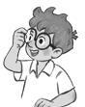  a. ❑ | 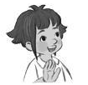  b. ❑ | 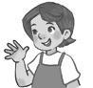  c. ❑

3. Read and tick.
1. A: Hi. I’m Ben
B: Hi, Ben. I’m Mai.

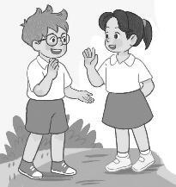  a. ❑ | 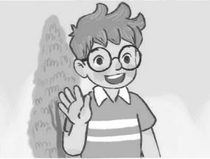  b. ❑ | 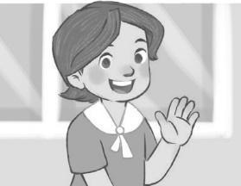  c. ❑

2. A: What’s this?
B: It’s a nose.

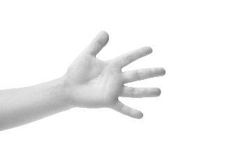  a. ❑ | 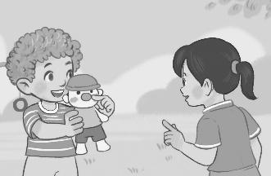  b. ❑ | 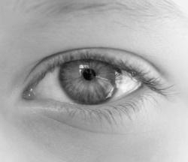  c. ❑

3. I have a pencil case.

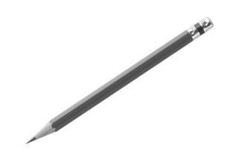  a. ❑ | 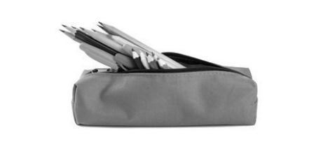  b. ❑ |   c. ❑

4. It’s break time. Let’s play volleyball.

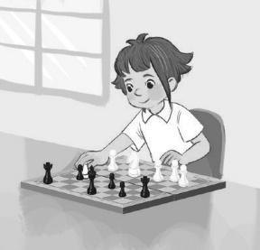  a. ❑ | 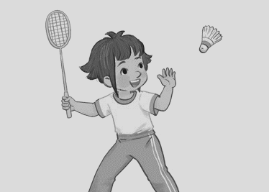  b. ❑ | 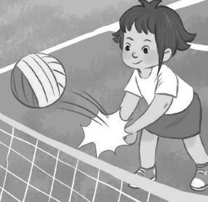  c. ❑

4. Look and write.
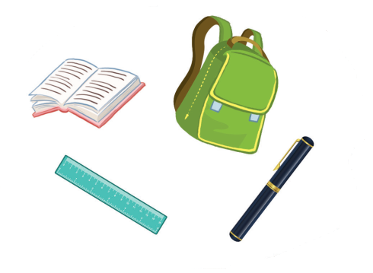
Let’s see what I have. I have a school (1) ______. I (2) ______ a book. I have a (3) _______ and a pen. Oh, I (4) _________ have an eraser.

5. Let’s talk.
1. Greeting/  Responding to greetings | 2. Asking the student’s name/ age | 3. Introducing someone | 4. Asking questions about parts of the body | 5. Asking about hobbies
6. Making suggestions/ Expressing agreement | 7. Giving instructions/ Asking for permission | 8. Asking about school things | 9. Asking about the colours of school things | 10. Talking about break time activities

ANSWER KEY

1.
Key: 1. th 2. h 3. cl 4. oo
Audio script:
1. Thank you, Peter.
2. This is my blue bedroom.
3. Welcome to our classroom!
4. My school is near here.
Key: 1. a 2. b 3. b 4. b

2.
Audio script:
1. A: Let’s go to the playground.
B: OK, let’s go.
2. A: Bill, be quick. Let’s go to the music room.
B: OK. My music notebook is here.
3. Woman: Come in and sit down, Nam.
4. Mum, this is my friend, Linh.
Key: 1. a 2. c 3. a 4. b
3.
1. a 2. b 3. b 4. c
4.
(1) bag (2) have (3) ruler (4) don’t
5.
Suggested questions and answers:
1. Hello, (pupil’s name). How are you? (Giving clues: Are you fine?/ OK? Yes? No?)
2. Hi! My name’s _____________. What’s your name?/ How old are you?
(Giving clues: My name’s ____./ I’m _____ and you are _______./
Are you ______? Yes? No?)
3. Is this (one pupil’s name)?
4. What’s this?/ Touch your (a body part).
(Point to any body parts learnt to ask or give commands to check pupil’s understanding.)
5. What’s your hobby? (Giving clues: Do you like (swimming)? Swimming? Yes? No?)
6. Is this __________?
Let’s ___________.
7. May ___________?
(Point to one flash card, have the pupil give instructions or ask for permission.)
8. I have _______. Do you have _______?
9. What colour is it? What colour are they? (Giving clues: Is it red? Yes? No?)
10. I play badminton at break time. What about you, (pupil’s name)?
For some topics, the teacher points to the flash card or realia, has the pupils listen and say/ respond. Depending on the pupil’s speaking performance, the teacher can give him/ her some clues to encourage him/ her to speak English.

