END-OF-TERM TEST 3 (SEMESTER 2)
Time allowed: 35 mins
Full name: ............. Grade: ............. Mark: ............. / 20
Listen and tick. | Look, listen and write. | Read and tick. | Look and write. | Let’s talk.
………/ 4 | ………/ 4 | ………/ 4 | ………/ 4 | ………/ 4

1. Listen and tick.
1.    a. ❑ |   b. ❑ | 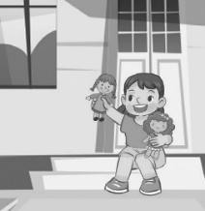  c. ❑
2.    a. ❑ |   b. ❑ |   c. ❑
3.  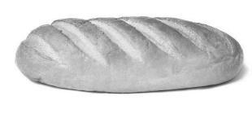  a. ❑ | 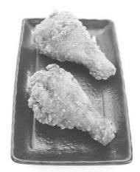  b. ❑ |   c. ❑
4.    a. ❑ |   b. ❑ |   c. ❑
2. Look, listen and write.

1. How old is Helen?
She’s ________________________.
2. What’s the job of the father?
He’s a _________________________.
3. What’s the job of the mother?
She’s a ________________________.
4. How old is the boy?
He’s ________________________.
3. Read and circle a, b or c.
1. A: What would you like to drink?
B: ________________________.
a. Yes, please.
b. I have some juice.
c. I’d like some milk.
2. A: Where’s the table?
B: ______________________.
a. They’re in the kitchen.
b. It’s in the bedroom.
c. I can see a table.
3. A: How many teddy bears do you have?
B: ______________________________________.
a. I have some.
b. I like teddy bears.
c. They’re on the bed.
4. A: What can you see?
B: ______________________________________.
a. The parrot is counting.
b. I can see a parrot.
c. It’s a parrot.
4. Read and complete.
three dog have birds and has

Hi. My name’s Ben. I (1) _______ many toys. I have two cars and (2) _______ trains. I have four ships (3) _______ five buses. I like my toys.
I have a friend. His name is Andy. He (4) ___________ some pets. He has one (5) _________ and two cats. He has three rabbits and four (6) ________. They are nice.

5. Let’s talk.
Point, ask and answer. / Point and say.
- 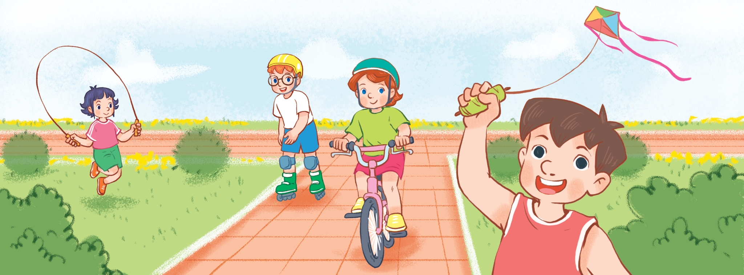 | 2.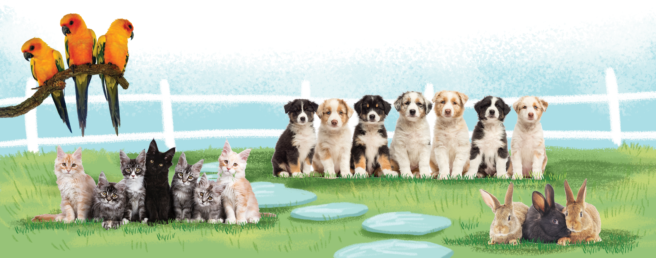
3. 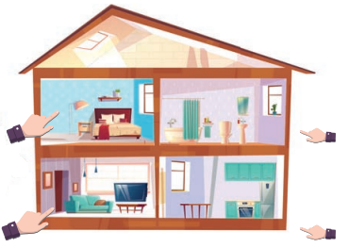 | 4.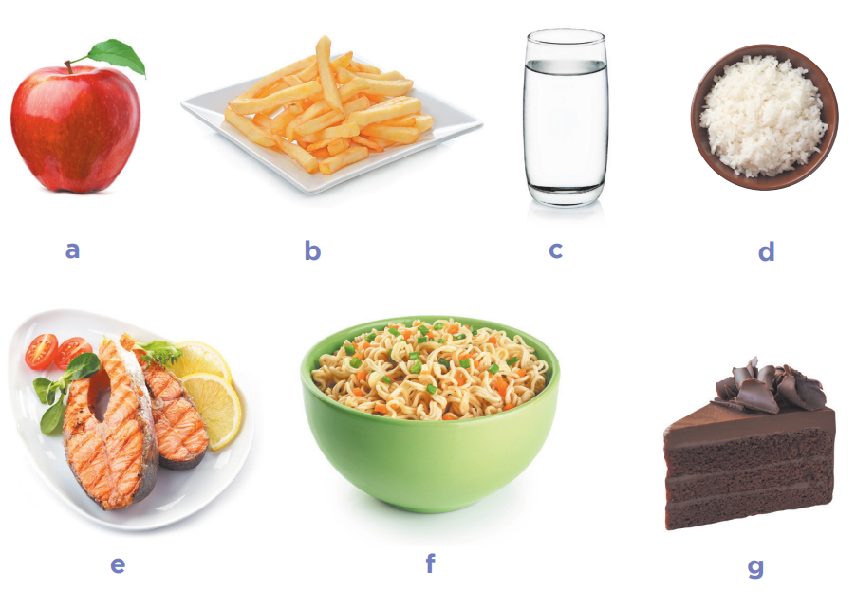

ANSWER KEY
1. Audio script:
1. A: Who’s that?
B: It’s my mother.
2. A: What’s his job?
B: He’s a driver.
3. A: Would you like some bread?
B: No, thanks.
A: What about some rice? Would you like some rice?
B: Yes, please.
4. A: What’s the monkey doing?
B: It’s climbing.
Key: 1. a 2. b 3. c 4. b
2. Audio script:
Hi. My name’s Helen. I’m eleven years old. This is my family. There are four people in my family. This is my father. He is a driver. This is my mother. She is a nurse. This is my brother. He is a pupil. He’s fourteen years old. We are happy.
Key: 1. eleven/11 (years old) 2. driver 3. nurse 4. fourteen/14 (years old)
3.
1. c 2. b 3. a 4. b
4.
1. have 2. three 3. and 4. has 5. dog 6. birds
5.
Lưu ý:
- Đối với kỹ năng nói, GV có thể sử dụng kết quả đánh giá thường xuyên trong các giờ học hoặc/và kết quả kiểm tra kỹ năng này cuối học kỳ.
- GV có thể tiến hành theo cá nhân HS hoặc chia cặp/nhóm để đánh giá về kỹ năng nói.
- GV có thể sử dụng tranh gợi ý trong bài test hoặc hỏi các câu hỏi khác liên quan đến các competencies đã học.
- Một số gợi ý về ngôn ngữ khi sử dụng tranh như sau:
 | Competences | Suggested language
1 | Talking about what someone is doing outdoors | He’s / She’s …
1 | Asking and answering questions about what someone is doing outdoors | – What’s he / she doing?  - He’s / She’s …
2 | Asking and answering questions about having pets | - Do you have any …?  - Yes, I do. / No, I don’t.
2 | Asking and answering questions about how many pets someone has | - How many … do you have?  - I have …
3 | Asking and answering questions about the location of a room in a house | - Where’s the …?  - It’s here / there.
3 | Talking about quantities of things in a room | There’s / There are … in the room.
4 | Offering and accepting or declining food or drinks | - Would you like some …?  - Yes, please. / No, thanks.
4 | Asking and answering questions about what someone would like to eat or drink | - What would you like to eat / drink?  - I’d like some …, please.

