UNIT 17

chain game

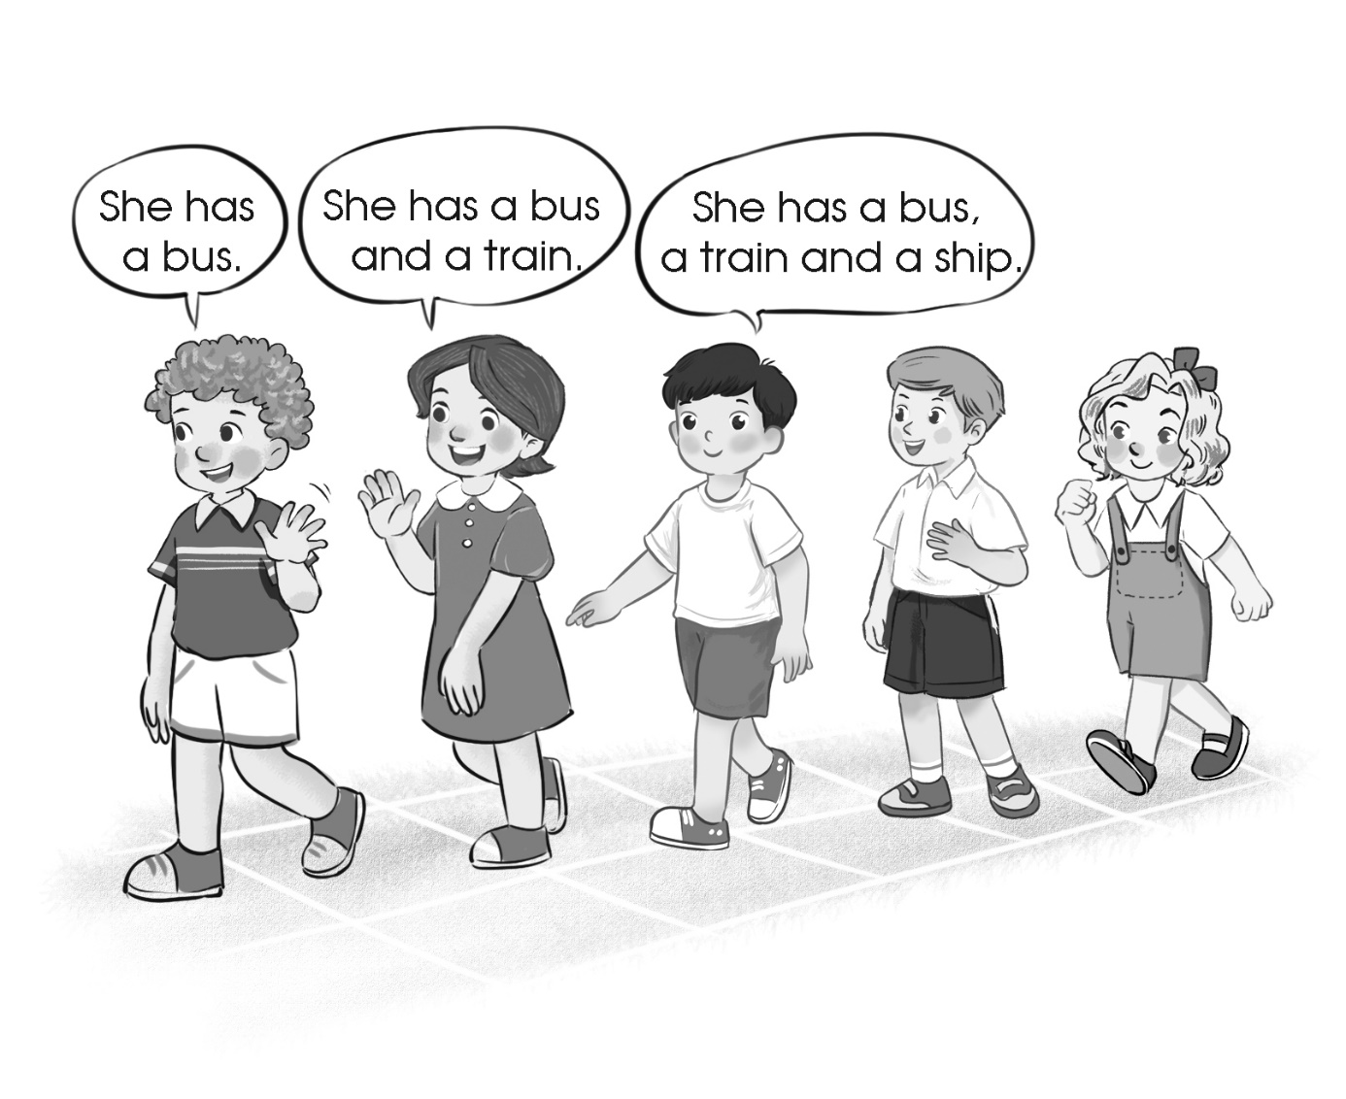

Teacher’s guide:
1. Goal:
- To revise the sentence patterns He/ She has … or They have … and vocabulary related to the topics Our toys.
2. Input:
- No special input needed.
3. Suggested procedure:
- Tell pupils that they are going to play Chain game using the sentence pattern and vocabulary learnt in Unit 17. Show them the picture above to make sure they understand how to play the game.
- Play the game together with the whole class (you can use different topics e.g. pets, school things, numbers): He has a cat; He has a cat and a dog; He has a cat, a dog and a parrot; …
- Divide the class into four-five groups and ask each group to play the game. If the chain breaks down because somebody cannot remember the sentence or add one more word, the group will be out.
4. Extension:
- For better class, ask pupils to use adjectives and numbers to make sentence chains
(e.g. I have a brown ship.)

