UNIT 8

game

Find hidden things
Pair and talk.
A: I have ____________. Do you have _____________?
B: Yes, _________. / No, __________.
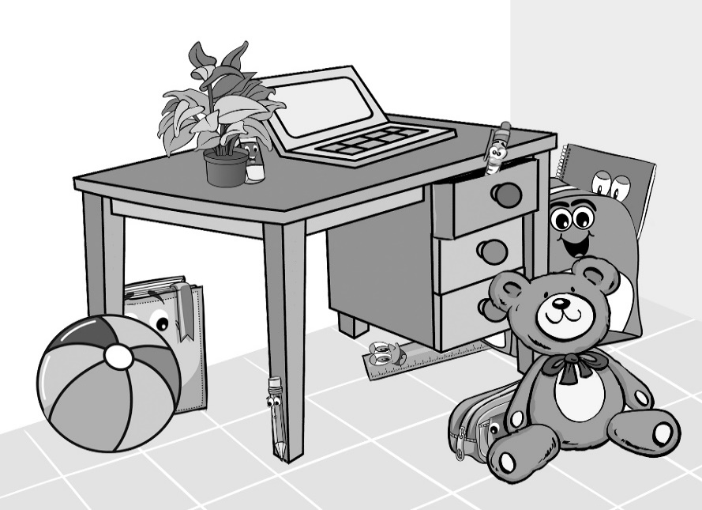

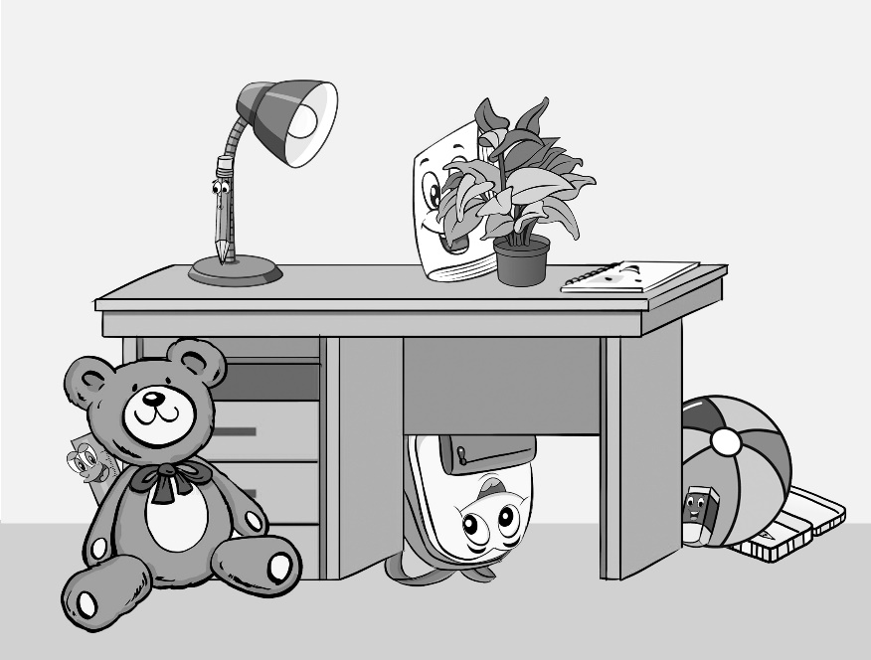
I have ______.
Do you have _______? – Yes, I do./ No, I don’t.
book, eraser, notebook, pen, pencil, pencil case, ruler, school bag
a

b

