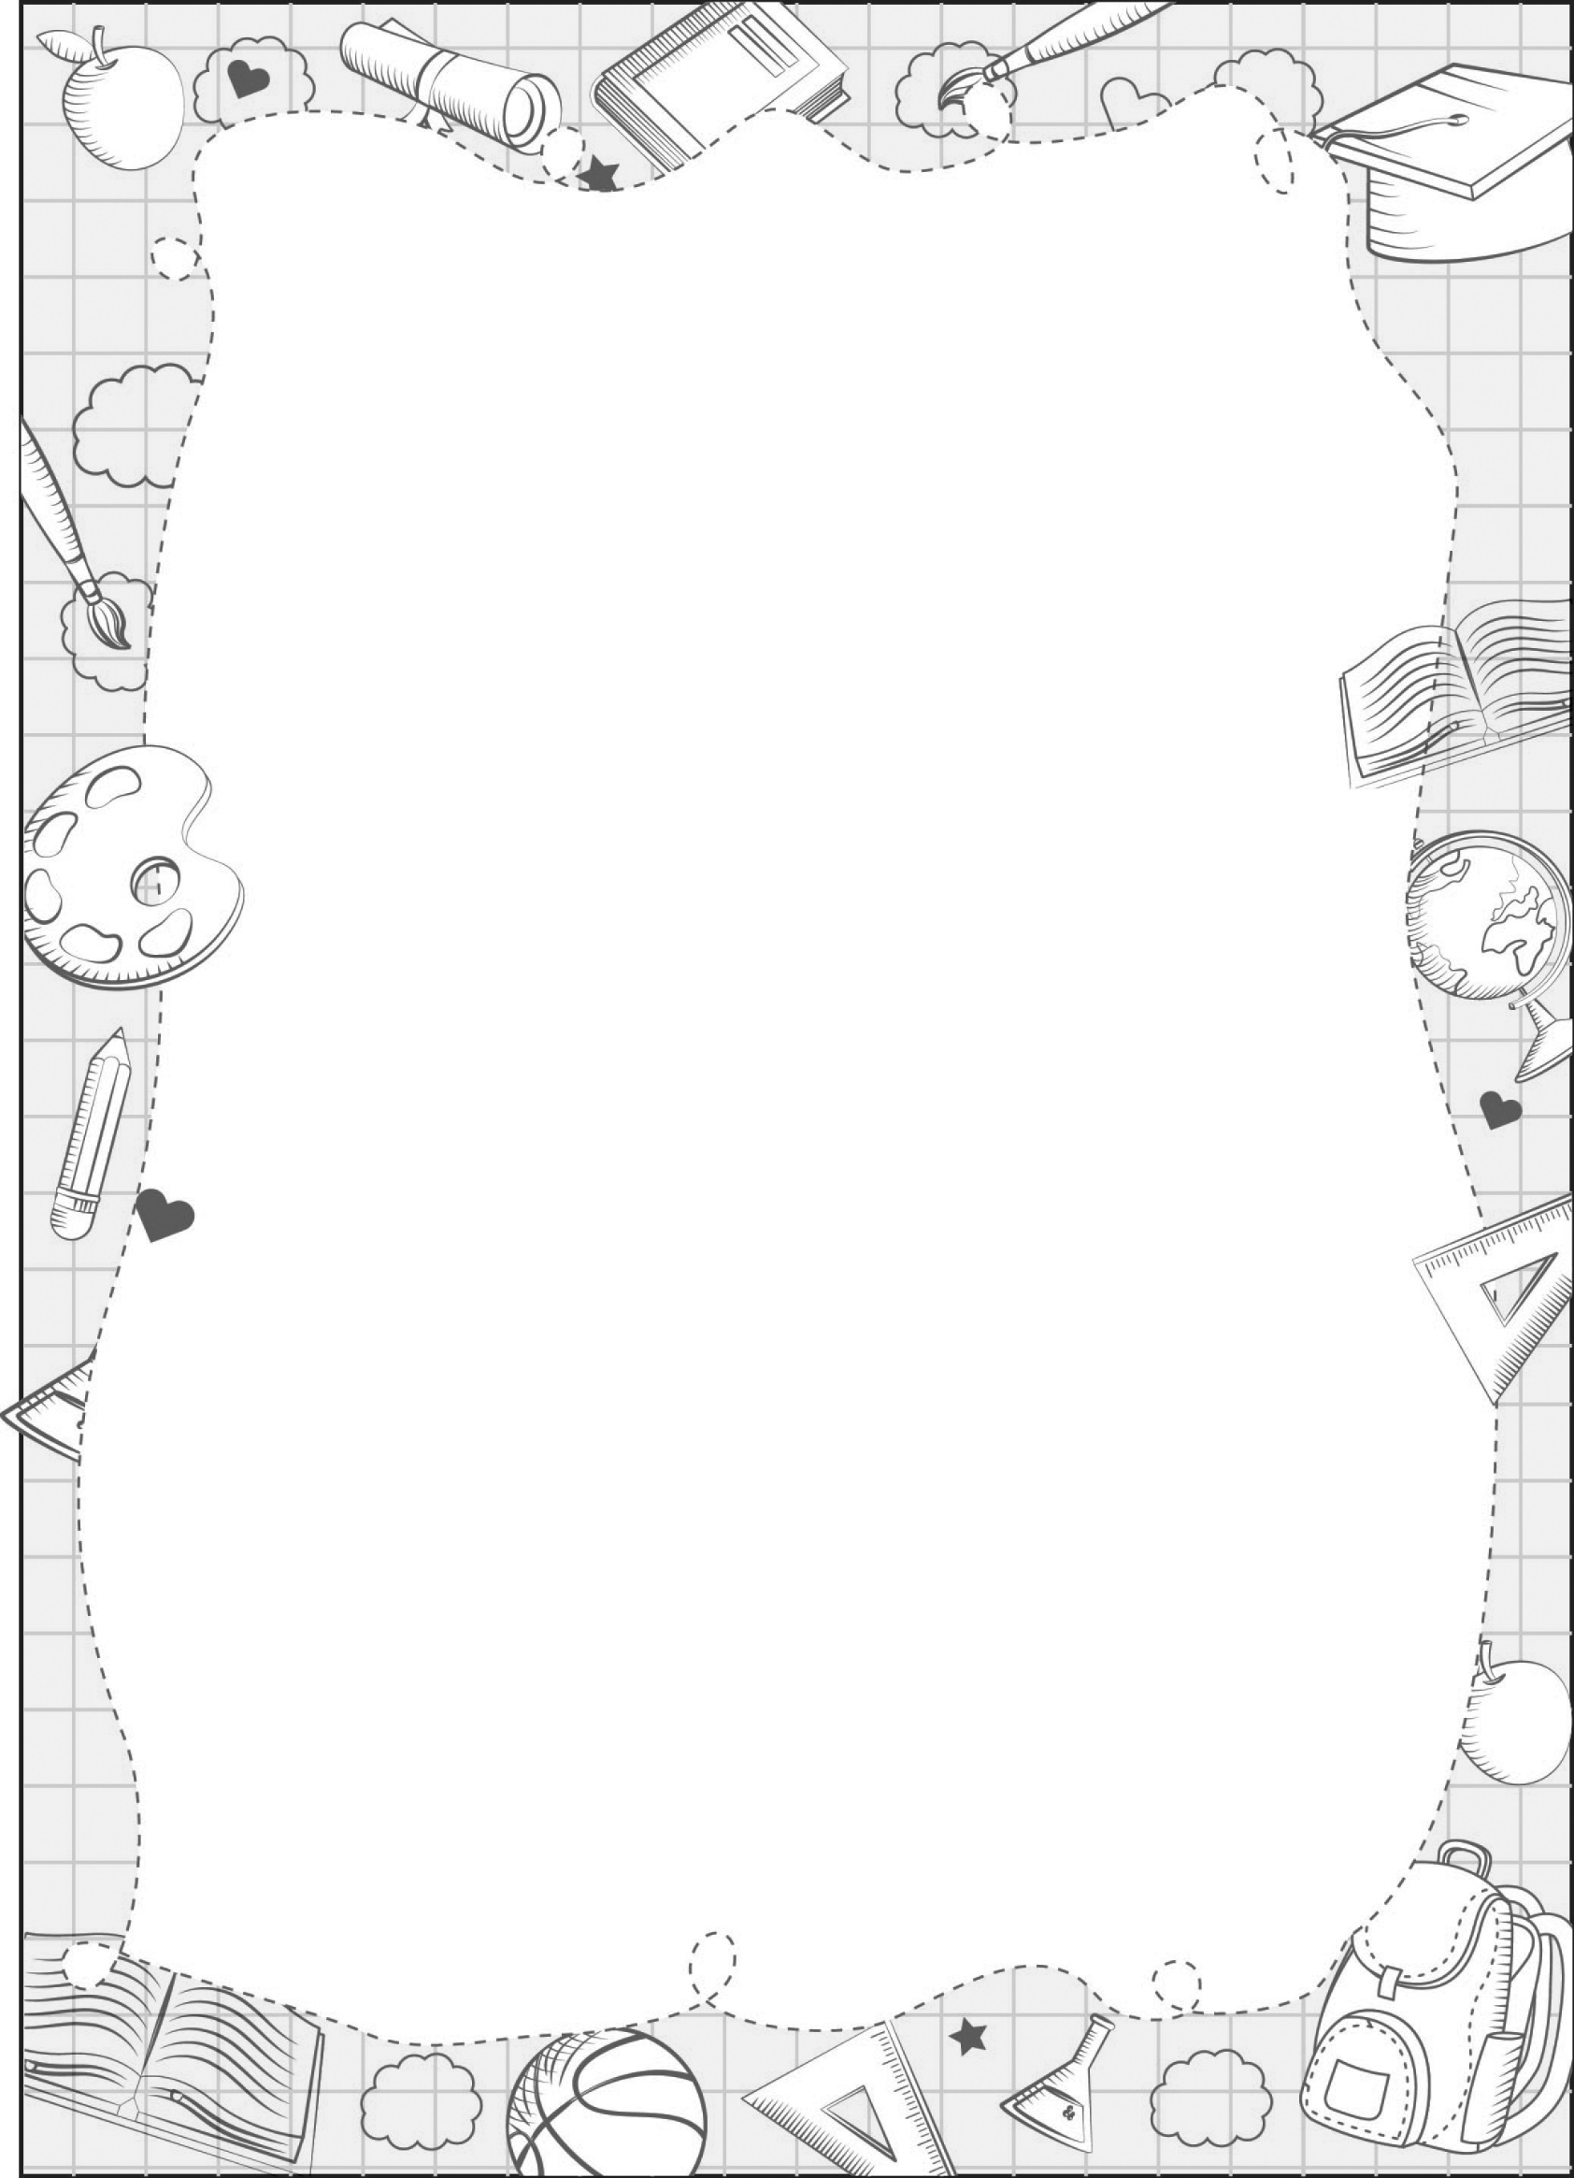
UNIT 10

portfolio

BREAK TIME ACTIVITIES

Class: .............
Name: .............

What do you do at break time?

Name: ______  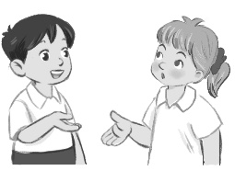 | Name: ______  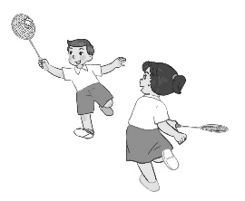 | Name: ______  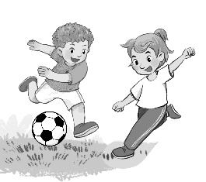 | Name: ______  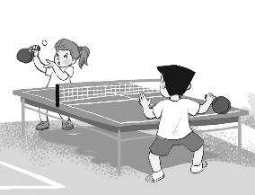
Name: ______  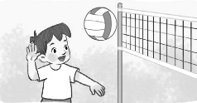 | Name: ______  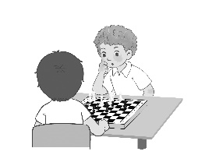 | Name: ______  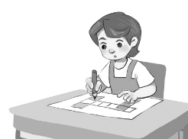 | Name: ______  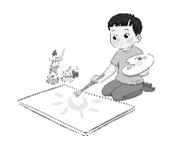
Name: ______ | Name: ______ | Name: ______ | Name: ______
I _______ at break time.
What do you do at break time? – I _________.
break time, chat, play badminton, chess, football, table tennis,
volleyball, word puzzles

