UNIT 14

project

My dream house

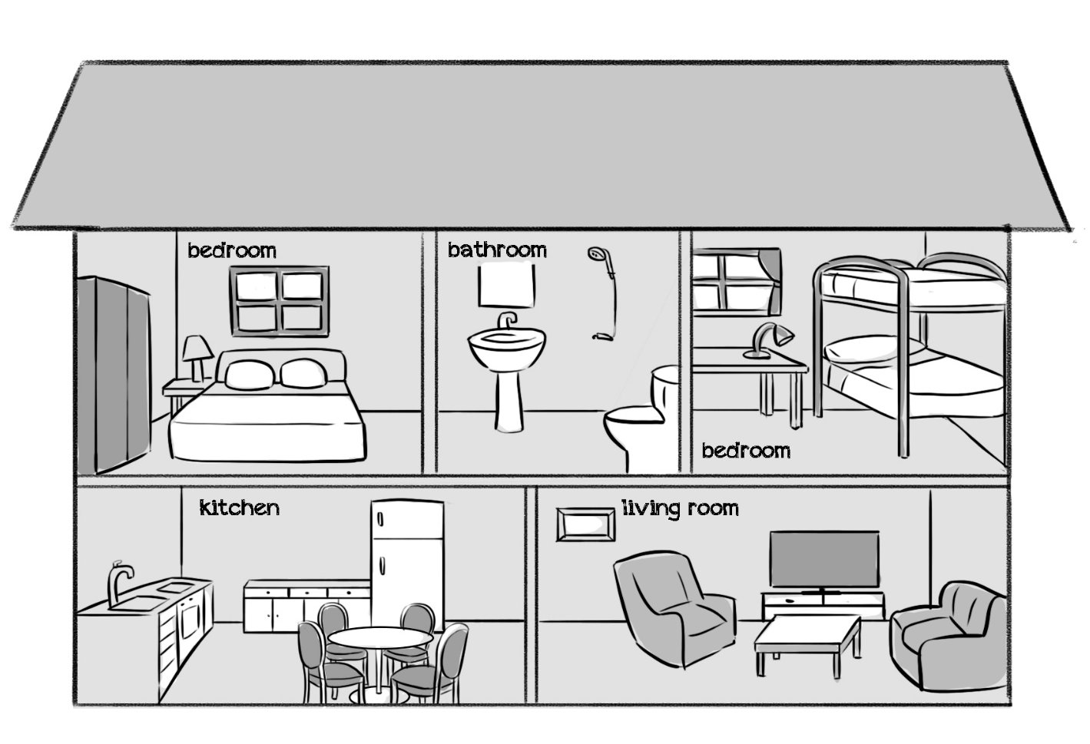

Teacher’s guide:
1. Goal:
- To revise vocabulary related to the topic My house and Colours.
2. Input:
- Chalk, blackboard, paper, coloured pencils/ crayons
3. Suggested procedure:
- Tell pupils that they are going to draw a dream house. Show them an example of a dream house as illustrated above.
- Ask pupils to work individually (or in pairs/ groups) to discuss and make a list of the rooms and furniture items they would like to have in their dream house.
- Get pupils to take out a piece of paper and make a model of their dream houses with rooms and furniture. Ask them to colour the pictures.
- Have some pupils to show and describe their dream houses, using There is/ There are, It’s/ They’re in/ on …
4. Extension:
- For better class, ask pupils to spot the differences in the pictures they have made.

