Exercise 1 : Read and answer the questions.
Lucy / 8 years old
0971-449 -746
Tony / 7 years old
0935 -756 -213

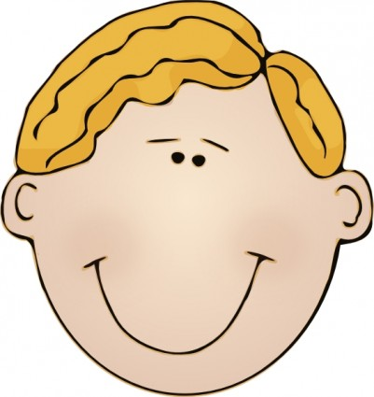


Peter / 10 years old
0939-756 -213
Anna/ 9 years old
0925-437-560




a) How old is Tony ?  + What is his phone number ? | …………………………………………………….  .  …………………………………………………….
b) How old is Lucy ?  + What is her phone number ? | ……………………………………………………..  …………………………………………………….
c) How old is Anna ?  + What is her phone number ? | …………………………………………………….  .  …………………………………………………….
d) How old is Peter ?  + What is his phone number ? | ……………………………………………………..  …………………………………………………….
Exercise 2 : Look and read . Put a tick () or a cross () in the box.
9

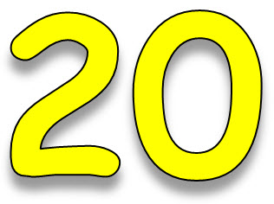  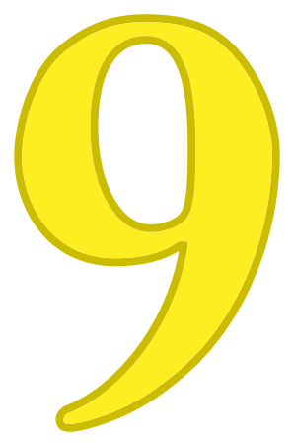=

a)Twenty plus nine is twenty – nine. b) She is eleven years old.
12

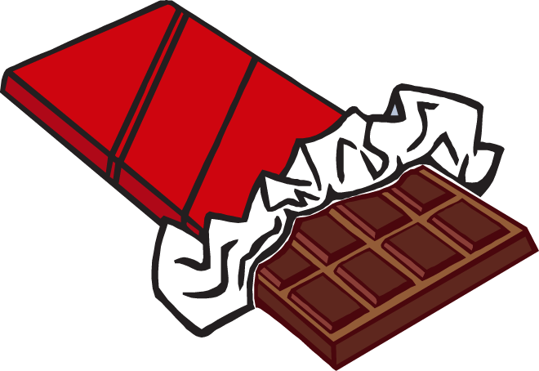


c) They are twelve years old. d) Would you like some chicken ?
  = 33
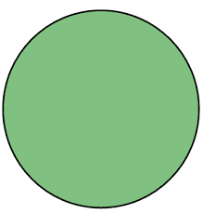

e) Thirty plus three is thirty – five. f) This is a square.
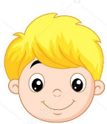

14

g) He’s fourteen years old. h) I can see four stars.
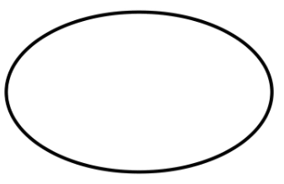
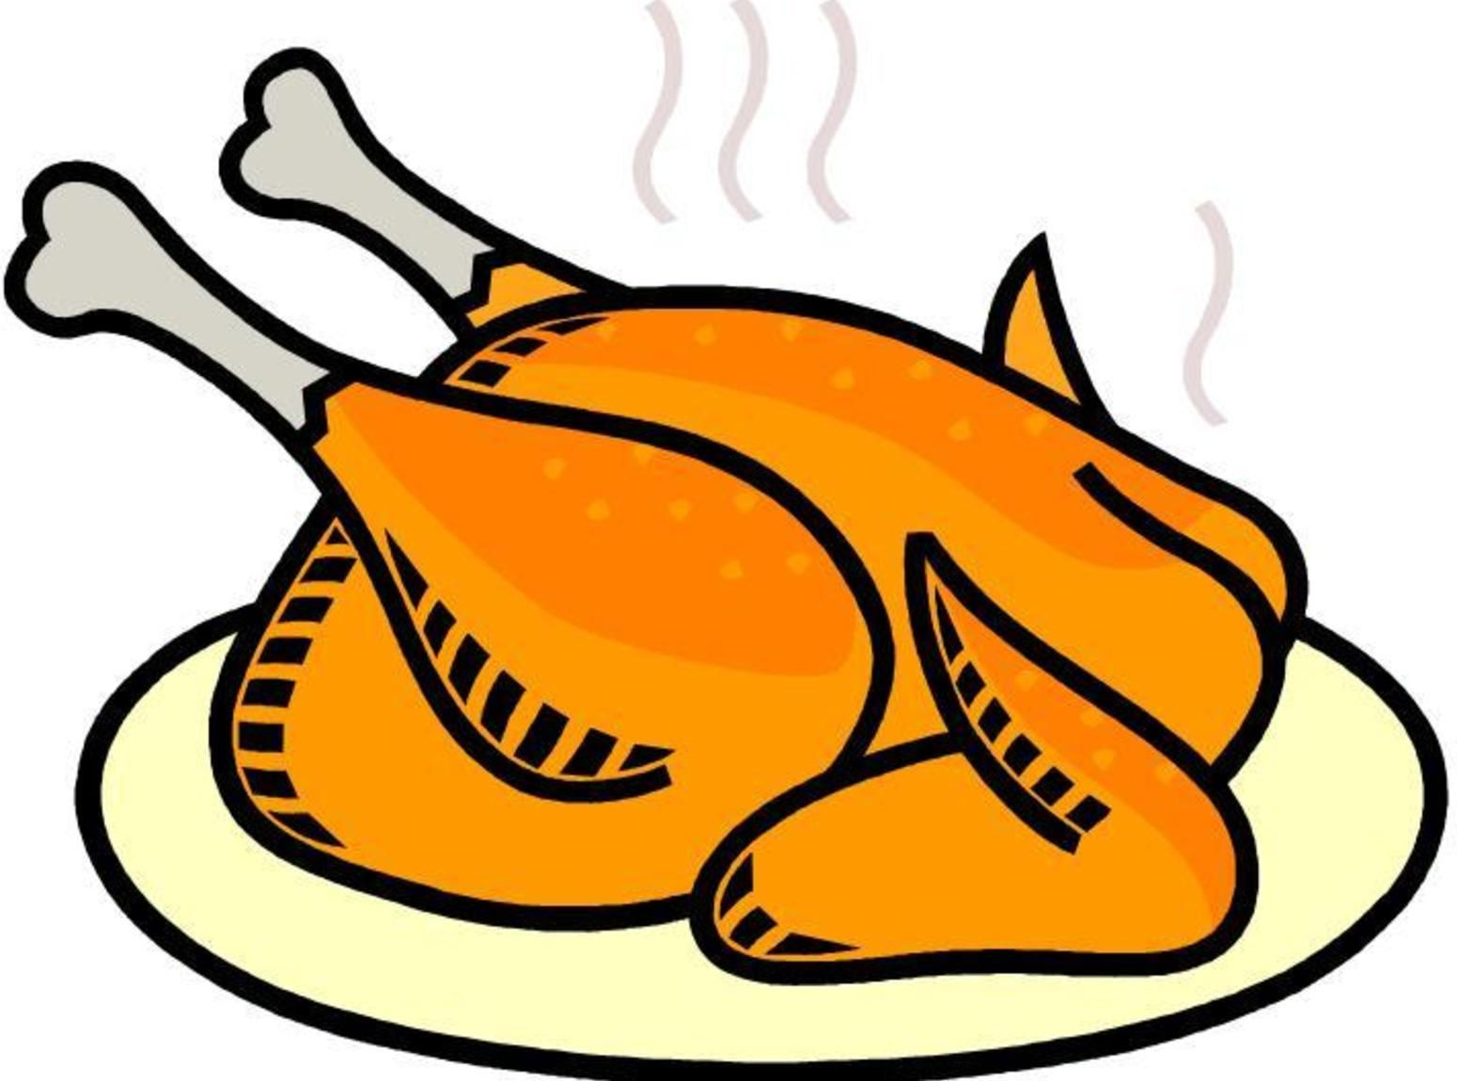

i) This is an oval. j) My favourite food is chicken.
Exercise 3: Choose the correct answer.
- What (am/is/are) your phone number? It’s 546746453
- How (old/age/year) is she? She’s 16 years old.
- They are 20 years (old/young/age).
- How old (am/is/are) they? They’re 35 years old.
- How (much/many) stars can you see? I can see six stars.
- How many (circle/circles) can you see? 3 circles.
- 30 plus 16 (am/is/are) 46.
- (would/will) you like some chocolate? Yes, please.
- Is your mother thirty years old ? ( Yes /No) , she is.
10. How old is Lucy ? ( He / She ) is eight years old.
11. How old is your grandfather ? He is seventy (years / year ) old.
Exercise 4 : Read and complete the sentences.
a) How old ………………she ? She’s twelve ………… old.
b) How old ……………… they ? They ……………… 11 years old.
c) How many circles ……………… you see ? I can ……………… eleven circles.
d) Would you ……………… some chicken ? Yes , ………………, please.
e) ……………… you ……………… some chocolate ? No , ……………… you.
f) Forty plus five ……………… forty – five.
g) What is your favorite food ? My ……………… food is pizza.
h) How many stars can you see ? I can ………………eight ………………
i) Is your sister ten years old ? ………………, she is.
j) Would you like some milk ? Just a little, ……………
k) What is her name ? ………………… is Rosy.
Exercise 5: Look , read and answer these questions.
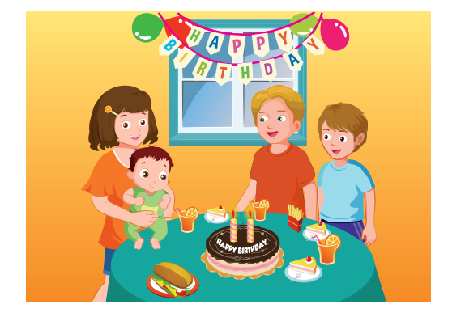
A) How many people are there ? …………………………………………………
B) How many balloons are there ? …………………………………………………
C) What shape is the window ? …………………………………………………..
D) How old is Max ? …………………………………………………
E) What shape is the cake ? …………………………………………………
F) How many glasses of orange juice are there on the table ?
……………………………………………………………………………………..
Exercise 6 : Make questions for these answers.
A) My phone number is 0845 – 266 – 187.
………………………………………………………………………………………?
B) His phone number is 0125 – 844 – 509.
………………………………………………………………………………………?
C) My sister is eleven years old.
………………………………………………………………………………………?
D) He is fourteen years old.
………………………………………………………………………………………?
E) They are twenty years old.
………………………………………………………………………………………?
F) Kim’s favorite drink is orange juice.
………………………………………………………………………………………?
G) My favorite food is chicken.
………………………………………………………………………………………?
H) I can see four blue circles.
………………………………………………………………………………………?
I) Toby’s father’s name is Harry.
………………………………………………………………………………………?
J) I would like to eat a lot of beef.
………………………………………………………………………………………?
K) Her phone number is 0791 – 306 -052.
………………………………………………………………………………………?
L) My grandfather is seventy – five years old.
………………………………………………………………………………………?
Exercise 7 : Look and read . Write yes or no.
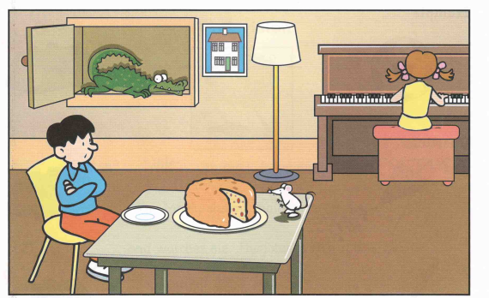
- There is a cake on the table.
- The mouse is under the chair.
- The boy is sitting at the table.
- There is an elephant in the cupboard.
- The girl is playing the piano.
- The lamp is between the cupboard and the picture.
- The boy is wearing a hat.

Exercise 8 : Find the mistakes and correct them.
A) Tony like orange juice and milk.
…………………………………………………………………………….
B) How old are they ? They’re eighteen year old.
…………………………………………………………………………….
C) Would you like some chicken ? No, a lot , please.
…………………………………………………………………………….
D) Twenty eight plus six is thirty three.
…………………………………………………………………………….
E) Anna would like to eating some fish.
…………………………………………………………………………….
F) How old is your grandmother ? He is seventy years old.
…………………………………………………………………………….
G) How many oval can you see ? I can see an oval.
…………………………………………………………………………….
Exercise 9 : Reorder the words to make correct sentences.
A) What / his/ is/ phone /number ?
…………………………………………………………………………….
B) How / she / is/ old ? nine / years /old./she’s/
…………………………………………………………………………….
C) Forty /five / plus / forty - five /is
…………………………………………………………………………….
D) Would / like /some / beef ?/you /Just /a/little ,/please/
…………………………………………………………………………….
E) can / you / How /many/ rectangles ?/see
…………………………………………………………………………….

Exercise 10 : Circle the odd one out.
 | sixty | circle | ninety | thirty
 | rectangle | oval | square | juice
 | teacher | mother | father | grandmother
 | beef | chicken | fish | milk
 | water | juice | milk | chocolate
 | he | she | his | they
 | How | How many | How old | Would
 | yellow | green | brown | five
Exercise 11 : Read and complete the sentences.
old | name | Would | like | What
seventy | is | time | likes | color
- What’s your …………………? My name’s Helen.
- How ……………… are you , Bill ? I’m 8 years old.
- ……………… is your telephone number ? It’s 0791 – 306 -052.
- What ……………… is it ? It’s 9 o’clock.
- What ………………is your cat ? It’s black.
- Do you……………… ice cream ? Yes, I do.
- How old is your grandfather ? He is ……………… years old.
- ………………you like some chocolate ? Yes, please.
- Thirty plus seven……………… thirty – seven.
- Tony ……………… chicken and beef.
Exercise 12 : Read and match.
- What is your phone number ? | - Yes, please.
- What is his name ? | - It’s 0125 - 844 -509
- How old is she ? | - I can see five rectangles.
- Is he nine years old ? | - They are fourteen years old.
- How old is your father ? | - Yes, he is.
- How old are they ? | - His name is Tony.
- How many rectangles can you see ? | - She’s eight years old.
- Would you like some chicken ? | - My father is forty years old.
Exercise 13 : Look, read and answer these questions.
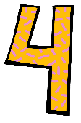
8
a) How old is he ? b) What is four plus five?
………………………………… …………………………………
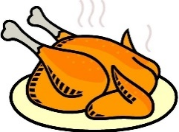
c) What would you like to eat? d) What is Lucy’s favorite drink?
………………………………… …………………………………

11
e) How many circles can you see ? f) How old are they ?
………………………………… …………………………………
Exercise 13 : Read and answer these questions.
Hello ! My name is Mary. I’m nine years old. I have long brown hair and big eyes. There are six people in my family . I have one brother and two sisters . I like playing table tennis and basketball . I don’t like football . I love pizza ! It’s my favorite food. My favorite drink is milk . I usually drink milk every morning. | 
A) What is her name ?
…………………………………………………….
B) How old is she ?
…………………………………………………….
C) How many people are there in her family ?
…………………………………………………….
D) What is her favorite food ?
…………………………………………………….
E) Does she like playing table tennis ?
…………………………………………………….
F) What is her favorite drink ?
…………………………………………………….
g) Does she have short brown hair ?
…………………………………………………….

