Exercise 1 : Look and read . Put a tick () or a cross ()
 | a) It’s my head. |  |  | b) It’s my foot.
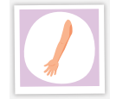 | c) It’s my leg. |  | 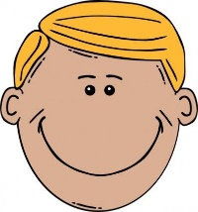  blond | d) He has black hair.
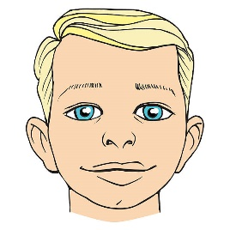 | blue  e) He has blue eyes. |  |  | f) Touch your cheeks.
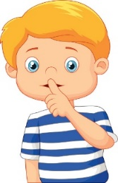 | g) Touch his hand. |  | 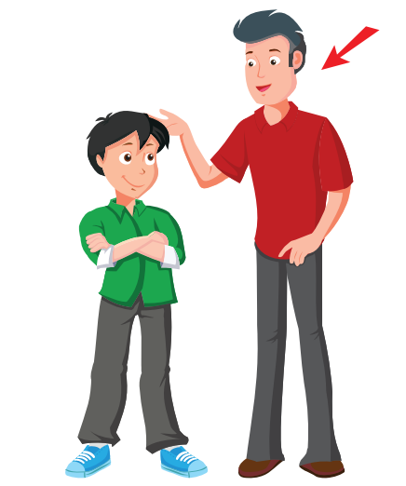 | h) He’s taller than me.
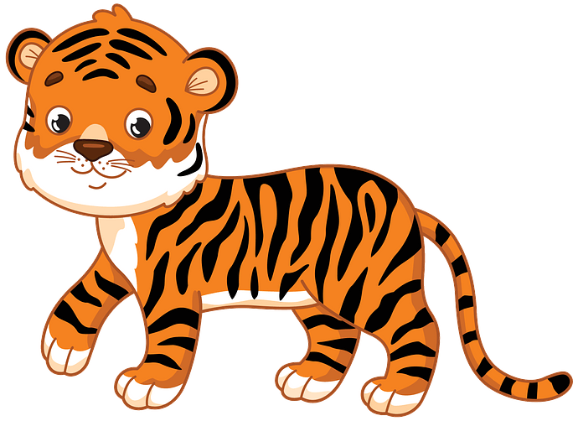 | i) The tiger has four legs. |  | 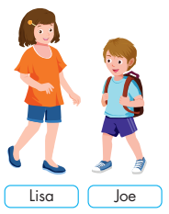 | j) Lisa’s shorter than Joe.
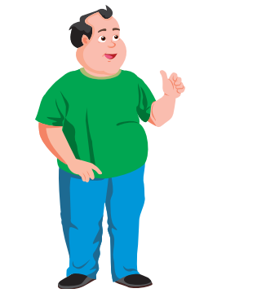 | k) The man is fat. |  | 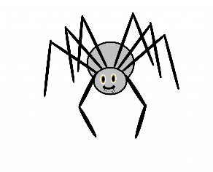 | l) It’s black. It has six legs.
Exercise 2 : Read and match.
- What is this? | - It’s small. It has four legs.
- What does she look like ? | - Yes, she does.
- What is your favorite subject ? | - She has blue eyes.
- What does it look like ? | - They are brown.
- Who is taller than Tony ? | - I have music on Friday.
- When do you have music ? | - Lisa is taller than Tony.
- What color are his eyes ? | - My favorite subject is math.
- Does she have long hair ? | - It’s my face.
Exercise 3 : Read and circle the correct word.
a) These ( is / are ) my eyes.
b) What does she look like ? She ( have / has ) short black hair.
c) ( Do / Does ) she have long hair ? No, she doesn’t.
d) It’s small and brown. It has eight ( leg/ legs )
e) Toby is ( fatter / fater ) than Peter.
f) ( Who / What ) is taller than Andy ? Peter is taller than Andy.
g) Tigers ( lives/ live ) in the forests of Vietnam.
h) What does your sister look like ? ( She / He ) has small nose.
i) He is ( short / shorter ) than me.
j) Is she tall ? ( Yes / No ) , she is.
k) What color ( is / are ) her eyes ? They’re blue.
L) This is my ( nose / noses )
m) What is his favorite subject ? He ( like / likes ) math.
n) (Where / Who ) is the doll ? It’s in the box.
Exercise 4 : Look and fill in the blanks.
straight hair | fat | thin | long hair
tall | short hair | short | wavy hair

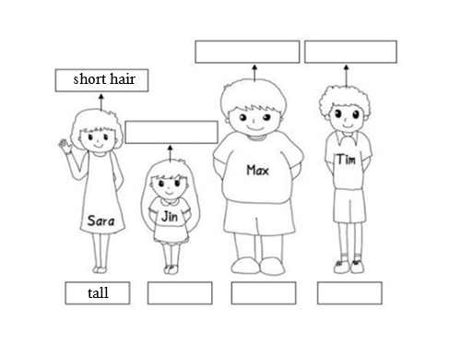 | - Sarah is tall. She has short hair.  - Jin is ………………………….  She has ……………………..  - Max is ………………………..  He has …………………………  - Tim is ……………………….…  He has …………………………
Exercise 5 : Read the text. Write “T” for the right sentences, “F” for the wrong sentences .
Hello, My name is Mary. I’m nine years old. I’m tall and thin. This is my dad. He is young and handsome. He’s short black hair. This is my mom. She is slim and beautiful. She’s long black hair. And This is my brother. He is John. He is short and cute. He’s short blonde hair. I love my family very much.
- Her name is Rosy.
- She is eleven years old.
- Mary’s mom is thin and beautiful .
- Mary’ dad is young and handsome
- Mary’ dad has short black hair.
- Mary is tall and thin .
- Mary’s mom has long blond hair.
- Mary’s brother has short blond hair
Exercise 6 : Read and fill in the blanks.
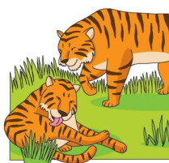 | TIGERS  Tigers are big animals . They have a long body , a short (1) __________ and four legs .They have a long tail too . Tigers are (2) __________ and brown. They like meat and they don’t eat (3) _______ They can swim very well. They can (4) ____________ too. Children can see tigers at the (5 ) ____________
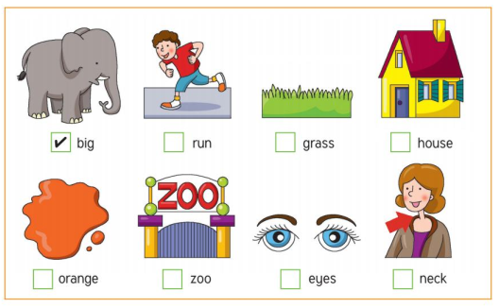
Exercise 7: Make questions for these answers.
a) …………………………………………………………….?
- She has black short hair.
b) …………………………………………………………….?
- It is my head.
c) …………………………………………………………….?
- Toby is taller than Harry.
d) …………………………………………………………….?
- It’s big and black . It has four legs.
e) …………………………………………………………….?
- My brother is short. He has brown hair.
Exercise 8 : Find the mistakes and correct them.
a) What does she look like ? She have blue eyes.
……………………………………………………………………………….
b) What are these ? It’s my ear.
……………………………………………………………………………….
c) She have big brown eyes and straight black hair.
……………………………………………………………………………….
d) My mother is tall than my sister.
……………………………………………………………………………….
e) The elephant is smaller than gorilla.
……………………………………………………………………………….
f) It’s big and grey. It has two big ear.
……………………………………………………………………………….
g) My father is tall. She has curly, black hair and a beard
……………………………………………………………………………….
h) Rose is short than Mary.
……………………………………………………………………………….
Exercise 9 : Circle the odd one out.
 | - face | - hand | - leg | - read
 | - elephant | - mouth | - monkey | - bear
 | - short | - sing | - listen | - spell
 | - tall | - big | - thin | - body
 | - orange | - tail | - black | - grey
 | - teacher | - mother | - sister | - brother
 | - old | - young | - touch | - fat
 | - beef | - pork | - fish | - juice

Exercise 10 : Look and read . Write yes or no
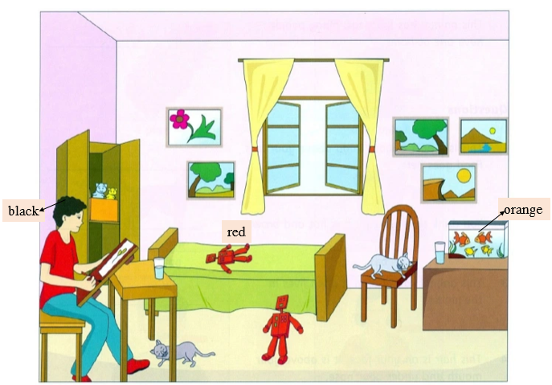
- There are two cats and they are sleeping.
- There is a dog on the chair.
- The orange fish are bigger than the yellow fish.
- The boy with brown hair is reading a book.
- There are four pictures on the wall.
- There is a robot on the bed and it’s red.
- There is a box in the cupboard with books in it.
- There are three glasses of water in the room.

Exercise 11 : Put the word in the correct order:
a) The girl/ than/ the boy./taller/is/
…………………………………………………………………………….
b) a /kangaroo./stronger/ than/An / is/elephant/
…………………………………………………………………………….
c) was/ today./Yesterday / hotter/
…………………………………………………………………………….
d) are/ Snakes / snails ./faster /than /
…………………………………………………………………………….
e) She/ straight, / brown /has /hair /and/ eyes./ brown/
…………………………………………………………………………….
g) What / look / does/ your/ like ?/ sister /
…………………………………………………………………………….
h) It/two / swings. / has & can/ It /sing /and/ fly./
…………………………………………………………………………….
i) / straight /My/blonde/brother/has/ hair./ & /And/has/he /blue eyes.
……………………………………………………………………………….
j) my /face./ This /is.
…………………………………………………………………………….
k) I /taller/ my /sister./ am / than/
…………………………………………………………………………….
l) Elephants /bigger/ than / are /horses .
…………………………………………………………………………….
m) Mary/ thinner / Rose./is/ than.
…………………………………………………………………………….
n) slower/The/ is/rabbit./ the /tortoise//than/
…………………………………………………………………………….
Exercise 12 : Read and write the name of the animal.
a) It’s small and green . It can swim . It can jump and hop . It lives in land and water.
b) It’s small . It has long ears . It can run very fast. It can hop . It likes carrots.
c) It is an insect . It lives in hives. It can fly . It is yellow and black. It likes flowers . It gives honey.
d) It’s big and grey . It has four legs and tail. It eats plants and fruit . It live in the forest . It can swim.
e) It’s black and orange. It has eight legs . It eats small animals . It lives in the jungles. It can climb.
f) It’s big and tall. It eats leaves and flowers .It lives in the grasslands. It has a long neck
g) It’s small and colorful. It has big wings. It lives in gardens and forests. It used to be a caterpillar.
h) It looks like a mouse. It loves cheese. It’s grey. It has a long pink tail . It has a long nose.

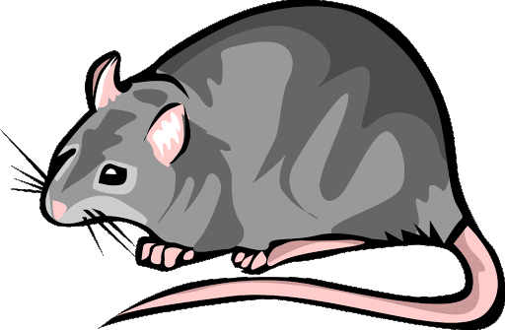 | 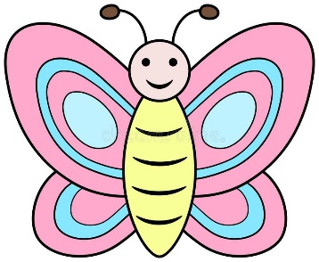 | 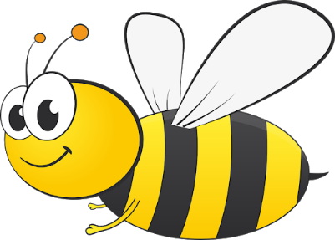 | 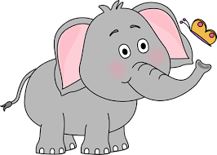
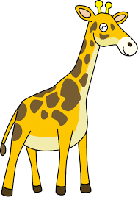 | 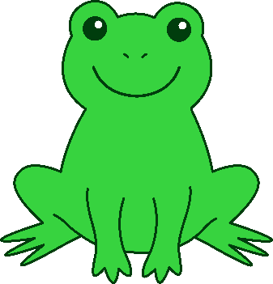 | 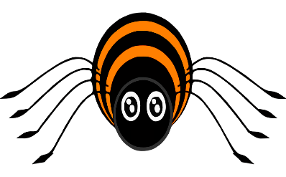 | 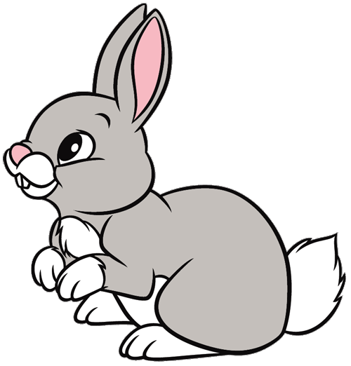

Exercise 13 : Look and write the comparative form.
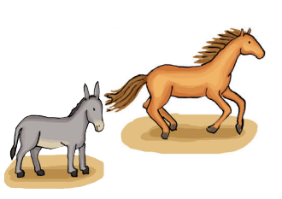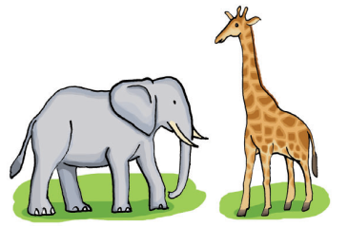
a) horse / donkey / fast b) elephant / giraffe / tall
- The horse is faster than the donkey. …………………………………………………
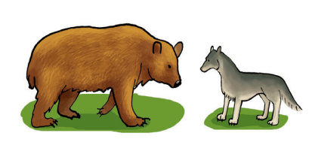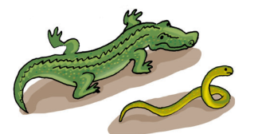
c) bear / wolf / big d) crocodile / snake / thin
………………………………………………… …………………………………………………
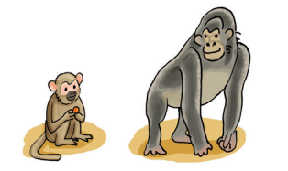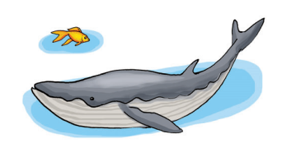
e) monkey / gorilla / strong f) whale / fish / long
………………………………………………… …………………………………………………
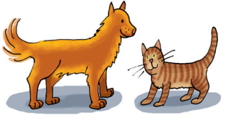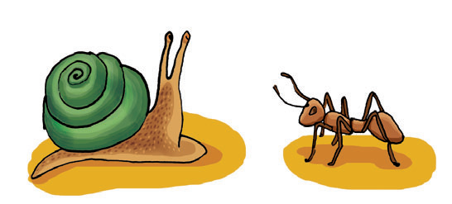
g) dog / cat / heavy h) snail / ant / slow
………………………………………………… ………………………………………………

