Lesson 1
Exercise 1 Look and write
father | mother | sister | brother | baby bother

 |  |  |  | 
………………………. | ………………………. | ………………………. | ………………………. | ……………………….
Exercise 2 Look and match
- She is my mother.
- He is my baby brother.
- She is my sister.
- He is my father.
e) He is my brother.

Exercise 3 Look and write
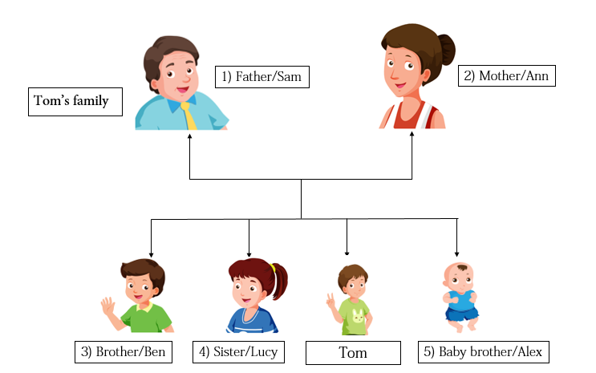
1) Who is he ? He is Tom’s father . He’s Sam.
2) Who is she ? ……………………………………………………………………………….
3) Who is he ? ……………………………………………………………………………….
4) Who is she ? ……………………………………………………………………………….
5) Who is he ? ……………………………………………………………………………….
Exercise 4 Look and read . Put a tick () or cross () in the box.

a) His name is Tom. b) He’s Tom’s father. c) She’s Tom’s sister.

c) His name is Alex. d) She’s Tom’s sister. e) His name is Ben.
Lesson 2
Exercise 1 Look , read and circle the right words



a) uncle
b) aunt
a) grandmother
b) sister
a) father
b) grandfather



a) aunt
b) grandmother
a) father
b) mother
a) uncle
b) cousin

Exercise 2 Find the following words in the puzzle .
aunt | cousin | grandfather | mother | uncle
brother | father | grandmother | sister
Tom’s family
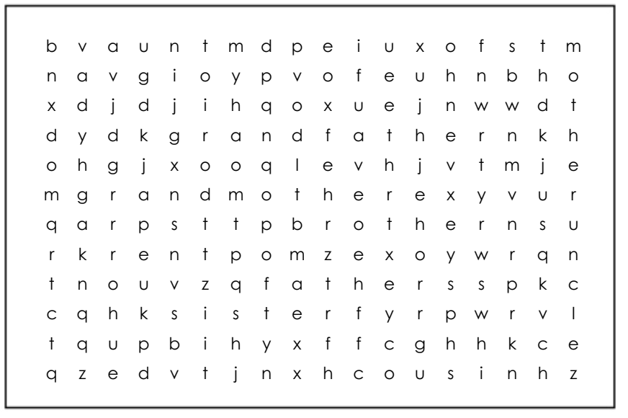
Exercise 3 Look and write

a) This is Tom’s ……………. b) This is …………….uncle.

c) ………... Tom’s grandfather. d) This is Tom’s …………….
Exercise 4 Read and match
a) | 1) This is Tom’s Aunt. | a) _
b) | 2) This is Tom’s grandfather. | b) _
c) | 3) This is Tom’s uncle. | c) _
d) | 4) This is Tom’s mother. | d) _
e) | 5) This is Tom’ sister. | e) _
Lesson 3
Exercise 1 Look and write the missing letters
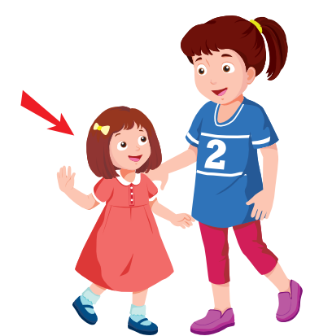 | 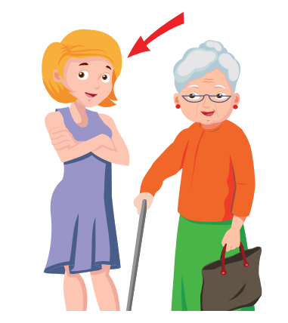 | 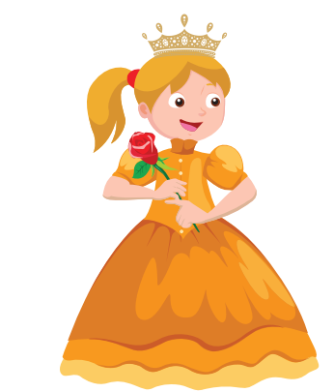
sh _ _ _ | you _ _ | pre _ _ y
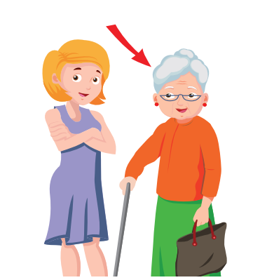 |  | 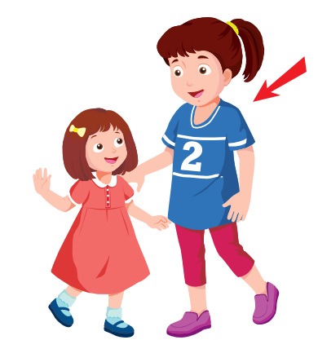
_ _ d | hand _ _ _ _ | _ _ ll
Exercise 2 Look and write
a) What does she look like ? | b) What does she look like ? | c) What does she look like ?
She is pretty . | …………………………………… | ……………………………………
d) What does she look like ? | e) What does she look like ? | f) What does he look like ?
…………………………………… | …………………………………… | ……………………………………
Exercise 3 Read and write

a) Is she pretty ? b) Is she old ? c) Is she short ?
………………………… ………………………… …………………………
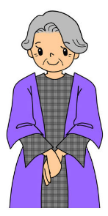
d) Is he handsome ? e) Is she young ? f) Is she tall ?
………………………… ………………………… …………………………
Exercise 4 Read and complete the sentences.
a) Is your brother tall ? Yes, …………………………
b) ……………is your sister short ? No, she isn’t . She’ s tall.
c) Is your grandfather old ? ……………, he is.
d) Is your mother pretty ? Yes, …………………………
e) Is your brother short ? No, he isn’t . He’s …………………
f) What does your aunt look like ? She ……………tall.
g) What does your …………… look like ? My father is short and fat.
e) …………… your uncle young ? Yes, he is.
Exercise 5 Read and match
- Who is he ? | - No, she isn’t . She’s short.
- Is your sister tall ? | - He’s Tom’s father.
- What does your brother look like ? | - I’m eight years old.
- What is this ? | - My name is Tom.
- Is it a pencil case ? | - It’s a camera.
- What is your name ? | - I’m from River Town.
- Where are you from ? | - Yes, it is.
- How old are you ? | - He’s tall and handsome.

Lesson 4
Exercise 1 Look and write the missing letters
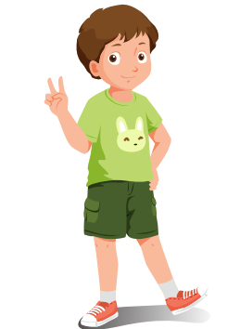 |  | 
b _ y | _ _ n | gi _ _
 | 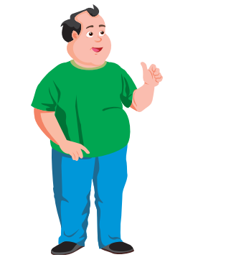 | 
_ _ man | fa _ | th _ n
Exercise 2 Look and circle
a) fat man / thin man.
b) short boy/ tall boy
c) thin man / fat man
d) short girl/ tall girl
Exercise 4 Look and write
Tom’s family
Bill
cousin
 Sam
father

fat man
short boy
Grace
Grandmother
Lucy
sister
old woman
tall girl

Ben
brother
Alex
brother baby
thin boy
fat baby

a) Who is the short boy ? He’s Tom’s cousin
b) Who is the tall girl ? ……………………………………………………….
c) Who is the old woman ? ……………………………………………………….
d) Who is the fat man ? ……………………………………………………….
e) Who is the fat baby ? ……………………………………………………….
f) Who is the thin boy ? ………………………………………………………
Lesson 5
Exercise 1 Look and write the missing letters
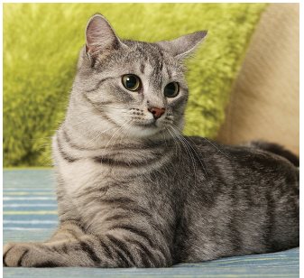 | 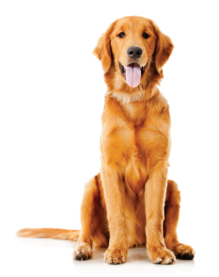 | 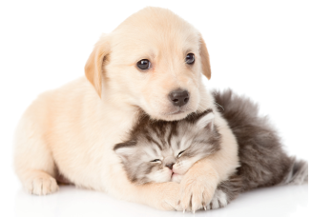
c_ t | _ _ g | c_ _ e
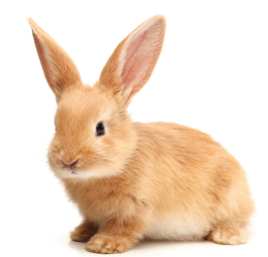 |  | 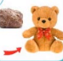
_ _ bbit | friend _ _ | _ _ ft
Exercise 2 Read and circle True or False
Our favorite pets
I’m Tony. I am nine years old. Rabbits are my favorite pets. They are soft and cute. There are three rabbits in my house. Anna is my sister .Cats are her favorite pets . She has a small cat. It’s cute and friendly . We like playing our pets.
- His name is Tony.
- He is eight years old.
- Rabbits are Tony’s favorite pets.
- Anna is Tony’s sister.
- Dogs are Anna’s favorite pets.
- Anna has a small cat.
Lesson 6
Exercise 1 Look, read and circle the correct option
a) This is Tom’s father. a) This is Tom’s aunt.
b) This is Tom’s uncle. b) This is Tom’s sister.
a) She is short. a) Tom’s grandmother is old.
b) She is tall. b) Tom’s grandmother is young.
a) The man is thin. a) The man is thin.
b) The man is fat. b) The man is fat.
Exercise 2 Look at the pictures and read the questions .Write one – word answers
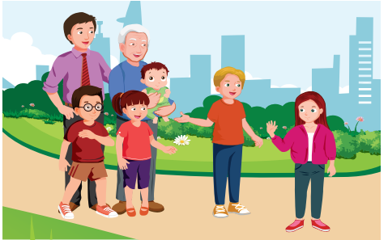
Examples :
Who’s he ? He’s my grandfather.
Is he young ? No , he isn’t. He’s old.
Questions:
1) Is your uncle short ? No, he isn’t. He’s …………………………………..
2) Are your cousins old ? No, they aren’t . They’re…………………………
Exercise 3 Make questions for these answers
A) He is Tom’s father . He’s Sam.
…………………………………………………………………………..
B) My brother is tall and thin.
…………………………………………………………………………..
C) No, she isn’t . My sister is short.
…………………………………………………………………………..
D) My favorite pets are rabbits.
………………………………………………………………………….

