Exercise 1 : Look and read . Put a tick () or a cross () in the box.
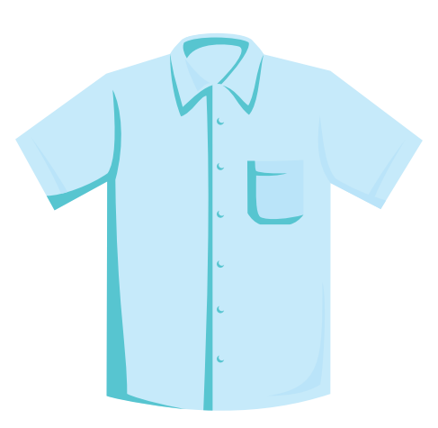 | a) This is my shirt. | 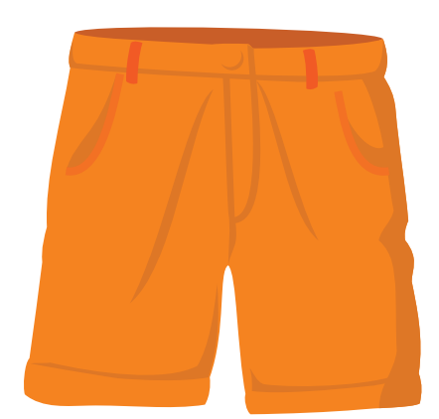 | b) These are my pants.
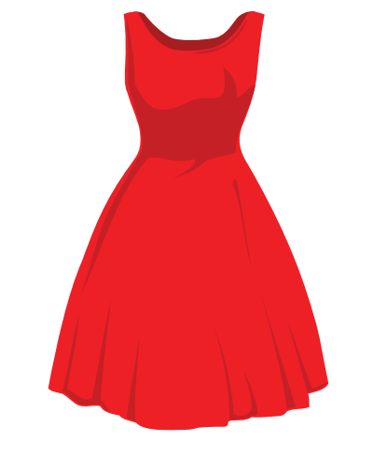 | c) Lucy’s dress is red. | 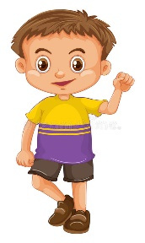 | d) He’s wearing brown shorts.
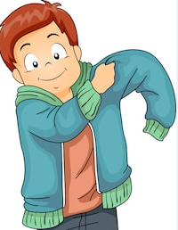 | e) He’s wearing pajamas. | 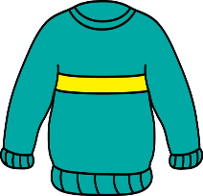 | f) This is a sweater.
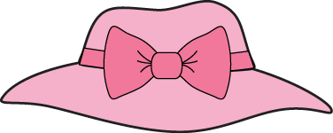 | g) Is this your cap ? | 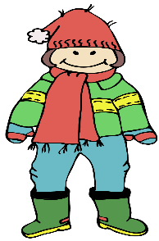 | h) She’s wearing green shoes.
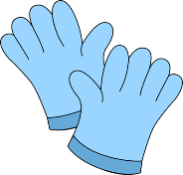 | i) They’re my gloves. | 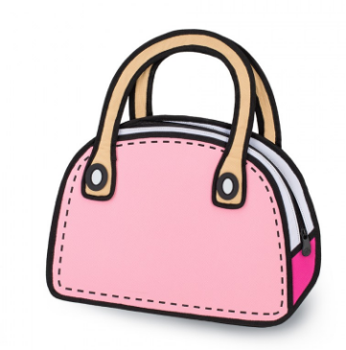 | j) This is Lucy’s watch.
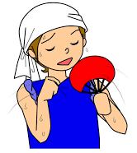 | k) He is cold. | 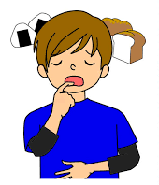 | l) I am hungry.

Exercise 2 : Read and match.
- What color are his shorts ? | - Yes, they are.
- Is this your sweater ? | - They’re blue.
- What is he wearing ? | - It’s Mary’s handbag.
- Whose gloves are these ? | - He’s wearing dark blue shorts.
- What color is her skirt ? | - It’s yellow.
- What is she wearing ? | - No, it isn’t.
- Are these your jeans ? | - She’s wearing a green skirt.
- Whose handbag is this ? | - They’re Peter’s gloves.
- What’s the matter , Grandma ? | - Yes, please.
10. Do you want a jacket ? | - I’m cold.
Exercise 3 : Read and complete the sentences.
a) What …………….. is your blouse ? It’s blue.
b) What color are your pants ? …………….. grey.
c) What is he wearing ? …………….. is wearing red shorts.
d) Is she wearing a yellow skirt ? Yes, she ……………..
e) What …………….. you wearing ? I’m wearing a purple cap.
g) Is this your jacket ? No, ……………..
h) ……………..these his jeans ? Yes, they are.
i) ……………..glasses are these ? They’re Tony’s glasses.
k) Whose handbag is this ? …………….. Rose’s handbag.
l) What’s the …………….., Lucy ? I’m cold.
m) Do you …………….. a sweater ? Yes, please.
n) Whose watch is this ? It’s Peter’s ……………..
o) Is he wearing ……………..brown jacket ? Yes , ……………..
Exercise 4 : Read , look and answer
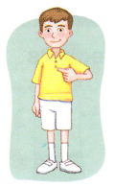 | 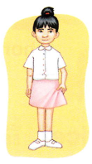 | 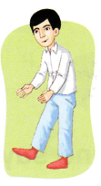
- What is he wearing ? | - What is she wearing ? | - What is he wearing ?
He is wearing a shirt. | ………………………………… | …………………………………
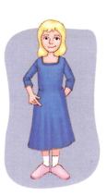 | 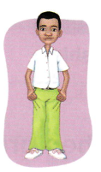 | 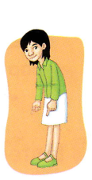
- What is she wearing ? | - What is he wearing ? | - What is she wearing ?
………………………………… | ………………………………… | …………………………………
Exercise 5 : Read and circle the correct word.
a) This ( are / is ) my jacket.
b) What is Toby wearing ? ( He / She ) is wearing grey pants.
c) Are these your glasses ? Yes, ( they are / they aren’t)
d) Is ( these / this ) his sweater ? No, it isn’t.
e) What are you ( wearing / wear ) ? I’m wearing a blue shirt.
f) (Who/ Whose ) is taller than Peter ? Harry is taller than Peter.
g) (Who/ Whose ) handbag is this ? It’s Linda’s handbag.
h) Whose boots are these ? ( It’s / They’re ) Rose’s boots.
i) Is she thirsty ? Yes , ( she is / she isn’t)
Exercise 6 : Make questions for these answers.
A) …………………………………? B) ……………………………………?
+ My mother is wearing a red skirt. + He is wearing blue jeans.
C) …………………………………? D) ……………………………………?
+ They’re Linda’s glasses. + Yes, they are my boots.
E) …………………………………? F) ……………………………………?
+ Brian’s jacket is orange. + My shorts are purple.
G) …………………………………? H) ……………………………………?
+ It’s Lucy’s handbag. + I am wearing a blue cap.
I) …………………………………? J) ……………………………………?
+ He’s short and fat . He has big ears. + Emily’s favorite subject is music.
Exercise 7 : Find the mistakes and correct them.
a) What is the matter , Mom ? I’m hotter.
…………………………………………………………………………..
b) Do you wants a jacket ? Yes, please.
…………………………………………………………………………..
c) What is your sister wearing ? He’s wearing a grey jacket.
…………………………………………………………………………..
d)What is he wearing ? He’s wear brown pants.
…………………………………………………………………………..
e) Who shirt is this ? It is Ruby’s shirt.
…………………………………………………………………………..
f) Are these your pajamas ? Yes, they aren’t.
…………………………………………………………………………..
g) Toby’s wearing a orange cap.
…………………………………………………………………………..
Exercise 8 : Circle the odd one out.
 | jacket | sweater | coat | jeans
 | What | Would | Whose | What
 | wear | tall | read | sing
 | short | fat | thin | face
 | eyes | ears | long | legs
 | curly | black | brown | yellow
 | his | your | her | they
 | shorts | jeans | shoes | pants
Exercise 9 : Put the words in the correct order.
A) My / is/ brown / mother / wearing /shirt./a/
…………………………………………………………………………………………..
B) Is / wearing / she / grey /pants ?/ - is / Yes,/she/
…………………………………………………………………………………………..
C) are / They/ Lucy’s / boots./
…………………………………………………………………………………………..
D) Are / your / socks ?/ these / - aren’t /they/No,/
…………………………………………………………………………………………..
E) These / socks./ Peter’s/are/
…………………………………………………………………………………………..
G) glasses / Whose/ are / these ?
…………………………………………………………………………………………..
H) is/ What / wearing ?/Toby/ - wearing / He’s / shorts//green/
…………………………………………………………………………………………..

Exercise 10 : Look and read. Write yes or no.
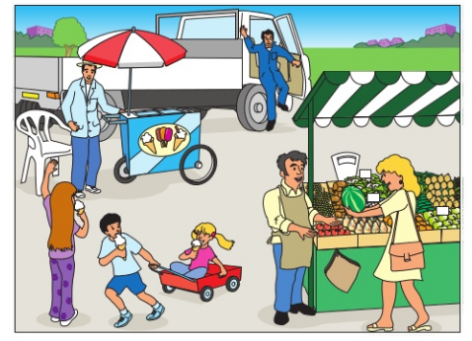
- The door of the lorry is open.
- The children are wearing hats.
- Three people are eating ice creams.
- The small girl is walking behind the boy.
- The big girl has long hair.
- A man is picking up a chair.
- The woman is holding some green grapes.
Exercise 11: Color the clothes and write the names of the children.
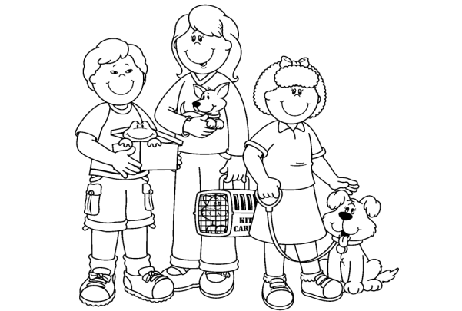

1) Hello , my name is Lucy. I’m 10 years old . I’m wearing a red jumper , blue pants and blue shoes . I have a small brown dog .
2) Hello , my name is Simon. I’m 9 years old . I’m wearing green shorts , brown shoes , yellow socks and an orange T- shirt. I have a green frog.
3) Hello , my name is Carol . I’m wearing a pink skirt, a purple T- shirt , pink socks and blue shoes. I have a big , brown dog.

Exercise 12 : Read the text again and answer the questions.
A) How old is Lucy ? B) What is Lucy wearing ?
…………………………………… ……………………………………
C) What does Lucy have ? D) Is Simon 10 years old ?
…………………………………… ……………………………………
E) What is Simon wearing ? F) Does Simon have a white cat ?
…………………………………… ……………………………………
G) How old is Carol ? H) What is Carol wearing ?
…………………………………… ……………………………………
I) What does Carol have ? J) Does Lucy have a brown dog ?
…………………………………… ……………………………………
Exercise 13 : Follow the lines and answer the questions
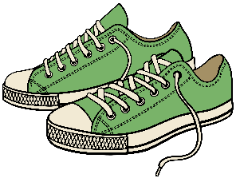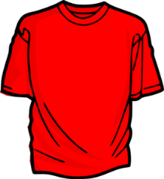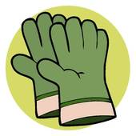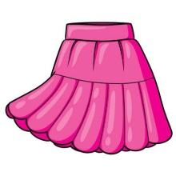
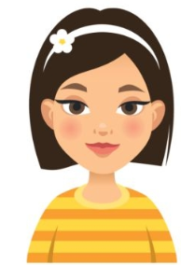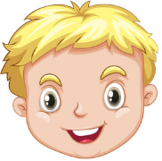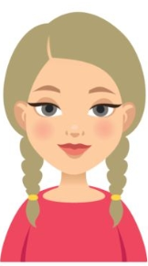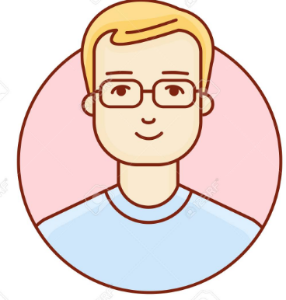
Tom
Mary
Sandy
Jim

A) Whose shoes are these ? B) Whose gloves are these ?
…………………………………. ……………………………………………
B) Whose skirt is this ? D) Whose T- shirt is this ?
…………………………………. ……………………………………………
Exercise 14 : Read this . Choose a word from the box. Write the correct next to number 1 – 5 . There is one example.
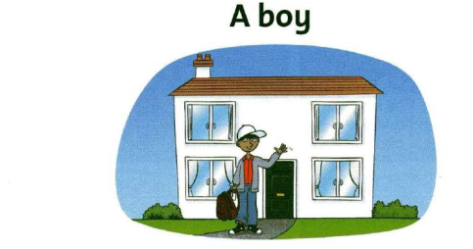
Hello . I’m Alex. Today I’m wearing a white hat and blue (1) ……………….I’m holding a nice brown (2) ………………. . I’m in front of my (3) ………………. .It has four (4) ………………. and a green (5) ………………..
What am I ? I am a boy.
