Exercise 1 Look and read . Put a tick () or a cross () in the box.
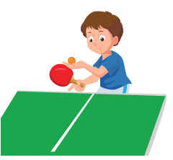
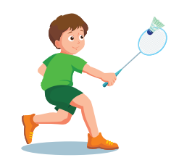
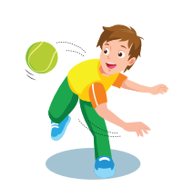
b) Toby can play table tennis.
a) He can play basketball.

d) Can she play chess well ?
c) Peter can throw the ball.




h) They can play chess well.
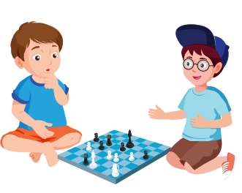
g) I love the sack race because I like jumping.
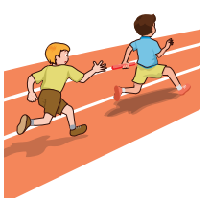
f) He likes skateboarding.
e) Tom likes watching TV.

Exercise 2 : Read and match.
- What can you do ? | - Yes, she can.
- Can you play volleyball ? | - I can play chess.
- Which game is your favorite ? | - Yes, I can.
- Can you play hockey well ? | - I love sack race because I like jumping.
- What can your brother do ? | - No, not very well.
- Can she play table tennis ? | - He can play badminton.
- What do you like doing ? | - Yes, I do.
- Do you like reading comic books ? | - He goes to bed at 10:00 p.m.
- What time does he go to bed ? | - I like playing computer games.
Exercise 3 : Read and complete the sentences.
a) Can you play table tennis ? Yes , ………………….
b) ………………….can he do ? He can play basketball.
c) What can your sister do ? …………………… play the guitar.
d) Can you play chess well ? Yes, ………………well.
e) Can she play the piano well ? ………………, she can’t play the piano.
f) Let’s ………………computer games.
g) ……………game is your favorite ? I love soccer because I like kicking the ball.
h) Toby’s favorite game ……………… the relay race.
i) I love capture the flag because I ………………running.
j) What does she like doing ? She ………………listening to music.
k) Can he play soccer ? Yes, he ………………
l) Let’s watch TV. Yes, I ………………watching TV.
m) What ………………Rosy like doing ? She likes playing volleyball.

Exercise 4: Read and answer these questions.
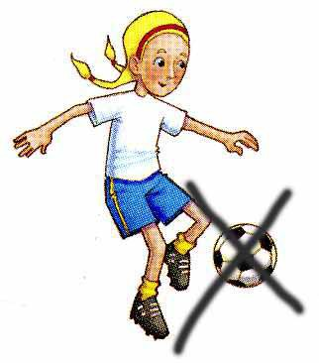

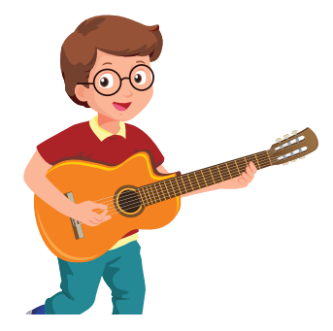

b) What can Toby do ?
……………………………………
a) What can he do ?
……………………………………
c) Can she play soccer ?
……………………………………

g) Which game is Peter’s favorite?
………………………………………..

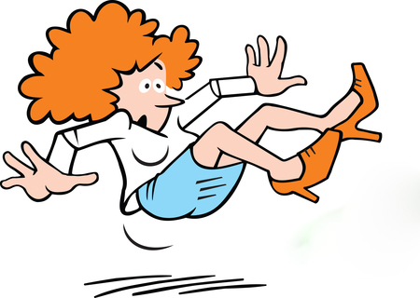
f) What does he like doing ?
………………………………………..
e) What does she like doing ?
………………………………………..
d) Can she dance well ?
……………………………………

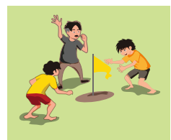
h) Does she like listening to music ?
………………………………………..
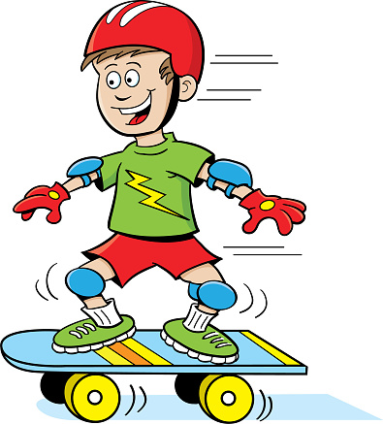

Exercise 5 : Look, read and put a tick () or a cross (X).
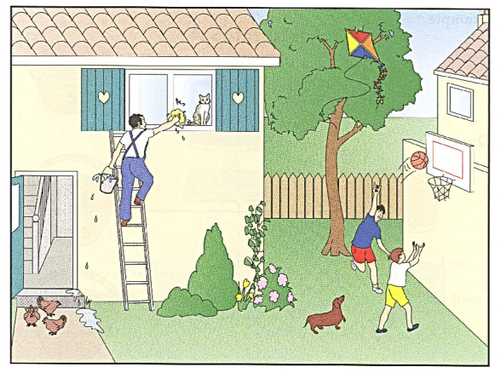
- Two boys are playing basketball.
- There is a cat in the garden.
- One of the children is wearing jeans.
- A man is painting the window.
- There is a kite in the tree.
- Some chickens are drinking the water.
- The dog has short legs.
Exercise 6 : Look, read and answer these questions
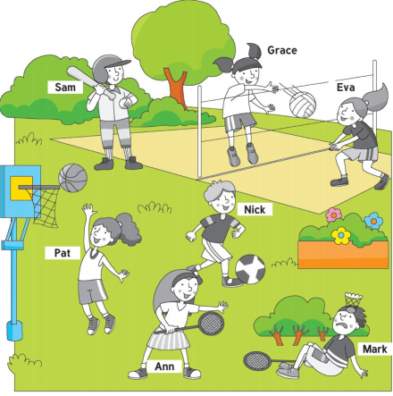 | a) How many people are there ?  ……………………………………………..  b) What can Pat do ?  ……………………………………………..  c) Can Mark play badminton well ?  ……………………………………………..  d) What can Grace and Eva do ?  ……………………………………………..  e) What can Nick do ?  ……………………………………………..  f) What can Anna do ?  ……………………………………………..  g) Can Sam play baseball ?  ……………………………………………..
Exercise 7 : Make questions for these answers.
a) I like reading comic books.
…………………………………………………………………………………
b) My brother can play badminton well.
…………………………………………………………………………………
c) No, I can’t play chess.
…………………………………………………………………………………
d) Peter likes playing computer games.
…………………………………………………………………………………
e) Alex’s favorite game is the sack race.
…………………………………………………………………………………
Exercise 8 : Read , Write the name Mark or Alex below the right pictures.
Mark and Alex are twin brothers.
Mark is very good at sports . He can swim , ride a horse and play badminton . He can’t play football.
Alex does some sports. He can play football and hockey . He can’t play tennis or baseball.

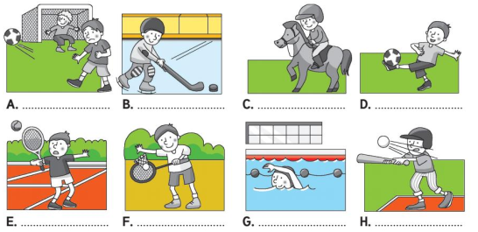
Exercise 9 : Circle the odd one out.
 | - math | - soccer | - badminton | - basketball
 | - morning | - hour | - afternoon | - evening
 | - write | - dance | - song | - swim
 | - April | - Monday | - Sunday | - Friday
 | - shoes | - socks | - sneakers | - gloves
 | - time | - lunch | - breakfast | - dinner
 | - catch | - throw | - kick | - tennis
 | - guitar | - bat | - drum | - violin
 | - March | - summer | - December | - May
Exercise 10 : Read and answer these questions.
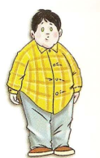
This is Tony. He’s ten years old. He’s short and fat. He has short black hair. He has small black eyes.
He can play badminton and basketball , but he can’t sing
and speak English.
His favourite toy is a kite. It’s purple.
His favorite subject is math. He has math on Monday and Friday.
He usually watches TV in his free time.
- What is his name ?
- How old is he ?
- What does he look like ?
- What can he do ?
- What is his favourite toy?
- What is his favorite subject?
- When does he have math ?
- What does he do in his free time ?
Exercise 11 : Find the mistakes and correct them.
a) My sister can playing badminton.
……………………………………………………………………………..
b) Can you play chess well ? Yes, not very well.
……………………………………………………………………………..
c) Can she play piano ? No, he can’t.
……………………………………………………………………………..
d) Let’s playing computer games. Yes, I like playing computer games.
……………………………………………………………………………..
e) She like playing badminton.
……………………………………………………………………………..
f) I love sack race because I likes jumping.
……………………………………………………………………………..
g) What does she like doing ? She likes watch TV.
……………………………………………………………………………..
h) Tom can plays the guitar pretty well.
……………………………………………………………………………..
i) She don’t like listening music.
……………………………………………………………………………..
j) Do you like skateboarding ? Yes, I don’t.
……………………………………………………………………………..
Exercise 12 : Put the words in the correct order
A) don’t / watching / I / like / TV./
……………………………………………………………………………..
B) My / well./ sister / very /sing /can/
……………………………………………………………………………..
C) My / can / table / tennis. / father /play/
……………………………………………………………………………..
D) Can / well ? / he / play / chess / & /not /No,/ well./ very/
……………………………………………………………………………..
E) Lucy / reading / comic/ books./likes/
……………………………………………………………………………..
F) play / Let’s /games./computer /
……………………………………………………………………………..
G) What /doing ?/does/ she /like /
……………………………………………………………………………..
Exercise 13: Read the text and tick the correct option.
