Exercise 1 : Read and complete the sentences.
 | a) What is his job ?  …………………………………  He helps sick people. |  | b) ………………………………?  She is a cleaner.  She cleans the room.
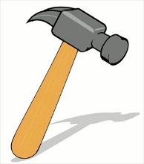 | c) What does a builder use ?  ………………………………… |  | d) ………………………………?  She is using a computer.
 | e) What is she doing ?  ………………………………… |  | f) …………………………………?  An artist uses a paintbrush.
 | g) Is he drawing a bridge?  ………………………………… | 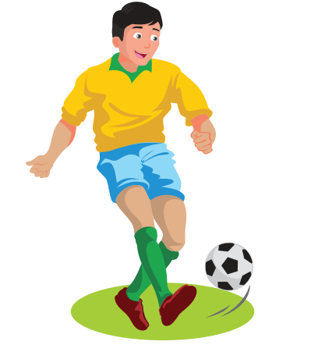 | h) What do you want to be ?  …………………………………
 | i) What does she want to be ?  She wants to be a …………… |   10,000 dong | j) How much is the candy ?  …………………………………
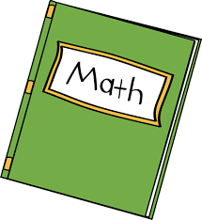  20,000 dong | k)…………………………………?  It’s twenty thousand dong. |  | l) What does he want to be ?  …………………………………..
Exercise 2 : Read and match.
- What is her job ? | - Yes, she is.
- What does a firefighter use ? | - She’s a cleaner .She cleans the hospital.
- Is she a nurse ? | - No, he isn’t.
- What are you doing ? | - A firefighter uses a hose .
- Is he drawing a bridge ? | - I’m building a model.
- What is she doing ? | - Yes, I do.
- What do you want to be ? | - She’s using a computer.
- Do you want to be a pilot ? | - It’s 30.000 dong.
- How much is the postcard ? | - I want to be a police officer.
Exercise 3 : Read and circle the correct words.
a) What is Lucy doing ? She is ( talk /talking ) on the phone.
b) What is his job ? He is a driver. He ( drives /drive ) the ambulance.
c) ( A teacher / A doctor) works in a school.
d) An artist uses a ( hammer / paintbrush )
e) What ( does/ do ) a teacher use ? A teacher usues a board.
f) What are you ( do/doing ) ? I’m listening to music.
g) Is Peter drawing a bridge ? Yes, ( he is / he isn’t)
h) What are they doing ? They are ( play/playing ) table tennis.
i) Bill and Sue ( is / are ) watching TV.
j) What do you want to be ? I ( want / wants ) to be a doctor.
k) Does Peter want to be a pilot ? No, ( he does / he doesn’t)
l) What is Anna doing ? ( He/ She ) is drawing a flower.
m) How ( many /much) is a box of juice ? It’s twenty – two thousand dong.
n) He is a doctor . He works in a ( school / hospital )
Exercise 4 : Exercise 1 Look , read and tick () or cross () in the box.
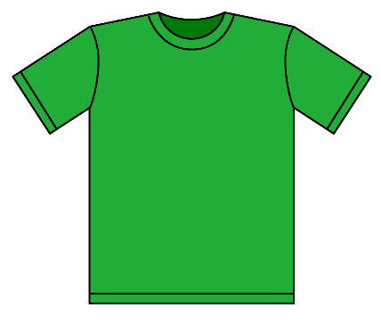  60.000 dong | 
a) How much is the T- shirt ?  It’s seventy thousand dong. | b) What is she doing ?  She is playing badminton. | c) What is your mom doing ?  She is watching TV.
 |  | 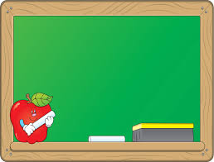
d) What does she want to be ?  She wants to be a singer. | e) He is a doctor.  He helps sick people. | f) What does a teacher use ?  A teacher uses a board.
Exercise 5 : Make questions for these answers.
a) My father is reading a newspaper.
……………………………………………………………
b) A firefighter uses a hose .
……………………………………………………………
c) He’s a driver . He drives the ambulance.
……………………………………………………………
d) My sister wants to be a teacher.
……………………………………………………………
e) The sweater is 120.000 dong.
……………………………………………………………
f) Peter is painting a picture .
……………………………………………………………
Exercise 6 : Find the mistakes and correct them.
a) How much are these shoes ? It’s 120.000 dong. They’re 120.000 dong.
b) What is your sister doing ? She is talk on the phone.
…………………………………………………………………………
c) What is her job ? He is a doctor. He helps sick people.
…………………………………………………………………………
d) What does Rosy want to be ? She wants to be a artist.
…………………………………………………………………………
e) How much is the school bag ? They’re 100.000 dong.
…………………………………………………………………………
f) What does an artist use ? An artist use a paintbrush.
…………………………………………………………………………
g) Is he drawing a bridge ? Yes, he isn’t.
…………………………………………………………………………
Exercise 7 : Put the words in the correct order.
A) What / doing ? / are / you / & / am / I / computer /a/using/
………………………………………………………………………………………………….
B) his / What / is /job ?/ &/He/a/is/doctor./ helps/ He/ people./sick/
………………………………………………………………………………………………….
C) My /wants/ sister/a / nurse./to/be/
………………………………………………………………………………………………….
D) much / How / the/ is /dress ? – 150.000 dong /It/is/
………………………………………………………………………………………………….
E) What/ they /doing ?/are – They / playing / are /basketball./
………………………………………………………………………………………………….
F) What / Lucy / does/ to / be ? /want /& /wants/She/to/a /teacher/be
………………………………………………………………………………………………….
Exercise 8 : Look and read. Write yes or no
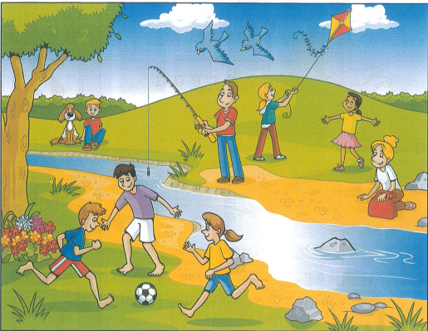
- A man is swimming.
- The woman has a red bag.
- Some of the children are play basketball.
- The dog is sitting next to the boy.
- There are flowers under the tree.
- One girl is flying a kite.
- The birds are standing on the beach.

Exercise 9 : Look at the pictures and read the questions. Write one – word answers.
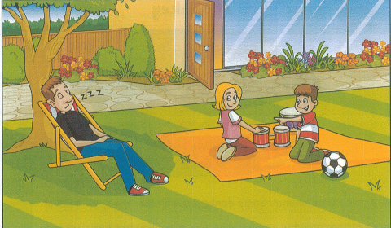 | 1) Where is the family ?  In the ………………..  2) What is Dad doing ?  …………………………………….  3) How many children are there ?  …………………………………….  4) How many balls are there ?  …………………………………….
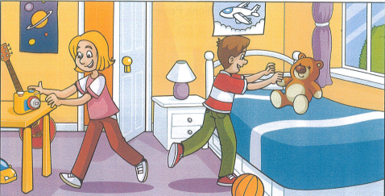 | 5) Where are the children?  …………………………………….  6) Where is the camera ?  ………………………………the table.  7) Where is the teddy bear ?  ………………………………the bed.
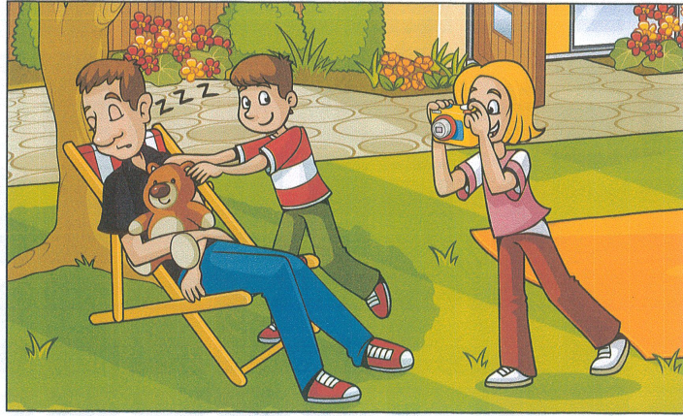 | 8) What is the boy putting on Dad ?  a …………………………………….  9) Who is taking a photo ?  the …………………………………….
Exercise 10 : Read and write
what | who | where | why | what time | how many | how much
a) ………………do you live ? I live in Ho Chi Minh City.
b) ………………does she get up ? She gets up at six o’clock.
c) ……………… does her mother work ? She works in a hospital.
d) ………………is her job ? She is a teacher.
e) ………………are they from ? They’re from the USA.
f) ………………are you doing ? I’m using a computer.
g) ………………do you go to school with ?
h) ………………is the skirt ? It’s 150.000 dong.
i) ………………do they do on Sunday ? They visit their grandparents.
k) ………………does your brother play tennis with ?
l) ………………are you happy ? I’m happy because It’s my birthday.
m) …………… does your father go home ? He goes home at half past five.
n) …………… do you learn English ? Because I want to sing English song.
o) …………… lessons has Nick got on Monday? He has four.
Exercise 11 : Circle the odd one out.
 | - school | - hospital | - post office | - teacher
 | - nurse | - doctor | - cleaner | - teach
 | - singing | - interesting | - playing | - watching
 | - how much | - how old | - hammer | - how many
 | - bridge | - football | - basketball | - volleyball
 | - swim | - climb | - ride | - park
 | - cinema | - playground | - living room | - zoo
 | - sweet | - juice | - delicious | - tasty
 | - their | - its | - our | - she
Exercise 12: Look at the picture and fill the gaps with the words given in the box.
What is eLisa’s Family Doing?
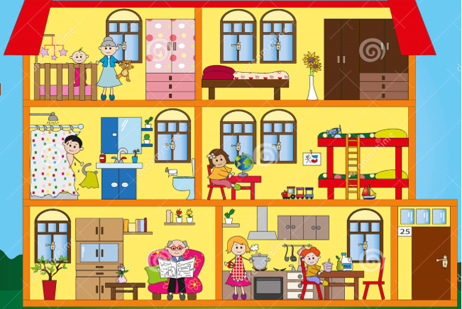

reading – eating – playing – doing homework – taking a shower – newspaper – cooking
kitchen - bedroom – baby’s room – living room – bathroom
- The grandma is ………………….with the baby. They are in the ………………….
- The dad is ………………….in the …………………………..
- Lisa is …………………………...in her …………………...
- The grandpa is ………………….a …………………. in the ………………….
- The mom is ………………….and the brother is ………………….in the …………………..

