Lesson 1
Exercise 1 Look and write
rainy | sunny | cloudy | windy | snowy

 | 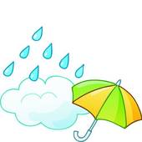 |  | 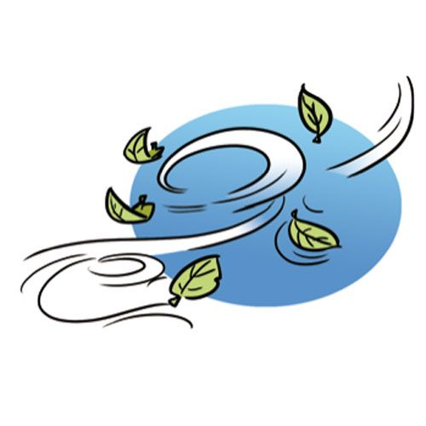 | 
………………… | ………………… | ………………… | ………………… | …………………
Exercise 2 Look and circle the right option
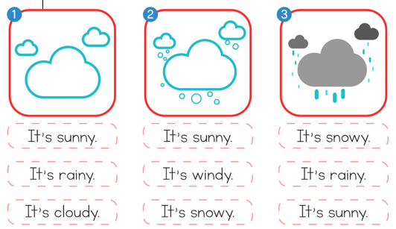
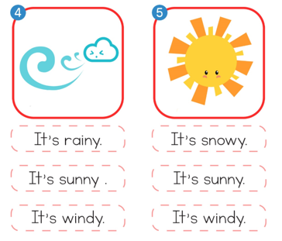
Exercise 3 Look at the table above and write sentences , as in the example :
Monday | Tuesday | Wednesday | Thursday | Friday | Saturday | Sunday
 |  |  | 
a) How’s the weather on Monday ?
It’s Sunny.
b) How’s the weather on Tuesday?
…………………………………………………………….
c) How’s the weather on Friday?
…………………………………………………………….
d) How’s the weather on Sunday ?
…………………………………………………………….
e) How’s the weather on Thursday?
…………………………………………………………….
d) How’s the weather on Wednesday ?
…………………………………………………………….
e) How’s the weather on Thursday?
…………………………………………………………….

Lesson 2
Exercise 1 Look and write the missing letters
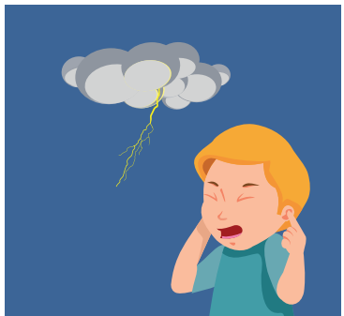 | 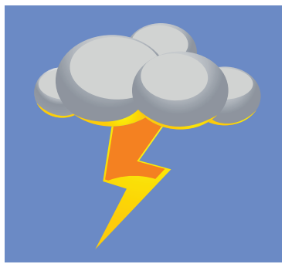 |  |  | 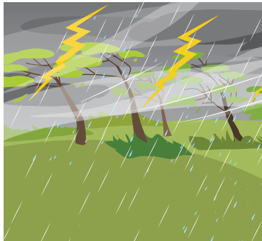
thun _ _ _ | l _ _ _tning | ra _ _ _ | rainb _ _ | _ _ orm
Exercise 2 Look , read and complete the sentences.
a) Can you hear the …………….? b) Can you see the …………….?
Yes, I can. Yes, I can.
c) Can you see the rainbow ? d) Can you see the …………….?
Yes, …………………………… ………………, I can.
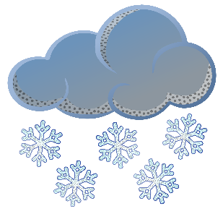
e) Can you see the…………….? f) Can you see the…………….?
Yes, I can. ………………, I can.
Exercise 3 Put the words in the correct order
a) see – Can – you – the - rainbow ? Yes, – can – I
…………………………………………………………………..
b) Can – hear – you – the - thunder ?
…………………………………………………………………..
c) the - rain – Can – you – see ?
…………………………………………………………………..
d) Can – the – you – see – snow ?
…………………………………………………………………..
e) lightning – Can – you – the – see ?
…………………………………………………………………..
Lesson 3
Exercise 1 Look and write
dry | cool | hot | wet | cold | warm

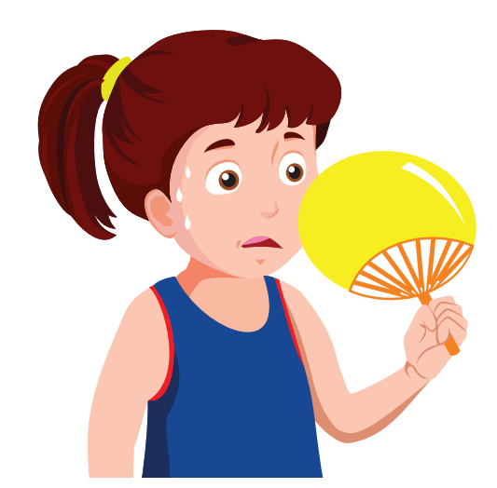 | 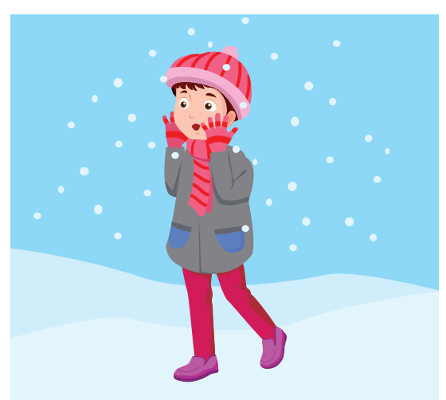 | 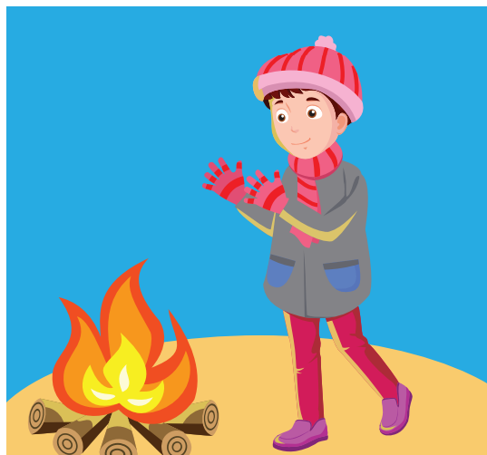
 | 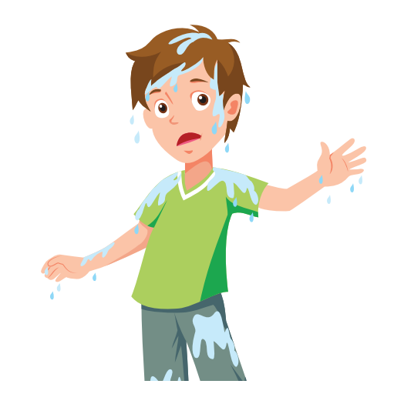 | 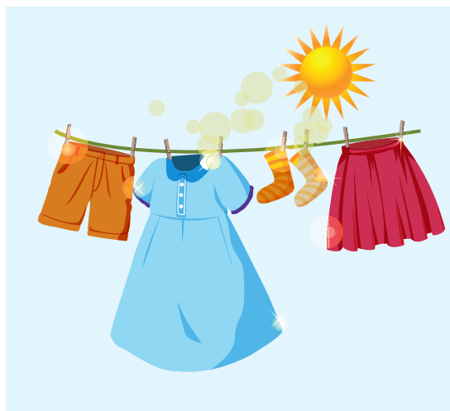

Exercise 2 Look and write
a) I am ………………… b) I am ………………… c) I am ………………
Exercise 3 Look and write :
Yes, I am. | No, I’m not.

a) Are you cold ? | b) Are you cool ? | c) Are you hot ?
…………………………… | …………………………… | ……………………………
d) Are you wet ? | e) Are you cold ? | f) Are you cold ?
…………………………… | …………………………… | ……………………………

Exercise 4 Read and complete
a) …………………………..? b) Are you cold ? c) …………………………..?
Yes, I am. …………………………… Yes, I am.
d) Are you hot ? e) …………………………… ? f) Are you cold ?
…………………………… Yes, I am …………………………..
Exercise 5 Look and match
- What can you see ? | - It’s sunny.
- Can you hear the thunder ? | - I can see the rainbow.
- How’s the weather ? | - Yes, I am.
- Are you cool ? | - I’m hot.
- How are you feeling today ? | - Yes, I can.

Lesson 4
Exercise 1 Look and write the missing letters
 |  | 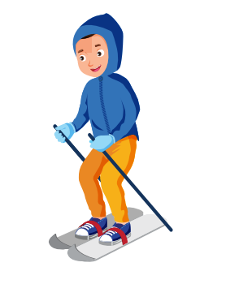 | 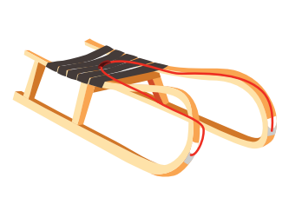 | 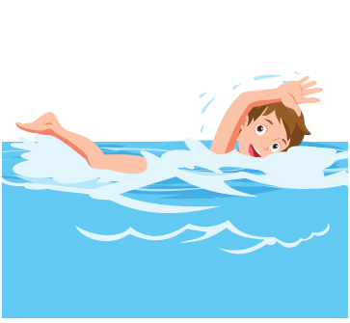
a) snow_ _ _ | b) _ _ owball | c) sk _ _ ng | d) sle_ _ _ ng | d) _ _ imming
Exercise 2 Read and match
a) We can go sledding. |  | 
b) We can go swimming. |  | 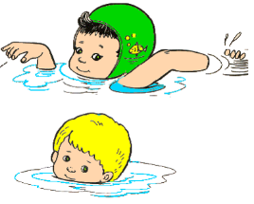
c) We can make a snowman.
d) He can go skiing. |  | 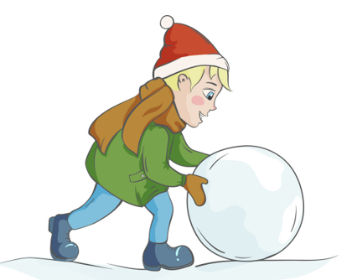
e) We can make a snowball. |  | 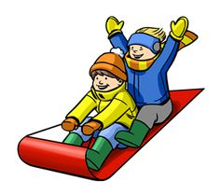

Exercise 3 Look and write
Yes, we can. | No, we can’t

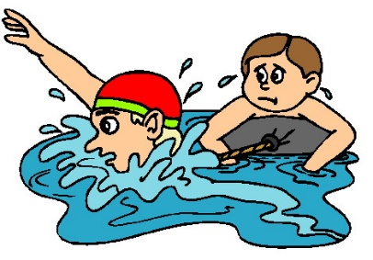 |  | 
a) Can we go swimming ? | b) Can we go sledding ? | c) Can we go skiing ?
……………………………………… | ……………………………………… | ………………………………………
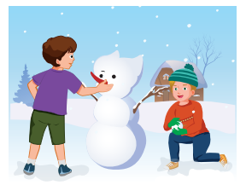 |  | 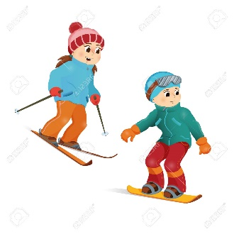
d) Can we make a snowman ? | e) Can we make a snowball ? | f) Can we go skiing ?
……………………………………… | ……………………………………… | ………………………………………
Exercise 4 Put the words in the correct order
A) Can / make / we / a snowman ? Yes, / can / we
………………………………………………………………………….
B) Can / go / we / skiing ? No, / can’t / we
………………………………………………………………………….
C) make / a / snowball / Can / we ? Yes, / can / we
………………………………………………………………………….
D) go / swimming / Can / we ? No, / can’t / we
………………………………………………………………………….
E) sledding / we / Can / go ? Yes, / can / we
………………………………………………………………………….
Lesson 5
Exercise 1 Look and write
seed | plant | grow | soil | sunlight

 |  |  |  | 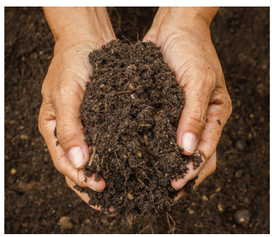
Exercise 2 Read this. Choose a word from the box. Write the correct word next to number (1 – 5) There is one example
soil | seeds | sunlight | plants | green
Growing rice
Rice grows from (1) seeds . Seeds need (2) ___________ and (3) ____________ to grow . Rice plants need water and warm weather . Young rice (4) ________ are very (5) ____________________
Exercise 3 Read and complete
a) What does a _________ need to grow?
A seed needs soil to grow.
b) What does a plant need to grow ?
__________ need sunlight to grow.
c) ____________ a plant need to grow ?
A plant needs water to grow
Lesson 6
Exercise 1 Look, circle the right option.
0. How’s the weather ? 1. Can you see the ………………?
It’s ………………. Yes, I can.
a. sunny b. rainy c. windy a. thunder b. snow c. rainbow
2. Can you hear the thunder ? 3. How’s the weather ?
…………………………… It’s ……………….
a. Yes, I can. b. No, I can’t a. cloudy b. windy c. snowy
4. Are you ………………? 5. Are you cool ?
Yes, I am. ………………………….
a. cool b. cold c. hot a. No, I’m not b. Yes, I am.

6) Can we go swimming ? 7) Can we make a ………….?
………………………………… Yes, we can.
a. Yes, we can b. No, we can’t. a. snowman b. snowball
Exercise 2 Look at the pictures and read the questions . Write one – word answers .
a) How’s the weather ?
It’s ______________.

b) What can Tony and Adam do ?
They can ________ a snowman.

c) Can they make a snowball ?

________________________
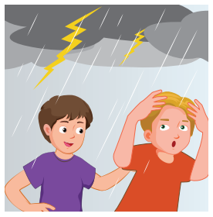 | a) How’s the weather ?  There is a __________.  b) What can Tony and Adam see ?  They can see __________.  c) Can they see the snow ?  _____________________
Exercise 5 Look and match
1) What can you see ? | a) It’s windy. | 1)
2) Can you see the rainbow ? | b) I can see the lightning. | 2)
3) How’s the weather ? | c) Yes, I am. | 3)
4) Are you warm ? | d) I’m cold. | 4)
5) How are you feeling today ? | e) Yes, I can. | 5)
6) Can we make a snowman ? | f) A seed needs soil to grow.
7) What does a seed need to grow? | d) Yes, we can.

