Unit 10

CAN ( Có thể)

GRAMMAR BOARD

NEGATIVE
PHỦ ĐỊNH
POSITIVE
KHẲNG ĐỊNH
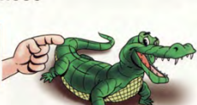
I can
You can
He can
She can
We can
They can
It can

I cannot= I can’t
You cannot= you can’t
He cannot= He can’t
She cannot= she can’t
We cannot= we can’t
They cannot= they can’t
We cannot= we can’t
It cannot= it can’t

QUESTION
CÂU HỎI

Can I ………?
Can you……..?
Can he……..?
Can she……..?
Can we……..?
Can they…….?
Can it………..?

Complete the sentences with possessive adjectives.
- Jame and Alice have a car. _Their___car


78
Look and write.


1


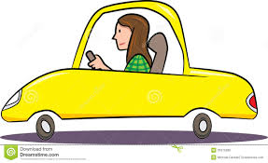




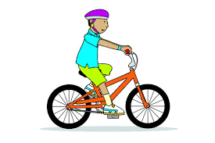
6. cook
5. ride a bike
4. read books
3. play the guitar
2. play football
1. drive a car






9. swim
8. walk
7. run

- She can drive a car.
- He can’t play football.
- _______________________
- _______________________
- _______________________

6._____________________
7._____________________
9. _____________________
8. ___________________

79
Write “can” or “can’t”.

2

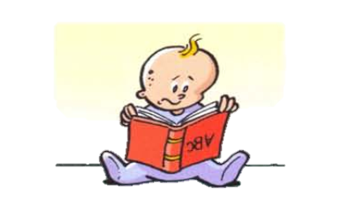


can
- He _____ play basketball.
- It………………walk
- He……………………..read




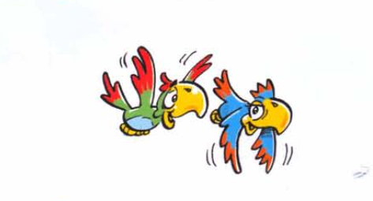

6. She………………count.
- He……………………swim
- They……………………fly




- She………………ride a bike
- It…………………jump.
- They…………………sing

Put the questions to the correct order.

3

- you/can/a/car/drive/?
- play/can/basketball/you/?
- you/can/cook?
___________________________
80
- you/can/swim?

_______________________________

______________________________

____________________________

Kangaroo can jump.
Read and circle “ True” or “ False

4
False
True
- Tiger can’t swim.
False
True
False
True
- Turtles can’t run fast.
False
True
- Elephants can jump high.
False
True
- Birds can fly.
False
True
- Cats can’t climb trees.
Look at the pictures, and give the short answers.

5



- Can he drive?
………………………………….
- Can he ride a horse?
………………………………….
- Can they walk?
…………………………..
- Can she sing?
………………………
6. Can he swim?
………………………
5. Can they swim?
………………………
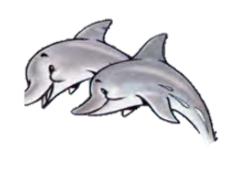
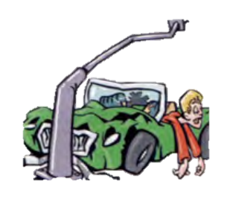
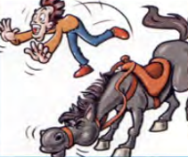
- Can he climb?
………………………

- Can it read?
………………………
- Can he run?
Yes, he can

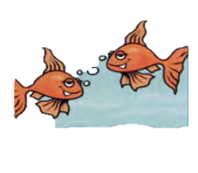

81
Ask your friends “Can you……” and circle the answers.

6

- Can you ……swim…………………………? Yes, I can/ No, I can’t.



- Can you ………………………………………? Yes, I can/ No, I can’t.


- Can you ………………………………………? Yes, I can/No, I can’t.



- Can you ………………………………………? Yes, I can/ No, I can’t.


Hi.
- Can you ………………………………………? Yes, I can/No, I can’t.



- Can you ………………………………………? Yes, I can/No, I can’t.



- Can you ………………………………………? Yes, I can/No, I can’t.



- Can you ………………………………………? Yes, I can/ No, I can’t.



- Can you ………………………………………? Yes, I can/No, I can’t.


10. Can you ………………………………………? Yes, I can/No, I can’t.


11. Can you ………………………………………? Yes, I can. No, I can’t.



12. Can you ………………………………………? Yes, I can/No, I can’t.

cook – dance - play the guitar - play the piano - play tennis -
ride a bicycle - ride a horse – sing – skate - skip - speak English – swim



82
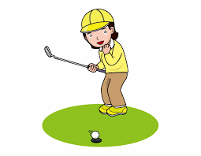
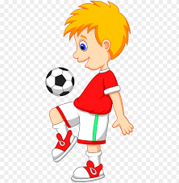
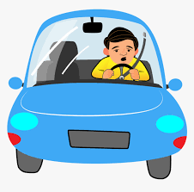


Match the sentences to the pictures.

7

1







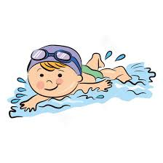
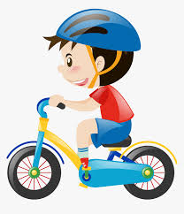

- He can play the guitar.
- He can ski.
- He can ride a bike.
- He can sing.
- She can play tennis.
10. He can play football.
11. He can drive a car.
- He can play the piano.

- He can swim.
- He can run.
- She can dance.
- She can play golf.

8
Write three things you can do and three things you can’t do.


1…………………………………
2…………………………………
3…………………………………
1…………………………………
2…………………………………
3…………………………………

83
MY VOCABULARY

No | Words | Vietnamese meanings.
1
2
3
4
5
6
7
8
9
10
11
12
13
14
15
16
17
18
19
20
22
23
24
25
84
V-E TRASLATION-DỊCH VIỆT ANH
No | Vietnamese | English
1 | Tôi có thể bơi. | I can swim.
2 | Anh ấy không thể đi xe đạp.
3 | Cô ấy không thể nhìn.
4 | Tôi có thể đọc nhưng tôi không thể viết. ( but: nhưng) | I can read but I can’t write.
5 | Chúng không thể chạy.
6 | Chim cánh cụt không thể bơi.
7 | Những con gà không thể bay.
8 | Anh ấy có thể đi xe đạp nhưng anh ấy không thể nấu ăn.
9 | Bà ấy có thể nấu ăn nhưng bà ấy không thể vẽ.
10 | Những con chim có thể bay.
11 | Chúng tôi có thể nhảy nhưng chúng tôi không thể hát.
12 | Ông ấy có thể chơi đàn piano nhưng ông ấy không thể chơi bóng đá.
13 | Chó không thể bơi.
14 | Thỏ có thể bật nhảy.
15 | Tôi không thể trèo cây.
16 | Mèo có thể trèo cây nhưng mèo không thể bay.
85

