PRESENT SIMPLE VS PRESENT CONTINOUS.

Unit 13

PRESENT SIMPLE & PRESENT CONTINUOUS

Sự thật hiển nhiên

S+ V ( s,es)

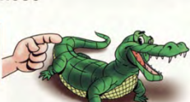
I often get up at 6:30 in the morning.
Thói quen , sở thích ở hiện tại

The earth goes around the sun.

Diễn tả sự việc xảy ra có thời gian biểu rõ rang như lịch tàu chạy, lịch chiếu phim, chiếu bóng.


Dấu hiệu: always, usually, often, sometimes, never, every day, once a week, twice a week…..
The film starts at 8 p.m

S+ am/is/are + V-ing

Diễn tả hành động đang xảy ra.

She is reading newspaper now.
.Hành động trái với thói quen ở hiện tạị.

I often get up at 6:30 in the morning. Today I am getting up at 7:30.

Diễn tả hành động chắc chắn xảy ra trong tương lai có sắp xếp trước.

He is visiting his grandmother
next week.
Dấu hiệu: Now, at the moment, at present, today, these days, this week, this month, look!, listen!

Complete the sentences with possessive adjectives.
- Jame and Alice have a car. _Their___car

Một số động từ sau thường không dùng ở hiện tại tiếp diễn
Tobe ( thì, là , ở) like ( thích) , love ( yêu), hate ( ghét), want( muốn), need ( cần), understand ( hiểu), know ( biết),have ( có)

117
Circle the correct options.



1

- They live/ are living in London now.
- He wash/washes his car every Sunday.
- I start/ am starting school at 9 a.m.
- We do/are doing homework at the moment.
- My mum walks/ is walking to work every day.
- Rob likes/ is liking eating pizza.
- You read/ are reading comics right now.
- The children always watch/are watching TV at the weekend.
- My cat is playing/ play in the garden.
10.She sleeps/ is sleeping now.
- I do/ am doing homework every day.
- We play/ are playing football on Tuesdays.
- My friends don’t go/ aren’t going to London today.
- Carrie usually has/ is having eggs for breakfast.
- Does she relax/ is she relaxing at the moment?
- They clean/are cleaning the house at the moment.
- Are they watching/ do they watch that film now?

2
Write the sentences using the words
He usually eats eggs for breakfast.
- He/usually/eat/ eggs/ for breakfast/. ………………………………………….
- you/do/homework/now/? …………………………………………
- They/not/ go/ to school/ on Sundays. ………………………………………….
- I/wear/ a red dress/ today/. …………………………………………
- She/ not/ read/ a book/now/. ……………………………………….
- You/like/chocolate/? ……………………………………….
- We/ not/play/tennis/every day/. ………………………………………
- Steve/sleep/at the moment/? ………………………………………..
118
Look at the pictures and write.

3
TODAY
EVERY DAY
Bob
Bob feeds the cat every day, but he is watering the flowers today
______________________________________________________________________________________________________
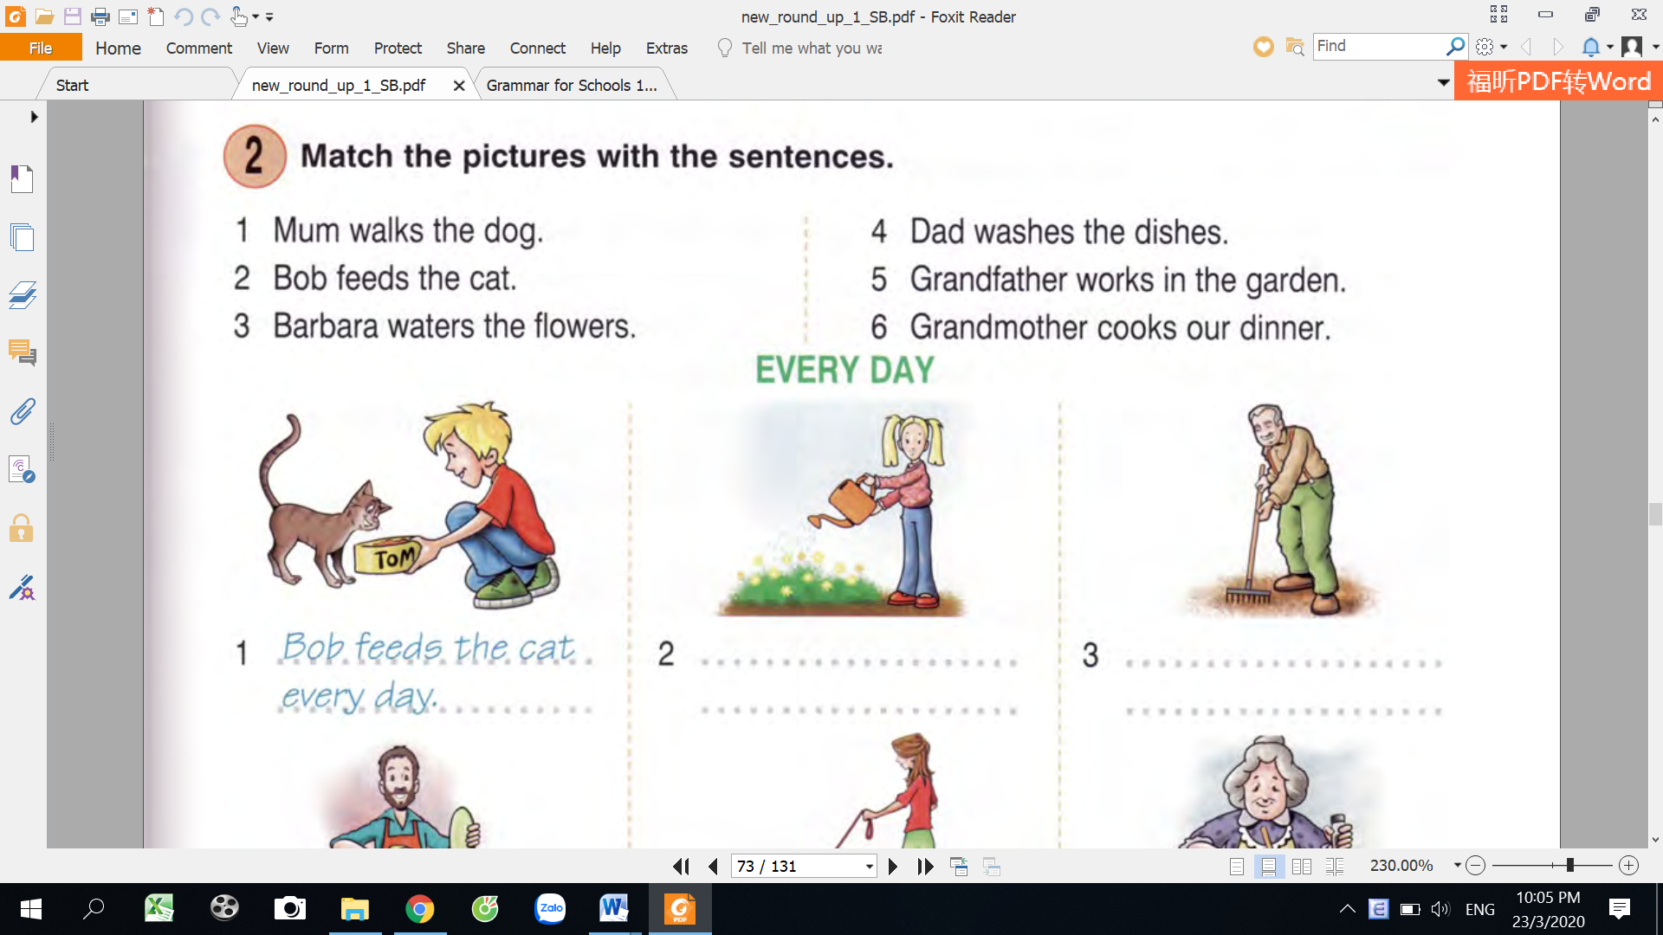
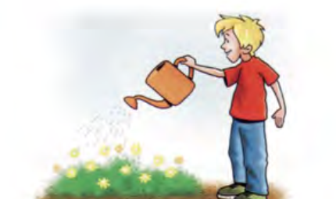

water the flowers
feed the cat
Barbara
__________________________________________________________________________________________________
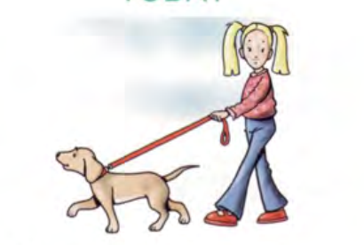
grandma
______________________________________________________________________________________________________
walk the dog
mum
dad
grandpa
______________________________________________________________________________________________________
______________________________________________________________________________________________________
______________________________________________________________________________________________________
wash the dishes
walk the dog
cook
cook
work in the garden
wash the dishes
feed the cat
work in the garden
water flowers
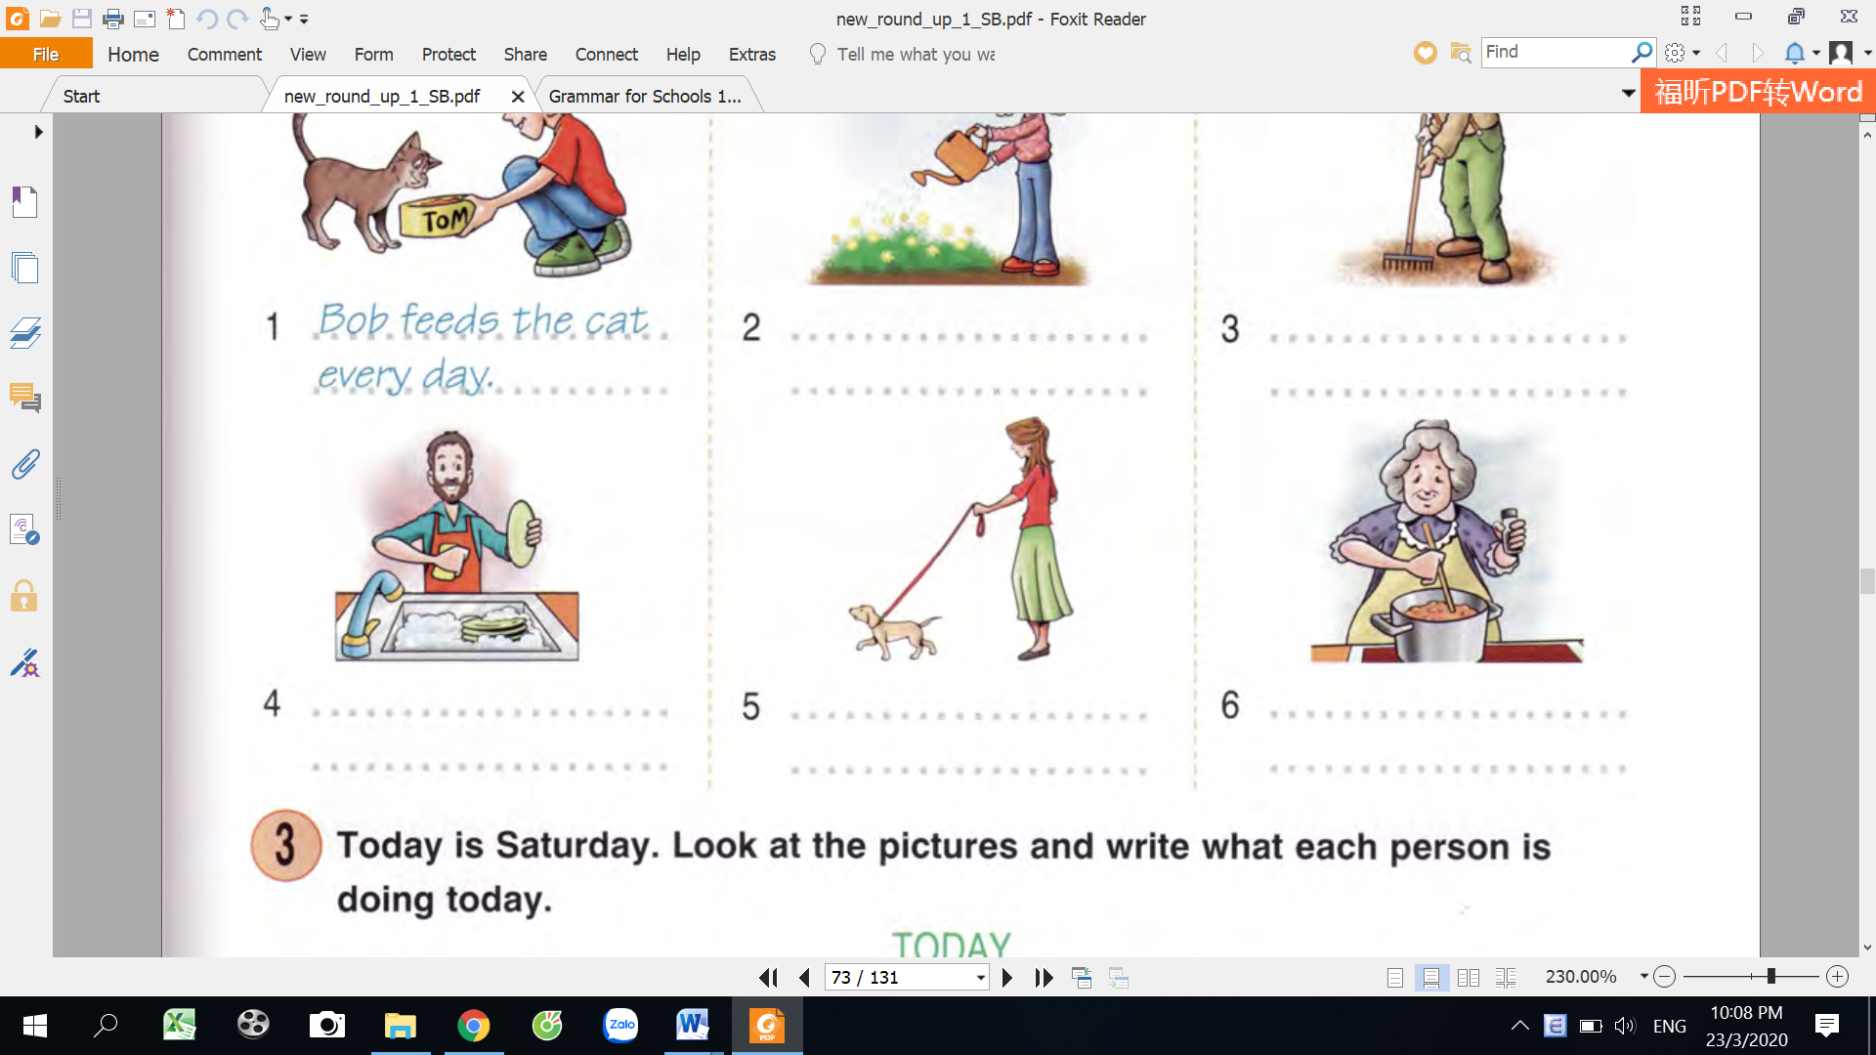
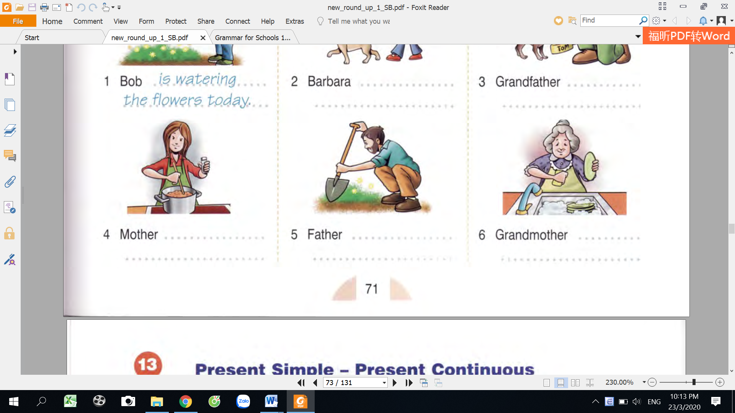

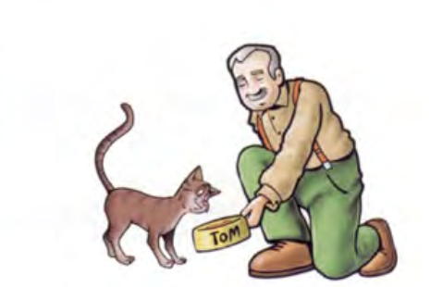

119
Write the correct forms of the verbs, circle the time expressions

4
take
take
- I always __________________a shower in the morning.
play
- Ken ___________________with his dog in the back yard right now.
finish
- My dad _________________work at 6 p.m every day.
brush
- I ________________my teeth three times a day.
have
- The girls _____________________lunch at the moment.
study
- Kathy _____________________for her English test now.
play
- They always _________________tennis on Fridays.
snow
- Look! It____________ outside. Let’s go out and make a snowman.
have
- I _______________piano lesson every Tuesdays.
live
- My grandparents _________________in HONG KONG.
walk
- Kate _________________her dog every afternoon.
go
- I _______________to the library now. Do you want to come?
drive
- Who ___________________that car? I can’t see the drivers.
eat out
- We usually _____________________once a week.
ride
- My sister is in the backyard. She ________________her bike.
wash
- Jack _______________his hands now.
learn
- Tom and Mike _______________________at the moment.
write
- I _________________an email right now.
take
- Ted _________________violin lessons twice a week.
wash
- Her mother __________________the dishes at the moment.
120
Order the words to make sentences.

5

drinking / I / now / juice / . / am / orange.
I am drinking orange juice now.
- golf / . / a week / Jim / once / plays

________________________________________________________
- play / are / . / today / rehearsing / a/at school / we
________________________________________________________
- you / for / are / ? / who / waiting
________________________________________________________
- every / visit / your cousins / week / do / ? / you
________________________________________________________
- always / a nap / they / the afternoon / have / in /.
________________________________________________________
- now / aren’t / the birds / watching/ . / we
________________________________________________________
- goes /. / bus / to / Alice / school / usually / by
________________________________________________________
- TV / the moment / is / at / who / ? / watching
________________________________________________________
- uniform / they / wear /at school /. / don’t
________________________________________________________
- my brother/ London/in/works/ every day/.
- doesn’t/coffee/drink/he/in the morning/.
________________________________________________________
121
Complete the questions.

6

1. How often does Peter go swimming_?
Peter goes swimming three times a week.
2. How many languages __________________________?
He speaks German, Spanish and Russian.
3. Why ________________________________________?
I’m crying because I’m so upset today.
4. Where ______________________________________?
They usually spend their weekends in the country.
5. When ______________________________on holiday?
Kate is going on holiday at the end of the month.
6. What time ___________________________________?
Paul finishes his work at 6.30.
7. What ________________________________this term?
He is studying English and Literature this term.
Give the correct forms of the verbs.

7

isn’t going
1. Robert _________________ (not /go) to Jane’s party next Saturday. He___________(not have) time.
2. There’s something wrong with Ted’s car at the moment, so he ____________ (go) to work by bus today.
3. The River Thames _________________ (flow) through London.
4. Mary has got an exam soon, so she ________________________ (work) at the moment.
5. Why ______________________________ (you/wear) a T-shirt? It’s so cold outside!
122
6. Please, switch the TV off! I __________________________(hate) this boring film.
7. Mr. Brown _________________(meet) his dentist this afternoon.
8. Turn the volume down! I ______________________(not/like) this music.
9. You ____________ (not/write) to your pen friend very often, but he ________ (write) to you every week.
10. Which __________________(your Dad/prefer): tea or coffee?
11. Ann _________________ (want) to be a teacher when she grows up.
12. ‘I __________ (meet) my friends at the cinema. ___________ (you/want) to come with me?’

8
Give the correct form of the verbs using present simple or present continuous tense.
doing
is
1. What _______________he (do) ______________now?
He (water)_________________flowers in the garden.
2. At the moment, my sisters (play)____________volleyball and my brother (play)________________soccer.
3. it is 9.00; my family (watch)___________________TV.
4. I always (visit) ______________my grandparents.
5. ____________your father (go)_____________to work by bus?
6. Today, we (have)______________English class.
7. Her favorite subject (be)__________________English.
8. Now, my brother (like)_________________eating bananas.
9. Look! Aman (call)_________________you.
10. Keep silent ! I (listen )____________________to the radio.
11. ______________ you (play)_________________badminton now?
12. Everyday, my father (get up)_________________at 5.00 a.m, but today, he (get up) __________________ at 6.00 am.
13. Every morning , I (watch)_________________tv at 10.00, but today I (listen ) ________________ to music at 10.00.
14. Every day , I (go) __________to school by bike but today I ________________(go) to school by motorbike.
15. Every morning, my father (have) ______________a cup of coffe but today he (drink)______________ milk.
16. At the moment, I(read)_______________a book and my brother (watch)_______ TV.
17. They usually (get up)___________________at 6.00 in the morning.
18. My father never (go)_________________fishing in the winter but he always (do)_____________ it in the summer.
19. _______________he (watch)______________TV at 7.00 every morning?
20. My children (go)________________to school by bike.
22. We (go)_______________to supermarket to buy some food.
23. Mr. Brown (go)________________on business to London every month.
24. My mother (like)______________coffee very much, but I (not like)______________it.
25. She (like )________________tea, but she (not like)____________________coffee.
26. I (love)_______________ cats, but I (not love)__________________dogs.
27. Every day ,I (go)______________to school on foot, but today I (go)____________________to school by bike.
28. My sister (get)______________ dressed and (brush)_______________her teeth herself at 6.30 every day.
29. It’s 9 o’clock in the morning. Lien (be)________in her room. She (listen) _______________to music.
30. We_______________________(play) soccer in the yard now.
is watering
123
124
MY VOCABULARY

No | Words | Vietnamese meanings.
1
2
3
4
5
6
7
8
9
10
11
12
13
14
15
16
17
18
19
20
22
23
24
25
125
V-E TRASLATION-DỊCH VIỆT ANH

No | Vietnamese | English
1 | Tôi thức dậy lúc 6 giờ hằng ngày. | I get up at 6 o’clock every day.
2 | Bố tôi thường đi làm bằng xe máy mỗi ngày nhưng hôm nay bố đi ô tô.
3 | Trong lúc này, chị gái tôi đang đọc truyện tranh (comics book), mẹ tôi đang nấu ăn, bố tôi đang uống cà phê.
4 | Tôi sẽ đi thăm ông bà vào tuần tới. ( hiện tại tiếp diễn nói về dự định trong tương lai) | I am visiting my grandparents next week.
5 | Peter thường ăn tối lúc 7 giờ nhưng hôm nay tối nay anh ấy ăn tối lúc 8 giờ.
6 | Nhìn này! em bé khóc.
7 | Tôi tới thăm ông bà tôi 2 lần 1 tuần.
8 | Bây giờ cô ấy đang đi mua sắm ở siêu thị.
9 | Trời thường nắng vào mùa hè nhưng bây giờ trời đang mưa.
10 | Tôi mua sách hàng tháng.
126
115

