COUNTABLE AND UNCOUTABLE NOUNS
Danh

Unit 14

COUNTABLE NOUNS
DANH TỪ ĐẾM ĐƯỢC

Có thể đếm được số lượng
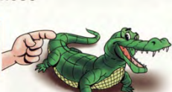
Two apples, one desk…..
Số ít đi với “ a, an”
Số nhiều thêm “ s”, “ es”

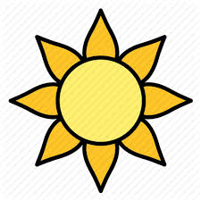
an elephant, two boys, three dresses.

UNCOUNTABLE NOUNS
DANH TỪ KHÔNG ĐẾM ĐƯỢC

không thể đếm được số lượng.

Sugar, rice, water, information.
Không đi với “ a” “ an”
Hoặc từ chỉ số lượng “ one, two….”

one water, two sugar.

Thường đi kèm với các từ ( some, any, little, much…..

There is some milk in the fridge.

Complete the sentences with possessive adjectives.
Luôn đi cùng động từ số ít.
- Jame and Alice have a car. _Their___car
My homework is very difficult.
127
COMMON UNCOUNTABLE NOUNS LIST.
Liquid
( chất lỏng)
juice water coffee tea lemonade wine
alcohol yogurt honey jam milk rain snow oil
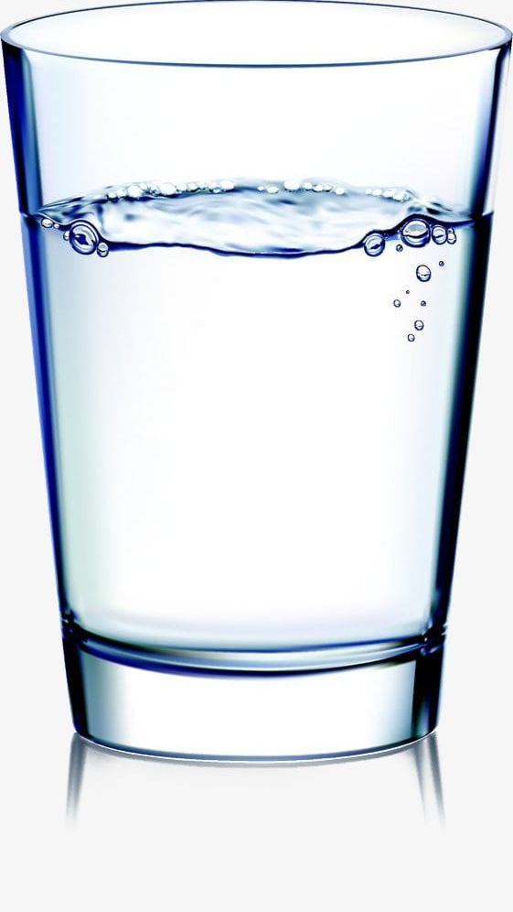

wood plastic stone glass silver metal wool paper
gold ice cotton….
Materials
Nguyên liệu
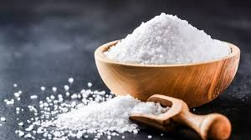
rice flour sugar soil salt pepper sand chalk wheat
Substances
Phụ liệu, gia vị,
love music art noise work homework housework
weather knowledge power
Others
( khác)
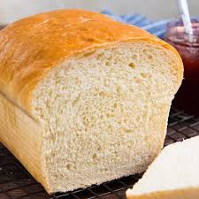 Some food
Một số đồ ăn
bread chocolate cheese pizza meat salad butter
information money advice news luggage traffic furniture time homework distance


Abstract nouns
Danh từ trừu tượng

128

GHI CHÚ
Một số danh từ không đếm được ta có thể trở thành danh từ đếm được nếu trước nó là các từ bên dưới như sau: a glass of water- two glasses of water
Ex:.



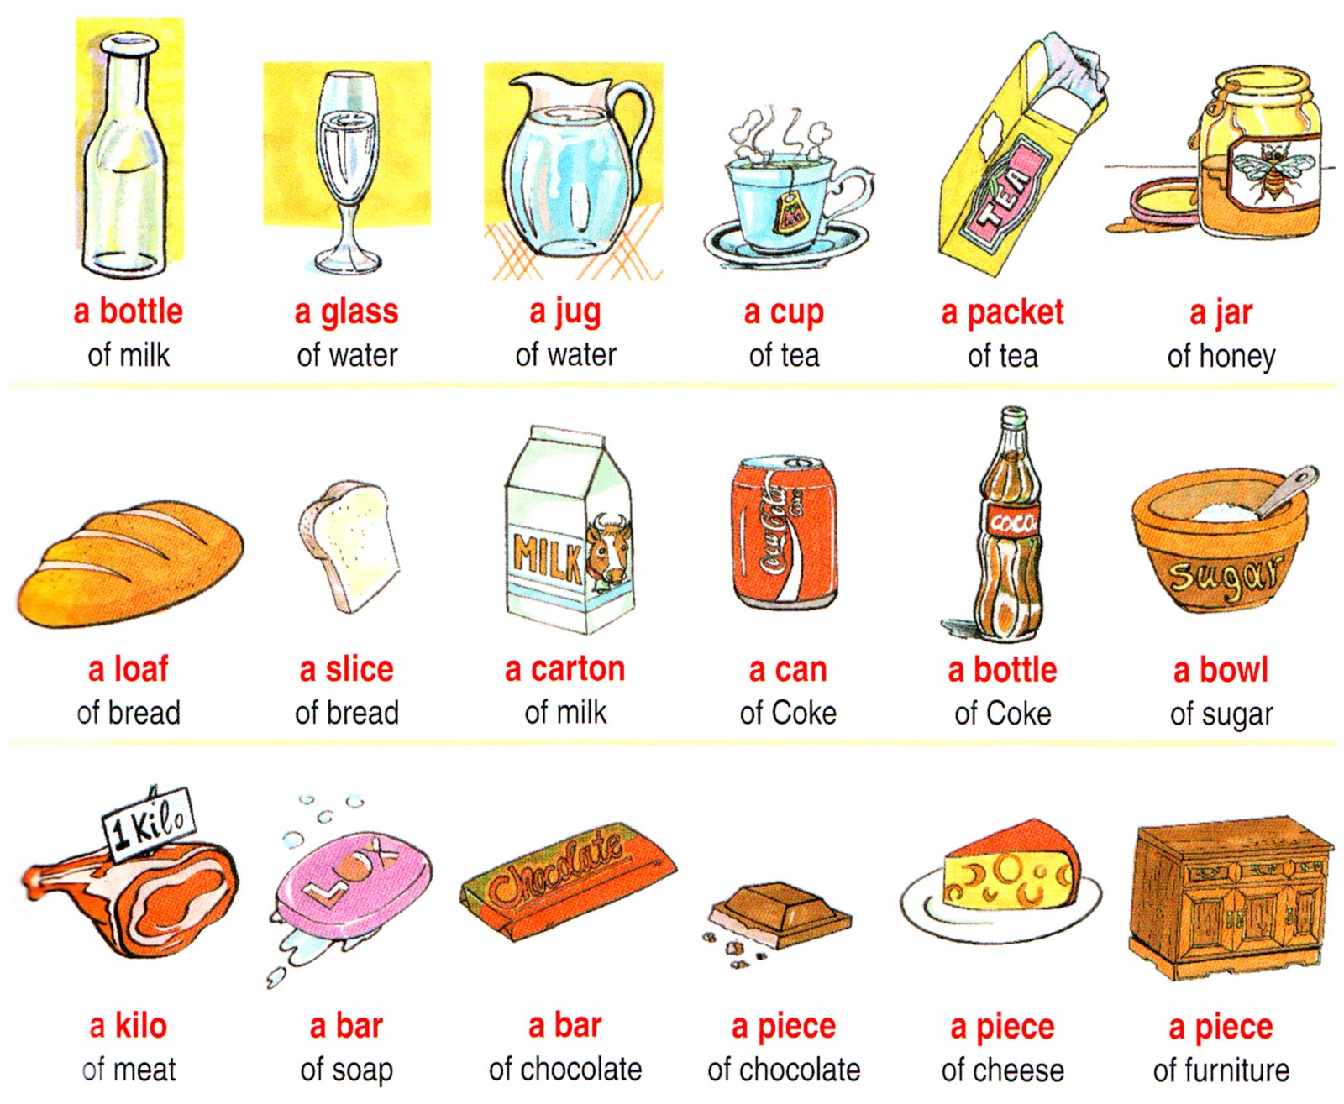

129

1
Write the following words in the correct box.

milk – onions – water – banana – cheese – biscuits- carrots – cereal – cherries-chicken- tomato – eggs – fish juice – rice - apple – lemons – salad – chips – strawberries - soup – potato – meat – toast– crisps – peaches – sandwich - apples – money – people – butter – chocolate– chip – cake vegetable – mice – ice-cream – music – children – flower- information – food – cup – shirt – bus- snow –child- pear - bread – vegetables – fruit – homework.

Countable plural
uncountable
Countable singular

_________________________________________________________________________________________________________________________________________________________________________________________________________________________________________________________________________________________________
milk
_________________________________________________________________________________________________________________________________________________________________________________________________________________________________________________________________________________________________
onions
_________________________________________________________________________________________________________________________________________________________________________________________________________________________________________________________________________________________________
banana,

Circle the correct words and write “ U” for uncountable nouns and “ C” for countable nouns.

2

- My teacher often gives us a lot of homework/homeworks.
U
- There are ten stories/story in the book.

- I need more information/ informations about English project.

- Is there any mail/mails in the mailbox?

- I’m hungry. I want some cheese/cheeses.

130

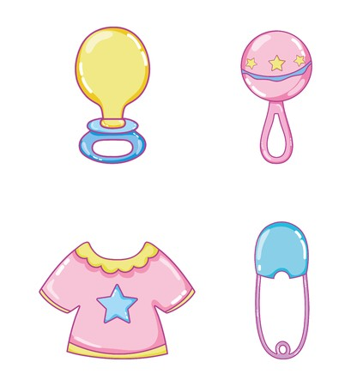
Danh từ không đếm được không dùng “ a, an” ta dùng “ some”
Lưu ý: “some” : một vài, một ít- dùng được cả với danh từ đếm được và không đếm được.
Circle the correct words.

3

- a/an apple | 5.a/some coffee | 9. a/some lemon
- a/some chocolate | - a/some potato | 10. an/some onion
- a/some sandwich | - an/some sugar | 11.a/an strawberry
- a/an banana | - a/an olive | 12.a/some jam
Look at the picture and write a/an/some.

4

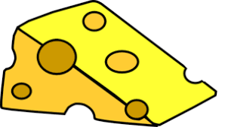
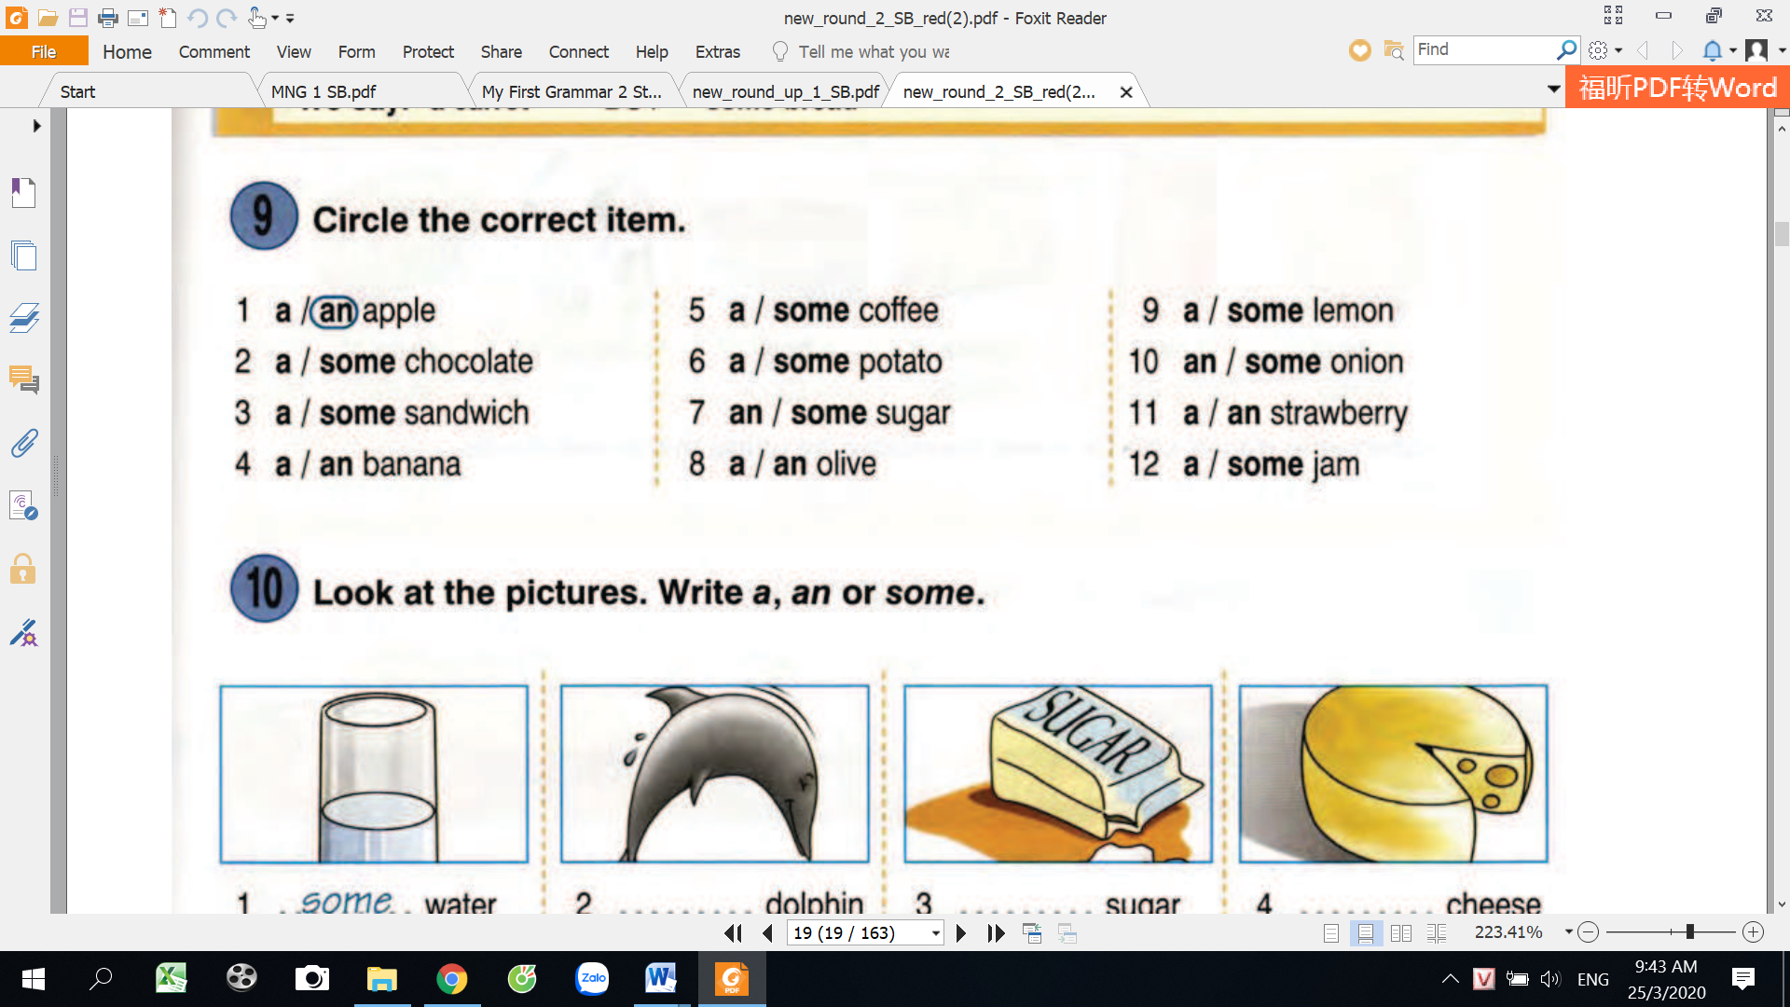
12……………orange
11……………milk
10……………..jam
9……………..bread
8……………doll
7……………..coffee
6……………..butter
5……………..meat
4……………..sugar
3……………..cheese
2…some water
1……a….dolphin
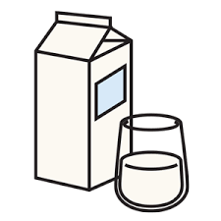
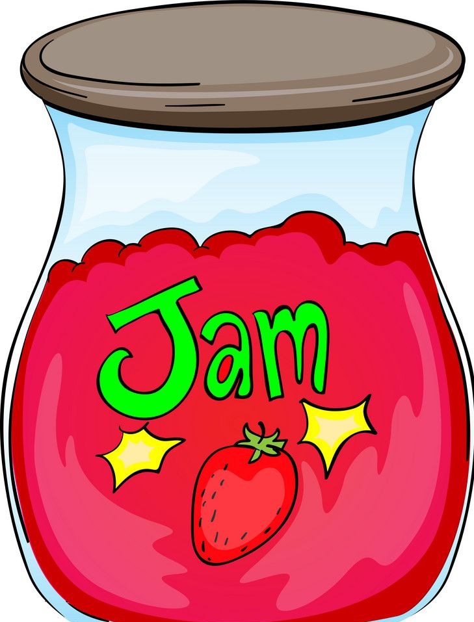
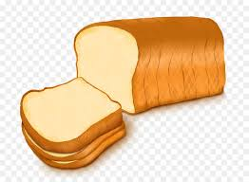
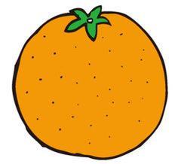
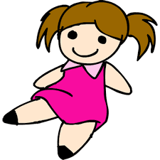
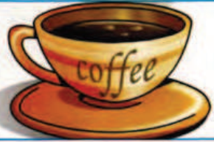
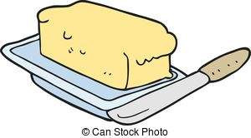
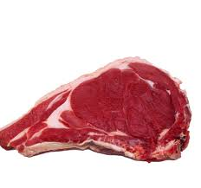

131
many/much/ A LOT OF: nhiều
many + danh từ đếm dược
much: danh từ không đếm được
A LOT OF+ cả danh từ đếm được và không đếm được.
<
HOW MANY/ HOW MUCH
Khi muốn hỏi về số lượng bao nhiêu ta dùng “ how many” và “ how much”
How many + danh từ đếm được
How much+ danh từ không đếm được
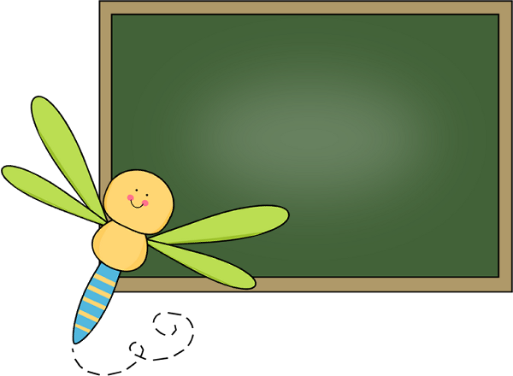

Choose the uncountable nouns in each group and write.

5

sugar
………………
1
cherry
sugar
biscuit
potato

2
apple
banana
………………
egg
coffee
3
pineapple
watermelon
meat
lemon
strawberry
……………….
……………….
……………….
……………….
burger
tomato
onion
cheese
milk
olive
orange
sandwich
bread
cake
carrot
4
5
6

6
Read and circle “ much/many”
and write.

- How much/many eggs are there in the fridge?
4. .How much/many sugar is there in the bowl?
3. How much/many books are there on the table?
2. How much/many money have you got?

5. .How much/many oranges are there on the table?
132
6. I’ve got many-much books.
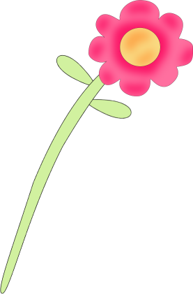
7. He slept many-much yesterday.
8. There are many - much sweets there.
9.Sam has many-much free time.
10. Tom has many-much friends.
11. We have many-much lessons today.
12. There are many-much tables there.
13. Sam ran many-much kilometers.
14. There isn’t many-much milk at home.
15. We haven’t got many-much computers.
16. Liz hasn’t got many-much sisters.
17. Bill hasn’t got many-much cars.
18. There is many-much information here.
19. I haven’t got many-much flowers.
20. Ben hasn’t got many-much money.
21. Mona has many-much guests.
22. Paul has many-much toys at home.
Write the questions using “ How many/ How much”
and write.

7
How many bottles of milk are there
1. ___________________________________________?

4. ________________________________?

There are five chairs in the room.

There are four bottles of milk there.

5. ________________________________?

2. ________________________________?

There isn’t much water in the jar
There are three kilos of apples in the basket.

6. ________________________________?

6. ________________________________?

6. ________________________________?

3. ________________________________?

133
There are ten toys on the floor.

There isn’t much butter in the fridge.
Look at the pictures and write the correct words.
and write.

8

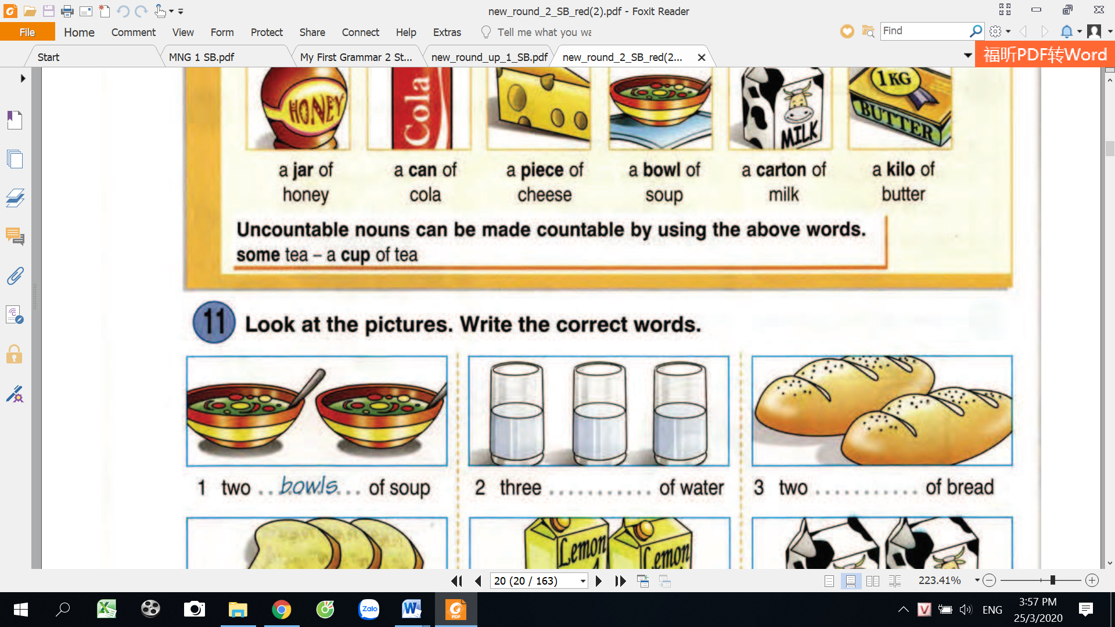

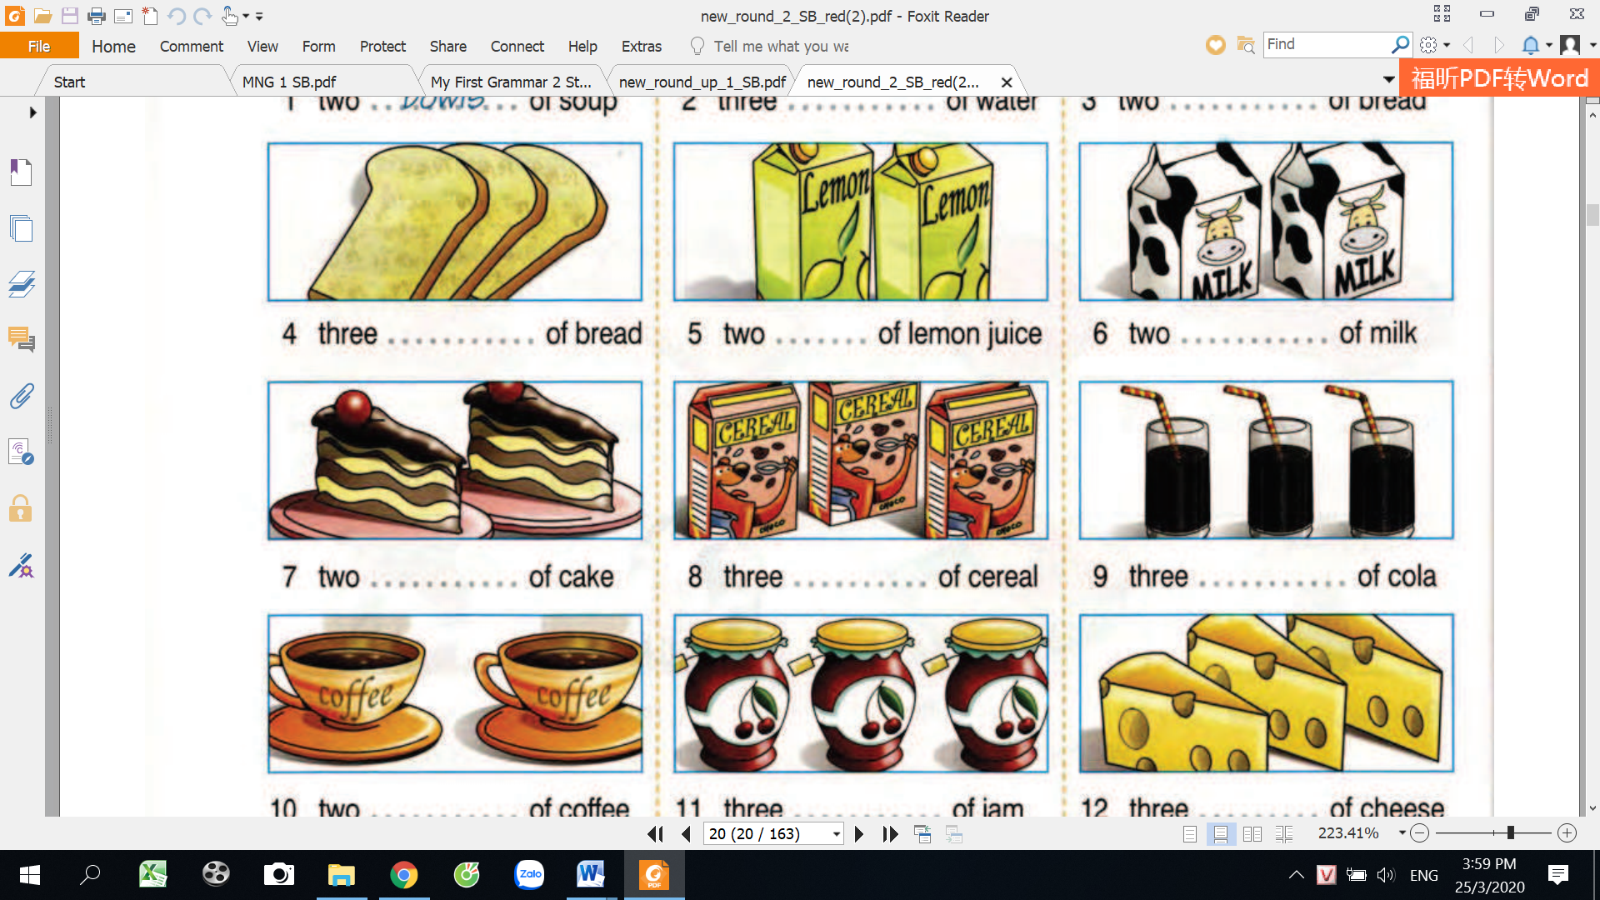
three_________of cake.
two _________of milk
three _________of cereal.
three_________of cheese.
three_________of coca.
two _________of lemon juice.
three _________of jam
two _________of coffee
three _________of bread
two ____________of soup.
three___________of_water
two __loaves___of bread
bowl, loaf carton x2 piece x2
glass x2 slice box cup jar

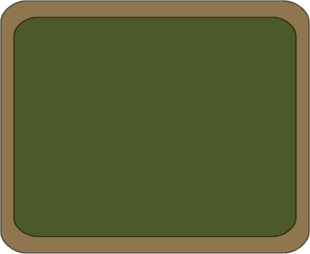
2
3
1

4
6
5

9
7
8

12
11
10

134
Một vài, một ít, một chút
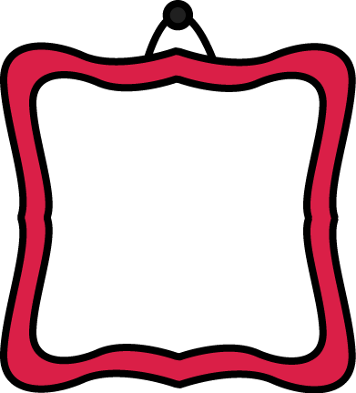
SOME
ANY

1.Dùng trong câu phủ định và câu hỏi.
- Dùng trong câu khẳng định

2. Đứng trước danh từ số nhiều đếm được và không đếm được
- Đứng trước danh từ số nhiều đếm được và
không đếm được

3.Có thể dùng trong câu hỏi với cấu trúc “ would you like…..?

-There isn’t any milk in the fridge.
- Is there any water in the bowl?
-I have some friends
-Would you like some milk?

Read and circle.
and write.

9

- There are some/any strawberries in the fridge.
- Are there some/any pens on the desk?
- There aren’t some/any cats in the house.
- I’ve got some/any sandwiches in my bag.
- Would you like some/any coffee?
- We haven’t got some/any biscuits.
135
- There aren’t some/any pineapples.
- Are there some/any eggs in the fridge.
- There isn’t some/any lemonade in the bottle.
- We’ve got some/any money in our bags.
- There isn’t some/any ice-cream.
- There is some/any milk in the carton.
Read and fill “ some “ or “ any”
and write.

10

- There is ___some_____milk in the fridge.
- We don’t need __________ flour.
- Can I have ________water, please?
- Are there _________eggs in the fridge?
- There are ____________cats in the garden.
- Would you like ___________chocolate?
- I don’t have __________money.
- There aren’t ______________oranges on the table.
Read and fill “ a, an, some, any”
and write.

11
- Have you got _________brothers or sisters?
- I’m lonely. I don’t have __________friends.
- There are __________parrots in the cage.
- Can I have __________more tea, please?
- We haven’t got ____________bananas.
- Would you like ____________sugar in your tea?
- I have ___________news for you.
- There is _________money in my wallet.

a
1. She’s wearing _________uniform.
2. He’s eating_____________ pear.
3. Gina wears_______ pair of trainers.
4. I’m sorry but there aren’t________ onions.
5. Can I have _____________ more tea? Yes, of course.
6. You are carrying _________heavy boxes.
7. Martha’s got ___________good information there.
136

8. There’s ____________ supermarket.
9. I want ______________ piece of pizza.
10. I’d like to read _____good books.
11. Excuse me, Can I have _________ white bread?
12. There are ______________ tables in the basement.
13. Don’t add _________ more salt, please!
14. You didn’t buy __________apples today.

12
Find the mistake in each sentence and correct it.
and write.

any
___________________

- I don’t have some money.
___________________
- I want a egg for breakfast this morning.
___________________
- I don’t have many money.
___________________
- I need an information about bus schedule.
___________________
- Do you have some friends in America?
___________________
- Are there any picture on the wall?
___________________
- I want to listen to some musics.
___________________
- There are any girls in the classroom.
___________________
- My brother doesn’t have some homework today.
___________________
10.My teacher often gives us a lot of informations.
Circle five countable nouns and underline uncountable nouns.
and write.

13

Going to the beach

When you go to the beach you need to take a lot of things with you. You need a swimsuit for swimming, and a T-shirt to wear for playing on the beach. You should wear a pair of sandals to walk on the hot sand. If the sun is strong, it’s good idea to rub some sun cream on your skin and to wear a pair of sunglasses to protect your eyes. Don’t forget to take some water to drink and some food to eat. Remember to clear all your rubbish and throw it into the rubbish bin.

137

14
Choose the correct word in the baskets to fill the gaps.

“ Let’s go shopping” Jo’s mother said to her. “ We need to buy a lot of ______________1.( food/foods). We need fruit, some ______________2.( kiwi/kiwis), some _____________3.( lemon/lemons) and ____________4.( a/some) pineapple. We also need vegetables such as ____________5.( onion/onions) and ___________6.( potato/potatoes). To make a cake for your birthday, we need ____________7.( some/a) flour and six ____________8.( egg/eggs). Then we must go to the butcher’s and buy ____________9.( a/some) meat. On the way home we can get_________10.( some/a) bread from the baker’s.
Jo and her mother go shopping

food

Countable nouns
Put the tick in the correct box.
uncountable nouns

15


- A lot of children like playing video games.

- There is not much sugar in the bowl.

- Would you like another burger?

- In the mountain, it’s very cold in the winter.

- Help yourself to some more rice.

- Remember to close the window when you leave.

- Mary drinks orange juice for breakfast every day.
- The visitors arrived with a lot of luggage.
- Don’t eat too much food before you go to bed.

- We need to buy some toothpaste.
138
MY VOCABULARY
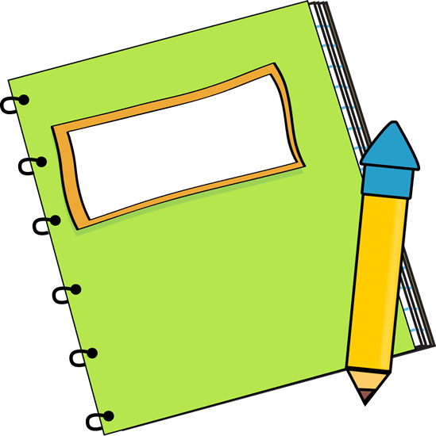
No | Words | Vietnamese meanings.
1
2
3
4
5
6
7
8
9
10
11
12
13
14
15
16
17
18
19
20
22
23
24
25
139

V-E TRASLATION-DỊCH VIỆT ANH
No | Vietnamese | English
1 | Có một chút sữa trong tủ lạnh | There is some milk in the fridge.
2 | Anh ấy không có một chút tiền nào.
3 | Chúng tôi cần một vài thông tin.
4 | Mẹ tôi thường ăn một chút bánh mì và sữa vào buổi sáng.
5 | Có bao nhiêu đứa trẻ trong vườn? Có 5 đứa trẻ.
6 | Có chút nước cam nào trên bàn không? Có một chút.
7 | Không có chút bánh mì nào trên đĩa.
8 | Trong hộp cơm trưa ( in the lunch box), có một ổ bánh mì, một vài quả nho và một chút sữa.
9 | Đừng ăn nhiều thức ăn trước khi bạn đi ngủ vào buổi tối.
10 | Không có nhiều đường ở trong cái bát.
11 | Anh ấy không có nhiều tiền trong ví. (wallet: ví)
12 | Có nhiều táo trong hộp.
140

