QUESTIONS ( CÂU HỎI)
Danh

Unit 15



YES/NO QUESTION

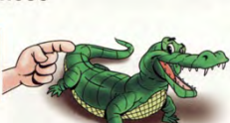
Là câu hỏi cần câu trả lời “ yes” hoặc “ No” . Gọi là câu hỏi không có từ để hỏi.

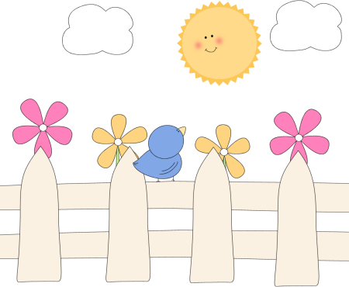


Dạng câu hỏi này sẽ bắt đầu bằng những trợ động từ như ( am, is, are, do, does, can, have, has, did)
Are you hungry?
Do you play tennis in your free time?
Have you got a sister?
Is she eating bananas?



WH-QUESTION

Là câu hỏi cần thông tin - câu hỏi chứa từ để hỏi.



Là câu hỏi bắt đầu bằng những từ để hỏi như ( what, where, who..) + trợ động từ + S+ V…..

Complete the sentences with possessive adjectives.
What is your name?
Where is she going?
When is your birthday?
Is she eating bananas?
- Jame and Alice have a car. _Their___car

141
Have you got a phone?
Does Tom listen to music?
YES/NO QUESTION
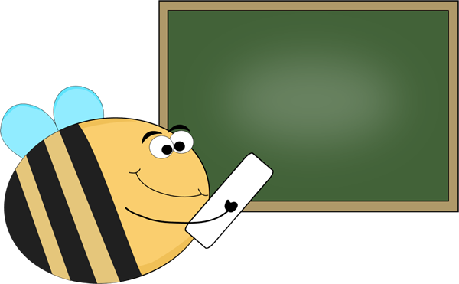

1
Change the statements to the questions.
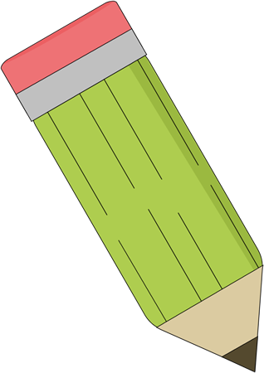
6. It’s old.
- You are happy.
Can you run fast?
_______________________________________
_______________________________________
5. get up early/you/do.
_______________________________________
8. you/like/sports/playing/do.
_______________________________________
_______________________________________
_______________________________________
7. there/an/ apple/is/in/your bag
4. there/spiders/are/in/your/bedroom
_______________________________________
3. you/have/ a /computer/got.
_______________________________________
- run fast/you/can
2. hungry/they/are
_______________________________________
Are you happy?
9. They’re cleaning the house.
_______________________________________
_______________________________________
5. There are three apples on the table.
_______________________________________
4. You’re having dinner.
_______________________________________
3. He can run fast.
_______________________________________
2. She’s a teacher.
_______________________________________
10. There’s a spider in my bed.
_______________________________________
8. David can ride a horse.
_______________________________________
7. We’ve got lemonade.
_______________________________________

2
Write the words in the correct order to make questions.


6. your teacher/red hair/have/does

142
Change the statement to the questions.
- You watch television in the evening.
Do you watch TV in the evening?
_________________________________________________________
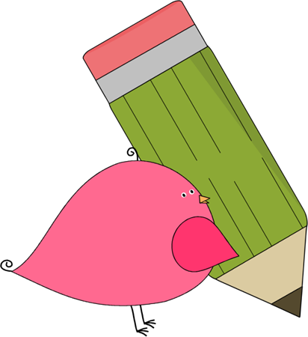
- They eat dinner at 7 o’clock.
_________________________________________________________
- He listens to music in his room.
________________________________________________________
- You wear jeans at school.
_______________________________________________________

- Isabel plays basketball on Fridays.
_______________________________________________________
- You understand your homework.
______________________________________________________
- The boys like chicken.

______________________________________________________
- Milly’s dad flies a plane.
______________________________________________________
- They live in a big house.
_____________________________________________________

10.We finish school in July.
______________________________________________________
11.He often studies hard for his exams.
_____________________________________________________
12.The girls usually go the park on Sundays.
_______________________________________________________________
143

4
Write the short answers for the questions.

No, you can’t
Yes, you can
- Can I go to the cinema?
Yes,
2. Have you got a sister?
No,

3. Can he ride a horse?

Yes,
No,
4. Are you talking to Peter?

Yes,
No,
Yes,
No,
5. Has Billy got a red phone?

6. Are your shoes nice?

Yes,
No,
7. Is it raining?

Yes,
No,
8. Does Linda like listening to music?

Yes,
No,

9. Is there a clock in your classroom?

Yes,
No,

5
Match the questions to the answers.

- No, they aren’t
- Is Molly at school today?
b. Yes, I would.
- Would you like to watch that film?
c. No, he doesn’t
- Can I go to the party?
d. Yes, he has
- Are they having dinner?
e. Yes, there are
- Does Jame like milk?
f. Yes, she is
- Are there burgers in the fridge?
- Has Pau got a new pen?
144
g. No, you can’t
TỪ ĐỂ HỎI

QUESTIONS WORDS




HOW FAR: bao xa-khoảng cách

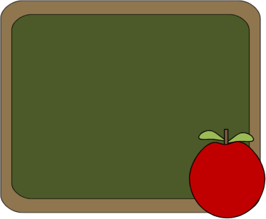
HOW LONG: bao lâu ( khoảng thời gian
HOW OLD: hỏi tuổi
HOW OFTEN:có thường xuyên không ( tần xuất)
WHAT: cái gì ( hỏi về vật)
WHO: ai ( hỏi về người)
WHERE: ở đâu ( hỏi về địa điểm)
WHEN: khi nào( hỏi về thời gian)
WHY: tại sao( hỏi về lý do)
WHICH: cái nào ( lựa chọn)
HOW MANY/HOW MUCH: bao nhiêu
WHAT TIME: mấy giờ,
HOW: Như thế nào, bằng cách nào
WHOSE: của ai ( hỏi về sở hữu)
WH-QUESTION

6
Write the question words to the anwers.

_________
6. That is the Eiffel Tower.
Who
- They are my teacher.

_________
7. They are my parents.
_________
- It’s a mouse.

_________
8. It’s an old book.
_________
- Those are mangoes.

9. They’re students at my school.
_________
_________
- That is the President.

_________

10. They’re pyramids.
_________
- They are Mike’s friends.
145

7
Read and cirlcle.
- What/When is it? It’s a monkey.
- Where/When are you going? To the park
- What/When is your birthday? May 15th
- Where/Who is your pen? On my desk.
- When/What are they? They’re Jane and Lisa.
- What/When time is it? It’s four o’clock.
- Where/When is Dad? He’s in the garden.
- What/Who is your name? Ann
- Where/When is John going? to the cinema.
10.Who/What are those women? They’re teachers.
- .What time/When do you get up? 7 o’clock.
- .What/Who are you? I’m Kim.

8
Match the questions to the answers.
- It’s my kite.
- What’s your name?
b. at the zoo
h. He’s my brother.

g. It’s on July 15th

f. She’s at school.
e. at 10 o’clock.
d. My name’s Ben
c. She’s my friend.
8. When do you get up?
7. Who’s he?
6. Where are Ali and Lisa?
5. What’s this?
4. Who’s she?
3. When’s your birthday?
2. Where’s Lucy

146

9
Read and write the questions words.
who
whose
where
when
what


- ___Whose___books are these? They’re Lisa’s
- ____________that boy? He’s my teacher.
- ___________is your name? Mary.
- ___________is it? It’s a watch.
- ___________do they live? In London.
- __________is this skateboard? It’s mine.
- ___________are those girls? They’re Kate’s friends.
- ___________do you finish work? At 2 o’clock.
- ____________lives in this house? My grandma.
10.___________________toys are those? They are my brother’s.
Answer the question about yourself.

10
________________________________
- What’s your favorite sport?
________________________________

- What’s your best friend’s name?
________________________________
- When is your birthday?
________________________________
- Where do you live?
- When’s your father’s birthday?
________________________________
- What’s your favorite food?
________________________________
- Who sits next to you in your class?
________________________________
- Who is your teacher?
________________________________
147
Choose the correct items.

11

- ________________is that boy? - He’s Ben.

A.Who
B, Whose
C. What
- _______________do they like? - They like chocolate.
A. Where
B, What
C. Who
- ______________ is she going? - to the shops.
A. When
B, What
C. Where
- _____________do you play football? - On Sundays.
A. What
B, When
C. Where
- _____________are my keys? - On the table.
A. Where
B, What
C. When
- _____________hat is it? - It’s Layla’s.
A. Who
B, What
C. Whose
- ____________is talking on the phone? - Jack
A. Who
B, What
C. When
- ___________are the children? -At the cinema.
A. Who
B, Where
C. When
- ___________are they? - They’re snakes.
A. Who
B, What
C. Whose
10.______________is your dad’s birthday? -In April.
A. When
B, What
C. Where
11. ____________is this ball? - It’s Alex’s
A. What
B, Whose
C. Where
12. _____________is the baby? - In the bedroom
148
A. Whose
B, What
C. Where
- They eat bananas.

12
Complete the sentences using ( what, who, whose, when, what time, where.

- _____________do monkeys eat?
- Tom sits next to me.
- ____________sits next to you?
- I had cereal
- ____________did you have for breakfast?
- It’s my dad’s
- ____________camera is that?
- That’s Sam’s bike.
- ___________bike is that?
- John can run 5 km.
- ____________can run 5 km?
- She plays the violin.
- _____________instrument Amy play?
- They’re on the playground.
- ____________are the boys?
- It’s at 4:30.
- _______________is your baseball practice?
- He was born in 1997.
10.___________was he born?
- He lives in London.
11._____________does your uncle live?
- We ate at Chinese restaurant.
12._____________did you eat dinner?
- She started two years ago.
13.______________did Amy start swimming?
- It’s Sunny secondary school.
14.______________is your school?

13
Write “ how much/ how many”.

- __________________dogs do you have?
- _________________lessons are there in this book?
- ________________homework do you have?
- ________________milk you drink every day?
- ______________days are there in a week?
- ______________letters are there in English alphabet?
- _______________food is there on the table?
- ________________furniture is there in the room?
149
MY VOCABULARY


No | Words | Vietnamese meanings.
1
2
3
4
5
6
7
8
9
10
11
12
13
14
15
16
17
18
19
20
22
23
24
25 |  | 150
V-E TRASLATION-DỊCH VIỆT ANH

No | Vietnamese | English
1 | Cái gì đây?
2 | Bạn đang đi đâu vậy?
3 | Bạn sống ở đâu?
4 | Bạn sinh ra khi nào?
5 | Mấy giờ bộ phim bắt đầu?
6 | Cái bút chì này của ai?
7 | Có bao nhiêu học sinh trong lớp của bạn?
8 | Tại sao bạn khóc?
9 | Bạn có thường xuyên chơi bóng đá không?
10 | Trường bạn cách nhà bạn bao xa?
11 | Bạn bao nhiêu tuổi?
12 | Mấy giờ bạn đi ngủ?
13 | Ai kia?
14 | Bạn có thường xuyên đi siêu thị không?
15 | Peter đâu? Anh ấy đang ở phòng khách.
151

