PRONOUNS ( ĐẠI TỪ)

Unit 16

SUBJECT PRONOUN
ĐẠI TỪ CHỦ NGỮ
ĐỨNG ĐẦU CÂU - LÀM CHỦ NGỮ

z

I like apples He likes apples
He

we
you
I





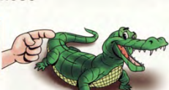
me
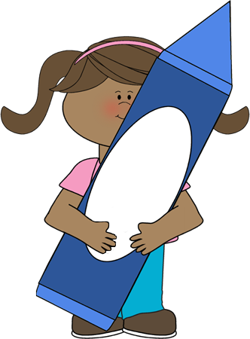
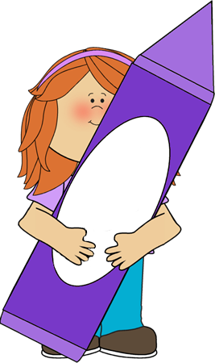
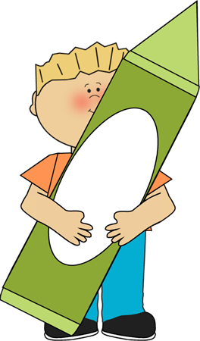
us
you


ĐỨNG SAU ĐỘNG TỪ-BỖ NGHĨA CHO ĐỘNG TỪ
Mark sings to Jane. ------ He sings to her
Jane loves Mark. -------She loves him.


OBJECT PRONOUN
ĐẠI TỪ TÂN NGỮ
I like him I like her
He

it
she
he
they




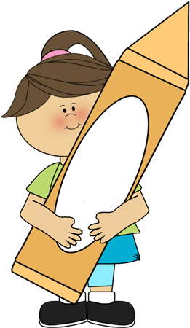
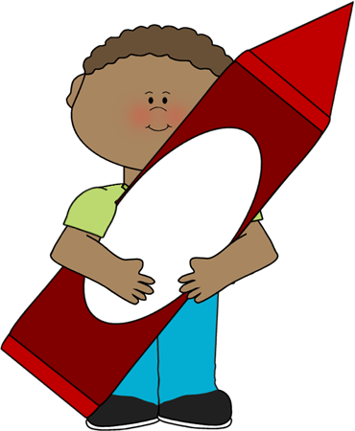
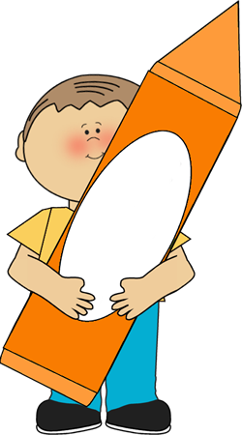


her
it
him
them

Complete the sentences with possessive adjectives.
- Jame and Alice have a car. _Their___car

152

1
Look at the pictures and fill with object pronouns ( me, you, him, her, it, them, us.


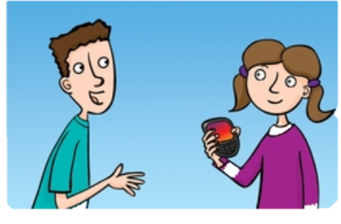
3
2
1
him


him
She’s Jane. That computer belongs to ______
I’m Charlie. This guitar belongs to ______
They’re Ed and Ivy. This car belongs to ______
We’re Dave and Iris. This dog belongs to ______
She’s Carla. This phone belongs to ______
He’s Fred. That kite belongs to ______
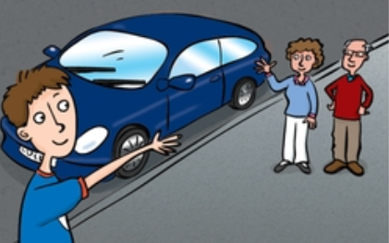
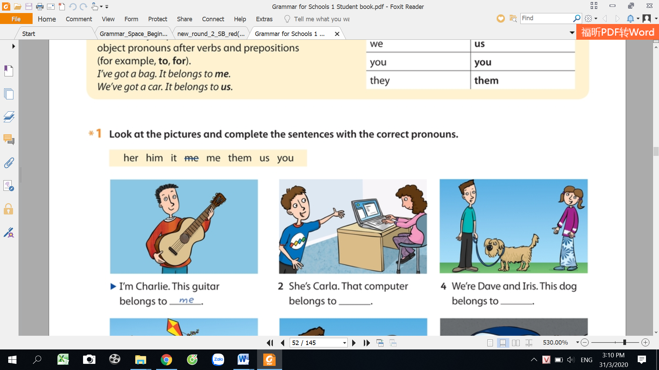
6
5
4

2
Replace the underline words with the correct pronouns.

These presents are for you and me.
5
1
Ben, can you sing with ______.
_________ can climb______.
Dave and Mary can climb the tree
Sofia gives a presents to Kelly.
She gives a present to _______.
These presents are for_____.
Look at Gary and Jason!
_______can fly_________.

Nick can fly the kite.

_____ are playing with __________.
The children are playing with their toys.
Look at ________.They’re angry.
Tom likes ice-cream.
He likes it.
6
2
7
3

153
8
4

3
Write the original words of the underline pronouns.

maths
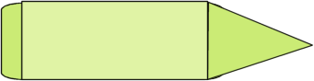
- Bill and John fight all the time. Stop them.
- Maths is difficult. I don’t like it.
………….
………….
- Kate and I don’t understand Chinese. Help us!
………….
………….
………….
6. Jane is a funny girl. Everybody likes her.
5. My uncle has many stamps. He collects them.
4. This computer is broken. Please repair it.

4
Circle the correct words.

- I can't see Mary. I can't see her/him/it/they.
- Karen is next to Peter. Karen is next to he/him/her/it
3. Can you help Peter and Ann? Can you help them/her/him/it
10. Where are you? I can't see us/you/your/yours.
9. Dave can't swim. Help he/him/her/them!
8.The cat is under the chair. Can you see he/she/it/its
7. Carol is at school. She can't come with it/he/him/her.
6. These are my bananas. You can't eat it/they/them/their.
5. We are going to the cinema. Come with me/us/we/they
4. Drink your apple juice! Drink it/its/them/him.

154
1. My friend, Sue is fantastic. I love she.
Underline and correct the mistakes, rewrite the sentences.

5
My friend ,Sue is fantastic. I love her
…………………………………………………………………
2. Do you play tennis with they?
…………………………………………………………………
3. My brother hates hamburgers. He never eats it.
……………………………………………………………………
4. Do you come with Sue and I?
……………………………………………………………………
5. The boys don’t play with her because her is very unfriendly.
……………………………………………………………………
6. Does him like cooking? Yes, he does.
……………………………………………………………………
7. Sarah never listens to him sister.
……………………………………………………………………
8. Paul and Mary don’t invite we to parties.
……………………………………………………………………
Choose the correct answer.

6

1. ………… is in class with ………
a. her/ us b. he/we c. She/us
2. Does ………… use a laptop at home?
a. he b. it c. him
3. These are my mum’s friends. ………… usually goes out with …………….
a. she/ they b. her/them c. she/them
4. Do ………… eat pasta? No, I don’t like ……
a. we/it b. you/it c. you/her
5. We don’t talk to Sam. We’re angry with ………
a. he b. him c. his
6. Can you pass ……… the sugar, Terry?
a. you b. I c. me
7. “When do you do homework?” “I do ……… after school.”
a. them b. it c. he
8. Give ....... to …………, please.
a. I/it b. it/I c. it/me
155

