ADJECTIVES –TÍNH TỪ

Unit 19

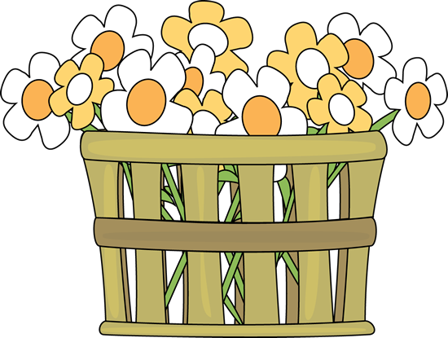


ADJECTIVES
TÍNH TỪ

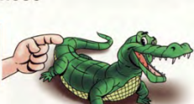



ADJECTIVES ORDER
TRẬT TỰ TÍNH TỪ

Đứng sau động từ to be “ am, is, are, was, were, be….)
He is hungry.

Đứng trước danh từ- bỗ nghĩa cho danh từ
She is a beautiful girl.

Đứng sau một số động từ liên kết “ linking verbs”
smell ( ngửi), taste( nếm), sound ( nghe như), look ( nhìn), feel ( cảm thấy). become-turn-get ( trở nên, trở thành), seem ( dường như)

You look tired. ( bạn trông mệt mỏi)
The food taste good. ( Thức ăn nếm ngon.)

Complete the sentences with possessive adjectives.
- Jame and Alice have a car. _Their___car /
189
mục đich
chất liệu
nguồn gốc
màu sắc
hình dáng
tuổi tác
kích cỡ
quan điểm
color
age
opinion
purpose
material
origin
shape
size

1
Underline and write the adjective and noun.

NOUNS
ADJECTIVES
small
villages
……………….
………………
……………….
……………….
……………….
……………….
10. This is an old house.
……………….
9. I have a fat cat.
……………….
8. The pretty girl sang the song.
7. We want to drink some hot coffee.
……………….
……………….
……………….
……………….
6. Sam bought an expensive hat yesterday.
…………………..
………………
…………………..
………………
………………..
……………….
5. We had a big dinner last night.
4. I had an exciting experience today.
3. We often eat at a Chinese restaurant.
2. Do you like hot weather?
…………………
………………….
- The farmers live in small villages.

2
Rewrite the sentences using the underline adjectives.

The man is poor.
……………………………………………….
- He is a poor man.
The suitcases
……………………………………………….
……………………………………………….
……………………………………………….
……………………………………………….
……………………………………………….
6. They are angry birds.
5. This is a boring movie.
4. It is a long shirt.
3. There are ten difficult questions.
2. They are heavy suitcases.
The ten questions

The shirt
This movie
The birds
190

3
Look at the pictures and write the words in the correct order.
3
2
1

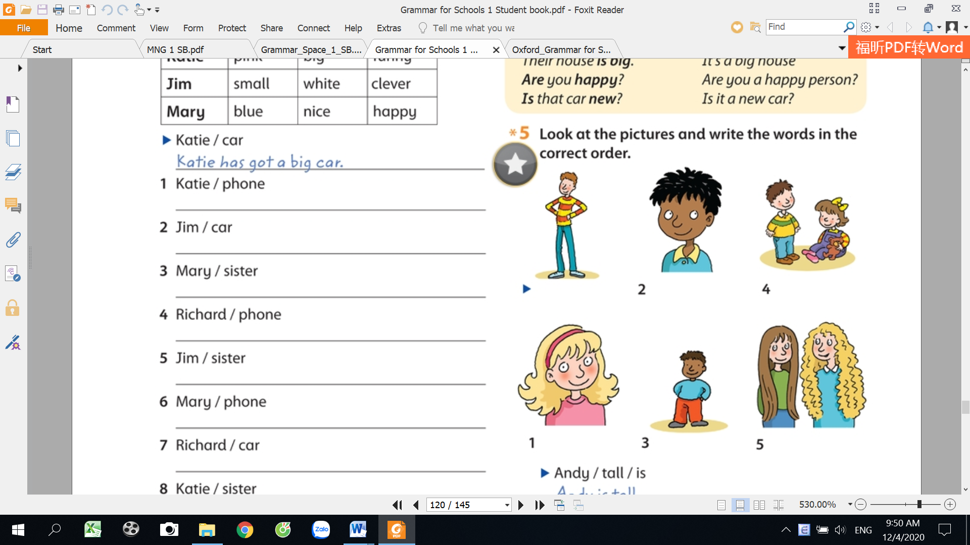

Andy is tall.
5
4

2
_________________________
_________________________
_________________________
dark/your hair/is
short/you/are
blone/Mary/is/
_____________________________
is/their hair/long
are/the children/young
_____________________________
Andy/tall/is
_________________________

6

Underline the adjectives.

4
11. Her hair is long
- He’s got an old house.
12. This dress is expensive.
- This is a small car.
13. Mary like colorful butterflies.
- My sister has got a nice phone.
14. My bag is white and pink
- Is that a new watch?
15. Henry is a fast runner.
- She’s wearing a blue shirt.
16. There is a deep pond in the park.
- I like new shoes.
17. Emma wears thick glasses at school.
- That’s a funny book.
- Do you like a big house?
18. They are beautiful flowers.
19. This pizza smells good.
- There’s a beautiful cat.
20. I felt sad after the test.
10.Have you got a black bag.
191

5
Circle the correct adjective for these pictures.

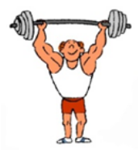

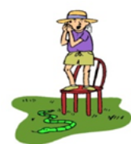
4
3
2
1
20
19
18
17
16
15
14
13
12
11
10
9
8
7
6
5
fast, weak, strong

happy, hairy,bald

tall, lazy, diligent

tall, small, big

thin, slow, fast

young, old, big

happy, fast, lazy
slow, fast, weak

ugly, sad, beautiful

happy, angry, sad

fat, big, thin

short, big, small

young, thick, fat

sad, hairy,bald

thin, young,old

pretty,handsome

tall, afraid, small

happy,afraid,sad

sad, strong, weak

sad, angry, happy

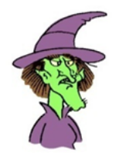
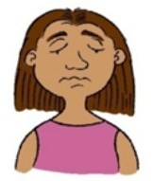




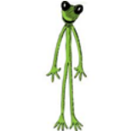


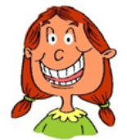

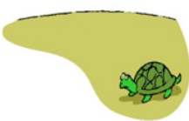





192

6
Match the adjectives with their opposite meanings.
heavy
7.cheap
11.light
12.wet
hard
expensive
dangerous
dark
thin
dry

clean
10.dirty
9.thick
8.safe
pretty
large
quiet
early
6.little
5.birght
4.late
3.noisy
2.ugly
1. soft

7
Choose and write the opposite adjectives.
a short player
funny
angry
_________________________________
- A player: a tall player
_________________________________
- Coffee: cold coffee
_________________________________
- A movie: a boring movie
heavy
hot
_________________________________
- A cat: a happy cat

_________________________________
- A horse: a fast horse
quiet
ugly
_________________________________
- A box: a light box
_________________________________
- A man: a young man
short
old
_________________________________
- A room: a big room
_________________________________
- A girl: a beautiful girl
small
slow
_________________________________
10. A monkey: a noisy monkey
193

8
Choose and write the correct adjectives.
cold
rich
special
small
dry
expensive

new
favorite
delicious
noisy
dark
polular
rich
- My grandpa is very ______________. He has a lot of money.
- They have a very _____________class. There are only five students.
- It’s _________________outside. Wear your gloves!
- Tomorrow is a _____________________day. It’s my birthday.
- Jack is ___________________at school. Everyone likes him.
- I need a _______________towel. This one is wet.
- My dad has an_______________bike. It’s light and fast.
- It’s ____________________in the city. There are many cars.
- This sofa is _____________________. We bought it yesterday.
10.These apples are ______________. They taste great.
11. English is my ________________subject. I like it very much.
12. It’s _____________here. I can’t see anything.
Write the opposite of the adjectives.

9
weak
11.delicious…
12.dry……………
13.noisy………….
14. dark……………
15.smart…………

6.dangerous……..
7.tall……………
8.clean………….
9. long…………….
10.rich……………
1.strong……..........
2.happy……………
3. boring………….
4. easy…………….
5.bitter……………

194

LINKING VERBS+ ADJECTIVES

Động từ lên kết khác với động từ thường chỉ hành động “ action verbs” như “ run, go…”
Động từ liên kết thườg dùng để kết nối và bổ nghĩ cho danh từ
Theo sau là một tính từ.

ĐỘNG TỪ LIÊN KẾT
LINKING VERBS
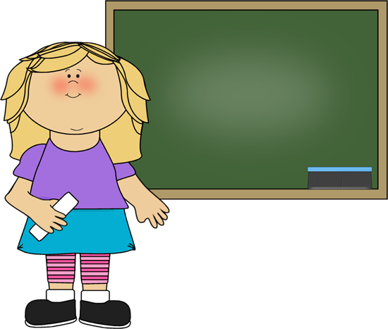

The earth is round.
The dog looks happy
The flowers smell good.
The workers felt tired.
The chocolates taste sweet.
The film sounds interesting.
The weather becomes/gets/turns colder.
He seems unhappy.
be: thì, là
smell ( ngửi),
taste( nếm),
sound ( nghe như),
look ( nhìn),
feel ( cảm thấy). become-turn-get ( trở nên, trở thành),
seem ( dường như)

LINKING VERBS

The dog looks happy
The flowers smell good.
The workers felt tired.
The chocolates taste sweet.
The film sounds interesting.

I look at the sky.
I smell the flowers.
I felt the dog’s hair.
I tasted the soup.
The bell sounded for dinner.

ACTION VERBS

195

10
Choose and write, underline the linking verbs.
good
tired good sad
- The dinner smells…………………………………
easy comfortable busy
- The sofa feels………………………………………..
fun nervous crazy
- The new books sound …………………………..
expensive angry short
- The bike looks………………………………………
messy bitter spicy
- Korean food tastes…………………..................
sad big delicious
- The stadium looks………………………………
sweet good terrible
- Pyew! Something smells……………………….
sad wonderful careful
- The new audio system sounds……………...
happy sad lazy
- What’s wrong? You look………………………
good slow happy
10. It’s my favorite cake. It tastes……………..
honest exciting tired
11. The new book looks……………………………
Underline the verbs and write in the column.

11
Action verbs
Linking verbs
sounds
_________________
_________________
- You idea sounds great
looked
_________________
_________________
- He looked at the moon above the hill.
_________________
_________________
- Her new computer looks expensive.
_________________
_________________
- I smelt the roses in the garden.
_________________
_________________
- My sister lost her shoes at the park.
_________________
- The students were excited about the games.
_________________
_________________
_________________
- The dinner smells delicious.
- I found an old watch in the drawer.
_________________
_________________
_________________
- We can see many stars tonight.
196
_________________
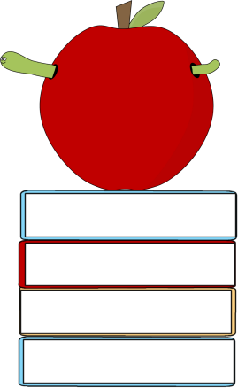

Nếu trong một câu có nhiều tính từ đứng cạnh nhau ta sắp xếp theo thứ tự sau

ADJECTIVES
ORDER
TRẬT TỰ CỦA TÍNH TỪ
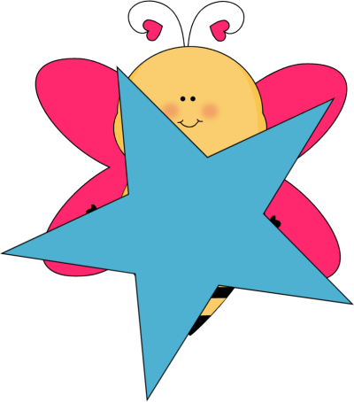
Opinion
size
age
shape
color
origin
material
purpose

Opinion ( Quan điểm) | Nice, beautiful , good, bad
Size ( Kích cỡ) | small, big, large, enormous, tiny, short, long.
Age ( tuổi tác) | new, old, antique, five-year-old….
Shape ( hình dáng) | Circle, square, triangle, curly, straight wavy
Color ( màu sắc) | red, white, pink, purple, gold, silver,…..
Origin ( nguồn gốc) | Chinese, American…..
Material ( chất liệu) | wooden, wool, cotton, paper, leather, steel, iron, metal
Purpose ( Mục đích) | dinning, swimming, writing…
197
MY VOCABULARY


No | Words | Vietnamese meanings.
1
2
3
4
5
6
7
8
9
10
11
12
13
14
15
16
17
18
19
20
22
23
24
25 |  | 198
V-E TRASLATION-DỊCH VIỆT ANH

No | Vietnamese | English
1 | Đây là một cô gái xinh. | This is a beautiful girl.
2 | Thành phố này ồn ào.
3 | Món ăn này nhìn ngon.
4 | Hôm qua bố đã mua cho tôi một chiếc váy mới màu đỏ.
5 | Thành phố này cảm giác rất dễ chịu.
6 | Ông tôi rất giàu nhưng tôi rất nghèo.
7 | Đó là một người đàn ông hạnh phúc.
8 | Con mèo trắng của tôi rất dễ thương. ( dễ thương: lovely)
9 | Tôi đã xem một bộ phim hôm qua. Bộ phim đó rất nhàm chán.
10 | Kia là một cuốn sách thú vị. Tôi đã đọc nó tuần trước.
11 | Chúng tôi sẽ mua một ngôi nhà mới , lớn,màu xanh vào năm tới.
12 | Anh ấy là một người đàn ông tốt bụng. Anh ấy thường giúp đỡ tôi.
199

