ADVERBS-TRẠNG TỪ

Unit 20





Trạng từ chỉ thời gian

ADVERBS OF TIME
Yesterday, today, tomorrow

ADVERBS
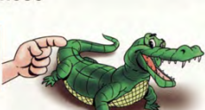
ADVERBS OF FREQUENCY
ADVERBS OF MANNER


Trạng từ chỉ cách thức
Careful-carefully
Quiet-quietly
Trạng từ chỉ tần xuất
never,hardly ever, rarely, seldom, sometimes, often, usually, always….

Trạng từ chỉ nơi chốn

ADVERBS OF PLACE
here, there, outside, inside…..

ADVERBS OF DEGREE

Trạng từ chỉ mức độ
Very, quiet, really….

Complete the sentences with possessive adjectives.
- Jame and Alice have a car.
200
good-well
fast-fast
hard-hard
late- late
early-early
ear


happy-happily
easy-easily
simple-simply

slow-slowly
careful-carefully
quick-quickly

Thêm “ ly” sau tính từ thành lập trạng từ chỉ cách thức
ADJECTIVE + LY= ADVERBS
(Anh ta đã làm bài kiểm tra một cách cẩn thận)
A
He did the test carefully
A
Đứng sau động từ thường- bổ nghĩa cho động từ
Trạng từ chỉ cách thức

ADVERBS OF MANNER

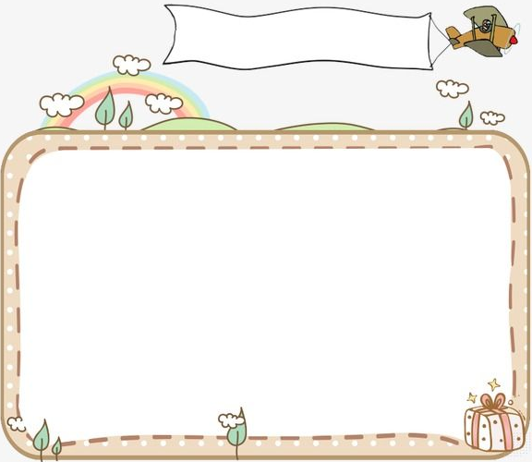

1
Underline the verbs and circle the adverbs


8. Cheetahs run fast.
- John did his homework quickly.
14. He drives slowly.
13. Sam goes to bed late.
12. I went to school late yesterday.
11. My mother cooks well.
10.He studies English hard.
9. He got up early this morning.
6. Write carefully in your notebooks!
7. The students ran to the class noisily.
4. Can crocodiles see well underwater?
2. I call his name loudly.
5. My dog learns new tricks easily.
3. Mary dances badly.

201

2
Circle the correct words
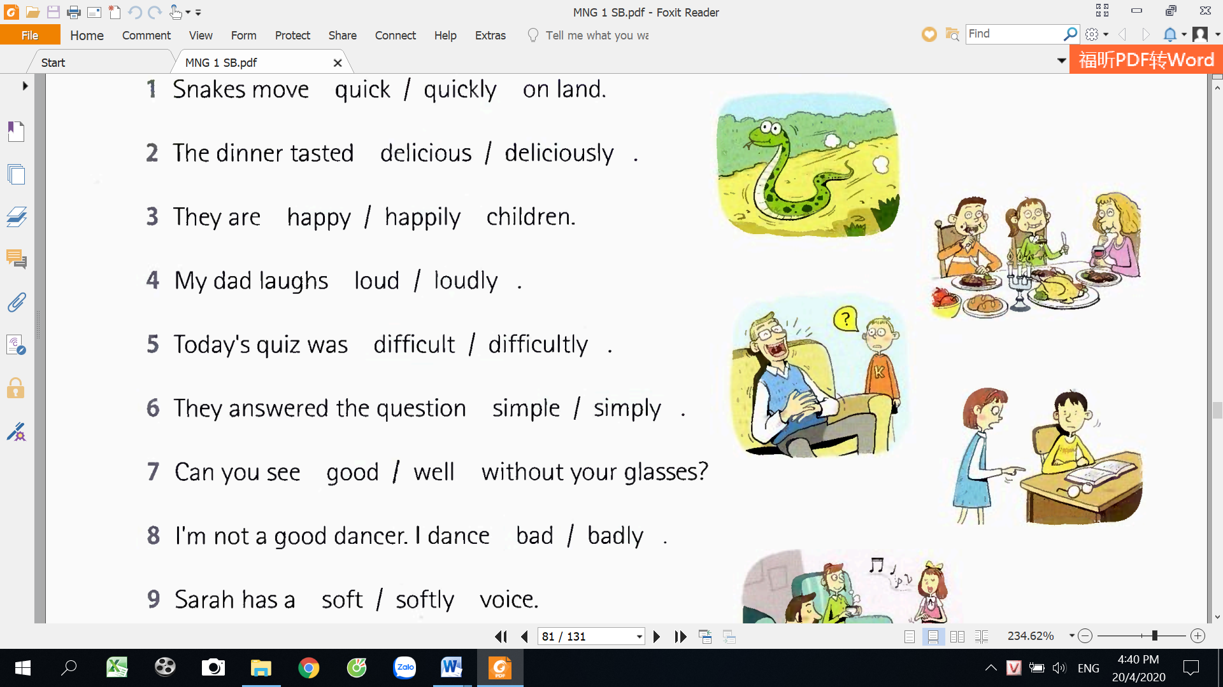
- Snakes move quick/quickly on land.
- The dinner taste delicious/deliciously.
- They are happy/happily children.
- My dad laughs loud/loudly.
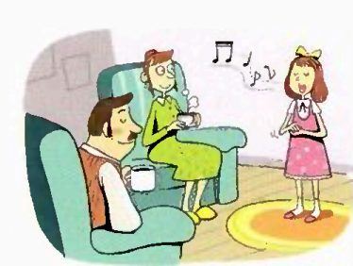
- Today’s test was difficult/difficultly.
- They answered the questions easy/easily
- Can you see good/well without glasses?
- I’m not a good dancer. I dance bad/badly.
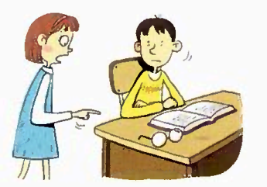
- Sarah has a soft/softly voice.
- John walked out of the room quiet/quietly.

3
Look, choose and write.

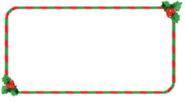
2
3
1



slowly
quietly
well
loudly
happily
fast
The baby is smiling ……………
The cat is walking ……………
Army speaks English ……………
The boys are playing drum………….
The turtle walks ……………
The cheetah runs……………

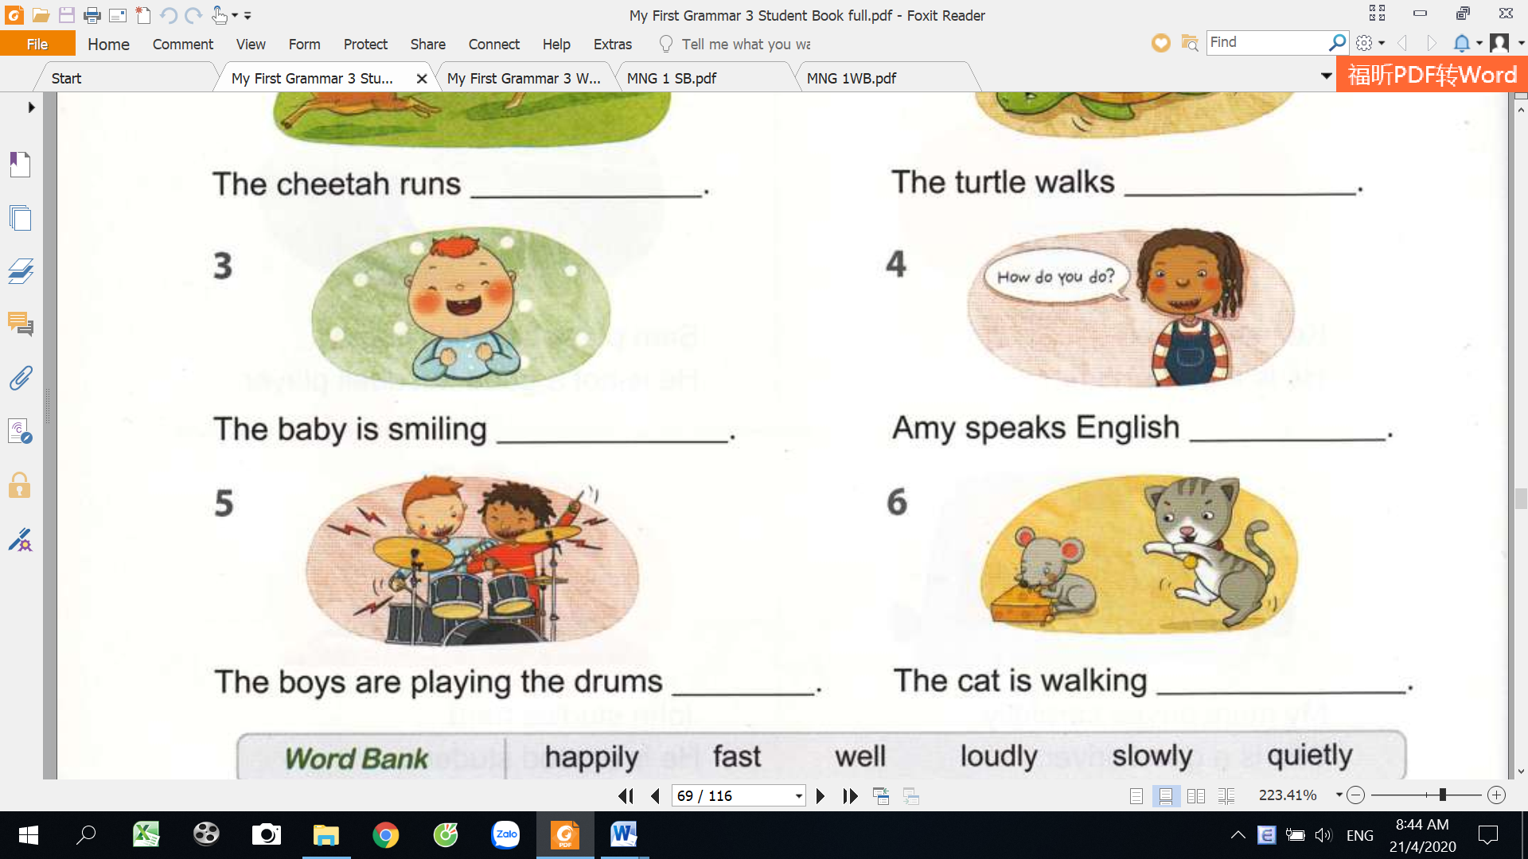
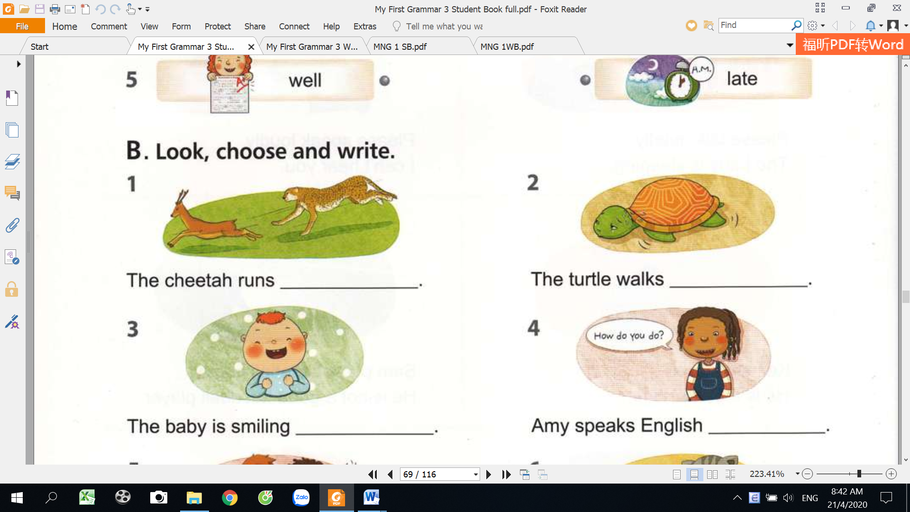
2

loudly

66
5
4

202

4
Write the correct forms of the adverbs.
clearly
13. good…………..
14. hard………….
15. angry…………
16. bad……………
9. loud…………..
10. fast………..
11. happy………
12. early…………
- slow……………...
- late………………..
- noisy……………..
- careful……………
- ear…………….
- soft………………..
- simple……………
- honest……………
- clear…………….
- soft………………..
- simple……………
- honest……………

5
Write the words in the correct boxes

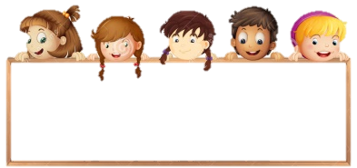
hard
simply
bad
well
noisily
badly
easy

fast
soft
carefully
late

simple
good
slowly
angry

hard
quiet
slow
easily

simply
quietly
noisy
bad

……………………………………………………………………………………………………………………………………………………………………………………..
……………………………………………………………………………………………………………………………………………………………………………………..
……………………………………………………………………………………………………………………………………………………………………………………..
ADJECTVES OR ADVERBS
ADVERBS
ADJECTIVES


203

6
Write the sentences in the right order.
1
running
horse
is
fast
The
.
.
.
.
.
.

The horse is running fast.
_________________________________________________________________________________
5
F
E
D
C
B
A
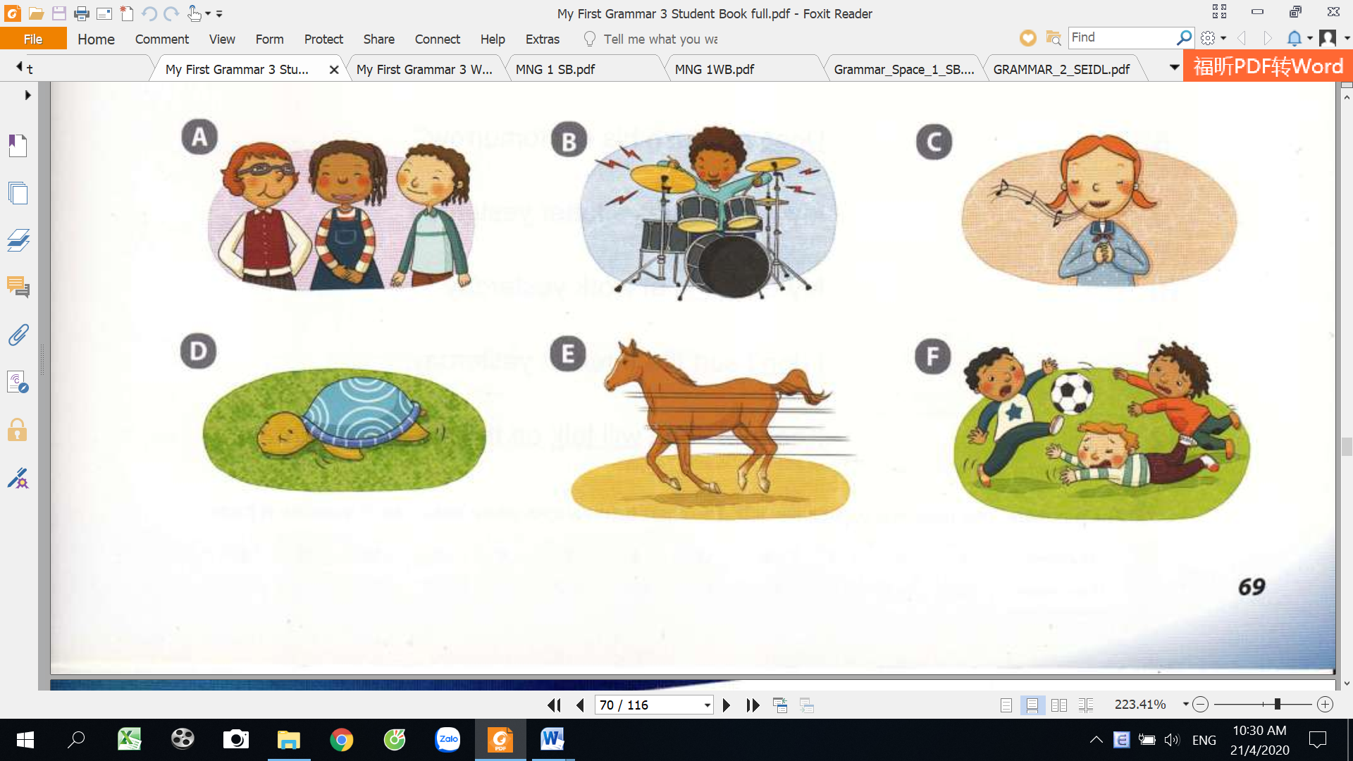
6
5
4
3
2
are
happily
The
smilling
girls
singing
girl
is
The
beautifully
slowly
The turtle
moving
is
on the grass
The
soccer
playing
are
boys
poorly

………………………………………………………………………………………………………………

………………………………………………………………………………………………………………
loudly
boy
The
is
playing drums

………………………………………………………………………………………………………………

………………………………………………………………………………………………………………

………………………………………………………………………………………………………………

204

7
Complete the sentences using the adverbs. Circle the verbs.
well
- Simon and I can’t dive_______________.
good
7. John can lift the box _________________.He’s strong.
8. Jane came ____________for the meeting.
9. The dog wagged their tail __________________.
10. They lost the game. They played______________.
4. The fireman saved the children_____________.
quick
loud
2. Mr Brown always speaks ___________.
high
3. A plane is flying _________in the sky.
5. You have to write your address______________.
6. Does your dad drive______________?
happy
bad
late
easy
careful
correct

Rewrite the sentences with the same meaning.

8
Mr green drives carefully.
…………………………………………………………………………
- Mr Green is a careful driver.
- Harry is a bad player.
…………………………………………………………………………
- My mother is a good cook.
…………………………………………………………………………
…………………………………………………………………………
- Peter is a fast swimmer.
…………………………………………………………………………
- Mr Bean is a hard worker.
…………………………………………………………………………
- Lucy is a slow writer.
…………………………………………………………………………
- Mr David is a quiet speaker.
…………………………………………………………………………
- Anna is a neat writer.
205

9
Choose the correct adverbs and write in the gaps.
LEARNING TO PLAY AN INSTRUMENT
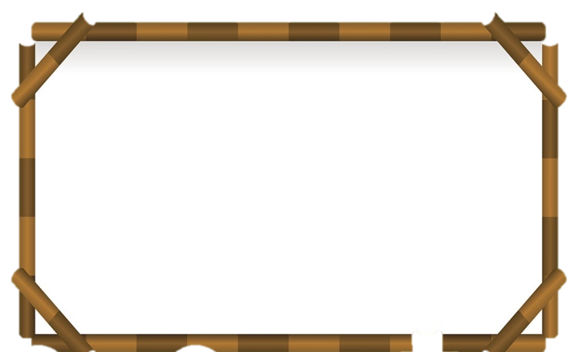
carefully
Learning to play a musical instrument is difficult. You must choose your instrument……………….. ( careful/carefully). Many children start with the recorder. It is small and be carried …………………….( easy/easily). It can be bought …………………( cheap/cheaply). You start playing with a group and learning the note ……………….( slow/slowly). At first, you may play ………………….(bad/badly) but you must practice at least once a day. Then you learn ………………( quick/quickly) and soon can play ( good/well). Parents like to listen__________ ( proud/proudly) your children playing , and the children play ………………..( happy/happily) together. It’s lovely to hear an orchestra play ………………….( beautiful/beautifully).

Circle the correct words.

10
- She can cook beautiful/beautifully.
- The exam is very easy/easily.
- Tom never drives fast/fastly.
- I can answer the question easy/easily.
- Do you speak English good/well?
- I opened the door silent/silently.
- English is not a difficult/difficultly language.
- Mary is my close/closely friend.
- It’s boring/boringly day.
10.The student’s really successful/successfully.
206
Ngoài trạng từ chỉ cách thức “ adverbs of manner” chúng ta còn có các loại trạng từ khác quan trọng như “ adverbs of frequency” : trạng từ chỉ tần xuất- đã được học trong UNIT 11.
SUMMARY
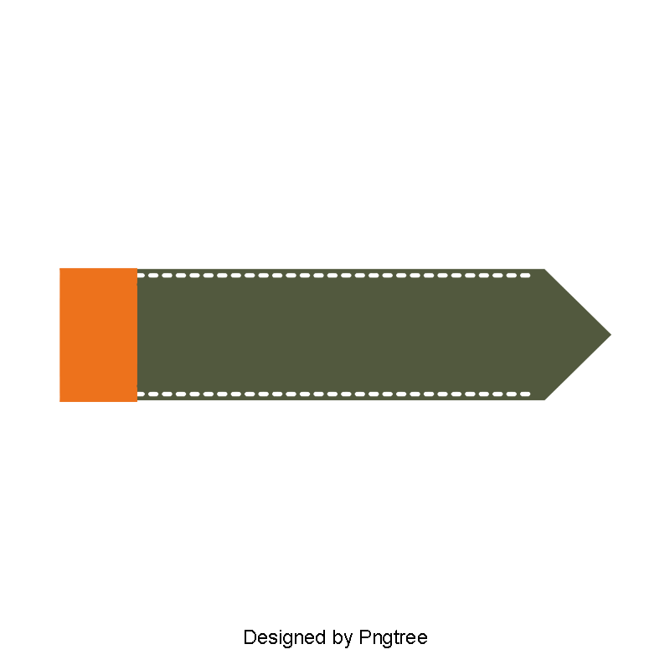



ADVERBS OF PLACES
ADVERBS OF DEGREE
ADVERBS OF TIME
TRẠNG TỪ CHỈ MƯC ĐỘ
TRẠNG TỪ CHỈ NƠI CHỐN
TRẠNG TỪ CHỈ THỜI GIAN

here: ở đây
there: ở đó
outside: bên ngoài
inside: bên trong

quite/rather: khá
very/really: rất
extremely: vô cùng
Your English quiet good ( Tiếng anh của bạn khá tốt)

yesterday: hôm qua
today: hôm nay
tonight: Tối nay
tomorrow: ngày mai

Đứng trước tính từ hoặc một trạng từ khác để nhấn mạnh mức độ

207
MY VOCABULARY

No | Words | Vietnamese meanings.
1
2
3
4
5
6
7
8
9
10
11
12
13
14
15
16
17
18
19
20
22
23
24
25
208
V-E TRASLATION-DỊCH VIỆT ANH
No | Vietnamese | English
1 | Anh ấy chạy rất nhanh. | He runs fast.
2 | Họ nói tiếng anh rất giỏi.
3 | Những bạn trai đang đánh trống rất to ( play drum: đánh trống)
4 | Bố tôi làm việc rất chăm chỉ  ( chăm chỉ: hard)
5 | Peter là một cậu bé cẩn thận. Cậu ấy thường đi xe đạp rất chậm chạp.
6 | Trò chơi đó rất nguy hiểm.
7 | Những học sinh có thể làm bài kiểm tra đó một các dễ dàng.
8 | Hôm qua tôi đã đi học muộn.
9 | Mẹ tôi thường thức dậy sớm vào buổi sáng.
10 | Nhìn này! Em bé đang cười rất hạnh phúc.
11 | Anh ta đang bước vào phòng một cách chậm chạp.
12 | Cô ấy đã vượt qua kỳ thi một cách dễ dàng.
209

