Unit 3

PERSONAL PROUNOUNS ( ĐẠI TỪ NHÂN XƯNG)

GRAMMAR BOARD

I | tôi | 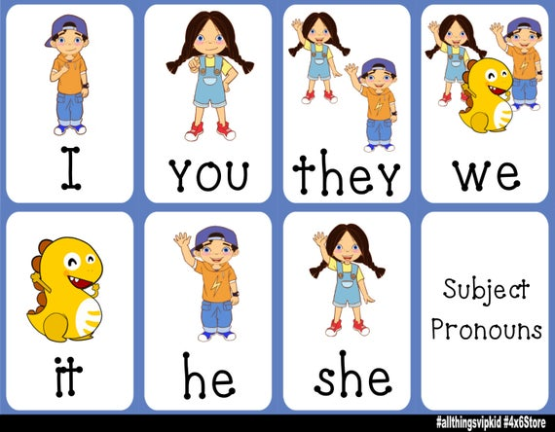
you | Bạn, các bạn
We | Chúng tôi, chúng ta
They | Họ, chúng nó
He | anh ấy
She | cô ấy
It | nó
17
1
Circle the correct words


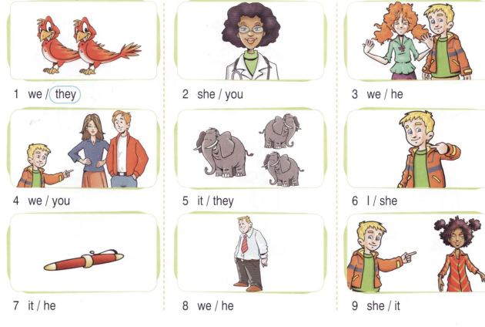
Look and write.

9. She/it
7. It/he
8. we/he
6. I/she
5. it/they
4. we/you
- we/he
- She/you
- We/they

2

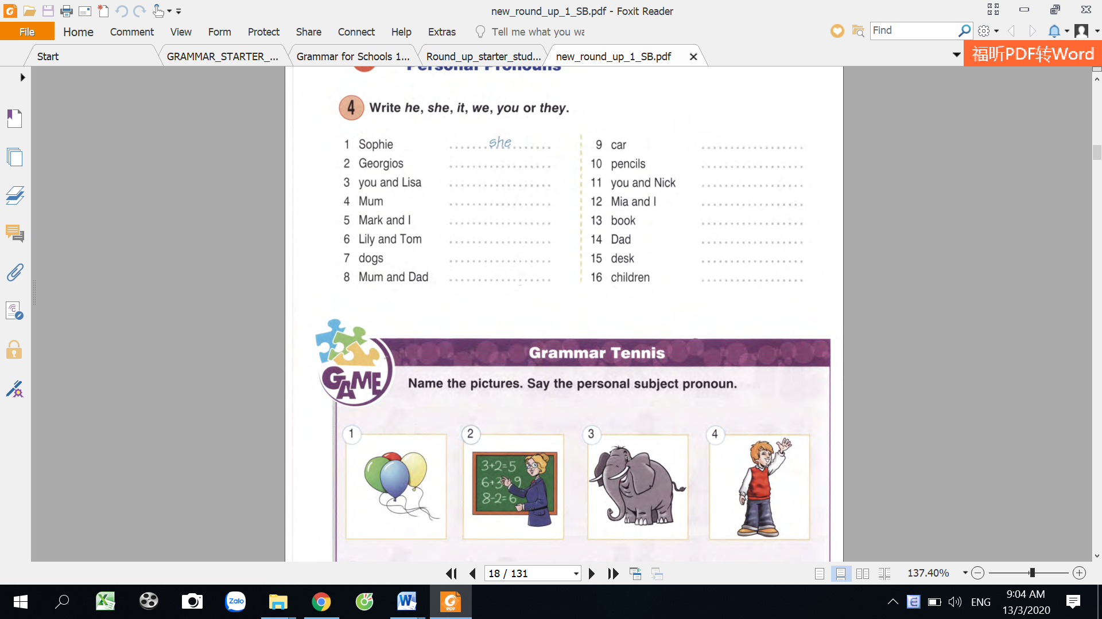
- they
2.
4.
3.

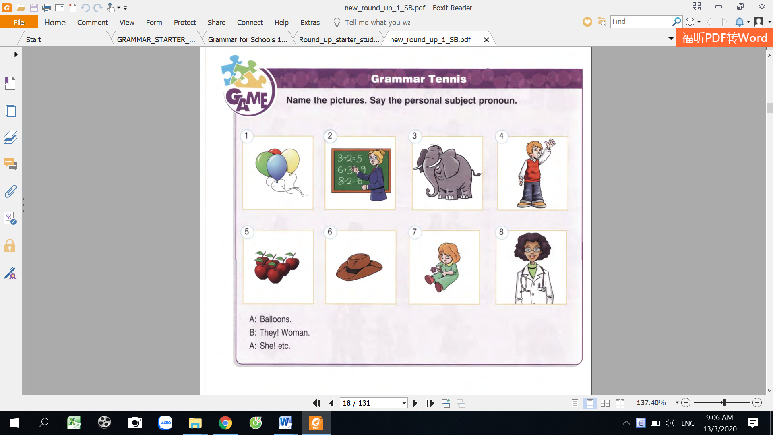
8.
7.
6.
5.
18
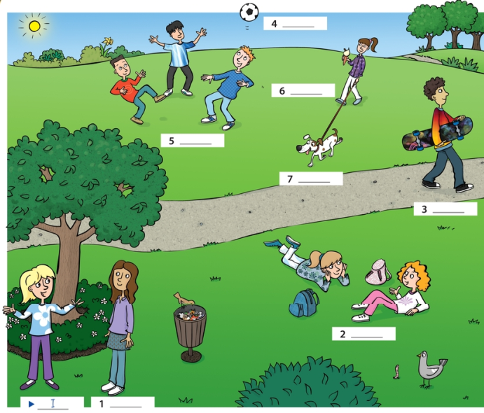

3
Write he, she, it, we, they, you
.

Look at the pictures and write pronouns.

7.

6.
5.
4.
3.
2.

4

- Sophie | ……she………… | 9. car | …………………………
- Peter | …………………… | 10. pencils | …………………………
- You and Lisa | ………………… | 11. You and Nick | …………………………
- mum | …………………… | 12. Mia and I | ………………………
- Mark and I | …………………… | 13. book | …………………………
- Lily and Tom | …………………… | 14. Dad | …………………………
- dogs | ………………… | 15.desk | …………………………
- Mum and dad | ……………………  19 | 16. children | ………………………

5
Look and write.

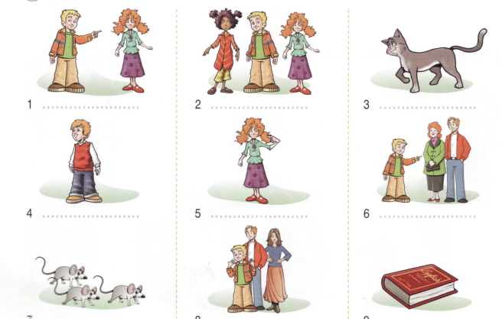
9. …………………
7. ………………
8. …………………
6. ………………
5. ……………
4. ………..
3………………..
2……………….
1………………

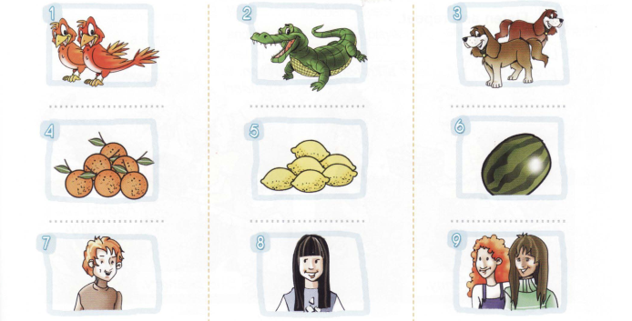
20
17. …………….
16. …………..
18. …………..
15. …………..
13. …………
12. ……………
11. ………….
10. …………….
14. …………..
4
3
2
1


6
Choose the right option.

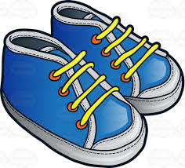
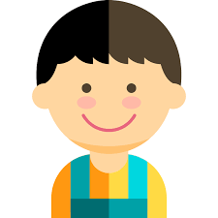
16
15
14
13
12
11
10
9
8
7
6
5
a. He c. It
b. She d. They

a. He c. It
b. She d. They

a. He c. It
b. She d. They

a. He c. It
b. She d. They

a. He c. It
b. She d. They

a. He c. It
b. She d. They

a. He c. It
b. She d. They

a. He c. It
b. She d. They

a. He c. It
b. She d. They

a. He c. It
b. She d. They

a. He c. It
b. She d. They

a. He c. It
b. She d. They

a. He c. It
b. She d. They

a. He c. It
b. She d. They

a. He c. It
b. She d. They

a. He c. It
b. She d. They

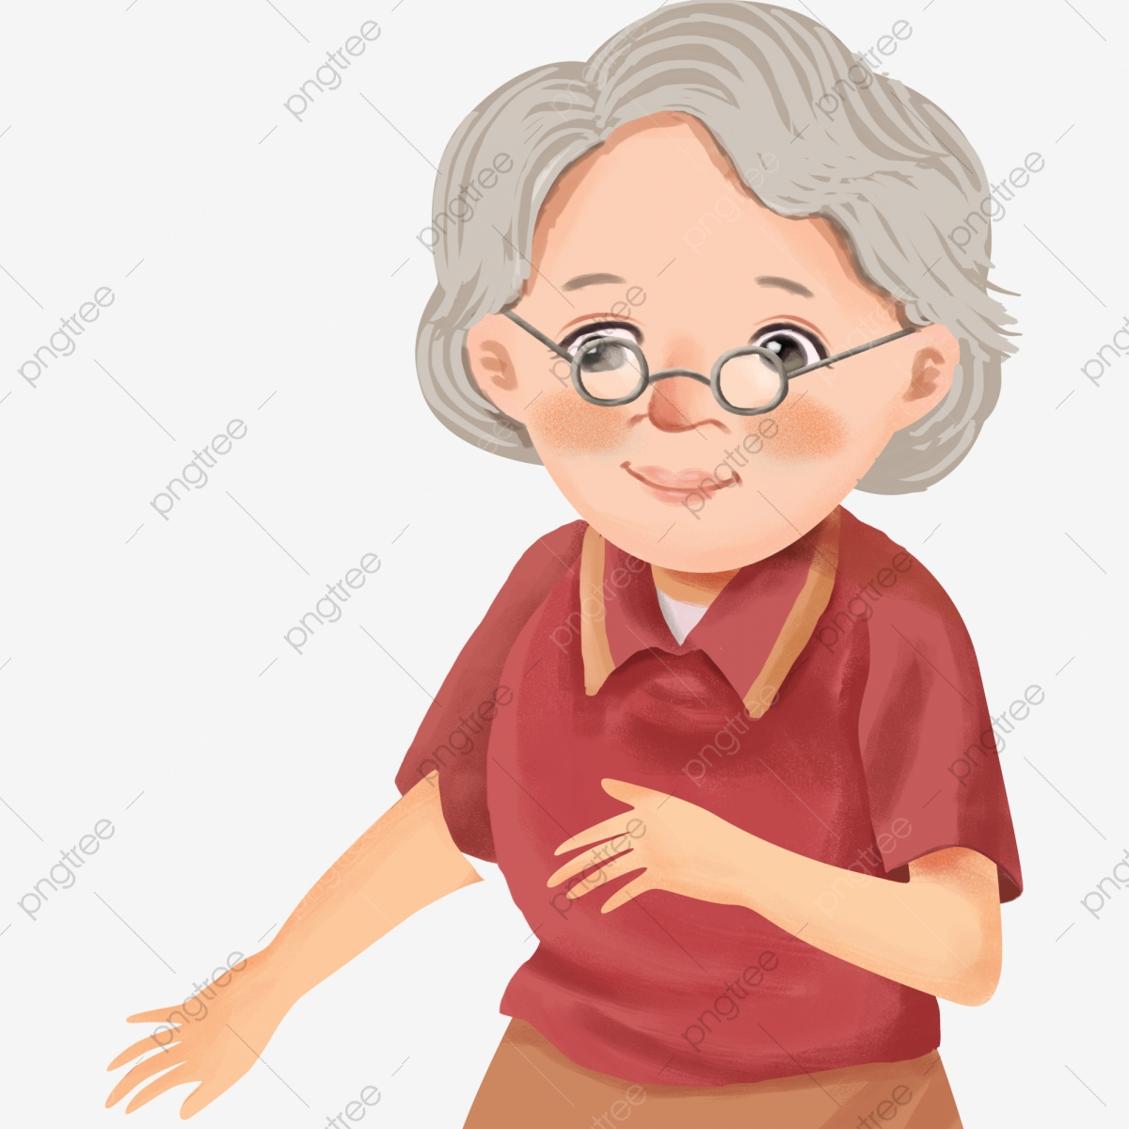

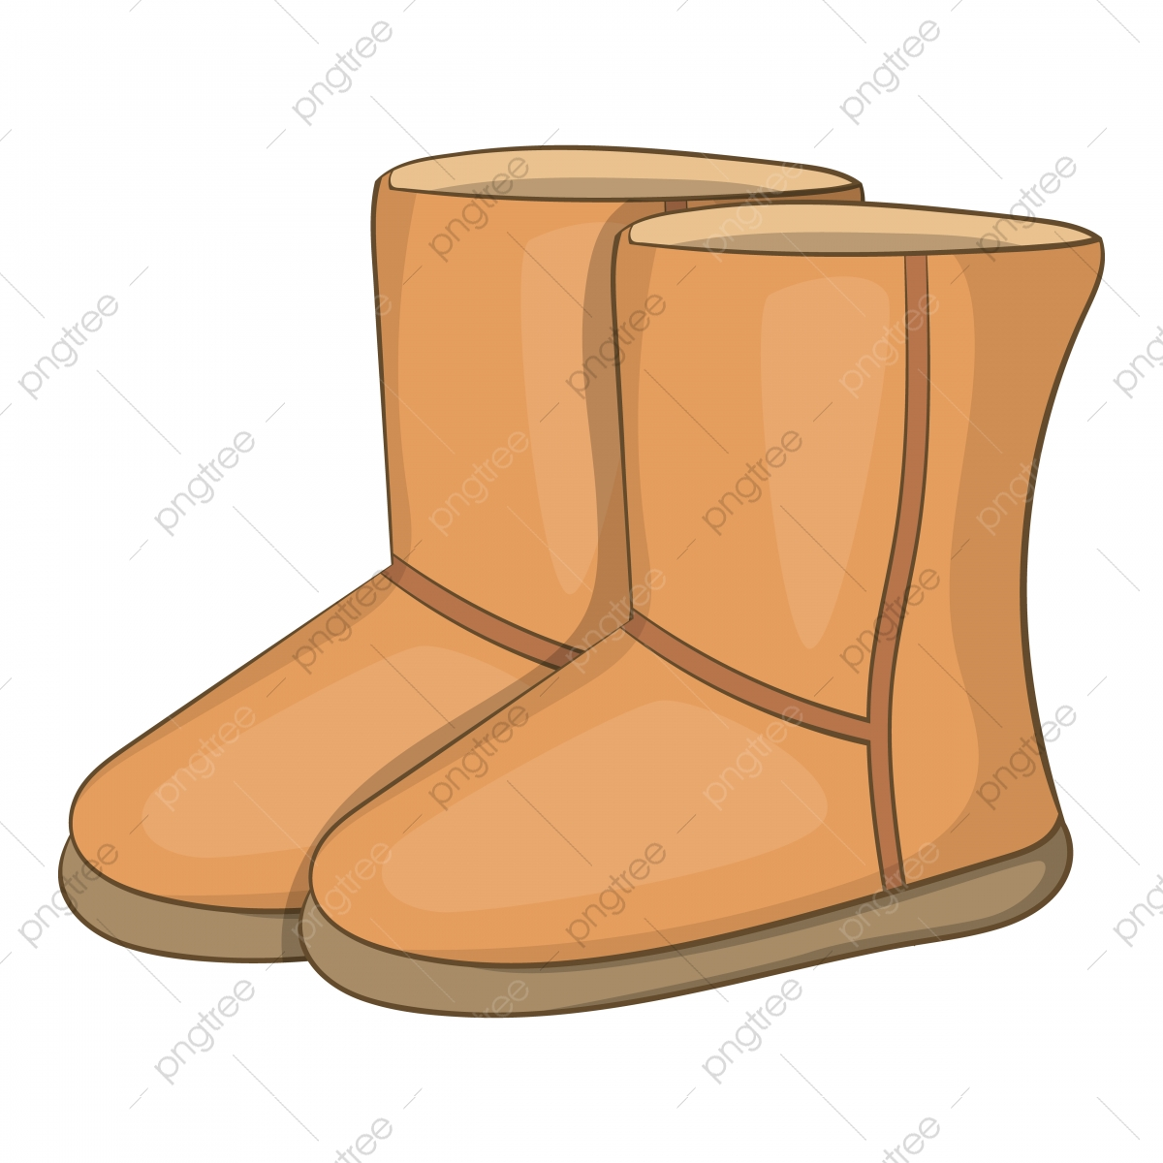
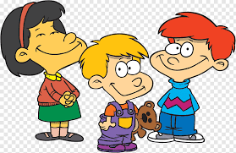


21
These chairs are good.

7
Look and rewrite the sentences.

Peter is in the bathroom.
_______________________________________
He is in the bathroom.
1
22
_______________________________________
_______________________________________
Sarah is a student.
_______________________________________
Tim’s drawing is cute.

_______________________________________
These flowers are pink.

_______________________________________
Tom and I are going home.

The school bus is yellow.
_______________________________________
_______________________________________
You and Mary are students.
_______________________________________
The school things are expensive.
_______________________________________
This calculator is red.
_______________________________________
My brother is cute.
Daisy is a nice girl.

