VERB” TOBE” ( ĐỘNG TỪ TOBE)

Unit 4

GRAMMAR BOARD
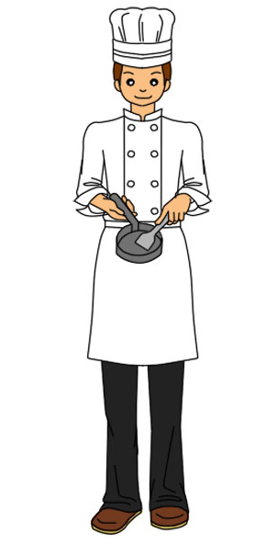
He is a cook.
He is not a pilot

He
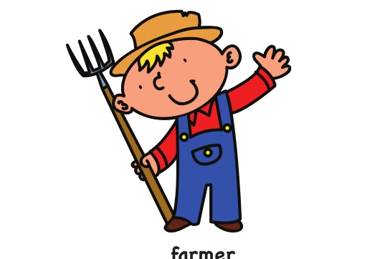
You are a famer
You are not a driver


She is a nurse.
She is not a teacher.
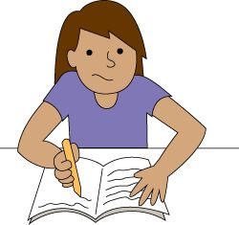
I am a student
I am not a doctor
POSITIVE ( KHẲNG ĐỊNH)
I am = I’m
He/she/it is = He’s/she’s/it’s
You/We/They are = You’re/We’re/They’re

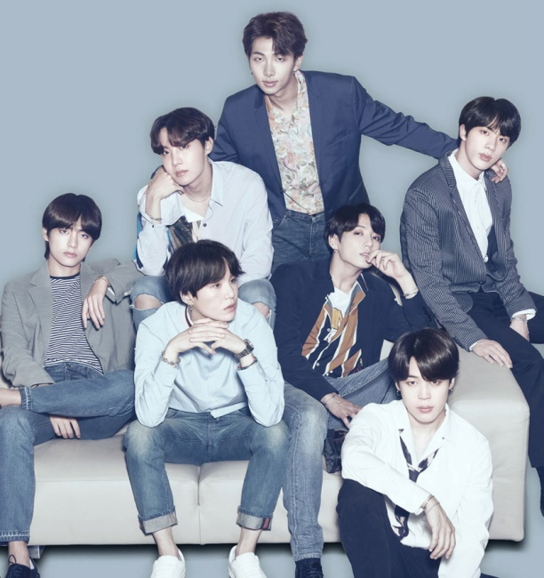
They are singers.
They are not students
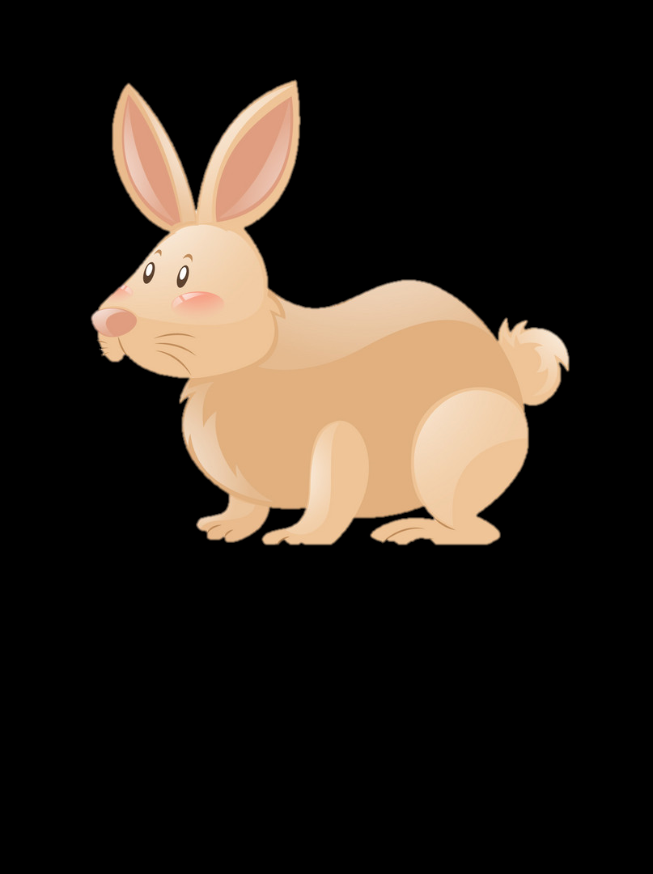
It is a rabbit.
It is not a dog.

We are fire fighters
We are not doctors

NEGATIVE ( PHỦ ĐỊNH)
I am not = I’m not

He/She/it is not = He/she/it isn’t
You/We/They are not = You aren’t/they aren’t/we aren’t
23
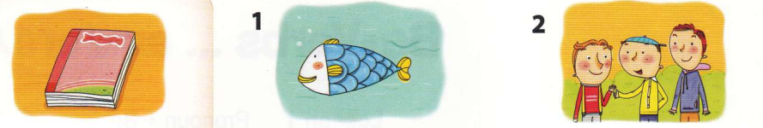

1
Look and write “ is, are”


3. We……….friends.
2. It ………..a fish.
1. It…is………a book.

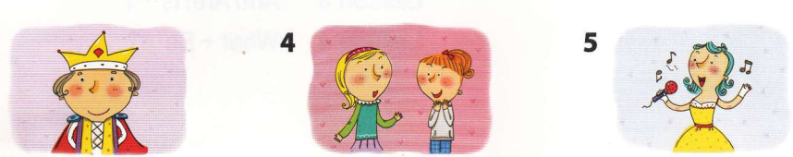
6. She…………a singer.
5. They…………..girls.
4. He…………a king.

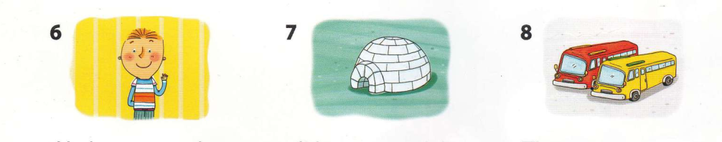
7. He……………..a boy.
8. It…………..an igloo.
9. They………….buses.

2
Look and write the contraction.

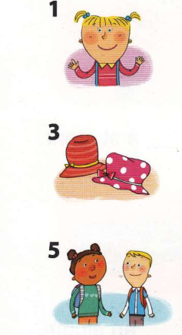
__________________students..
_________________ students.

__________________hats
66
5
4
32
22
1
_________________ a desk.
__________________ a desk.
__________________a lion.
__________________a lion.
__________________ a cook.
__________________ a cook.
__________________hats.
__________________hats.

She is a girl.
She’s a girl
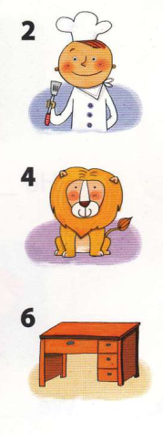
24

3
Read and write the contraction of the sentences.
She’s a singer.
1 | She is a singer. = | ………………………………………
2 | They are doctors = | ………………………………………
3 | You are cooks. = | ………………………………………
4 | It is a book. = | ………………………………………
5 | I am a boy. = | ………………………………………
6 | We are students. = | ………………………………………
7  4  Fill in “ I”, “ he”, “ she” “ it”, “ they” “ we”, “ ‘m not”, “ isn’t”, “ aren’t”  4 | He is a teacher. = | ………………………………………
1. He isn’t a policeman.
He is a singer.
2……………………… a teacher.
I’m a doctor.
3……………………… a postman.
He’s a pilot
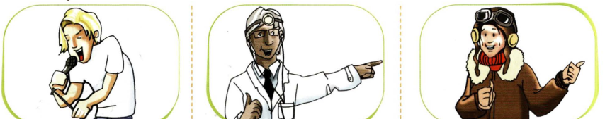

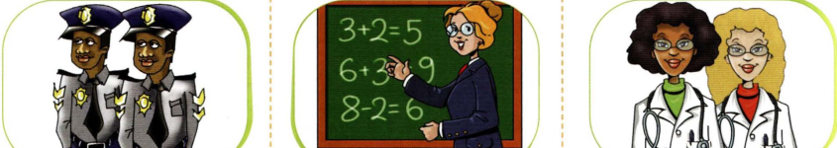
6………………….singers.
We’re doctors.
4………………… .fire fighters.
They are policemen.
5………………….an engineer.
She’s a teacher.
7…………………. balloons.
They are robots.
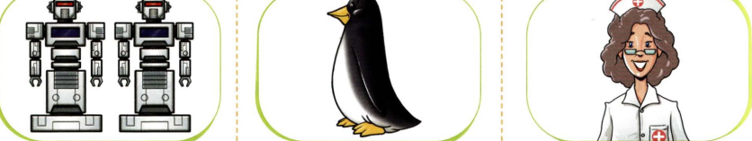
9…………………. a teacher.
She’s a nurse.

25
8…………………. a fox.
It’s a penguin.

5
Look, read and write

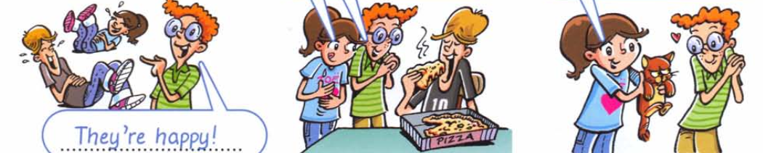
3. It/small
……………………………..
2. We/hungry
…………………………..
- They/happy
They are happy

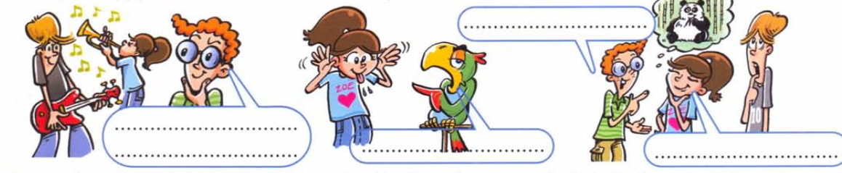
6. It/not/red and yellow
…………………………………
5. She/not/funny
……………………………
4. You/not/ bad
……………………

6
Look, circle and write. is, are, isn’t, aren’t.

1
2
3
4
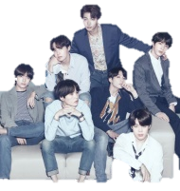

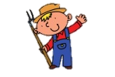


3. They………………….(drivers/ driver)

1.She isn’t a ( pilot/pilots)

4. We………………….( singers/singer)

2.He……………….a ( farmer/farmers)

26
QUESTION ( CÂU HỎI)

9
QUESTION
ANSWER

Am I..?
Yes, you are
No, you aren’t
No, I am not
Yes, I am
Are you….?
No, he/she/it isn’t
Yes, he/she/it is
Is he/she/it…?
Yes, we are
No, we aren’t
Are you….?
No, they aren’t
Yes, they are
Are they…….?
No, you aren’t
Yes, you are
Are we…….?

7
Answer the questions.

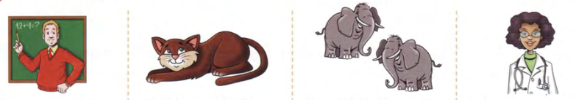
- Is he a teacher?
Yes, he is
- Is it a mouse?
No, it isn’t. It’s a cat
- Are they horses?
_______________________
- Is she a doctor?
______________________

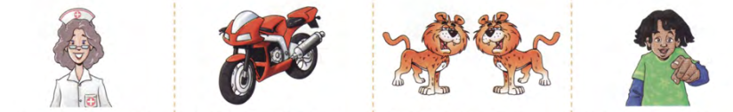
- Is it a motorbike?
_______________________
- Are you eight?
______________________

ch

- Are you a nurse?
______________________
- Are they dogs?
_____________________

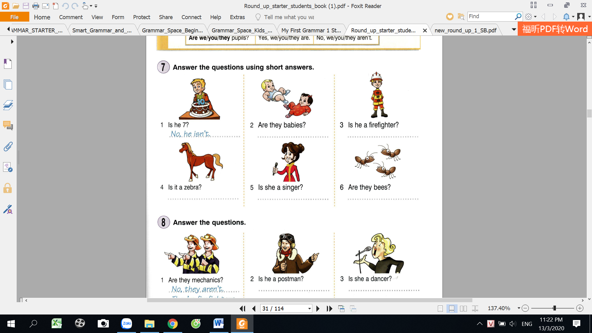

27
- Are they ants?
__________________________
- Is she a singer?
______________________
- Is it a zebra?
__________________________

8
Answer the questions.
Write “am, is, are”

Write the negative form
1. He _______ a policeman.
2. I _________a student.
3. She ______a secretary.
4. Your brother _____twelve years old.
5. Karin and Mark _______brother and sister.
6. It _______ a large truck.
7. I ________ going to the station.
8. My neighbours _________ Japanese.
9. Your girlfriend _________very cute!
10. I ___________going to school today.
1. He _______ a policeman.
2. I _________a student.
3. She ______a secretary.
4. Your brother _______twelve years old.
5. Karin and Mark _______brother and sister.
6. It _______ a large truck.
7. I ________ going to the station.
8. My neighbours _________ Japanese.
9. Your girlfriend ___________ very cute!
10. I ___________going to school today.
isn’t
is

Rearrange the sentences.

9

5. We / not / are / at home. We / not / are / at home.
- I / not / a teacher. / am
I am not a teacher.
_______________________________________
_______________________________________
Re-arrange the sentence.
1. I / not / a teacher. / am ___________________________
2. She / my mother. / is ___________________________
3. The boys / playful. / are ___________________________
4. The girl / in the room. / is ___________________________
5. We / not / are / at home. ___________________________
5. My dad / smart. / is ___________________________
6. My mother / a housewife. / is ___________________________
7. She / not / my sister. / is ___________________________
8. The teacher / angry. / is ___________________________
9. The dog / in the kennel. / is ___________________________

6. My dad / smart. / is We / not / are / at home.
2. She / my mother. / is
_______________________________________
7. She / not / my sister. / is We / not / are / at home.
_______________________________________
3. The boys / playful. / are
_______________________________________
_______________________________________
8. The teacher / angry. / is We / not / are / at home.
4. The girl / in the room. / is
28
_______________________________________
_______________________________________

10
Read and complete.
Is
she isn’t
- ___________she a dancer? No, ____________________.
- __________they from Japan? No, _____________________.
- __________he a bus driver? Yes,_____________________.
- ________it a rabbit? Yes, _____________________.
- _________they dirty? Yes, ______________________.
- __________Mary from Italy? No, _______________________.
- ________Mr Damce a doctor? No, _______________________.
- ________you a pilot? No, _______________________.
- __________they penguins? Yes,______________________.
- ____________you dancers? Yes,______________________.

11
Write in the plural.

They are girls
------------------------------------------------------------
- She is a girl.
------------------------------------------------------------
2. He is a teacher.

------------------------------------------------------------
3. It’s a deer.

------------------------------------------------------------
4. I am a boy.

------------------------------------------------------------
5. It is a box.

------------------------------------------------------------
6. You are a student.

------------------------------------------------------------
7. It is not a strawberry.

------------------------------------------------------------
8. He is not a farmer.

------------------------------------------------------------
9. You are from Australia.

------------------------------------------------------------
10. It’s a pencil.

29

12
Fill in “ am, is, are”
I……am……Linda. I ( 1)______. a student at a primary school. Mary (2)________my mum. She (3)________.a teacher. Peter (4) __________ my dad. He ( 5)_________a doctor. David (6) _________.my brother. He (7)____an engineer. We (8) __________happy family.

…………………………………………………………………………………………………………………………………………………………………………
…………………………………………………………………………………………………………………………………………………………………………
…………………………………………………………………………………………………………………………………………………………………………
…………………………………………………………………………………………………………………………………………………………………………
…………………………………………………………………………………………………………………………………………………………………………
…………………………………………………………………………………………………………………………………………………………………………
…………………………………………………………………………………………………………………………………………………………………………
…………………………………………………………………………………………………………………………………………………………………………
…………………………………………………………………………………………………………………………………………………………………………
…………………………………………………………………………………………………………………………………………………………………………
…………………………………………………………………………………………………………………………………………………………………………
…………………………………………………………………………………………………………………………………………………………………………
…………………………………………………………………………………………………………………………………………………………………………
…………………………………………………………………………………………………………………………………………………………………………

…………………………………………………………………………………………………………………………………………………………………………

…………………………………………………………………………………………………………………………………………………………………………
…………………………………………………………………………………………………………………………………………………………………………
…………………………………………………………………………………………………………………………………………………………………………

…………………………………………………………………………………………………………………………………………………………………………
…………………………………………………………………………………………………………………………………………………………………………
…………………………………………………………………………………………………………………………………………………………………………

Writing activity
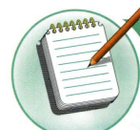

Write a short text about you and your family. Use the text in the exercise 12 as a model.

30

No  MY VOCABULARY   | Words | Vietnamese meanings.
1
2
3
4
5
6
7
8
9
10
11
12
13
14
15
16
17
18
19
20
22
23
24
25
 |  | 31
V-E TRASLATION-DỊCH VIỆT ANH
No | Vietnamese | English
1 | Chúng tôi là học sinh. | We are students.
2 | Anh ấy là một kỹ sư.
3 | Cô ấy là một y tá.
4 | Chúng là những con sư tử.
5 | Tôi không phải là bác sĩ. Tôi là giá viên
6 | Họ là không phải là ca sĩ. Họ là cứu hỏa.
7 | Cô ấy là ca sĩ đúng không? Đúng vậy.
8 | Ông ấy là nông dân đúng không?  Không, ông ấy là nha sĩ.
9 | Bạn là một phi công.
10 | Bạn có phải là phi công không?  Đúng vậy.
11 | Nó là một con chuột.
12 | Chúng là những con chuột.
13 | Nó là một con kiến.
14 | Nó là một củ hành đúng không?  Không, nó là một quả táo.
15 | Các bạn là những học sinh.
16 | Anh ấy không phải là một công nhân.
17 | Bà ấy không phải là một y tá.
18 | Chúng là những quả bóng bay.  32

