UNIT 1: WHAT'S YOUR ADDRESS?
PART 1: THEORY
- VOCABULARY
English | Pronunciation | Vietnamese
pupil | /ˈpjuːpəl/ | học sinh
address | /əˈdres/ | địa chỉ
hometown | /ˈhəʊmtaʊn/ | quê nhà
centre | /ˈsentər/ | trung tâm
view | /vjuː/ | cảnh, tấm nhìn
floor | /flɔːr/ | sàn nhà
district | /ˈdɪstrɪkt/ | huyện
street | /striːt/ | phố
lane | /leɪn/ | làn đường, ngõ
flat | /flæt/ | căn hộ
village | /ˈvɪlɪdʒ/ | làng
tower | /taʊər/ | tòa tháp
city | /ˈsɪti/ | thành phố
mountain | /ˈmaʊntɪn/ | núi
town | /taʊn/ | thị trấn
island | /ˈaɪlənd/ | đảo
countryside | /ˈkʌntrisaɪd/ | vùng nông thôn
small | /smɔːl/ | nhỏ bé
quiet | /ˈkwaɪət/ | yên tĩnh
far | /fɑːr/ | xa
beautiful | /ˈbjuːtɪfəl/ | đẹp
busy | /ˈbɪzi/ | bộn rộn
large | /lɑːdʒ/ | lớn, rộng
crowded | /ˈkraʊdɪd/ | đông đúc
pretty | /ˈprɪti/ | đẹp
tall | /tɔːl/ | cao
modern | /ˈmɒdən/ | hiện đại

- GRAMMAR
- Hỏi xem ai đó từ đâu đến
(?) Where + do/does + S + come from?
(+) S + come/comes + from + ...
Ví dụ:
Where do you come from? Bạn từ đâu đến?
I come from England. Tôi đến từ Anh.
Where does Linda come from? Linda từ đâu đến?
She comes from Australia. Cô ấy đến từ Úc.
- Hỏi địa chỉ của ai đó
(?) What is + possessive adj + address?
(+)It’s ...
(+) S + live/lives ...
Ví dụ
Giaoandethitienganh.info

What is your address? Địa chỉ của bạn là gì?
It is 153 Tay Son Street. Là số 153 phố Tây Sơn.
I live at 153 Tay Son Street. Tớ sống ở 153 phố Tây Sơn
What is her address? Địa chỉ của chị ấy là gì?
It is Ha Noi Tower. Là Tháp Hà Nội.
She lives in Ha Noi Tower. Chị ấy sống ở Tháp Hà Nội.
- Hỏi xem nơi nào đó như thế nào
(?) What is + (place)... + like?
(+) It’s + adj.
Ví dụ
What is your hometown like? Quê hương của bạn thế nào?
It’s peaceful and quiet. Rất yên bình và tĩnh lặng.
- PHONICS Track 01
Trong tiếng Anh, một từ khi có từ hai âm tiết trở lên thì một âm tiết thường được phát âm mạnh hơn và dài hơn so với các âm tiết còn lại. Âm tiết được phát âm mạnh hơn và dài hơn đó được gọi là ầm tiết mang trọng âm. Các em hãy nghe và tập thực hành phát âm chính xác
các âm dưới đây.
Listen and practise these words. Pay attention to the stress of words.
‘city ‘country ‘language ‘tower
‘modern ‘villa ‘building ‘district
PART II: LANGUAGE: VOCABULARY – GRAMMAR – PHONICS
- VOCABULARY
- Match each picture with each word.
No. | Pictures | Opt. | Words
1 |  | A | village
2 | 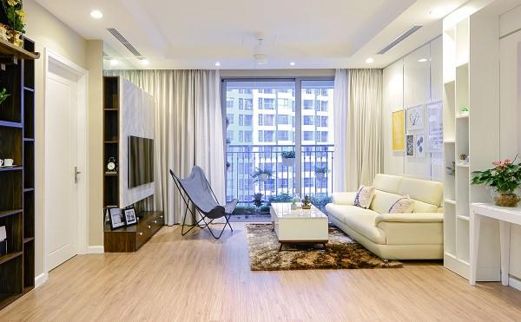 | B | pupil
3 |  | C | flat
4 |  | D | city centre
5 | 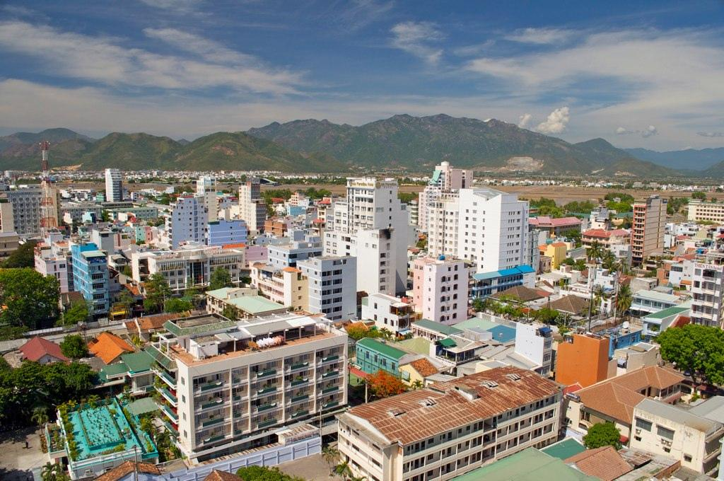 | E | tower
Your answer.
1. 2. 3. 4. 5.
2. Look at the picture and complete the word.
1 |  | m__ __ __ __ __ __ __
2 |  | t__ __ __
3 |  | i__ __ __ __ __
4 |  | c__ __ __ __ __ s__ __ __
5 |  | c__ __ __

- Complete the sentence with the correct word.
far crowded village island
come mordern flat floor
- Our city is very big and .
- The is beautiful and quiet.
- Do you like living in an ?
Giaoandethitienganh.info

- How is it from here to your countryside?
- My house is on the tenth of Dai Lien Tower.
- The city is so ___________________ and polluted.
- How often do you ______________ back to your hometown?
- Linda lives in _____________ 19, on the eighth floor of Diamond Tower.
- Look at the picture and complete the sentence.
1 |  | Where do you live?  I live at _______________  ______________ _______________ .
2 |  | Does she live ain a big city?  __________, she __________________.
3 |  | Do you live in a ___________________ ?  Yes, I do.
4 |  | This is my house. It has a beach _____________ .
5 |  | Do you live in a two – floor house?  No, I live in a _____________ .

- GRAMMAR
- Circle the redundant word in each sentence.
- What is your friend address?
- What's is James' address?
- I am live in Hanoi.
- My address is at 15 Pine Street.
- I live on the 25th floor of in Kaengnam Tower.
2. Underline the incorrect word and rewrite the correct one.
- Where are you come from?
- I lives in flat 10 on the second floor of Eiffel Tower.
- Hoa and Minh lives at 52 Ba Trieu Street.
- Jimmy lives on his family in London, England.
- Do your live in 93 Pineapple Road?
3. Reorder the words to make correct sentences.
- is/ city/ your/ like?/ What
____________________________________________________________________
- or/ your/ Is/ quiet/ city/ noisy?
____________________________________________________________________
- town/ beautiful/ is/ My peaceful./ and
____________________________________________________________________
- in/ Nam/ a/ and/ small/ lives/ city./ busy
____________________________________________________________________
- town/ Danny’s/ large/ is/ modern./ and
____________________________________________________________________
- Complete the sentence with a suitable word.
- I live my parents in Ha Nam Province.
- My city is very large crowded.
- My is 53 Pine Street, Wood District.
- Do you live in a city or in the ?
- Is your schoolbag or cheap?

- PHONICS
1. Mark the stress of the following words. The number 1 has been done for you as an example. Track 02
- ‘English 2. teacher 3. pupil 4. Parents
5. mother 6. doctor 7. tower 8. Busy
2. Mark the stress of the underlined words then say the sentence aloud. Track 03
- My parents live in a small village.
- Does Linda like living in the city?
- The mountain is so big and beautiful!
Giaoandethitienganh.info

- My brother is a factory worker.
- We often go to the theatre at the weekend.
PART III: SKILLS: LISTENING – SPEAKING – READING – WRITING
- LISTENING
Listen and do the tasks followed. Track 04
- Decide if each statement is True (T) or False (F).
Statements T/F
- James is living in Scotland.
- James doesn’t have many friends.
- James and his friend speak English.
- Mr. Paul and Mrs. Susan are very friendly.
- Lewis and Amy are in secondary school.
- Listen again and complete the text.
My name is James. I have moved to Scotland to study. Now I am living with the
Smith’s family. Since I got here, I’ve been really (1) ______________ with the study and making new friends. I speak (2) ______________ all the time here. We’re a real mix of nationalities: Chinese, Russian, Thai, Italian, Spanish, (3) ______________ but we all speak in English.
My host family is really nice. Mr. Paul and Mrs. Susan are very friendly and (4)_______________. The children are called Lewis and Amy. They’re both students at a primary school. They are so (5) _____________________.
II. SPEAKING.
Complete the conversation with available sentences. Then practise it with your friend.
- Where’s she from
- She’s from London, England
- How are you
- What’s her nationality
- Who’s that
Tony: Hello, Mai.
Mai: Hello, Tony. (1) ?
Tony: I’m fine, thank you. And you?
Mai: I’m fine, thanks. (2) _______________________________?
Tony: That’s Linda.
Mai: (3) ____________________________________________?
Tony: She’s from England.
Mai: Where in England is she from?
Tony: (4) _______________________________________
Mai: (5)
Tony: She’s English.
III. READING
Read and do the task followed.
This is the Pecker’s family. This is Peter Pecker. He is from Amsterdam, Holland. His wife, Jane, is American. She is from Boston, USA. Now she works and lives with her husband in Milan. Their child is Jimmy. He is a pupil at an international primary school. He has lot of friends at school. His best friend is Tom. He comes from England. He’s English.
- Read and decide if each statement is True (T) or False (F).
- Jane is from UK.
- Now Jane lives with her husband in Milan.
- Tom is the son of Mr. Pecker and Mrs. Jane.
- Jimmy has few friends at school.
- Tom comes from England.
- Read the passage again and answer the question.
- Where does Peter come from ? _____________________________________________________________________
- What is Jane’s nationality?
_____________________________________________________________________
- How many children do they have?
Giaoandethitienganh.info

_____________________________________________________________________
- What is her son’s name?
_____________________________________________________________________
- Who os Jimmy’s best friend?
_____________________________________________________________________
- WRITING
- Look at the picture and write sentences. The number 0 has been done for you as an example.

- Mai - Vietnam - Ha Noi 1. Thanh - Viet Nam - Ha Noi
Where does Mai come from
She comes from Vietnam _______________________________
Where in Vietnam is she from? _______________________________
Ha Noi. _______________________________

2. Ricky - Canada - Toronto 3. James - America - New York
__________________________________ _____________________________
__________________________________ _____________________________
__________________________________ _____________________________
__________________________________ _____________________________
2. Write sentences basing on available words. The first one has been done for you as an example.
- Jen/ Australia/ Australian
Hello, my name is Jen. I come from Australia. I am Australian.
- Linh/ Vietnam/ Vietnamese
_____________________________________________________________________
- Kathy/ England/ English
_____________________________________________________________________
- Jordy/ Laos/ Laotian
_____________________________________________________________________
- Kamilia/ Malaysia/ Malaysian
_____________________________________________________________________
- Janice/ America/ American
_____________________________________________________________________

