Exercise 1 Look and write
driver – teacher – baker - dancer

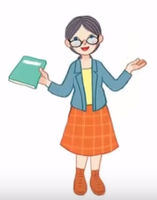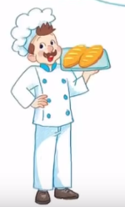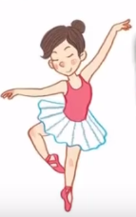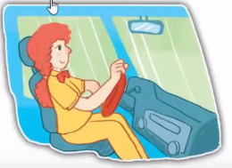

Exercise 2 Read and match
a) She is a teacher.
b) He is a baker.
c) She is a driver.
d) She is a dancer.
Exercise 3 Look and tick () or cross ()
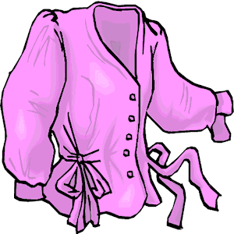
a) He is a teacher. b) Look at the trousers. c) She is a teacher.
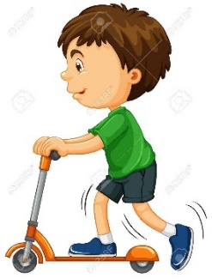
d)She is a baker. e) She is a dancer. f) She is riding a scooter.
Exercise 4 Read and complete
a) She ………..a driver. b) She is a ………… c) ………………. a teacher.
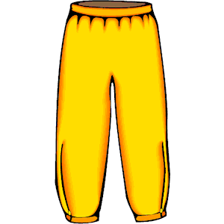
d) He is a ………….. e) Look at the ………… f) Look at the …………
Exercise 5 Put the words in the correct order
 |  | 
a) driver – She – is - a | b) is – teacher – She - a | c) doctor – He – is - a
……………………………………. | ……………………………………. | ……………………………………
d) She – dancer – is - a | e) He – a – is - baker | f) trousers – Look – at - the
……………………………………. | …………………………………… | ……………………………………
Exercise 6 Find the word which has a different sound in the part underlined
a) dancer | b) river | c) teacher | d) bread
a) water | b) sweater | c) breakfast | d) weather
a) school | b) spoon | c) coach | d) scooter
a) blouse | b) mouse | c) clouds | d) coach
a) chips | b) Tim | c) bike | d) milk
a) sheep | b) feet | c) three | d) leaf
a) bread | b) weather | c) breakfast | d) beach
a) coach | b) boat | c) coast | d) cloud
a) son | b) mother | c) box | d) honey
Exercise 7 Look and circle the best answer
0.She is a ………… 1. She is a …………
a. driver b. teacher c. baker a. baker b. driver c. dancer
2. My mother is a ………… 3. I have a …………
a. teacher b. dancer c. doctor a. sweater b. blouse c. coat

4.My father …………a baker. 5. He is eating a…………
a. am b. are c. is a. apple b. peach c. sweet
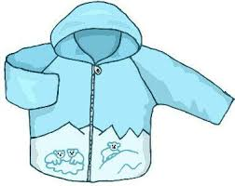
6. This is my ………….… 7. There is an apple ………….the table.
a. sweater b. coat c. blouse a. under b. on c. next to

