Exercise 1 Look and write
black – blossom – blanket – blackberries

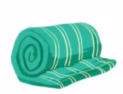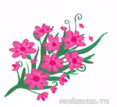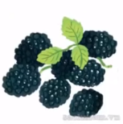

Exercise 2 Read and match
a) It’s black.
b) I like blossom.
c) There is a blanket.
d) I like blackberries

Exercise 3 Look and tick () or cross ()
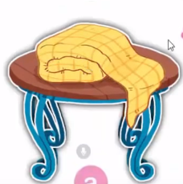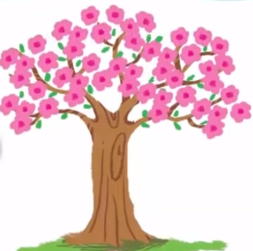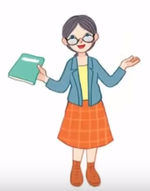
a) The blanket is on the table. b) I like blackberries . c) She is a teacher.
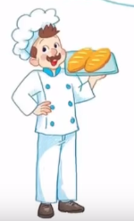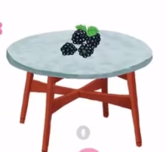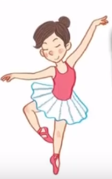
d)He is a driver. e) The blackberries are on the table. f) She’s a dancer.
Exercise 4 Read and complete
a) It’s on the………… b) They …… on the tree. c) It…………. black.
d) They are…………the table. e) It is a ………… f) I like …………

Exercise 5 Put the words in the correct order
a) on – They – are – the - table | b) It – the – is – on - table | c) blossom – like - I
……………………………………. | ……………………………………. | ……………………………………
d) on – the – tree – They - are | e) is – blanket – It - a | f) It – black - is
……………………………………. | …………………………………… | ……………………………………
Exercise 6 Find the word which has a different sound in the part underlined
a) blue | b) black | c) blanket | d) plate
a) blossom | b) bread | c) breakfast | d) brown
a) blouse | b) blanket | c) beach | d) blackberries
a) blouse | b) mouse | c) clouds | d) coach
a) food | b) moon | c) boy | d) book
a) meet | b) green | c) three | d) red
a) peach | b) leaf | c) bread | d)read
a) coach | b) boat | c) coast | d) cloud
a) face | b) cake | c) bag | d) lake

Exercise 7 Look and circle the best answer
0.The blanket is on the ………… 1. My sister likes …………
a. plate b. table c. chair a. blossom b. blackberries c. peaches
2. It is a ………… 3. The blackberries are………the table
a. coat b. sweater c. blanket a. under b. on c. near
4.My father is a ………… 5. Is she a teacher ? …………, it is.
a. driver b. baker c. teacher a. No b. Yes
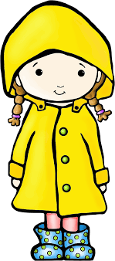
6. I want to be a ………… 7. She is wearing a …………
a. driver b. dancer c. teacher a. coat b. blouse c. sweater

