Unit 12
THIS IS MY HOUSE
PART I: THEORY

- VOCABULARY

English | Pronunciation | Vietnamese
living room | / ˈlɪvɪŋ ruːm/ | phòng khách
kitchen | / ˈkɪʧɪn/ | nhà bếp
bathroom | / ˈbɑːθru(ː)m/ | phòng tắm
bedroom | / 'bedru:m/ | phòng ngủ
dining room | / ˈdaɪnɪŋ ruːm/ | phòng ăn
garden | /'ga:dn/ | vườn
pond | / pɒnd/ | ao
yard | / jɑːd/ | sân
tree | /tri:/ | cây
gate | / geit/ | Cửa
fence | / fens/ | Hàng rào gỗ
hedge | hɛʤ | Hàng rào cây cối
over there | / ˈəʊvə ðeə/ | ở phía đó, ở đằng kia
in | / ɪn/ | Bên trong
around | / əˈraʊnd/ | Xung quanh

- GRAMMAR

- Mô tả có một cái gì đó ở đâu (ở đâu)
(+) There is a + name of the thing.
Example
There is a garden. (Có một khu vườn.)
(+)There is a + thing + adv of place.
Example
There is a garden in front of the house. (Có một khu vườn ở trước nhà.)
- Để nói về tính chất của cái gì.
(+) It is + adj.
Example
It is big. (Nó to.)
- Hỏi và trả lời xem có cái gì đó không
(?) Is there a + thing?
(+) Yes, there is.
(-) No, there is not.
Example
Is there a living room? (Có 1 phòng khách phải không?)
Yes, there is. (Có.)

(?) Is there a + thing + adv of place.
(+) Yes, there is.
(-) No, there is not.
Example
Is there a book in the bag? (Có một cuốn sách trong cặp phải không?)
No, there is not. (Không có đâu.)

- PHONICS
Practice pronouncing these sounds and these words. Track 05

/ ʧ/ | Chess  / ʧes/ | Kitchen  / ˈkɪʧɪn/ | chalk  / ʧɔːk/ | chair  / ʧeə/
/ θ / | bathroom  / ˈbɑːθru(ː)m/ | three  / θriː/ | thanks  /θæŋks/ | Think  /θɪŋk/

PART II: LANGUAGE: VOCABULARY - GRAMMAR – PHONICS

- VOCABULARY

- Mat each picture with each word

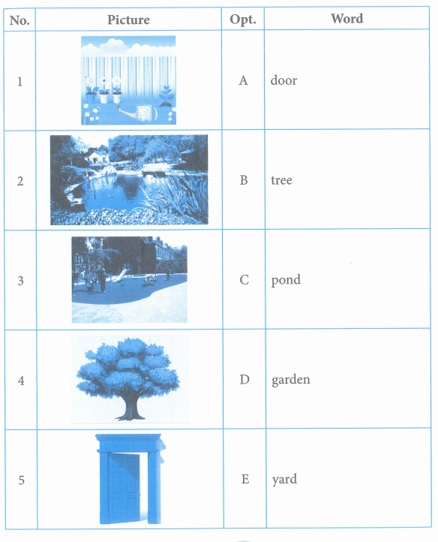
- Look at the picture and complete the word
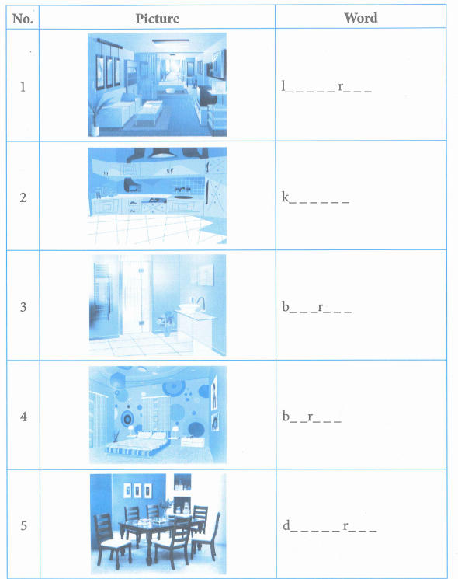

3.Choose the odd one out
1. A. father B. bedroom C. mother D. brother
2. A. pond B. yard C. fence D. bathroom
3. A. colour B. brown C. black D. white
4. A. football B. chess C. play D. skating
5. A. kitchen B. dining room C. bathroom D. house

- GRAMMAR

1. Match each question with each answer.
No. | Question | Opt. | Answer
1 | Do you like table tennis? | A | Yes, I do.
2 | Who is that woman? | B | No. There is a hedge around the garden.
3 | How old is your mother? | C | She is 37 years old.
4 | Is there a pond over there? | D | She is my grandmother.
5 | Is there a fence around the garden? | E | Yes, there is.

Your answer:
- 2. 3. 4. 5.

- Underline the mistake in each sentence then rewrite the correct one.

- Who is this woman? - He is my aunt
...............................................................................................
- How old is your uncle? - She is 60 years old
...............................................................................................
- Your garden are very nice
............................................................................................
- Is there a bedroom there? - No, there is
........................................................................................................
- Is the living room small? - No. It is small.
..................................................................................................................

- Write sentences basing on available words, the first one has been done for you as an example.
- tree/ in garden/ yes
Is there a tree in the garden?
Yes, there is.
- fence/ around house/ no
....................................................................................................................
....................................................................................................................
- hedge/ around garden/ yes
.....................................................................................................................
......................................................................................................................
- bathroom/ in house/ yes
......................................................................................................................
........................................................................................................................
- pond/ in garden/ no
........................................................................................................................
.......................................................................................................................
- bedroom/ in house/ yes
.........................................................................................................................
.........................................................................................................................

- Write sentence basing on available word, the first one has been done for you as an example
living room/ large
The living room is large
- kitchen/ small
................................................................................................................................
- bathroom/ clean
...............................................................................................................................
- bedroom/ cozy
.............................................................................................................
- yard/ big
..............................................................................................................
- gate/ green
............................................................................................................

- PHONICS

- Complete the word and say aloud. Track 06

Ch th
- -----ess 2. -----ree 3.----alk
4.----ildren 5. -----anks 6.Ba--room

- Listen and complete the sentence. Track 07
Do you like ------------------ ?
That is a piece of -----------------------
There are ----------------------- brown books
Jen is in the ---------------------------
Where are the -------------------------------?

PART III: SKILLS: LISTENING - SPEAKING - READING – WRITING
- LISTENING

Listen and complete the text. Track 08
Hello. My name is Amy. I live in London. My house has (1)
floors. On the ground floor there is a hall, a living room and a small (2)
. Upstairs, there are two bedrooms and a (3) . My
bedroom is small but very (4) . It is blue and there are many
things in the room. Every night, I see stars through the (5) . It is
great and I love my room.

- SPEAKING
Complete the conversation with available phrases.
- lets take a look at my room
- there is a hedge around the garden
- Are your parents at home
- this is the bathroom
- Its so large and beautiful

Mindy: Come in, Anna.
Ann: Wow, what a beautiful house. (1).............................................
Mindy: No, they are at work now. Come on, (2).................................
Here is my bedroom.
Ann: Its so nice. Its blue.
Mindy: Yes. I like blue. And (3)...............................................
Ann: Your bathroom is so big. Oh, where is your parents bedroom?
Mindy: Its over there
Ann: (4) ............................................ And, do you have a garden?
Mindy: Yes, and (5) ..............................................................

- READING

Read and do the task followed.
Hi! My name is Kate. I live in a big house in London. Downstairs, there is a hall, a living room, a toilet, a dining room and a kitchen. The kitchen is next to the toilet. Upstairs, there are two bedrooms, a bathroom and a study. There is a small garden in front of the house. My bedroom is very beautiful and it is blue. I like it very much

- Complete the sentence

- Kate lives in ......................................................
- The living room is..............................................
- The toilet is ......................... the kitchen
- There are two .......................... upstairs.
- In front of the house, there is a ...................................
- Decide if each statement is true (T) or false (F)
Statement True/ False
- Kate lives in London ...................................
- Kate lives in a big house ....................................
- There is a kitchen behind the toilet. ...................................
- There are six rooms upstairs ....................................
- Kates bedroom is blue ....................................

- WRITING

Write sentences basing on available words, the first one has been done for you as an example.
- a large bathroom/ in my house
There is a large bathroom in my house.

- two big ponds/ in front of her house
..............................................................................................................
- a small yard/ behind his house.
.........................................................................................................
- three beautiful bedrooms/ in their house.
..............................................................................................................
- a green hedge/ around Nams house
..............................................................................................................
- a cozy kitchen/ in our house
...................................................................................................................

