UNIT 12: DON'T RIDE YOUR BIKE TOO EAST!

 PART I: THEORY

I. VOCABULARY
English | Pronunciation | Vietnamese
window | /ˈwɪndəʊ/ | Cửasổ
accident | /ˈæksɪdənt/ | Tai nạn
tip | /tɪp/ | Lờikhuyên, mẹo
stove | /stəʊv/ | Bếpga
kitchen | /ˈkɪtʃɪn/ | Nhàbếp
balcony | /ˈbælkəni/ | Ban công
answer | /ˈɑːnsə(r)/ | Trảlời
loudly | /ˈlaʊdli/ | To (âmthanh)
prevent... from ... | /prɪˈventfrəm/ | Ngănchặn … khỏicáigì
young | /jʌŋ/ | Trẻ, trẻtuổi
sharp | /jʌŋ/ | Sắcnhọn
hear | /hɪə(r)/ | Nghe
reply | /rɪˈplaɪ/ | Phảnhồi
fall | /fɔːl/ | Ngã, rơi
scratch | /skrætʃ/ | Cào
bite | /baɪt/ | Cắn
sting | /stɪŋ/ | Đốt (ong)
make sure | /meɪkʃʊə(r)/ | Đảmbảorằng
allow | /əˈlaʊ/ | Cho phép
Play with the knife | /pleɪwɪððənaɪf/ | Nghịchdao
Cut yourself | /kʌtjɔː(r) ˈself/ | Tựcắtchảymáu

get burnt | /ɡetbɜːnt/ | Bịbỏng
Touch the stove | /tʌtʃðəstəʊv/ | Chạmvàobếpga
Play with matches | /pleɪwɪðˈmæʧɪz/ | Nghịchdiêm
Ride the bike too fast | /raɪdðəbaɪktuː fɑːst/ | Đixeđạpquánhanh
Climb the tree | /klaɪmðə triː/ | Leo trèocâycối
Run down the stairs | /rʌndaʊnðəsteə(r)z/ | Chạyxuốngcầu thang
Break the leg/ arm | /breɪk ðə leg/ ɑːm/ | Làmgãychân/ tay
Fall off the bike/ motorbike | /fɔːlɒfðəbaɪk/ ˈməʊtəˌbaɪk/ | Nagxxeđạp/ xemáy
Roll off | /rəʊlɒf/ | Lăn ra (khỏicáigì)
Dangerous | /ˈdeɪndʒərəs/ | Nguyhiểm
Common | /ˈkɒmən/ | Thôngthường
safe | /seɪf/ | Antoàn

II. GRAMMAR
1. Đưa ra lời cảnh báo và phản hồi lại lời cảnh báo tai nạn
(-) Don’t + V-inf!
(-) OK, I won’t.
Example:
- Don’t play with the knife! Đừng nghịch dao!
OK, Iwon’t. Được rồi, tớ sẽ không làm.
2. Hỏi và trả lời câu hỏi về việc phòng ngừa tai nạn (?) Why shouldn’t + s + V-inf?
(+) Because ...
Example:
- Why shouldn’t Iplay with the cat? Tại sao tớ không nên nghịch con mèo?
Because he may scratch you. Vìnócóthểcàocậu.

III. PHONICS
Trong tiếng Anh, các câu dạng wh-question hoặc câu mệnh ỉệnh luôn có giọng điệu đi xuống. Các em hãy nghe và tập thực hành phát âm chính xác các câu dưới đây.

Mark the intonation of the following sentences. (Track 04)
1. Don’t climb this tree. OK, I won’t.
2. Don’t swim in this river. OK, I won’t.
3. Why shouldn’t I climb this tree? Because you may fall down.
4. Why shouldn’t I swim in this river? Because you may drown.
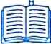

PART II : LANGUAGE: VOCABULARY – GRAMMAR – PHONICS
I. VOCABULARY
1. Look at the picture and tell what they are doing.
1 | 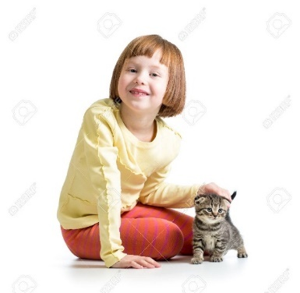 | She is _____________________________
2 | 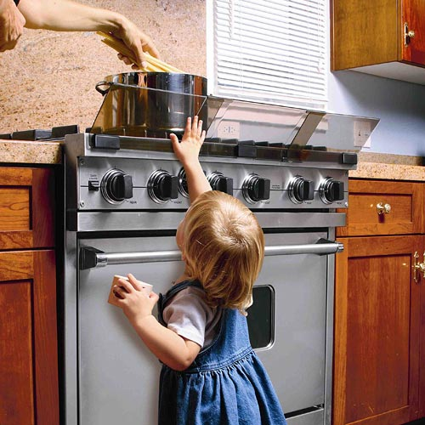 | She is _____________________________
3 | 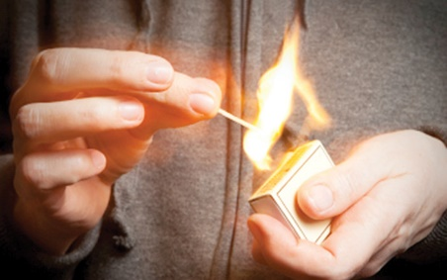 | He is _____________________________
4 | 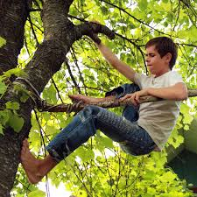 | He is _____________________________
5 | 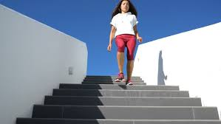 | She is _____________________________
2. Match each cause with each result.
1. | ride the bike too fast | A. | Cut yourself
2. | Climb the tree | B. | Fall off the bike
3. | Play with matches | C. | Get burnt
4. | play with the knife | D. | Drown
5. | go swimming in the lake | E. | Fall down
Your answer:
1. _______ 2. _______ 3. _______ 4._______ 5. _______
3. Complete the sentence with a suitable word.
bite run down drown fall down sting
matches scratch sharp burn fall off
- Don’t touch the stove. You may get a .
- Don’t play with the cat. He may you.
- Don’t play with the dog. He may you.
- Don’t play with the bee. He may you.
- Don’t play with the knife. You may get a cut.
- Don’t the stairs. You may break your leg.
- Don’t ride too fast. You may .
- Don’t climb that tall tree. You may .
- Don’t swim in the lake. You may .
- Don’t play with . You may get burnt.
II. GRAMMAR
1. Reorder the words to make correct sentences.
1. go/ we/ barefoot?/ shouldn’t/ Why
……………………………………………..……………………………………………
2. may happen/ when/What/ you/ that small branch?/ climb
……………………………………………..……………………………………………
3. Be/ the neighbor’s/with/ kittens!/ careful
……………………………………………..……………………………………………
4. bite/ may/next door/ you./ The dog
……………………………………………..……………………………………………
5. may happen/ when/What/1 play/ the sharp knife, with
……………………………………………..……………………………………………
2. Circle the correct answer.
- What’s (1) matter/ wrong with you?
I have got a burn.
(2) Why/ When do you have it?
Because I touch the stove. (3) What/ How should I do?
You should put ice (4) by/ on your burn. I will get you some.
- Don’t play with the sharp knife (5) and/ or you will cut yourself.
- He is (6) riding/ rode his motorbike too fast. He may (7) fall off/ fell off it.
- What is the matter with Nam?
He has a backache (8) because/ while yesterday he (9) carried/ carries many heavy bags.
I will take him to the doctor.
No. You should tell the doctor to (10) coming/ come here because Nam can’t go anywhere.
3. Put the verbs in brackets into the correct form.
- (1. not touch) the stove or you will get burnt.
- He had better (2. not play) with matches.
- Yesterday she (3. run down) the stairs and (4. break) ___________ her leg.
- (5. not allow) your baby sister (6. play) ___________ with the cat. It may (7. scratch) ____________her.
- (8. make) sure your baby can’t (9. roll off) ____________ the bad.
- Don’t let your baby sister (10. open) any windows.
III. PHONICS
1. Mark the intonation of the following sentences. (Irack 05)
1. Don’t ride your bike too fast._______
OK, I won’t. _______
2. Don’t play with matches._______
OK, I won’t._______
3. Why shouldn’t I ride my bike too fast?_______
Because you may fall off the bike._______
4. Why shouldn’t I play with matches?_______
Because you may get burnt._______
2. Listen again and read the sentences in 1 aloud. Pay attention to theintonation of sentences.
PART III: SKILL: LISTENING – SPEAKING – READING – WRITING
I. LISTENING
1. Listen and complete the text. (Track 06)
MAKE YOUR HOME SAFE FOR CHILDREN
Here are some measures you can take in your home to make sure your children stay safe:
- Don’t leave children alone in a room where there’s a (1) __________.
- Keep matches, (2)__________and candles in a place where childrencan’t see or reach them - and put child locks on cupboards.
- Don’t let children play or leave toys near a fire or (3)__________.
- Never leave children alone in the kitchen when you’re cooking and
never let them play near the (4)__________.
- Make sure your (5)__________appliances are switched off when they
are not being used.
2. Listen and complete the text. (Track 07)
SAFETY
Accidents can happen in any place and at any time. You should be (1)__________responsible and sensible to avoid any possible accidentshappening to you and your younger brother or sister.
Please follow these safety rules:
1. Be careful when you use a sharp (2)__________like a knife or a pairof scissors. Keep away from animals such as (3)__________and dogs. Theymay bite or scratch you.
2. Be responsible. Never let your younger brother or sister or any otherkids play withlighters. They may start a (4) __________fire. Get youryounger brother or sister to (5)__________a helmet when they are on abike or a motorbike.
3. Be clever when an accident happens. Call for help when necessary.
II. SPEAKING
Complete the conversation with available sentences. Then practise it with your friend.
A. He may scratch you
B. You may fall down if you climb that tall tree
C. My kite is stuck in the tree
D. Let’s watch TV or do something like that
E. I’m playing with the cat.
Mrs. Hamilton: what are you doing?
Joey: (1) ____________.
Mrs. Hamilton: What cat?
Joey: Dad bought me a cat this morning.
Mrs. Hamilton: Oh no, don't play with him, (2) ____________.
Joey: Yeah, mum.
Mrs. Hamilton: As you are bored, it's windy and you can fly your kite.
Joey: (3) ____________. Oh, I will climb it.
Mrs. Hamilton: Ask dad to do it for you. (4) ____________.
Joey: But look at those bees. Dad may get a bite from them.Mum, what should I do?
Mrs. Hamilton: (5) ____________.
III. READING
Read and answer the question.
FRANK'S ACCIDENT
It was on my birthday. My parents gave me a wonderful black bike. It was so cool and I really liked it. In the afternoon, I rode my bike through the forest and I thought it was the best part of my birthday. I teas so happy. Suddenly a rabbit ran across the path. I tried to stop but I was too fast. Too late! I fell off the bike and landed among some bushes. Ouch! My right leg was hurt, I couldn’t move. I shouted for help but there was no one nearby. I even didn’t have a mobile with me.
Then there were strange noises from behind the trees and I saw someone. It was Pluto. He teas looking for me. He called an ambulance and then I teas taken to the nearest hospital. It was lucky for me.
Now, my foot is in plaster and I can’t walk to school. But that’s not so bad.
1. What did Frank’s parents give him as a birthday present?
……………………………………………..……………………………………………
2. Did Frank love that present?
……………………………………………..……………………………………………
3. What did he do in the afternoon?
……………………………………………..……………………………………………
4. What suddenly happened when he was riding his bike?
……………………………………………..……………………………………………
5. Did Frank keep going or try to stop?
……………………………………………..……………………………………………
6. What was the matter with his leg?
……………………………………………..……………………………………………
7. Could he walk or ride?
……………………………………………..……………………………………………
8. Why couldn’t he make a phone call?
……………………………………………..……………………………………………
9. What did Pluto do to help Frank?
……………………………………………..……………………………………………
10. What’s wrong with his foot now?
……………………………………………..……………………………………………
IV. WRITING
1. Look at the picture and answer the question.
1 | Why shouldn’t I play with the dog?  __________________________________. | 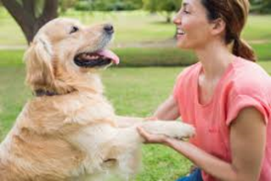
2 | Why shouldn’t I play with the cat?  __________________________________. | 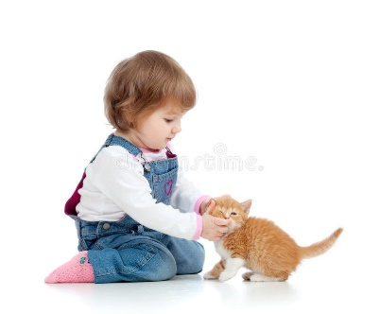
3 | Why shouldn’t I play with the lighter?  __________________________________. | 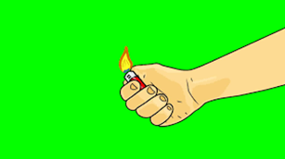
4 | Why shouldn’t I climb that tall tree?  __________________________________.
5 | Why does she get a cut?  __________________________________. | 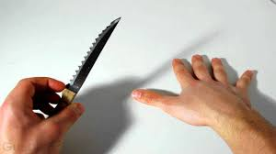
2. Look at the picture and write sentences, the first one has been done for you as an example.
0 | 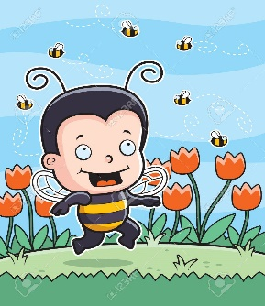 | You shouldn’t play with the bee because it may sting you.
1 | 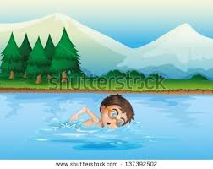 | ________________________________________  ________________________________________
2 | 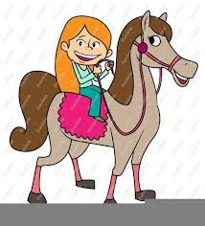 | ________________________________________  ________________________________________
3 | 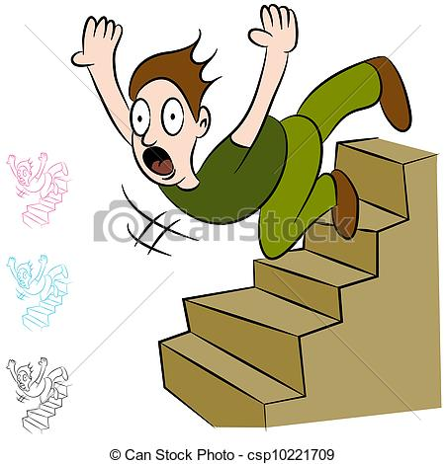 | ________________________________________  ________________________________________
4 | 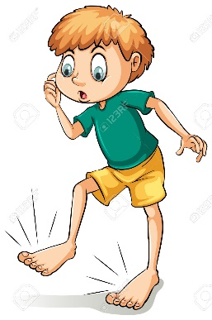 | ________________________________________  ________________________________________
5 | 