Exercise 1 Look and write
brush – Brian – branch - bridge

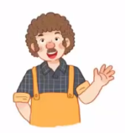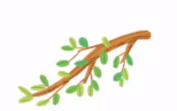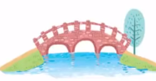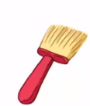

Exercise 2 Read and match
a) There is a brush.
b) He is Brian.
c) There is a bridge.
d) There is a branch .

Exercise 3 Look and tick () or cross ()
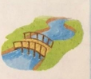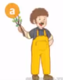
a) He is Mike. b) There is a bridge over the river c) Brian has a brush
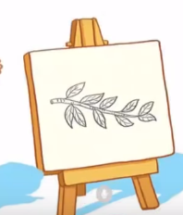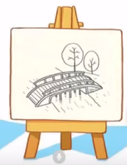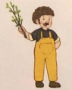
d) Brian is drawing a branch . e) Brian is drawing a brush f) He’s holding a branch.
Exercise 4 Read and complete
a) He is ……………. b) He’s drawing a ……………. c) He’s drawing a ……………….
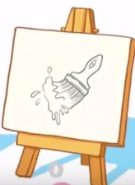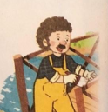
d) He’s drawing a ………….e) He’s ………… a branch . f) Brian has a …………

Exercise 5 Put the words in the correct order
a) Brian – is – a brush - drawing | b) Brian – is – a branch- drawing | c) holding – He’s – a branch
……………………………………. | ……………………………………. | ……………………………………
d) Brian – He - is | e) Brian– bridge - drawing – is -a | f) bridge – There - is - a
……………………………………. | …………………………………… | ……………………………………
Exercise 6 Find the word which has a different sound in the part underlined
a) blouse | b) black | c) blanket | d) bridge
a) brown | b) brush | c) present | d) brothers
a) blue | b) peach | c) blanket | d) blackberries
a) blouse | b) mouse | c) clouds | d) coach
a) blossom | b) playing | c) plate | d) plane
a) tree | b) branch | c) truck | d) train
a) breakfast | b) sea | c) beach | d)read
a) road | b) shoes | c) coach | d) raincoat
a) look | b) boots | c) food | d) coast

Exercise 7 Look and circle the best answer
0.Brian is drawing a ………… 1. He is …………a branch.
a. branch b. blossom c. tree a. hold b. holding c. holds
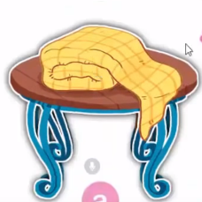
2. Brian is drawing a ………… 3. Is the blanket ..……the tale ? Yes, it is.
a. lake b. road c. bridge a. under b. on c. near
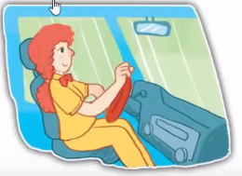
4.Is she a teacher ? No, ………… 5. Who is this ? He is …………
a. she is b. she isn’t c. she a. Ben b. Mike C. Brian
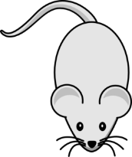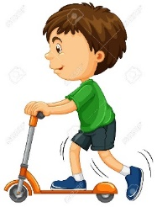
6. It is a ……………. 7.He has a …………
a. mouse b. cat c. monkey a. bike b. boat c. scooter

