Exercise 1 Look and write the missing letters
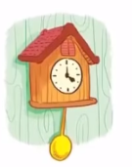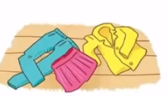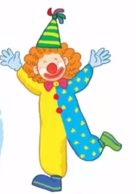
_ _ _ wn
_ _ oud
clo _ _ es
cl _ ck

Exercise 2 Read and match
a) I can see clothes.
b) I can see a clock.
c) I can see clouds.
d) I can see a clown.

Exercise 3 Look and tick () or cross ()
a) I can see a bag. b) I can see a clown . c) I can see clothes.
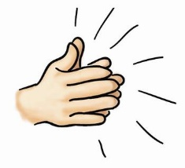
d) I can see a branch e) clap your hands. f) I can see a clock.
Exercise 4 Read and write : Yes, I can or No, I can’t
a) Can you see a boat ? b) Can you see a clown ? c) Can you see clothes?

……………………………. ……………………………. …………………………….
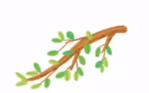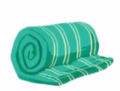
d) Can you see clouds ? e) Can you see a brush ? f) Can you see a blanket ?

……………………………. ……………………………. …………………………….
Exercise 5 Put the words in the correct order
a) clock – Can – see – you –a ? | b) clothes – see – Can – you ? | c)see – you – Can - a -branch?
……………………………………. | ……………………………………. | ……………………………………
d) clown – Can – you – see – a ? | e) Can – see – clouds – you ? | f) see – Can – you– a blanket ?
……………………………………. | …………………………………… | ……………………………………
Exercise 6 Find the word which has a different sound in the part underlined
a) clock | b) blossom | c) blanket | d) blackberries
a) clean | b) clown | c) cloud | d) crab
a) mouse | b) coach | c) house | d) cloud
a) blouse | b) coast | c) boat | d) coach
a) sun | b) bus | c) run | d) boots
a) ready | b) leaf | c) sea | d) beach
a) breakfast | b) brown | c) bridge | d)blossom
a) three | b) bee | c) head | d)tree
a) coat | b) boots | c) boat | d) coast

Exercise 7 Look and circle the best answer
0.Can you see a ………… ? 1. What can you see ?
Yes, I can. I can see a …………
a. boat b. car c. clock a. clock b. clown c. cloud
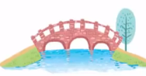
2. These are my ………… 3. There is a …………
a. sweater b. clothes c. blouse a. bridge b. brush c. branch
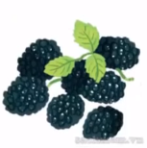
4. I like ……………… 5. Is he a ……………… ? Yes, he is.
a. blackberries b. blossom a. teacher b. baker C. driver
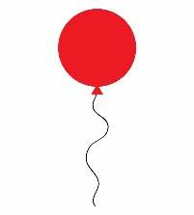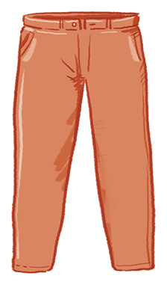
6. Is it a ……………? Yes, it is. 7.Look at the …………
a. clock b. ball c. balloon a. blouse b. sweater c. trousers

