Exercise 1 Look and write
chocolate | cheese | cherries | chicken

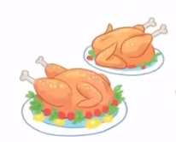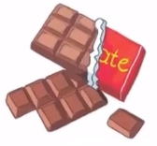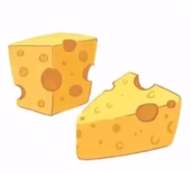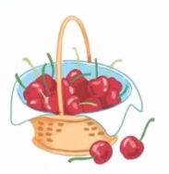

Exercise 2 Read and match
a) We need some blackberries
b) We need some chicken.
c) We need some cherries.
d) We need some chocolate.
e) We need some cheese. |  | 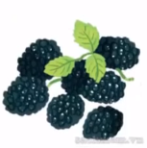
Exercise 3 Look and tick () or cross ()
a) We need some cheese. b) We need some chicken. c) We need some cherries.
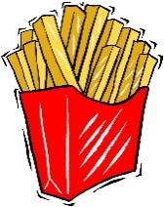
d) We need some chocolate. e) We need some peaches. f) We need some chips.
Exercise 4 Read and write
a) What do we need ? b) What do we need ? c) What do we need ?

……………………………. ……………………………. …………………………….
d) What do we need ? e) What do we need ? f) What do we need ?

……………………………. ……………………………. …………………………….
Exercise 5 Put the words in the correct order
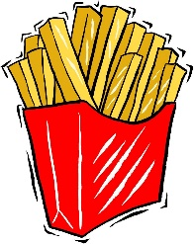
a) chips – We – need - some | b) We – some – cherries - need | c) We – some – chocolate - need
……………………………………. | ……………………………………. | ……………………………………
d) cheese – some – need - We | e) We – some - chicken - need | f)blackberries – need – We – some
……………………………………. | …………………………………… | ……………………………………
Exercise 6 Look and write
bl | br | cl | ch

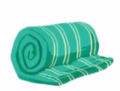 |  | 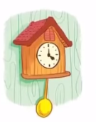 | 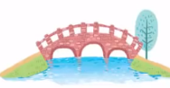
_ _ anket | _ _ eese | _ _ ock | _ _ idge
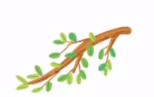 | 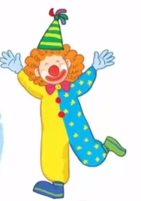 |  | 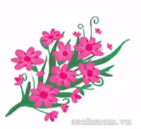
_ _ anch | _ _ own | _ _ ips | _ _ ossom

Exercise 7 Look and circle the best answer
0.Can you see a ………… ? 1. What do we need ?
Yes, I can. We need some …………
a. clock b. clown c. cloud a. chicken b. cheese c. chips
2. I like ………… 3. There are some …………
a. chocolate b. chips c. chicken a. chips b. bread c. cheese
4. I have a ……………… 5. Let’s buy some ……………… .
a. clock b. coat b. car a. peaches b. apples C. cherries
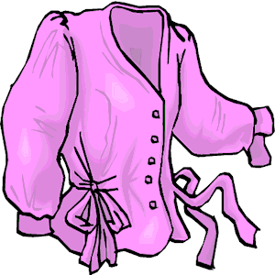
6. I don’t like……………… 7. My ……………… is purple.
a. cherries b. oranges c. blackberries a. blouse b. sweater c. coat

