UNIT 15: DO YOU HAVE ANY TOYS?

PART I: THEORY
- VOCABULARY
English | Pronunciation | Vietnamese
toy | / tɔɪ / | Đồ chơi
doll | / dɒl / | Búp bê
teddy bear | / ˈtɛdi beə/ | Gấu bông
car | / kɑː (r)/ | Ô tô
robot | / ˈrəʊbɒt / | Rô bốt
puzzle | / ˈpʌzl / | Trò xếp hình
yoyo | / ˈjəʊjəʊ / | Yo- yo
ship | / ʃɪp / | con tàu
plane | / pleɪn / | máy bay
kite | / kaɪt / | con diều
drum | / drʌm / | cái trống
boat | / bəʊt / | con thuyền
have | / hæv / | có
has | / hæz / | có
- GRAMMAR
- Để nói mình sở hữu cái gì
(+) I have a + name of the thing.
(-) I do not have a + name of the thing.
Example: I have a book. (Tôi có một cuốn sách.)
I do not have a rubber. (Tôi không có cục tẩy.)
- Nói rằng ai đó sở hữu cái gì
(+) He/ She + has a + name of the thing.
(-) He/ She + does not have a + thing.
Example: He has a school bag. (Anh ấỵ có một cái cặp sách.)
She doesn’t have a ruler. (Chị ấỵ không có thước kẻ.)
- Hỏi xem ai đó có sở hữu cái gì không
(?) Do you have a + name of the thing?
(+) Yes, I do.
(-) No, I do not.
Example: Do you have a ball? (Bạn có một quả bóng không?)
No, I do not. (Không, tôi không có.)
- Hỏi xem người nào đó có sở hữu vật gì không
(?) Does + he/she + have a + name of the thing?
(+) Yes, he/she + does.
(-) No, he/she + does not.
Example: Does she have a robot? (Cô ấy có con rô bốt nào không?)
Yes, she does. (Cô ấy có.)
- PHONICS
Practice pronouncing these sounds and these words. Track 17pleɪn  /pl/ | plane  /pleɪn/  ˈhaʊsplɑːnt  pleɪ  pliːz | houseplant  /ˈhaʊsplɑːnt/ | play  /pleɪ / | please  /pliːz/
/ ʃ / | ship  /ʃɪp / | bookshelf  /ˈbʊkʃɛlf / | Short  /ʃɔːt / | show  / ʃəʊ /

PART II: LANGUAGE: VOCABULARY - GRAMMAR - PHONICS
- VOCABULARY
- Look at the picture and tick to the correct answer.
No. | Picture | A | B | c
1 | 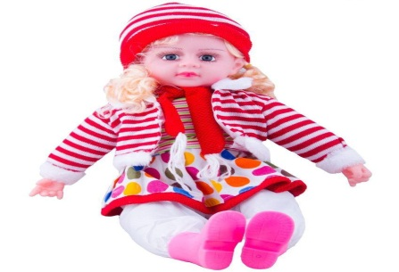 | ball | doll | balloon
2 |  | teddy | doll | clown
3 | 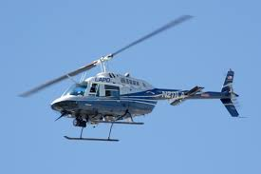 | aeroplane | train | helicopter
4 | 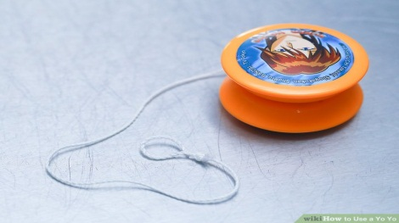 | yoyo | jumping rope | ball
5 |  | car | boat | train

- Match each picture with each word.
No. | Picture | Opt. | Word
1 |  | A | kite
2 | 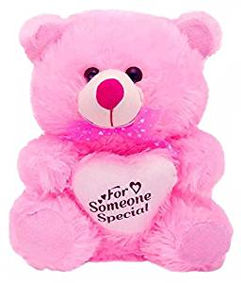 | B | yoyo
3 |  | C | teddy bear
4 | 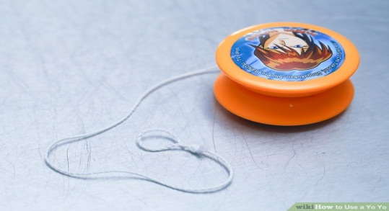 | D | boat
5 | 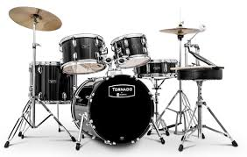 | E | drums

- Do the puzzle: find the word: SOFA, WARDROBE, CUPBOARD, DOOR, MIRROR, SHIP,PLANE, KITE, DRUM, HAVE.
M | I | R | R | 0 | R | E | I | C | M | N
E | S | H | I | P | T | P | C | U | E | K
H | 0 | N | L | I | D | R | H | P | Q | A
0 | F | D | K | 0 | 0 | B | F | B | M | G
W | A | R | D | R | 0 | B | E | 0 | N | D
K | A | R | Q | R | R | I | A | A | E | K
C | Q | F | M | L | U | C | G | R | P | H
R | P | L | A | N | E | M | S | D | B | L
G | P | B | 0 | D | H | A | V | E | F | I
- GRAMMAR
- Match the first part with the second part to make correct sentence.
No. | Part 1 | Opt. | Part 2
1 | Does she | A | the ships?
2 | Where are | B | have a teddy bear?
3 | How many | C | any kites over there?
4 | Are there | D | robots and planes are there?
5 | Is | E | there a book on the bookcase?
- Match each question with each answer.
No. | Question | Opt. | Answer
1 | Are there any sofas in the room? | A | They are on the wall
2 | How many mirrors are there? | B | There are three mirrors.
3 | Where are the pictures? | C | No, he doesn’t.
4 | Do you have a doll? | D | Yes. There is one sofa.
5 | Does your brother have a puzzle? | E | Yes, I do.
- Circle the correct answer.
- Where is/ are the pictures?
- The photos are on/ in the reading room wall.
- The garden and the pond is/ are very nice.
- How many bookshelfs/ bookshelves are there in the reading room?
- Does she have a kite? - Yes, she does/ doesn't.
- Underline the mistake in each sentence then rewrite the correct one.
- Are there any map in the room?
________________________________________________________________
- How many mirror are there in the bathroom?
________________________________________________________________
- Where is the fans?
________________________________________________________________
- Do you have a sofas?
________________________________________________________________
- Does she have two ship?
________________________________________________________________
- PHONICS
- Complete the word and say aloud. Track 18
pl sh
1. _ _ ane 2._ _ort 3. book _ _elf
4. _ _ayground 5._ _ease 6. _ _ip
2. Listen and complete the sentence. Track 19
- She has three .
- Sit down, !
- The pencils are quite .
- Where are the__________________?
- There are some books on the_______________

PART III: SKILLS: LISTENING - SPEAKING - READING - WRITING
- LISTENING
Listen and complete the sentence. Track 19
Hello, my name is Lisa and this is my (1)____________. My room is full of colorful (2)_____________. Look at this. It’s a doll and it has a violet dress.And those are some (3)___________. They are blue. I also have two (4)____________: one is red and one is yellow. The last thing is the teddy bear. Itis (5)______________and white.
- SPEAKING
Complete the conversation with available phrases.
- I have two dolls
- But she has a helicopter
- Do you have any toys in your room
- It's Nana's bedroom
- She has many toys in thetoy box
Conversation 1
A: Is this your room?
B: Yes, it is.
A: (1) ?
B: Yes. I have many toys. A: Do you have a doll?
B: (2)
Conversation 2
A: What is it?
B: (3)
A: Is Nana's your sister?
B: Yes, she is.
A: Is there a toy box in her room? B: Yes. (4)
A: Does she have a plane? B: No, she doesn’t. (5)
- READING
Read and do the task followed.
Hello! My name is Peter. I am a pupil. I have a dog. This is my sister. Her name is Lucy. She is three years old. She has a cat. And this is the playing room. We have some toys here. Look! That is my sister’s doll. Next to the doll, there are somecolored pencils. And this is my train. The train is long and blue. I like the train very much.
1. Complete the sentence.
- Peter is a .
- Lucy is Peters .
- This is the room.
- Lucy and Peter have some in the room.
- The is long and blue.
- Answer the question by completing the answer.
- How old is Lucy?
She is years old.
- What pets does Lucy have?
She has a .
- What are there next to the doll?
There are some next to the doll.
- What color is the train?
The train is .
- What toy does Peter like?
He likes the
- WRITING
Write sentence basing on available words, the first one has been done for you as an example.
- you/ robot
Do you have any robots?=>Yes, I do.
- she/ doll
___________________________________________________________________
- he/ teddy bear
___________________________________________________________________
- they/ drum
___________________________________________________________________
- you/ ship
___________________________________________________________________
- she/yoyo
___________________________________________________________________

