Exercise 1 Look and write
T- shirt | shop | shoes | shorts
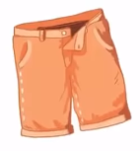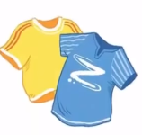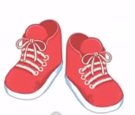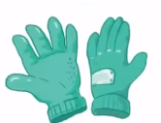

Exercise 2 Read and match
a) I want to buy some trousers.
b) I want to buy some T – shirts.
c) I want to buy some shoes.
d) I want to buy some shorts.
e) I want to buy some gloves. |  | 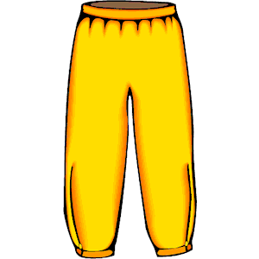
Exercise 3 Look and tick () or cross ()
a) I want to buy some gloves. b)I want to buy some shorts. c)I want to buy some shoes.
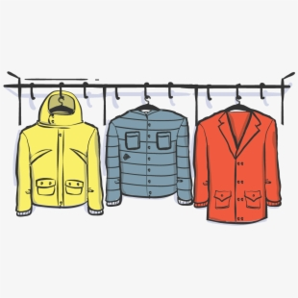
d) I want to buy some sweaters e)I want to buy some gloves. f) I want to buy some coats
Exercise 4 Read and write
a) What do you want to buy ? | b) What do you want to buy ? | c) What do you want to buy ?
…………………………………. | …………………………………. | ………………………………….
d) What do you want to buy ? | e) What do you want to buy ? | f) What do you want to buy ?
…………………………………. | …………………………………. | ………………………………….

Exercise 5 Put the words in the correct order
a) shoes – I– want - some - to - buy | b) T – shirts – I – want - some - to - buy
…………………………………………………… | ……………………………………………………
d) shorts – some – buy – to – I – want | e) I – some – want – to – buy - gloves
…………………………………………………… | ……………………………………………………
Exercise 6 Look and write
bl | br | cl | ch | sh

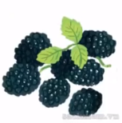 | 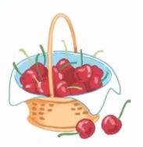 | 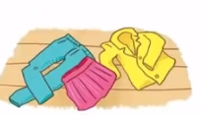 | 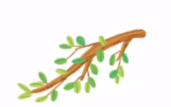
_ _ ackberries | _ _ erries | _ _ othes | _ _ anch
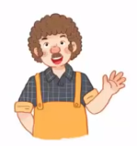 |  | 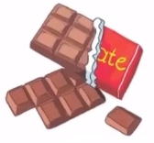 | 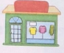
_ _ ian | _ _ oes | _ _ ocolate | _ _ op

Exercise 7 Look and circle the best answer
0. What do you want to buy ? 1. There is a clothes …………
I want to buy some …………
a. shoes b. coats c. shorts a. school b. house c. shop
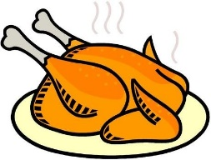
2. These are my ………… 3. We need some …………
a. trousers b. shorts c. gloves a. chicken b. chips c. cheese
4. I ………… to buy some T- shirts. 5. Let’s buy some ……………… .
a. wants b. wants b. want a. cheese b. chocolates c. cherries
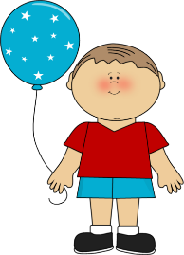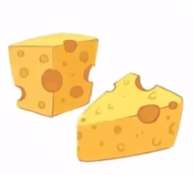
6. He is wearing blue……………… 7. My mother doesn’t like ………………
a. shorts b. gloves c. trousers a. chocolate b. chips c. cheese

