Exercise 1 Look and write
plane | plant | plum | plate
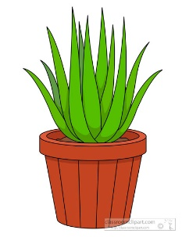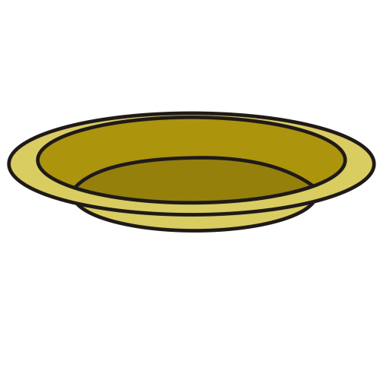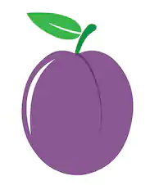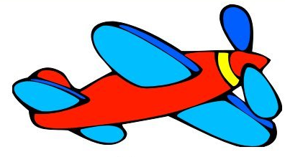

Exercise 2 Read and match
a) They are apples. |  | 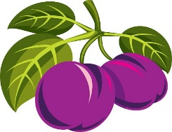
b) They are plums. |  | 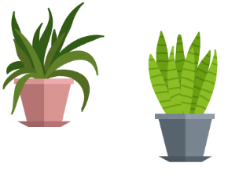
c) They are plants. |  | 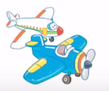
d) They are planes. |  | 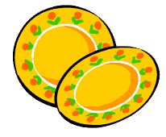
e) They are plates. |  | 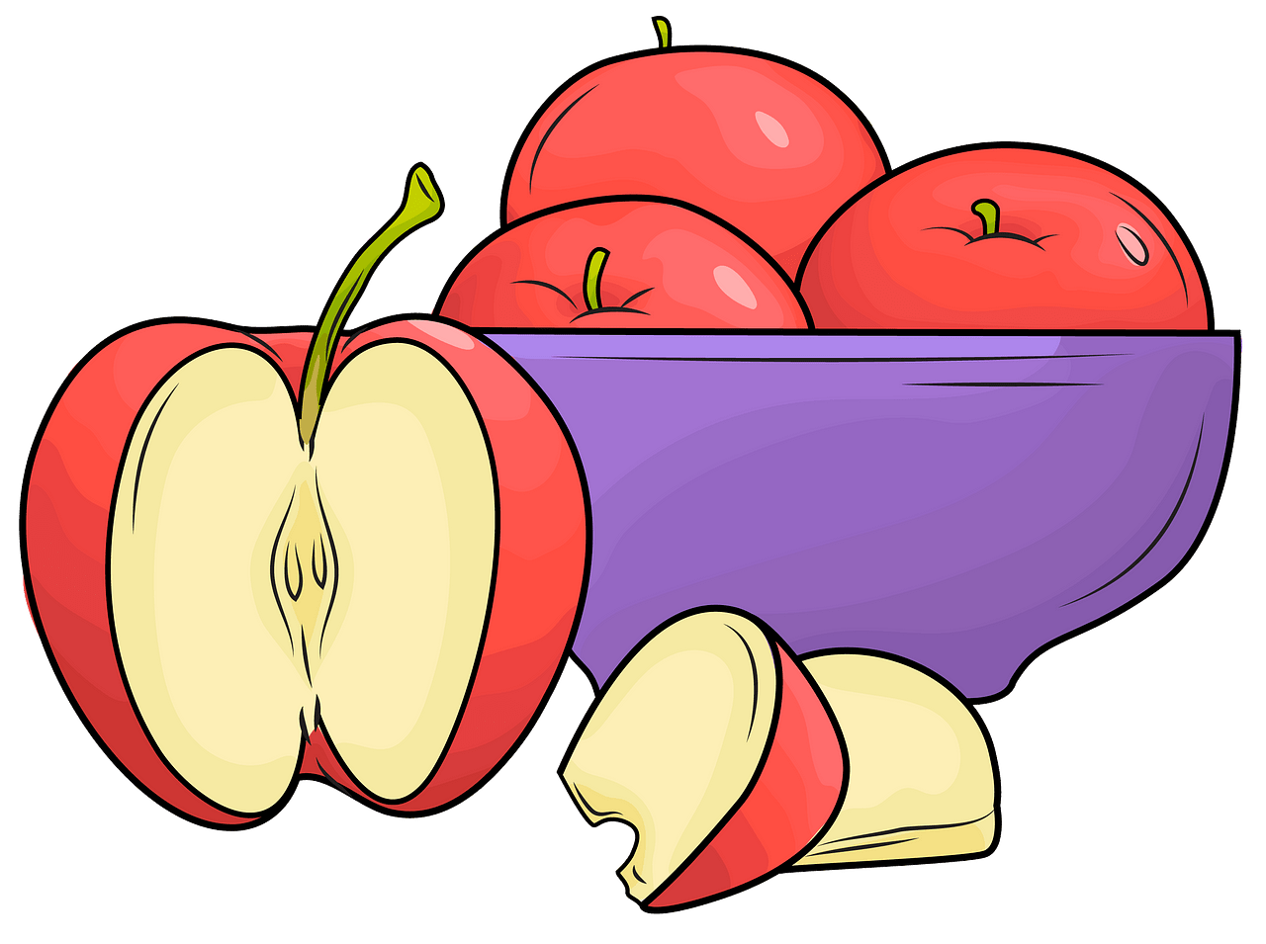
Exercise 3 Look and tick () or cross ()
a) They are apples. b)They are planes. c) They are plants.
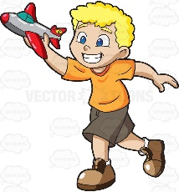
d) They are boats. e)They are plums. f) He’s playing with a plane
Exercise 4 Read and write
a) What are these ? | b) What are these ? | c) What are these ?
…………………………………. | …………………………………. | ………………………………….
 |  | 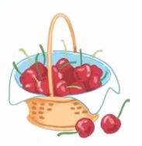
d) What are these ? | e) What are these ? | f) What are these ?
…………………………………. | …………………………………. | ………………………………….

Exercise 5 Put the words in the correct order
a) plates – are - They | b) They – plums – are
…………………………………………………… | ……………………………………………………
d) They – plants - are | e) are – planes - They
…………………………………………………… | ……………………………………………………
Exercise 6 Find the word which has a different sound in the part underlined
a) present | b) plate | c) play | d) plant
a) plant | b) plane | c) plum | d) black
a) brown | b) brush | c) tree | d) bridge
a) shoes | b) chocolate | c) shorts | d) T- shirt
a) cheese | b) chips | c) chicken | d) school
a) clown | b) blouse | c) clock | d) clothes
a) play | b) blossom | c) black | d) blanket
a) cat | b) bag | c) hat | d) cake
a) clock | b) boots | c) food | d) moon

Exercise 7 Look and circle the best answer
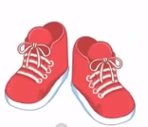
0. Are these ………… ? Yes, they are. 1. These are my …………
a. plums b. plants c. plates a. shorts b. socks c. shoes
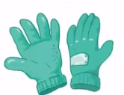
2. They are ………… 3. I want to buy …………
a. plates b. plants c. plums a. gloves b. shoes c. trousers
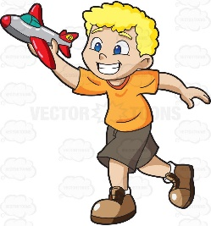
4. I ………… playing with a plane. 5. Let’s buy some ……………… .
a. is b. am c. are a. apples b. plums c. cherries
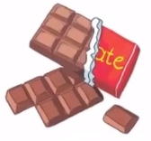
6. There are two ……………… 7. I want to buy some ………………
a. bikes b. boats c. planes a. chocolate b. chips c. cheese

