UNIT 16: LET'S GO TO THE BOOKSHOP


PART I: THEORY

I. VOCABULARY
English | Pronunciation | Vietnamese
airport | /ˈeəpɔːt / | Sân bay
bakery | /ˈbeɪkəri / | Tiệmbánh mì
bank | / bæŋk/ | ngân hàng
bookstore  bookshop | / ˈbʊkstɔː(r)/  / ˈbʊkʃɒp/ | cửa hàng sách
cafe | / ˈkæfeɪ / | tiệm cà phê
church | / ʧɜːʧ / | nhà thờ
department store | / dɪˈpɑːtmənt stɔː(r) / | cửa hàng bách hóa
cinema | / ˈsɪnəmə / | rạp chiếu phim
gallery | / ˈgæləri / | phòng trưng bày tác phẩm nghệ thuật
greengrocers | / ˈgriːnˌgrəʊsəz/ | cửa hàng rau quả
library | / ˈlaɪbrəri / | thư viện
museum | / mjuˈzɪ:əm / | viện bảo tàng
pharmacy | / ˈfɑːməsi/ | cửa hàng thuốc tây
park | / pɑːk / | công viên
railway station | / ˈreɪlweɪ ˈsteɪʃən / | trạm xe lửa
supermarket | / ˈsjuːpəˌmɑːkɪt/ | siêu thị
zoo | / zuː/ | vườn thú

II. GRAMMAR
- Rủ ai đó đi đâu
(?) Let’s go to the + place!
(?) Why don’t we go to the + place?
(?) How about going to the + place?
(+) Great idea!
(-) Sorry, I’m busy.
Example:Let’s go to the bookshop!=>Great idea! I want to buy some books, too.
- Hỏi lý do tại sao bạn đi đâu?
(?) Why do you go to the + place?
(+) Because I want to + V-inf.
Example: Why do you go to the cinema?=> Because I want to see the new movie.
- Hỏi lý do tại sao ai đó đi đâu?
(?) Why does he / she go to the + place?
(+) Because he / she wants to V-inf.
Example: Why does he go to the library?
=>Because he wants to borrow some magazines.
- PHONICS
Practice pronouncing the word.
bank / bæŋk / | bell / bel/
bookstore / ˈbʊkstɔː(r)/ | parade /pəˈreɪd/
cinema / ˈsɪnəmə / | library /ˈlaɪbrəri/
supermarket / ˈsjuːpəˌmɑːkɪt/ | decoration / dekəˈreɪʃən/

PART II: LANGUAGE: VOCABULARY- GRAMMAR- PHONICS
- VOCABULARY
- Look at the picture and complete the word.
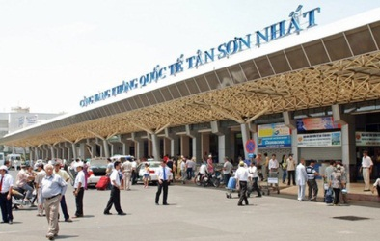  A_ _p_ _ _ | 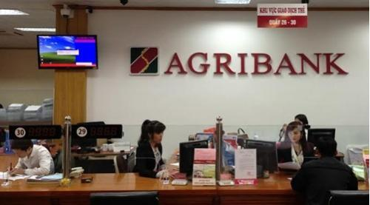  B _ _ _ | 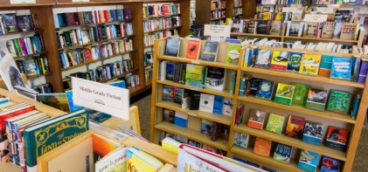  B_ _ _s_ _ _ _
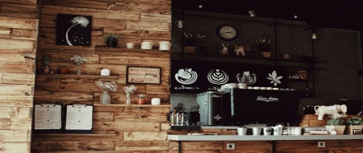  C_ _ _ | 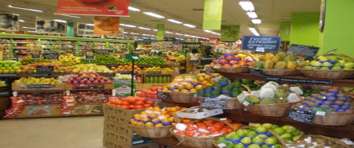  G_ _ _ _g _ _ _ _ _’s

- Match each picture with each word
No | Picture | Opt | Word
1 | 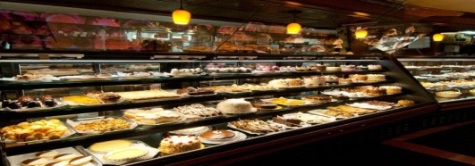 | A | supermarket
2 | 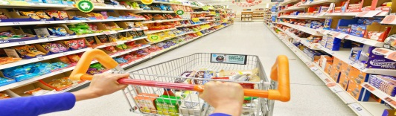 | B | Park
3 | 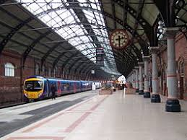 | C | zoo
4 | 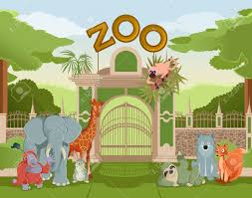 | D | Railway station
5 | 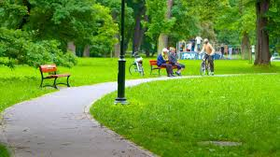 | E | bakery

- Do the puzzle: find the word: DEPARTMENT, CINEMA, GALLERY, LIBRARY, MUSEUM, PHARMACY, MOVIES, BOOKSHOP, GYM, HOTEL.
F | P | H | A | R | M | A | C | Y | Q | D | H | N | C
C | C | A | I | P | O | H | S | K | 0 | 0 | B | G | Q
0 | I | L | N | J | u | G | Y | P | R | B | U | Y | L
B | N | D | K | E | M | F | R | C | S | E | K | M | P
D | E | P | A | R | T | M | E | N | T | 0 | A | T | 0
V | M | S | X | R | A | X | L | I | B | R | A | R | Y
I | A | U | K | H | T | I | L | G | U | H | V | L | J
F | Q | V | S | S | P | V | A | X | D | N | J | E | M
0 | R | M | Y | E | C | u | G | P | R | E | K | T | N
L | E | X | G | Q | U | B | T | M | B | F | I | 0 | G
S | A | T | I | L | H | M | 0 | V | I | E | S | H | D
- GRAMMAR
- Match each question with each answer.
No. | Question | Opt. | Answer
1 | Where are you going? | A | I’m going to school.
2 | Would you like to go to the museum with me? | B | I need some eggs.
3 | Why do you go to the supermarket? | C | At the greengrocers near here.
4 | Would you like some orange juice? | D | No, thanks.
5 | Where can I get some fresh fruits? | E | No, thanks.I’m not thirsty.

- Look at the picture and complete the sentence Look at the picture and complete the sentence
No | Sentence | Picture
1 | I want to buy some …………………, so I go to the …………………….. | 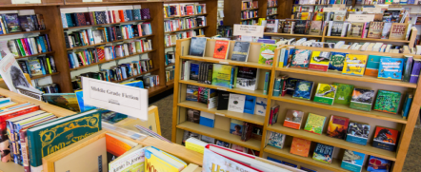
2 | Let’s go to the ………………….., I want to have some……………………. | 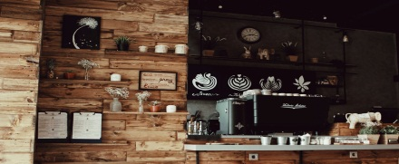
3 | Why don’t we go to the ……………….?  I want to withdraw some …………………
4 | Where can I get some ………………, You can get it at the ……………………… | 
5 | There is a new ……………… on Why don’t we go to the ………………. tonight? | 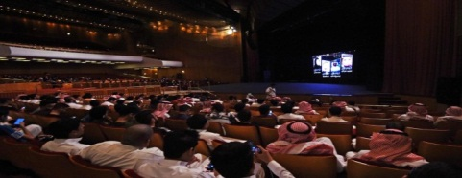

- Reorder the word to make correct sentences.
- do/ go to/ you/ Why/ the bank?/ want to
…………………………………………………………………………………
- don’t/ go to/ you/ the museum?/ Why
…………………………………………………………………………………
- the park/ go to/ Lets/ together!
…………………………………………………………………………………
- to buy/ the greengrocers/ going to/ How about/ fruits?
…………………………………………………………………………………
- the zoo/ go to/ today!/ Lets
…………………………………………………………………………………
- Circle the mistake in each sentence then rewrite the correct one
- Let’s going to the bookstore!………………………………………………………………………………
- Why don’t we go the supermarket?
…………………………………………………………………………………..
- Why does they want to go to the zoo?………………………………………………………………………………….
- I wants to go to the bookstore because I need to buy some new books.……………………………………………………………………………….
- Would you like to go to the cinema with I? - Yes, of course.
……………………………………………………………………………….…
- PHONICS - Track 11
Listen and complete the sentence.
- Where are you going? - I’m going to the .
- Where can I watch a new movie? - There is a near here.
- The baby looks so .
- I’m going to the this afternoon. Would you like to go with me?
- Is there a near here?
- Is that guy your brother?
- Could you buy me a...............on your way back?

PART III: SKILLS: LISTENING - SPEAKING - READING – WRITING

I. LISTENING - Track 12

Listen and complete the text.
- All the people go to the to see the films.
- Foreigners often stay in a when they come to our city.
- If you want to eat, you can go to a
- If you re ill, you can buy medicines in a
- At weekends we go to a to buy fruits and vegetables.
- Boys and girls study different subjects at .
- If you want to see the performance with funny animals, you have to
go to the .

8. We often buy things in a _____________\
- SPEAKING
Complete the conversation with available phrases.
- There is a bakery near here
- Or if you want to have a pizza or a hamburger
- Is there a restaurant near the cinema
- Thank you very much
- Is there a cinema near here
Mai Chi: (1) , Its on 13 Maple Street.
Jason: Thanks. I want to see a new movie. (2) ?
Mai Chi: Let me see. The National Movies is on 20 Apple Street. It is near here so you can walk there.
Jason: Thank you.
Mai Chi: Would you like to eat something before going to see a movie?
Jason:That’s a good idea. (3) ?
Mai Chi: The Italian Restaurant serves best Italian food. It is next to themovies, on 21 Apple Street, (4)________________________ , you canget it in the food stall. It’s opposite the bakery.
Jason: (5)
- READING
Read and complete the paragraph with available words.
Drinks bookstore capital supermarket library
airport money once fairy tales ticket
A LOOK AT THE MAP
Hanoi is a big city. It is the (1) of Vietnam. Life is convenient
in Hanoi because there are many interesting places there. This is the (2)
.If you want to travel to abroad, you can buy a (3)
here and take a flight. It is very fast. And look, this is a (4) . There
are many kinds of books in the bookstore such as textbooks, (5) ,
short stories. Bookstore is a great place. And if you do not have (6)
to buy books, you can borrow them in the (7) . There are lots of
books in the library too. And here is the (8) . In the supermarket,
they sell many goods such as food, (9) , books, clothes,... I go tothe supermarket (10) a week. How about you?
- WRITING
- Look at the picture and write sentences.

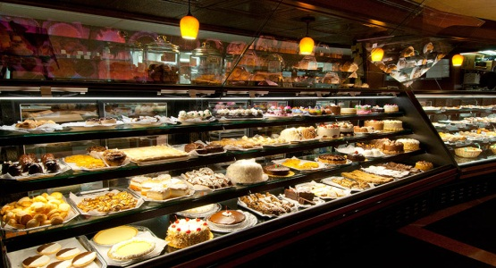  - bakery/ buy some bread  Let s go to the_______________  I want to __________________ | 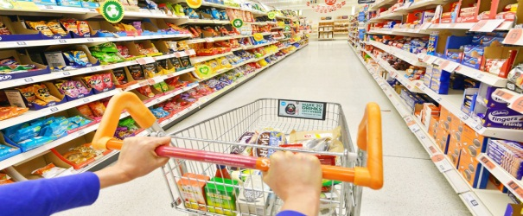  - supermarket/ buy some food  _________________________  _________________________
  - pharmacy/ buy some medicine  _________________________  _________________________ | 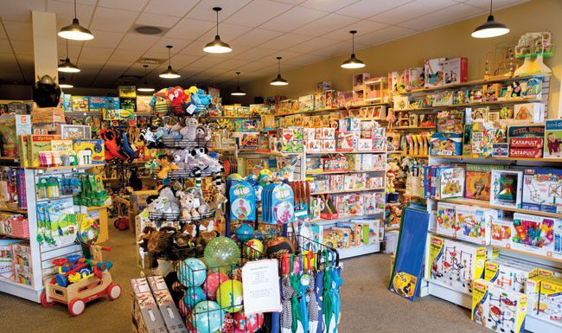  - toy store/ buy a robot  _________________________  _________________________

- Write sentences basing on available words, the first one has been done for you as an example
- you / bakery / buy some bread
Why do you want to go to the bakery?=>Because I want to buy some bread.
- he / bookstore / buy some magazines
……………………………………………………………………………………
- Johny / coffee / buy a cup of cappuccino
……………………………………………………………………………………
- Sam / gallery / see some new paintings
……………………………………………………………………………………
- Mikako / library/ borrow some books
……………………………………………………………………………………
- they / supermarket/ buy some food
……………………………………………………………………………………

