Exercise 1 Look and write
skirt | singing | skiing | sky | skating

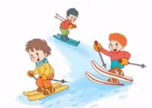 | 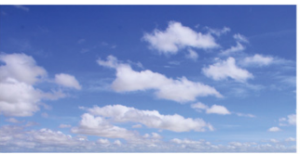 | 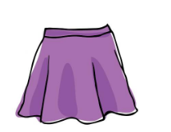 | 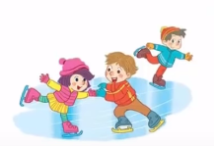 | 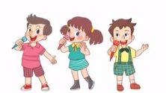
…………………… | …………………… | …………………… | …………………… | ……………………
Exercise 2 Read and match
a) The kite is flying in the sky.
b) They are singing. |  | 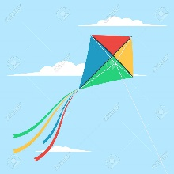
c) She is wearing a skirt.
d) They are skating.
e) They are skiing. |  | 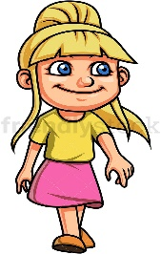
Exercise 3 Look and tick () or cross ()
a) They are skating. b)They are singing. c) The kite is flying in the sky.
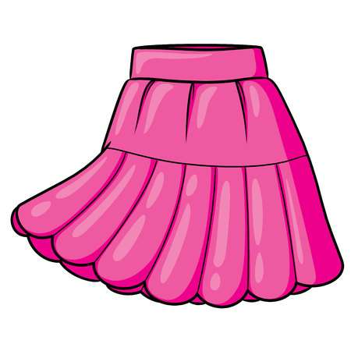
d) She’s wearing a coat. e)This is my skirt. f) They are skiing.
Exercise 4 Read and write
a) What are they doing ? | b) What are they doing ? | c) What are they doing ?
…………………………………. | …………………………………. | ………………………………….
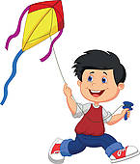 | 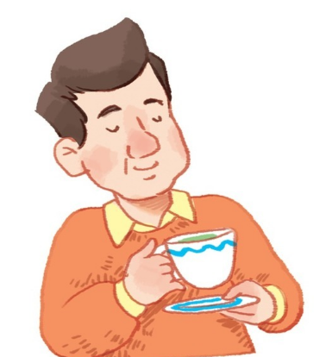 | 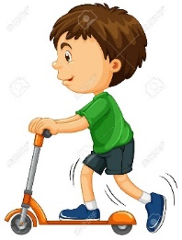
d) What is he doing ? | e) )What is he doing ? | f) ) What is he doing ?
…………………………………. | …………………………………. | ………………………………….
Exercise 5 Put the words in the correct order
a) skiing – They - are | b) He – flying – a kite - is
…………………………………………………… | ……………………………………………………
d) They – singing – are | e) skating – are - They
…………………………………………………… | ……………………………………………………
Exercise 6 Find the word which has a different sound in the part underlined
a) skating | b) slide | c) skiing | d) skirt
a) scarf | b) skating | c) skirt | d) street
a) black | b) plate | c) play | d) plant
a) sheep | b) cheese | c) she | d) shoes
a) peach | b) chips | c) clown | d) chair
a) close | b) cloud | c) clock | d) blossom
a) head | b) sea | c) beach | d) leaf
a) coast | b) road | c) coat | d) blouse
a) five | b) fish | c) bike | d) slide
Exercise 7 Look and circle the best answer
0. What are they doing ? They are……… 1. Are they …………? Yes, they are.
a. singing b. skiing c. skating a. skating b. skiing c. singing
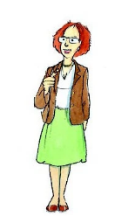
2. She is wearing a ………… 3. He’s flying a …………
a. shorts b. trousers c. skirt a. kite b. boat c. car

4. Are they plants ? No, ……………… . 5. Let’s buy some ……………… .
a. they are b. they c. they aren’t a. apples b. plums c. cherries
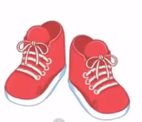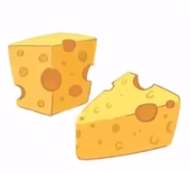
6. I want to buy …………shoes. 7. We need some ………………
a. a b. any c. some a. chocolate b. chips c. cheese

