Exercise 1 Look and write
train | trolley | truck | tray | tree

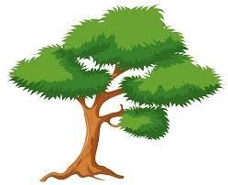 | 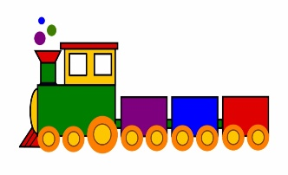 | 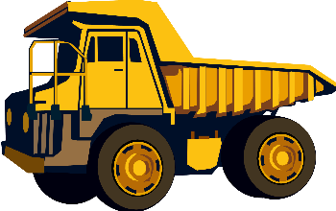 | 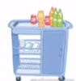 | 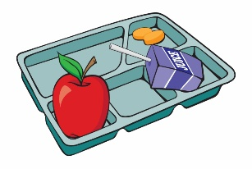
…………………… | …………………… | …………………… | …………………… | ……………………
Exercise 2 Read and match
a) The trolley is on the train. |  | 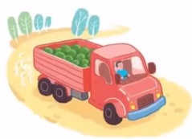
b) The truck is on the road. |  | 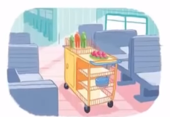
c) There is a green tree. |  | 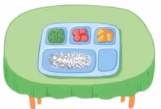
d) The tray is on the table. |  | 
e) It’s a triangle.
Exercise 3 Look and tick () or cross ()
a) It’s a circle. b)The tray is under the table c) The truck is on the road.
d) The trolley is on the train. e) There is a tray. f) There is a trolley.
Exercise 4 Read and write
a) Where is the tray ? | b) Where is the trolley ? | c) Where is the truck ?
…………………………………. | …………………………………. | ………………………………….
 |  | 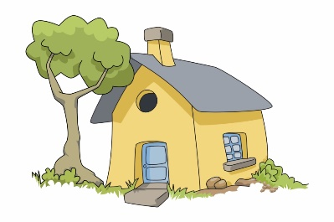
d) What shape is it ? | e) What is this ? | f) ) Where is the tree ?
…………………………………. | …………………………………. | ………………………………….

Exercise 5 Put the words in the correct order
a) The tray – on – the – table - is | b) the – train – The trolley – on – is
…………………………………………………… | ……………………………………………………
d) The truck – on – is – road - the | e) near – the – house – The – tree – is
…………………………………………………… | ……………………………………………………
Exercise 6 Circle the letters that match the beginning blend sound
 | 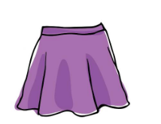 | 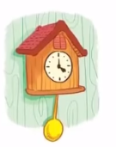 | 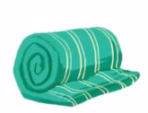
bl br tr | sn st sk | cl cr ch | pl br bl
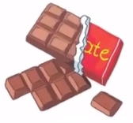 | 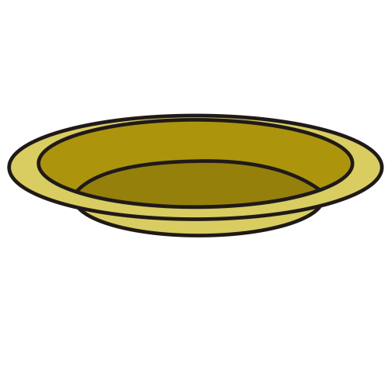 | 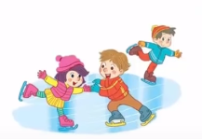
sh cl ch | pl bl sl | sk pl sh | tr cl pl
Exercise 7 Look and circle the best answer
0. Where is the tray ? It’s ………the table. 1. ………is the trolley ? It’s on the train.
a. near b. under c. on a. Where b. What

2. Is it a ………… ? Yes, it is. 3. Are they…………? Yes, they are.
a. square b. triangle c. circle a. singing b. skiing c. skating
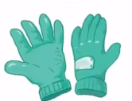
4. What are these ? They are ……….. 5. I want to buy some ……………… .
a. peaches b. chocolate c. plums a. shorts b. gloves c. shoes
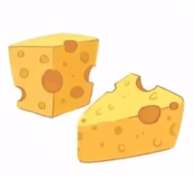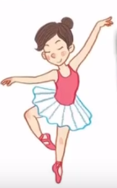
6. What do you like ? I like ……………… 7. I ……… to be a dancer.
a. cheese b. chicken c. chocolate a. wants b. wantes c. want

