Exercise 1 Look and write
clothes | grandfather | feathers | grandmother | brother

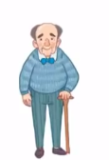 | 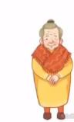 | 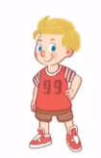 |  | 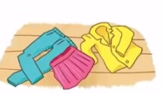
…………………… | …………………… | …………………… | …………………… | ……………………
Exercise 2 Read and match
a) That is my brother
b) That is my grandfather
c) They are feathers.
d) That is my grandmother.

Exercise 3 Look and tick () or cross ()
a) That is my brother. b)That is my grandfather. c) They are feathers.
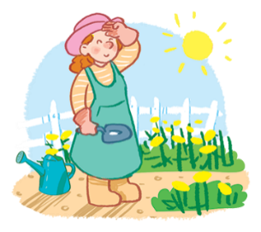
d) That is my grandmother. e) That is my mother. f) They are clocks.
Exercise 4 Read and write
 |  | 
a) Who is that ? | b) Who is that ? | c) What are these ?
…………………………………. | …………………………………. | ………………………………….
d) Who is that ? | e) Who is that ? | f) ) What are these ?
…………………………………. | …………………………………. | ………………………………….
Exercise 5 Put the words in the correct order
a) grandfather – is – That - my | b) That – brother – my - is
…………………………………………………… | ……………………………………………………
 | 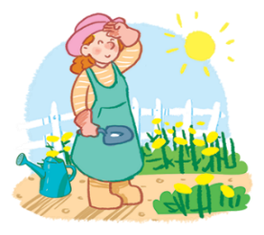
d) That – grandmother – my - is | e) mother – is – That - my
…………………………………………………… | ……………………………………………………
Exercise 6 Find the word which has a different sound in the part underlined
a) grandmother | b) brother | c) cheese | d) grandfather
a) train | b) three | c) truck | d) trolley
a) brother | b) brush | c) tray | d) bread
a) sheep | b) cherries | c) shop | d) shoes
a) shoes | b) school | c) skiing | d) skirt
a) black | b) blouse | c) blanket | d) breakfast
a) clown | b) clock | c) play | d) classroom
a) peach | b) sheep | c) shoes | d) shorts
a) clock | b) boots | c) food | d) moon

Exercise 7 Look and circle the best answer
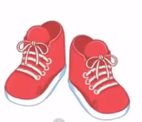
0. Who is that ? That is my………. 1. What are these ? These are my ……….
a. mother b. grandfather c. brother a. shoes b. shorts c. trousers
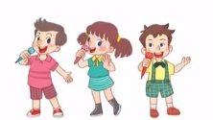
2. Is that your………… ? Yes, she is. 3. Are they singing ? ………, they are.
a. mother b. brother c. grandmother a. No b. Yes
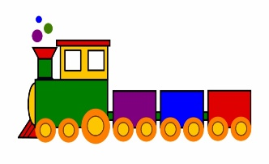
4. What are these ? They are ……….. 5. Is it a ………………? Yes, it is.
a. trees b. feathers. c. plants a. car b. truck c. train
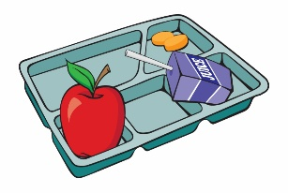
6. Who is that ? That is my………. 7. What is this ? It’s a………………
a. brother b. mother c. grandfather a. train b. trolley c. tray

