Exercise 1 Look and write
baby | grapes | table | cake

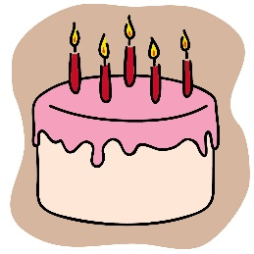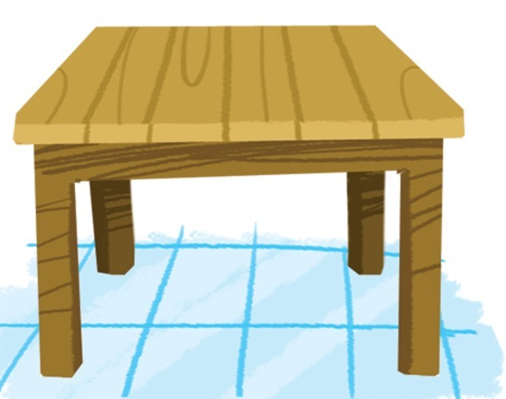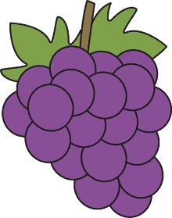

Exercise 2 Look and match
a) There is a table. |  | 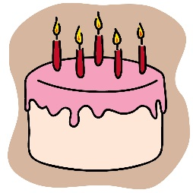
b) There are grapes.
c) I can see the baby. |  | 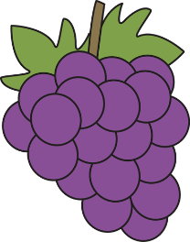
d) There is a cake.

Exercise 3 Look and complete
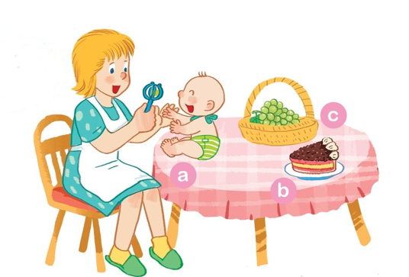 | a) The baby is on the …………………….  b) The cake ………………on the table.  c) The ………………are on the table.
Exercise 4 Look and tick () or cross ()
a) The apples are on the table. | 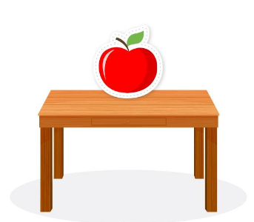
b) The book is on the table. | 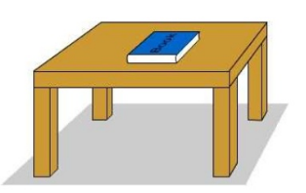
c) The grapes are on the table. | 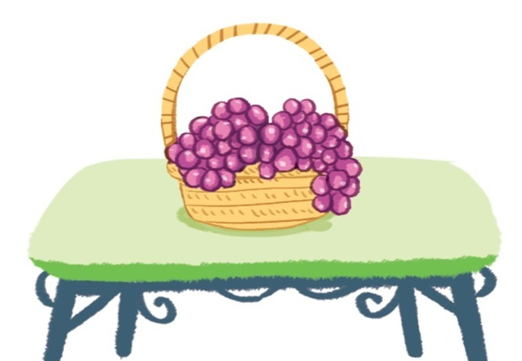
d) The bag is on the table. | 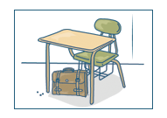

Exercise 5 Put the words in the correct order
a) Can – see – you – the plate – the – grapes – on ?
……………………………………………………………………………………………………
b) My – eating – grapes – mother – is
……………………………………………………………………………………………………
c) The – on – is – baby – the – table
……………………………………………………………………………………………………
d) playing – games – My – brother – is
……………………………………………………………………………………………………
e) There – table – is – a – the living room – in
……………………………………………………………………………………………………
f) There – a cake – is – the plate – on
……………………………………………………………………………………………………
Exercise 6 Find the word which has a different sound in the part underlined
a) lake | b) cake | c) table | d) cat
a) face | b) hat | c) bag | d) hand
a) ten | b) bed | c) hen | d) leaf
a) snake | b) baby | c) sand | d) sail
a) bag | b) hat | c) man | d) cake
a) gate | b) late | c) sad | d) game
a) van | b) rabbit | c) cake | d) hand
a) son | b) box | c) mother | d) honey

Exercise 7 Look and circle the best answer
0. Can you see the ……………..? 1. Can you see the ………….? Yes, I can.
a. baby b. girl a. grape b. grapes
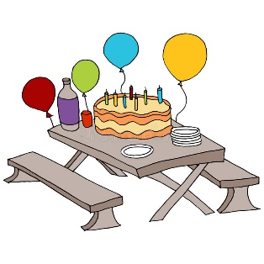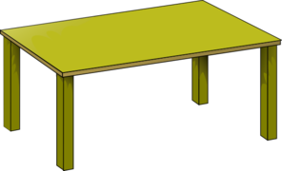
2. The cake is ………. the table. 3. There is a ……………..
a. under b. on a. chair b. table
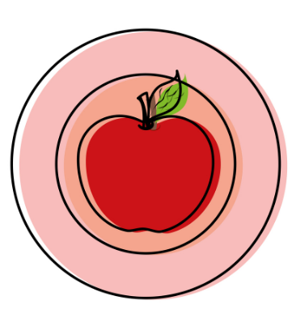
4. The apple is on the ………….. 5. The ………….. is on the table.
a. plate b. table a. books b. book
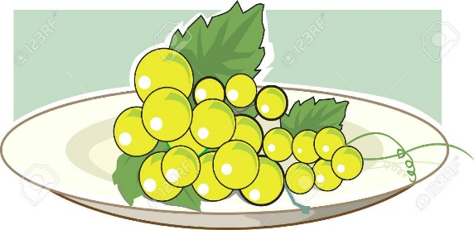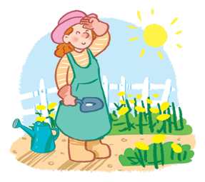
6) The…………on the plate. 7. Can you see the ……………….?
a. apples b. grapes a. son b. mother

