Exercise 1 Look and write
throat | mouth | thumb | tooth

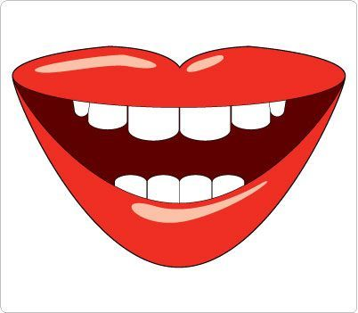 | 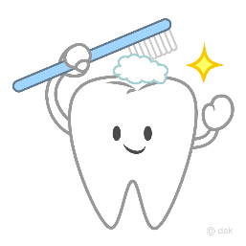 |  | 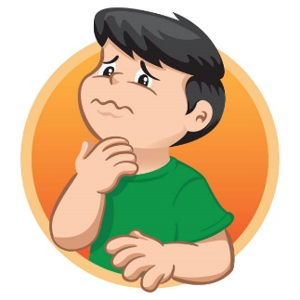
…………………… | …………………… | …………………… | ……………………
Exercise 2 Read and match
a) Touch your throat. |  | 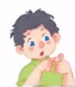
b) Touch your thumb. |  | 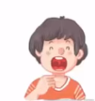
c) Show me your tooth. |  | 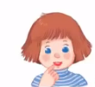
d) Open your mouth. |  | 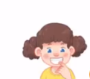

Exercise 3 Look and tick () or cross ()
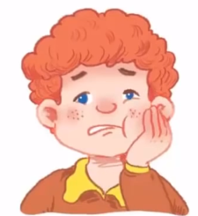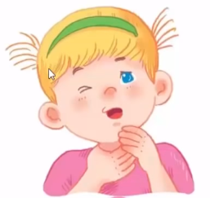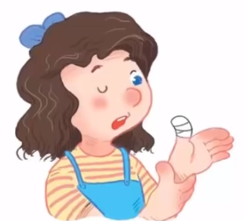
a) My head is painful. b) My throat is painful. c) My thumb is painful.
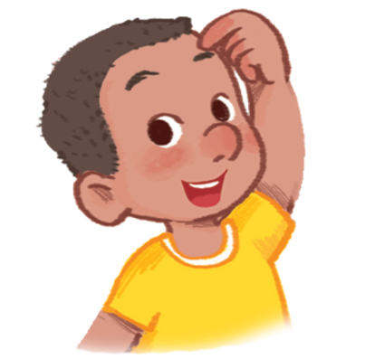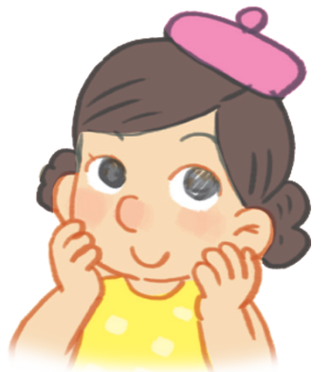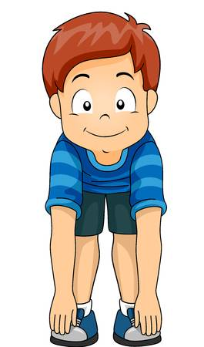
d) Touch your nose. e) Touch your face. f) Touch your throat.
Exercise 4 Read and write
 | 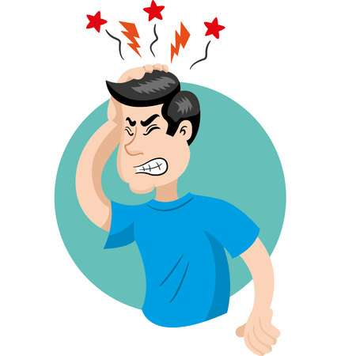
a) What is the matter ? | b) What is the matter ?
………………………………………………….. | ………………………………………………..
d) What is the matter ? | e) What is the matter ?
………………………………………………….. | ………………………………………………..
Exercise 5 Put the words in the correct order
a) head – My - is - painful. | b) My - painful – throat - is
…………………………………………………… | ……………………………………………………
d) My - thumb – painful - is | e) mouth – is – painful - My
…………………………………………………… | ……………………………………………………
Exercise 6 Find the word which has a different sound in the part underlined
a) grandmother | b) thumb | c) mouth | d) throat
a) brother | b) tooth | c) mother | d) feathers
a) brother | b) mother | c) grandfather | d) plate
a) bread | b) beach | c) peach | d) read
a) star | b) skating | c) skiing | d) skirt
a) train | b) branch | c) brother | d) breakfast
a) bee | b) tree | c) sheep | d) hen
a) school | b) sheep | c) shoes | d) shorts
a) clock | b) boots | c) dog | d) box

Exercise 7 Look and circle the best answer

0. What is the matter ? My ……. is painful. 1. Are these feathers ? ……,they are.
a. mouth b. throat c. tooth a. Yes b. No
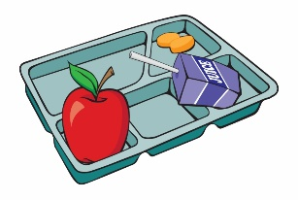
2. Is this a tray ? Yes, ………. 3. What is the matter ?My……. is painful.
a. is b. it isn’t c. it is a. thumb b. throat c. tooth
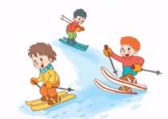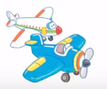
4. Are they singing ? No, ……….. 5. What are these ? They are ………..
a. they are b. they aren’t a. plants b. plums c. planes
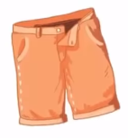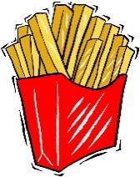
6. These are my………. 7. We need some……….
a. skirt b. coat c. shorts a. chips b. cheese c. chocolate

