UNIT 3: WHERE DID YOU GO ON HOLIDAY?
PART 1: THEORY (Lý thuyết)
I. VOCABULARY (Từ vựng)
English | Pronunciation | Vietnamese
Coach | /kəʊtʃ/ | Xekhách
Plane | /pleɪn/ | Máy bay
Train | /treɪn/ | Xelửa
Taxi | /ˈtæksi/ | Tắc xi
Motorbike | /ˈməʊtəbaɪk/ | Xemáy
Underground | /ˌʌndəˈɡraʊnd/ | Tàuđiệnngầm
Bay | /beɪ/ | Vịnh
Island | /ˈaɪlənd/ | Đảo
Imperial city | /ɪmˈpɪəriəl/ /ˈsɪti/ | Thành ( phố) cổ
Seaside | /ˈsiːsaɪd/ | Bờbiển
Province | /ˈprɒvɪns/ | Tỉnh
Zoo | /zuː/ | Vườnthú
Beach | /biːtʃ/ | Bãibiển
Airport | /ˈeəpɔːt/ | Sân bay
Railway station | /ˈreɪlweɪ/ /ˈsteɪʃn/ | Trạmxelửa
Train station | /treɪn/ /ˈsteɪʃn/ | Trạmxelửa, nhàga
Summer holiday | /ˈsʌmə(r)//ˈhɒlədeɪ/ | Kỳnghỉhè
Go on a trip | /ɡəʊɒnə trɪp/ | Đi du lịch
Weekend | /ˌwiːkˈend/ | Cuốituần
Family | /ˈfæməli/ | Giađình
Wonderful | /ˈwʌndəfl/ | Tuyệtvời
North | /nɔːθ/ | Miềnbắc
Take a boat trip | /teɪkə bəʊttrɪp/ | Đichơibằngthuyền
Photo of the trip | /ˈfəʊtəʊəvðətrɪp/ | ảnhchụpchuyếnđi

II: GRAMMAR( Ngữpháp)
1. Hỏi xem ai đó đã đi đâu vào kì nghỉ
Cách 1:
(?) Where did + S + go + on holiday?
(+) S+ went to ...
Vídụ:
Where did you go on holiday? Bạnđãđiđâuvàokìnghỉ?
I went to Ha Long Bay. TớđãđếnVịnhHạ Long.
Where did he go on his holiday? Anhấyđãđiđâuvàokìnghỉ( củaanhấy)?
He went on a trip with his family. Anhấyđãđi du lịchvớigiađình.
Cách 2:
(?) Where + was / were + S + last summer?
(+) S + was/ were ...
Vídụ:
- Where were you last summer? Bạnđã ở đâuhènămngoái?
I was at my grandparents’ house. Tớ ở nhàôngbàtớ.
- Where was Tom last summer? Tom đã ở đâuhènămngoái?
He was at PhuQuoc Island. Anhấy ở đảoPhúQuốc.
2. Hỏi xem ai đi bằng phương tiện gì?
(?) How did + S + get + there?
(+) S + got + there + by + ....
Vídụ:
How did you get there? Bạnđếnđóbằngphươngtiệngì?
I got there by plane. Tớđếnđóbằngmáy bay.
Giaoandethitienganh.info

How did he get to his hometown? Anhấyvềquêbằngphươngtiệngì?
He got there by bus. Anhấyvềđóbằngxebuýt.
III. PHONICS. Track 09
Trong Tiếng Anh có rất nhiều từ có 3 âm tiết. Chúng thường là danh từ và thường có trọng âm rơi vào âm tiết thứ nhất. Các em hãy nghe và thực hành phát âm các từ có 3 âm tiết và có trọng âm rơi vào âm tiết thứ nhất dưới đây.
Listen and practice these words. Pay attention to the stress of words.
‘foreigner ‘family ‘grandparents ‘holiday
‘motorbike ‘cinema ‘factory ‘president
PART II: LANGUAGE: VOCABULARY – GRAMMAR – PHONICS
I. VOCABULARY
1. Draw a line to match the words that go together.

- Ancient A. holiday
- Imperial B. town
- Railway C. station
- Boat D. city
- Summer E. trip
Your answer:
1............................2..........................3........................4.......................5.........................
2. Look at the picture and complete the word.
1 | 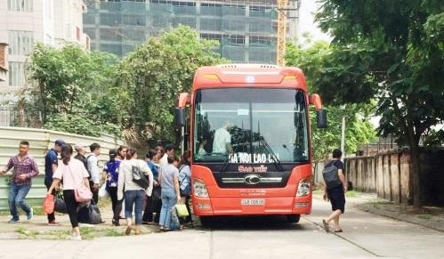 | C __ __ __ __
2 |  | P __ __ __ __
3 | 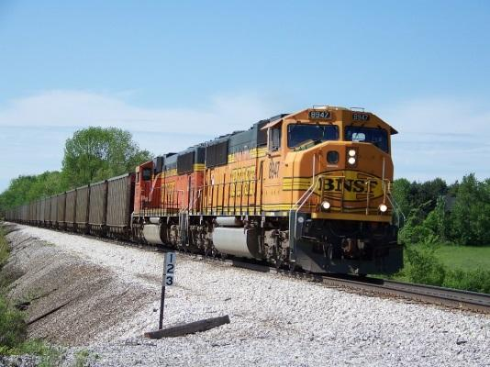 | T __ __ __ __
4 |  | M__ __ __ __ __ __ __ __
5 |  | S__ __ __ __ __ __

3. Choose the odd one out.
- A. province B. Zoo C. park D. airport
- A. island B. plane C. town D. village
- A. motorbike B. Bike C. bicycle D. Ancient
- A. town B. Village C. football D. countryside
- A. mountain B. library C. house D. flat
4. Complete each phrase with an available word/ phrase
Watch look for go on take talk
- ___________________________ with friends
- ___________________________ television
- ___________________________ information
- ___________________________a trip
- ___________________________ a boat trip
II. GRAMMAR
1. Write sentences basing on available words.
1. Where/ you/ go/ last summer?
.................................................................................................................................
2. Where/ you / yesterday?
.................................................................................................................................
3. How/ you/ get/ Tuan Chau Island/ your last holiday?
Giaoandethitienganh.info

.................................................................................................................................
4. How/ she/ get/ her/ hometown/ last year?
.................................................................................................................................
5. I / go/ plane/ my last summer holiday
.................................................................................................................................
2. Circle the incorrect word and rewrite the correct sentence.
1. Where did you went on holiday?
.................................................................................................................................
2. How did you get at HoaBịnh Province?
.................................................................................................................................
3. I walked by coach to my hometown.
.................................................................................................................................
4. How did you got there?
.................................................................................................................................
5. Nina went to her hometown with coach.
.................................................................................................................................
3. Match each question with each answer.
1. Where did you go on your holiday? A. By coach
2. How did you get there? B. I went to my friend’s
Hometown in Holland.
3. Did you get there by coach or by plane? C. Yes, I was
4. Were you at home last summer? D. I got there by train.
5. What was your trip like? E. It was so boring.
Your answer:
1..............................2.............................3...........................4.......................5..........................
4. Complete the sentence with a suitable word.
- What ______________she do after school?
- I usually _____________ late so I don’t have breakfast before school.
- Do you usually _____________ films after dinner?
- Last night, Lan and I ___________at my new friend’s house.
- On my last summer holiday, my family and I _____________ on a trip to Sam Son Beach.

III. PHONICS Track 10
1. Mark the stress of the following words. The number 1 has been – done for you as an example.
1. ‘dangerous 2. evening 3 . happiness 4. Beautiful
5. wonderful 6. Holiday 7. Statement 8. Badminton
2. Mark the stress of the underlined words then say the sentence aloud.
Track 11
1. Where did she go on her holiday?
2. My family stayed in a small hotel.
Giaoandethitienganh.info

3. There is a beautiful garden behind my house.
4. Did Tony play volleyball well?
5. Tom and Carl come from Canada.
PART III. SKILLS: LISTENING – READING – WRITING
I. LISTENING
Listen and do the tasks followed. Track 12
1. Listen and decide if each statement is True ( T) or False ( F)
Statements T/F
1. Brend and her friend went to Canada on last summer holiday ____________
2. They went to Canada by plane ____________
3. They just wore hats when they saw the falls ____________
4. Matthew comes from Germany. ____________
5. Matthew and Brenda could speak English ____________
2. Listen again and complete the text.
SUMMER HOLIDAYS
My name is Brenda. I live in New York, USA with my (1) __________________. On my last summer holiday, my family took me to (2) ______________________. We went there by plane. When we got there, we stayed at a (3) ____________________ near Niagara Falls. It was amazing. We wore (4) ________________ and hats to see the falls. We also met a (5) _____________boy.
His name is Matthew. We all could speak English so we made friends and spent lots of time together.
II. SPEAKING
Complete the conversation with available sentences. Then practice it with your friend.
- How did you get there
- She went to my grandparents’ house in the countryside.
- Who did you go with
- In the afternoon we went to watch the sunset
- How was your holiday
Nam: Hey, Trang!
Trang: Hello Nam. (1) ________________________________________________?
Nam: It was fantastic. Sam Son Beach is really great.
Trang: Sam Son Beach? Is it far from here? (2) _______________________
Nam: It’s not far from here. First, We catch a bus to the bus station, then we catch a coach to the beach.
Trang: (3) __________________________?
Nam: With my family: my parents and my little brother.
Trang: How about your little sister?
Nam: (4)_________________________________________
Trang: Oh, anyway. What did you do at Sam Son Beach?
Nam: Well, we went swimming in the morning. Then we had lunch with shrimps and crabs at a seafood restaurant. (5) _______________________________________
Trang: That sounds nice.
III. READING
Read and answer the question.
My name is David. I live in Berlin, Germany. Last week, my family and I spent the summer holiday on my grandparents’ farm in the countryside. It was so far from Berlin. First, we took a taxi to the airport. Then we went by plane. Everything on the farm was great. The weather was good. It was cool and sunny. We went to the farm and watered the plants. I helped my grandmother to get milk from cows, too.I found this job interesting. I did it every day until the end of the holiday. My parents liked walking on the farm and feeding sheep. We went back home yesterday.
Giaoandethitienganh.info

1. Decide if each sentence is True ( T) or False( F)
Statements T/F
1. David is from America ...............................
2. He spent his summer holiday on his parents’ farm ...............................
3. He went to the farm with his friends ...............................
4. They took a taxi to the airport. .............................
5. The weather was cool and sunny when they were on the farm .............................
2. Answer the questions.
1. When did David and his family go on summer holiday?
.......................................................................................................
2. Who helped the grandmother to get milk from cows?
.......................................................................................................
3. Did David like getting milk from cows?
.......................................................................................................
4. What did his parents like doing?
.......................................................................................................
5. When did they come back?
.......................................................................................................
IV. WRITING
1. Write sentences basing on available words. The first one has been done for you as an example.
0. You/ on last summer holiday/ Da Nang
Where did you go on last summer holiday?
I went to Da Nang
1. She/ last week/ NhaTrang
........................................................................................................................
........................................................................................................................
2. he/ last month/ the countryside
........................................................................................................................
........................................................................................................................
3. they/last night/ their grandparents’ house
........................................................................................................................
........................................................................................................................
4. your family/ on last winter holiday/ our hometown
........................................................................................................................
........................................................................................................................
5. her brother/ last year/ the seaside
........................................................................................................................
........................................................................................................................
2. Write sentences basing on available words. The first one has been done for you as an example
0. you/ train
How did you get there?
I got there by train.
1. you/ plane
........................................................................................................................
........................................................................................................................
2. Danny/ underground
........................................................................................................................
........................................................................................................................
3.your mother/ motorbike
........................................................................................................................
........................................................................................................................
4. Loan/ bicycle
........................................................................................................................
Giaoandethitienganh.info

........................................................................................................................
5/ Minh and Phuong/ plane
........................................................................................................................
........................................................................................................................

